ROBOTICS

**Operating manual**

RobotStudio

Trace back information:

Workspace 24A version a4

Checked in 2024-02-22

Skribenta version 5.5.019

Operating manual

RobotStudio

2024.1

Document ID: 3HAC032104-001

Revision: AS

© Copyright 2024 ABB. All rights reserved. Specifications subject to change without notice.

The information in this manual is subject to change without notice and should not be construed as a commitment by ABB. ABB assumes no responsibility for any errors that may appear in this manual.

Except as may be expressly stated anywhere in this manual, nothing herein shall be construed as any kind of guarantee or warranty by ABB for losses, damage to persons or property, fitness for a specific purpose or the like.

In no event shall ABB be liable for incidental or consequential damages arising from use of this manual and products described herein.

This manual and parts thereof must not be reproduced or copied without ABB's written permission.

Keep for future reference.

Additional copies of this manual may be obtained from ABB. Original instructions.

© Copyright 2024 ABB. All rights reserved.

Specifications subject to change without notice.

**Table of contents**

**Table of contents**

Overview of this manual ................................................................................................................... 9 Product documentation .................................................................................................................... 12

Safety ................................................................................................................................................ 14

Network security ............................................................................................................................... 15

1. **Getting Started 17**
   1. What is RobotStudio? ........................................................................................ 17
   2. System Requirements ........................................................................................ 19
   3. How to activate RobotStudio? .............................................................................. 23
   4. Connecting a PC to the controller ......................................................................... 31
   5. Network Settings ............................................................................................... 36
   6. Managing user rights and write access on a controller ............................................. 38
      1. Managing user rights and write access on an IRC5 controller .......................... 38
      2. Managing user rights and write access on an OmniCore controller ................... 41
   7. Manage user interface using mouse ..................................................................... 43
   8. Libraries, geometries and CAD files ...................................................................... 53
   9. How to install RobotWare and Add-Ins .................................................................. 56
2. **Building Stations 59**
   1. Understanding stations and projects ..................................................................... 59
   2. Preparing the computer for hosting RobotStudio ..................................................... 61
   3. Creating the station ........................................................................................... 65
   4. Importing robots and related components .............................................................. 66
   5. Creating a virtual controller ................................................................................. 68
   6. Synchronizing to virtual controller to create a RAPID program ................................... 70
   7. Configuring station with robot and positioner .......................................................... 71
   8. Configuring station with robot and Track motion ..................................................... 72
   9. Configuring Conveyor tracking ............................................................................ 73
   10. Configuring external axis .................................................................................... 76
   11. Programming MultiMove systems ......................................................................... 79
   12. Replacing robot in a station ................................................................................. 85
   13. Back up a system .............................................................................................. 86
3. **Programming robots in the 3D environment 89**
   1. Understanding offline programming ...................................................................... 89
   2. Robot axis configurations ................................................................................... 95
   3. Creating a workobject ........................................................................................ 98
   4. Creating a path with targets and move instructions .................................................. 99
   5. Creating a path from an edge or curve .................................................................. 100
      1. AutoPath ............................................................................................... 100
   6. Creating a collision free path between two targets or move instructions ...................... 102
   7. Configuring a stationary tool ............................................................................... 104
   8. Define arm configurations for the targets ............................................................... 105
   9. Testing positions and motions ............................................................................. 106
   10. Generating the RAPID program ............................................................................ 107
   11. Modifying target orientations ............................................................................... 108
4. **Understanding RAPID editor 109**
   1. Working with RAPID editor .................................................................................. 109
   2. RAPID editor intellisense .................................................................................... 111
   3. Manage RAPID modules and programs ................................................................. 113
   4. Adding code snippets ........................................................................................ 116
   5. Inserting instructions from the list ........................................................................ 118
   6. Editing standalone files and backups .................................................................... 119
   7. RAPID Data Editor ............................................................................................. 121

**Table of contents**

4.8 Creating custom instructions using Instruction Template 122

4.9 RAPID Path Editor 125

4.10 Applying and verifying the edits 127

5 Testing and Debugging RAPID 129

5.1 Debugging a task 129

5.2 Understanding program pointer 131

5.3 Working with RAPID breakpoints 133

5.4 Navigate through your program using RAPID Call Stack window 134

5.5 Using RAPID Watch window for debugging your RAPID code 135

6 Simulating programs 137

6.1 Playing Simulation 137

6.1.1 Simulation Setup 137

6.1.2 Simulation Control 139

6.2 Detecting Collision 140

6.3 Collision Avoidance 144

6.4 I/O Simulation 149

6.5 Simulation time measurement 152

6.6 Understanding TCP trace 153

7 Advanced RobotStudio simulations 155

7.1 Understanding SmartComponents 155

7.1.1 Smart Component 155

7.1.2 Basic Smart Components 157

7.2 The Infeeder example 181

7.3 Cable Simulation using Physics 192

7.4 Physics joints 194

7.5 Virtual commissioning using the SIMIT Smart Component 195

7.6 Virtual commissioning using the OPC UA Client Smart Component 204

8 Deploying and Sharing 213

8.1 Saving and loading RAPID programs and modules 213

8.2 Sharing a station 214

8.3 Capturing the selected screen 216

8.4 Recording a simulation 217

8.5 Creating a 3D animation of your simulation 218

8.6 Deploying a RAPID program to a robot controller 219

9 Installing robot controller software 223

9.1 Installation 223

9.1.1 About Installation 223

9.1.2 Using Modify Installation for RobotWare 7 224

9.1.3 Using Installation Manager for RobotWare 6 233

9.1.3.1 Startup and settings 233

9.1.3.2 Building a new robot controller 234

9.1.3.3 Modifying a robot controller 236

9.1.3.4 Copying a robot controller 238

9.1.3.5 Creating a robot controller from backup 240

9.1.3.6 Renaming a robot controller 242

9.2 Using System Builder for managing RobotWare 5 243

9.2.1 About System Builder 243

9.2.2 Viewing system properties 244

9.2.3 Building a new system 245

9.2.4 Modifying a system 249

9.2.5 Copying a system 253

9.2.6 Creating a system from backup 254

9.2.7 Downloading a system to a controller 255

**Table of contents**

9.2.8 Examples using the System Builder when offline ........................................... 256

* + - 1. A system with support for one robot and one positioner external axis .... 256
      2. Options settings for systems with positioners ................................... 259

9.3 A MultiMove system with two coordinated robots .................................................... 260

* + 1. Creating a coordinated system using System Builder ..................................... 260
    2. Creating a coordinated system using Installation Manager .............................. 262

1. **Working with system parameters 263**
   1. System parameters ........................................................................................... 263
   2. Adding instances .............................................................................................. 266
   3. Copying an instance .......................................................................................... 267
   4. Deleting an instance .......................................................................................... 268
   5. Save one configuration file .................................................................................. 269
   6. Saving several configuration files ......................................................................... 270
   7. Loading a configuration file ................................................................................. 271
2. **Monitoring robot signals 273**
   1. Signal analyzer ................................................................................................. 273
   2. Monitored signals .............................................................................................. 274
   3. Recording signals ............................................................................................. 277
   4. Recordings ...................................................................................................... 278
3. **Jobs 281**
4. **Screenmaker 287**
   1. Introduction to ScreenMaker ............................................................................... 287
   2. Development environment .................................................................................. 290
   3. Working with ScreenMaker ................................................................................. 295
      1. Managing projects ................................................................................... 295
      2. Application variables ................................................................................ 313
      3. Data binding ........................................................................................... 314
      4. ScreenMaker Doctor ................................................................................ 316
   4. Frequently asked questions ................................................................................ 319
   5. Tutorial ............................................................................................................ 322
5. **RobotStudio®Cloud 331**
6. **Home tab 337**
   1. Virtual controller ............................................................................................... 337
   2. Target ............................................................................................................. 339
   3. Path ................................................................................................................ 343
   4. Other .............................................................................................................. 346
   5. Virtual Reality ................................................................................................... 349
7. **Modeling tab 351**
   1. Import Geometry ............................................................................................... 351
   2. Create Mechanism ............................................................................................ 352
   3. Create Tool ...................................................................................................... 357
8. **Simulation tab 359**
   1. Station Logic .................................................................................................... 359
   2. TCP Trace ....................................................................................................... 366
9. **Controller tab 367**
   1. Add Controller .................................................................................................. 367
   2. Authenticate ..................................................................................................... 371
   3. Events ............................................................................................................. 380

**Table of contents**

* 1. Configuration ................................................................................................... 381
  2. FlexPendant Viewer ........................................................................................... 387
  3. Properties ........................................................................................................ 388
  4. Installation ....................................................................................................... 393
  5. Conveyor Tracking ............................................................................................ 402
  6. Motion Configuration ......................................................................................... 409
  7. Task Frames .................................................................................................... 411
  8. Go Offline ........................................................................................................ 412
  9. Create Relation ................................................................................................. 413
  10. Online monitor .................................................................................................. 415

1. **RAPID tab 417**
   1. Synchronize ..................................................................................................... 417
   2. Adjust Robtargets ............................................................................................. 420
2. **Add-Ins tab 423**
   1. Gearbox Heat Estimation .................................................................................... 423
3. **Options 427**
4. **Terminology 435**
5. **Technical support 453**

**Index 455**

**Overview of this manual**

**Overview of this manual**

**About this manual**

RobotStudio is a PC application for modeling, offline programming, and simulation of robot cells. This manual describes how to create, program and simulate robot cells and stations using RobotStudio. This manual also explains the terms and concepts related to both offline and online programming.

**Usage**

This manual should be used when working with the offline or online functions of RobotStudio.

**Who should read this manual?**

This manual is intended for RobotStudio users, proposal engineers, mechanical designers, offline programmers, robot technicians, service technicians, PLC programmers, Robot programmers, and Robot System integrators.

**Prerequisites**

The reader should have basic knowledge of:

* Robot programming
* Generic Windows handling
* 3D CAD programs

**Organization of chapters**

The operating manual is structured into the following chapters:

**Chapter Contents**

1. Getting Started Contains installation, activation and licensing information, introduction to feature levels, network settings and user rights.
2. Building Stations Contains information on how to prepare PC for hosting RobotStudio, introduction on project and stations and building stations. This includes importing and configuring the equipment to be simulated, as well as testing the reachability for finding the optimal station layout.
3. Programming robots Describes how to create robot movements, I/O

in the 3D environ- signals, process instructions and logics in a RAPID ment program for the robots. It also describes how to run and test the program.

1. Understanding RAP- Describes how to simulate and validate robot pro-

ID editor grams.

1. Testing and Debug- Describeshow to debug a task,introducesprogram ging RAPID pointer, RAPID breakpoints. RAPID Call Stack window and usingRAPID Watchwindow for debugging code.
2. Simulating programs Describes simulation setup, playing simulation, collision detection, collision avoidance and I/O simulation.

*Continues on next page*

**Overview of this manual**

*Continued*

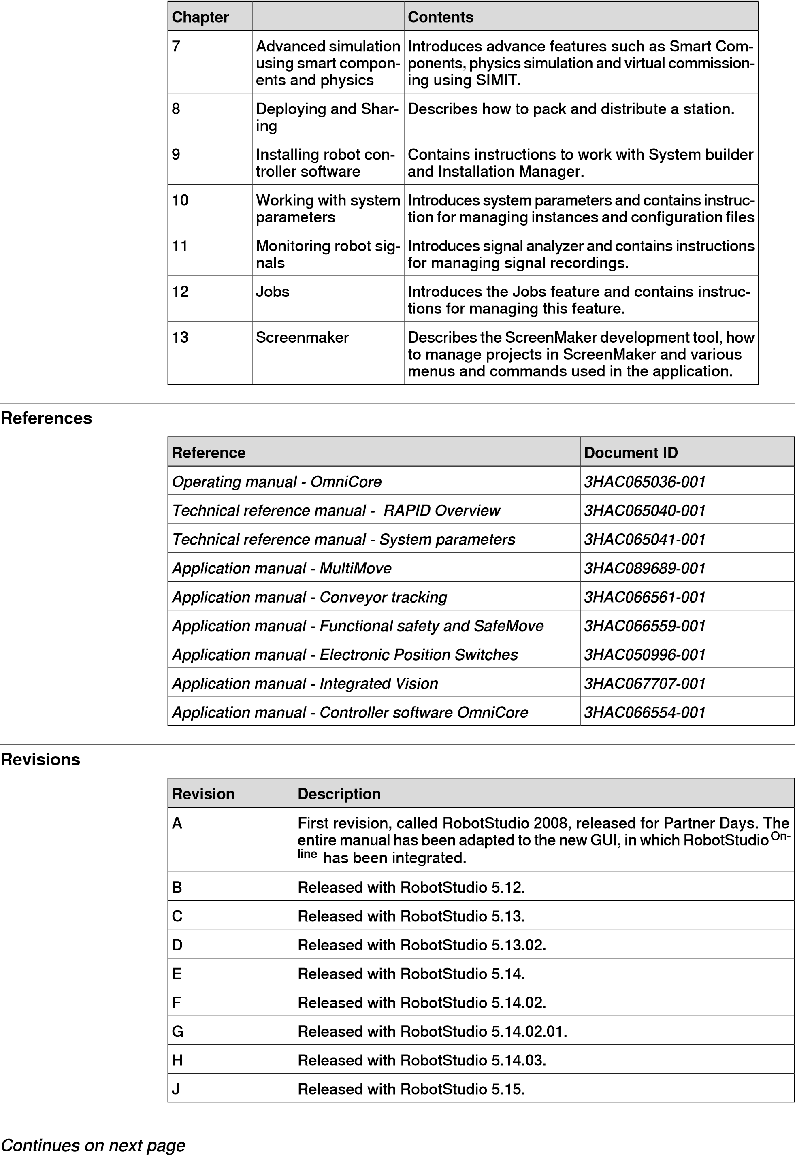

**Overview of this manual**

*Continued*

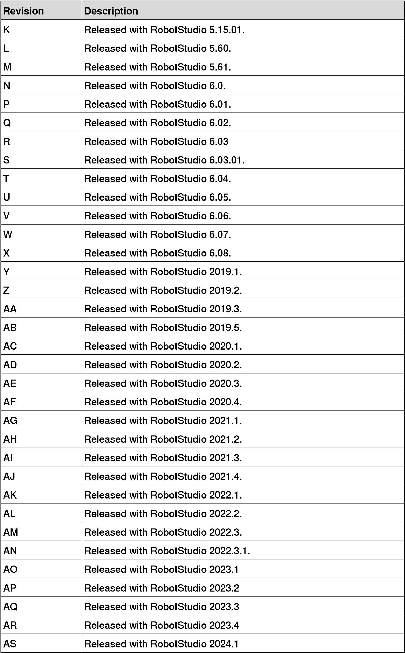

**Product documentation**

**Product documentation**

**Categories for user documentation from ABB Robotics**

The user documentation from ABB Robotics is divided into a number of categories. This listing is based on the type of information in the documents, regardless of whether the products are standard or optional.

**Tip**

All documents can be found via myABB Business Portal,

*www.abb.com/myAB*

[*B*](http://www.abb.com/myABB)

.

**Product manuals**

Manipulators, controllers, DressPack, and most other hardware is delivered with a **Product manual** that generally contains:

* Safety information.
* Installation and commissioning (descriptions of mechanical installation or electrical connections).
* Maintenance (descriptions of all required preventive maintenance procedures including intervals and expected life time of parts).
* Repair (descriptions of all recommended repair procedures including spare parts).
* Calibration.
* Troubleshooting.
* Decommissioning.
* Reference information (safety standards, unit conversions, screw joints, lists of tools).
* Spare parts list with corresponding figures (or references to separate spare parts lists).
* References to circuit diagrams.

**Technical reference manuals**

The technical reference manuals describe reference information for robotics products, for example lubrication, the RAPID language, and system parameters.

**Application manuals**

Specific applications (for example software or hardware options) are described in **Application manuals**. An application manual can describe one or several applications.

An application manual generally contains information about:

* The purpose of the application (what it does and when it is useful).
* What is included (for example cables, I/O boards, RAPID instructions, system parameters, software).
* How to install included or required hardware.
* How to use the application.

*Continues on next page*

**Product documentation**

*Continued*

* Examples of how to use the application.

**Operating manuals**

The operating manuals describe hands-on handling of the products. The manuals are aimed at those having first-hand operational contact with the product, that is production cell operators, programmers, and troubleshooters.

**Safety**

**Safety**

**Safety of personnel**

A robot is heavy and extremely powerful regardless of its speed. A pause or long stop in movement can be followed by a fast hazardous movement. Even if a pattern of movement is predicted, a change in operation can be triggered by an external signal resulting in an unexpected movement.

Therefore, it is important that all safety regulations are followed when entering safeguarded space.

**WARNING**

Program

changes

should

always

be

validated

and

tested

before

entering

production,

to

protect

humans

and

property.

Ensure

it

is

possible

to

stop

the

robot

with

a

protective

stop

device.

**Safety regulations**

Before beginning work with the robot, make sure you are familiar with the safety regulations described in the manual *Safety manual for robot - Manipulator and IRC5 or OmniCore controller*.

**Network security**

**Network security**

**Network security**

This product is designed to be connected to and to communicate information and data via a network interface. It is your sole responsibility to provide, and continuously ensure, a secure connection between the product and to your network or any other network (as the case may be).

You shall establish and maintain any appropriate measures (such as, but not limited to, the installation of firewalls, application of authentication measures, encryption of data, installation of anti-virus programs, etc) to protect the product, the network, its system and the interface against any kind of security breaches, unauthorized access, interference, intrusion, leakage and/or theft of data or information. ABB Ltd and its entities are not liable for damage and/or loss related to such security breaches, any unauthorized access, interference, intrusion, leakage and/or theft of data or information.

This page is intentionally left blank

1.1 What is RobotStudio?

1. **Getting Started**

**1.1 What is RobotStudio?**

**Overview**

RobotStudio is an engineering tool for configuring and programming ABB robots, both physical robots on the shop floor and virtual robots in a PC. Use this application for modeling, offline programming, and simulation of robot cells. Its advanced modeling and simulation features help in visualizing multi robot control, safety features, 3D vision, and remote robot supervision.

RobotStudio’s built-in programming environment allows *online* and *offline* programming of robot controllers. In online mode, it is connected to a *robot controller* and in offline mode, it is connected to a *virtual controller* that emulates a robot controller in a PC.

RobotStudio is downloadable from

http://new.abb.com/products/robotics/robotstudio/downloads. The 30 day basic(trial) version is free and offers full functionalities including CAD Converters. CAD Converters are not part of the Premium license and it requires additional options to be purchased. The Premium version offers complete functionalities and requires activation. To purchase a Premium license, contact your local ABB Robotics sales representative at www.abb.com/contacts.

**RobotStudio feature levels**

RobotStudio features are categorized into basic and premium levels. Administrator privileges on the PC is mandatory to install RobotStudio.

* **Basic** - Offers selected RobotStudio functionality to configure, program, and run a *virtual controller.* It also includes online features for programming, configuring, and monitoring a *robot controller* connected over Ethernet and it does not require activation. In the Basic Functionality mode, which is a reduced functionality mode, RobotStudio allows the usage of basic features only for both robot and virtual controllers. No existing files or *stations* are affected in this mode.
* **Premium** - Offers full RobotStudio functionality for *offline programming* and simulation of multiple robots. The Premium level includes features of the basic level and it requires activation. To purchase a Premium license, contact your local ABB Robotics sales representative at *www.abb.com/contacts*.
  1. What is RobotStudio? *Continued*

**Details of Premium and Basic features**

The following table lists the features provided with Basic and Premium *licenses*.

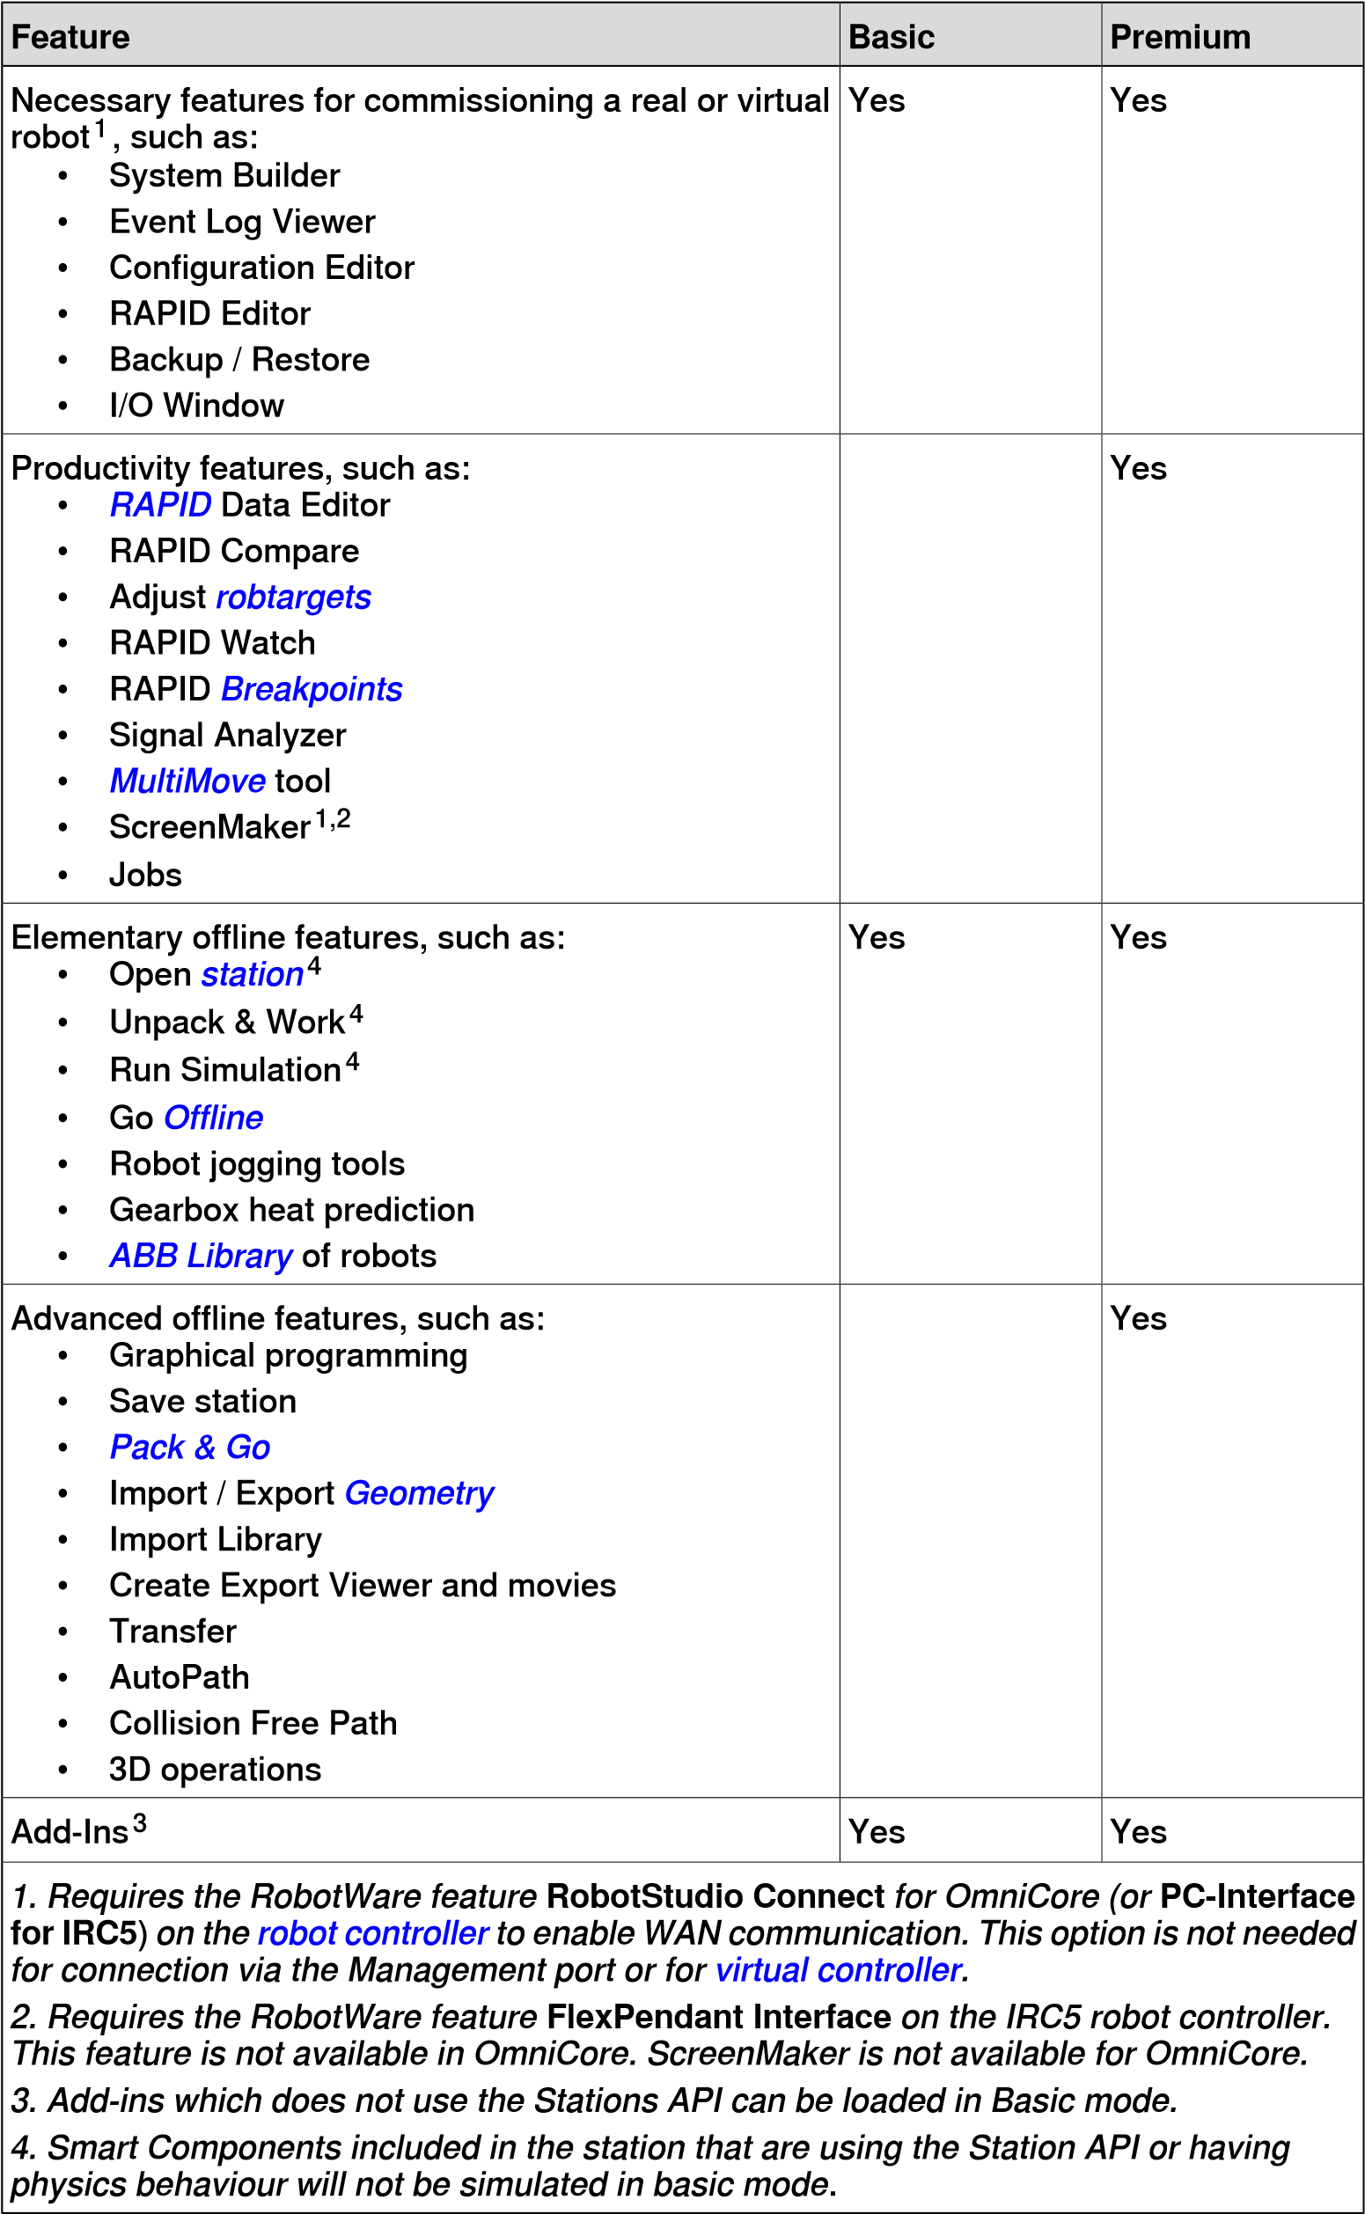

* 1. System Requirements

**1.2 System Requirements**

**Overview**

Before installing RobotStudio, ensure that the computer meets the following hardware and software requirements.

**Hardware**

High-performance desktop or laptop workstation, with the following requirements:

##### Part Requirement

CPU 2.0GHz or faster processor, multiple cores recom-

mended

Memory 8 GB minimum.

16 GB or more if working with heavy CAD models.

Disk 10+ GB free space, solid state drive (SSD) recom-

mended.

Graphics card High-performance, DirectX 11 compatible, gaming

graphics card from any of the leading vendors. For the Advanced lightning mode Direct3D feature level 10_1 or higher is required.

Display settings 1920 x 1080 pixels or higher resolutionis recommen-

ded.

dots per inch (dpi) Only Normal size supported for Integrated Vision.

Mouse Three-button mouse.

3D Mouse [optional] Any 3D mouse from 3DConnexion.

See http://www.3dconnexion.com.

RobotStudio supports *RobotWare* version 5.07 up to the latest released version, including revisions. See RobotStudio Release Notes for any compatibility limitations. You can connect RobotStudio to a *robot controller* either through its service port or over Ethernet.

* To connect RobotStudio over Ethernet:
  + - For IRC5 controllers the RobotWare option **616-1 PC Interface** is required.
    - For OmniCore controllers the RobotWare option **3119-1 RobotStudio Connect** is required.
* To run ScreenMaker or FlexPendant SDK applications on an IRC5 controller, the RobotWare option **617-1 FlexPendant Interface** is required.

Windows 10 Anniversary Update or later 64-bit edition

**Software**

**Description**

**Operating**

**system**

It is recommended to run Windows updates to get the latest updates to Windows before installing and running RobotStudio. Windows Firewall can block certain features that are necessary to run RobotStudio, which must be unblocked as required. You can view and edit the state of a program at **Start** > **Control Panel** >

1.2 System Requirements

*Continued*

**Windows Firewall**. For more information on Windows Firewall, *visit www.microsoft.com*.

**Firewall settings**

The firewall settings are applicable to robot and virtual controllers. The following table describes the necessary firewall configurations:

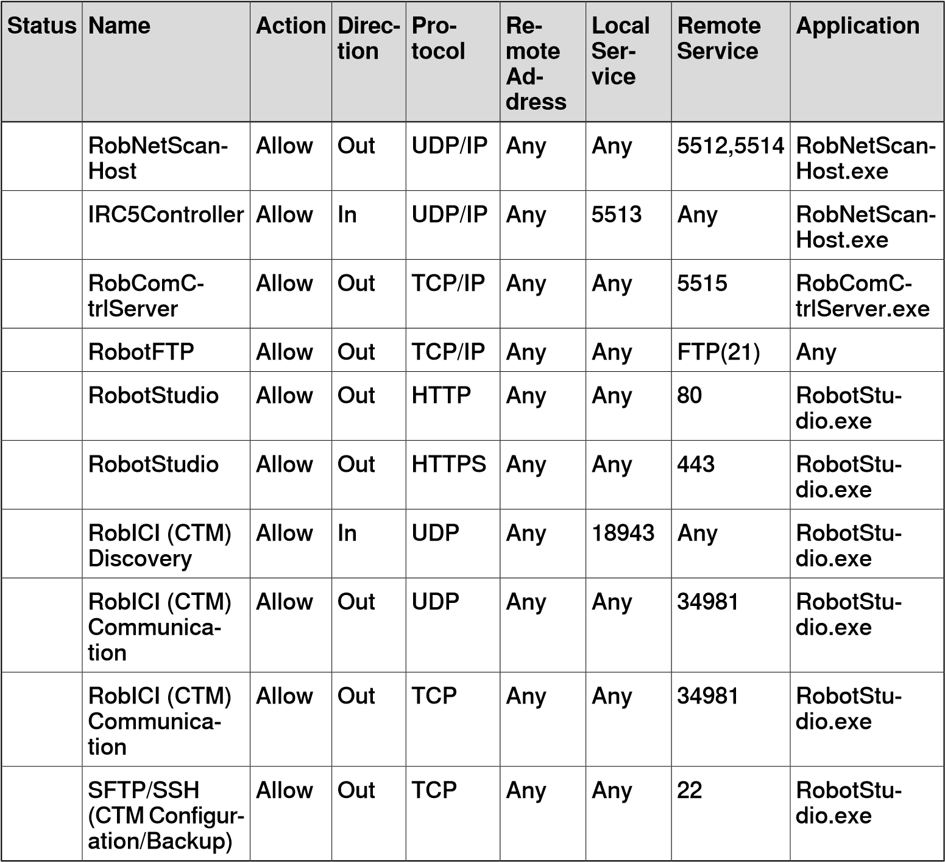

The following table describes the necessary firewall configurations for the RobotWare option, Integrated Vision:

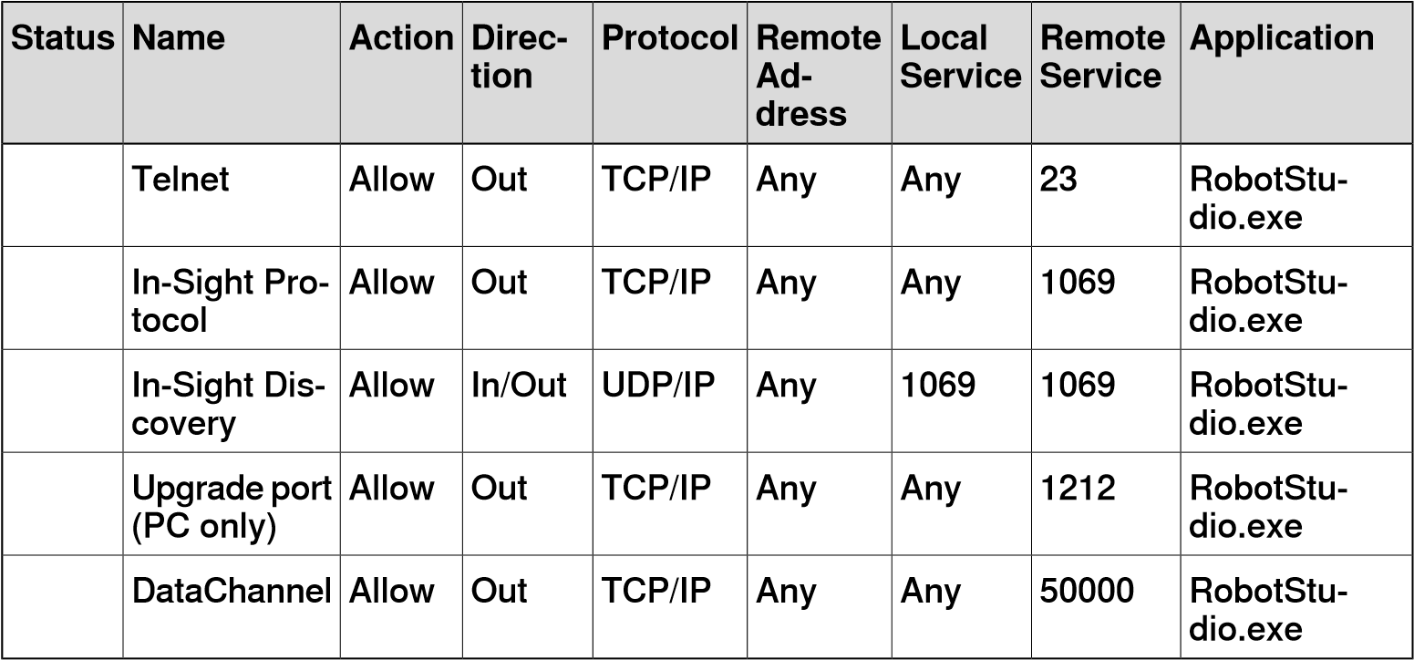

*Continues on next page*

1.2 System Requirements *Continued*

RobotStudio uses the current Internet Options, HTTP, and proxy settings.

**Note**

The following table describes the necessary firewall configurations for SLP Distributor.

**Application**

**Re-**

**mote**

**Ser-**

**vice**

**Local**

**Ser-**

**vice**

**Re-**

**mote**

**Ad-**

**dress**

**Pro-**

**tocol**

**Direc-**

**tion**

**Action**

**Name**

**Status**

Slps.Distribut-

or.Host.exe

Any

2468

Any

TCP/IP

In

Allow

Software Potential

Distributor (for the

web

interface)

Slps.Distribut-

or.Host.exe

Any

8731

Any

TCP/IP

In

Allow

Software Potential

Distributor (licens-

ing)

Slps.Distribut-

or.Host.exe

443

Any

Any

TCP/IP

Out

Allow

Software Potential

Distributor (activa-

tion)

**Services and processes**

The following table describes the Windows Services.

##### Name Application Type Startup Account Description

**Type**

ABB Industrial RobComC- Service Manual Local System Provides support for RobotCommunic- trlServer.exe account communicating with

ation Server ABB robot controllers.

ABB Industrial RobNetScan- Service Manual Local System Provides support for

Robot Discovery Host.exe account discovery of ABB ro-

Server bot controllers.

SLP Distributor is not part of the RobotStudio installation. It is optional and must be installed on a dedicated server. Install the SLP Distributor server on a dedicated PC accessible from the PCs where RobotStudio is going to be used. The following table details SLP Distributor.

##### Name Application Type Startup Account Description

**Type**

Software Po- Slps.Distribut- Service Automatic LocalSystem Allocates Pooled Re-

tential Distrib- or.Host.exe account sources to Software

utor Potential-protected ap-

plications.

The following table describes the applications that RobotStudio starts.

##### Application Description

7z.exe Compression/decompression command line tool. cfree_server.exe Used for collision free path planning.

CadConverter.exe Converts between CAD formats. comp.exe ABB compression command line tool.

ConvexHullBuilder.exe Creates convex hulls for collision avoidance and collision free path planning.

1.2 System Requirements

*Continued*

**Application Description** decomp.exe ABB decompression command line tool.

InstallationManager.exe Creates and modifies RobotWare 6.x systems.

InstallationManager7.exe Creates and modifies RobotWare 7.x systems.

PdfConverter.exe Used by Visual SafeMove to create PDF files.

PoissonRecon.exe Reconstructs meshes from point clouds. Used for swept volume generation.

RobotDiskRecovery.Exe Creates robot recovery disks.

RobotStudio.Installer.exe Performs actions that require elevation, such as initialization of license storage.

RobVC.exe The ABB virtual controller.

RSSystemInfo.exe RobotStudio Support Tool

RobotStudio.FleetManage- Executes jobs that communicate with multiple robot ment.JobRunner.exe controllers.

RunJob.exe A command line tool for executing jobs using *RobotStu-*

*dio.FleetManagement.JobRunner.exe.*

ScreenMaker.exe Creates FlexPendant user interfaces for RobotWare 5-

6.x systems.

SystemBuilder.exe Creates RobotWare 5 systems.

tar.exe Creates or extracts files from archives. Used for

backups.

Virtual FlexPendant.exe Virtual Flexpendant for RobotWare 5-6.x systems.

Vrchost64.exe The 64-bit ABB virtual controller.

**1.3 How to activate RobotStudio?**

**Activation of RobotStudio license**

Activation of RobotStudio installation is a procedure for validating the RobotStudio *license*. To continue using the application with all of its features, it must be activated. RobotStudio product activation is based on the anti-piracy technology and is designed to verify that software products are legitimately licensed. Activation works by verifying that the *activation key* is not in use on more personal computers than are permitted by the software license.

When you start RobotStudio for the first time after installation, it prompts for the

25-digit activation key (xxxxx-xxxxx-xxxxx-xxxxx-xxxxx). The software performs in the Basic Functionality mode in the absence of a valid activation key. A successful activation entails the user with valid licenses for the features covered by the subscription.

**Installing the trial license**

Use the following procedure to request for the the 30 day trial version. An active Internet connection is required for this procedure.

1. Download and install RobotStudio from *http://new.abb.com/products/robotics/robotstudio/downloads*.
2. Start RobotStudio. On the **File** tab, click the **Help** section.
3. Under **Support**, click **Manage Licenses**. The **Options** dialog appears with the **Licensing** options.
4. Under **Licensing**, click **Activation Wizard** to view RobotStudio license options. 5 Select the **I want to request a trial license** option, click the **Next** button.

RobotStudio installation dialog opens and starts to install the application, click **Finish** once the installation completes.

RobotStudio will connect to the cloud service and request a trial license. A trial license can be requested once per PC.

**Type of licenses**

##### Type of li- Description cense

Multi-user Allows you to centralize license management by installing *licenses* on a

single server rather than on individual client machines. A Multi-user license allows a number of users on the same TCP/IP network to share access to product licenses. The server administers the licenses to the clients as required. A Multi-user license allows several clients to use the software.

Multi-user licensing in RobotStudio uses the SLP Distributor server as the licensingserver.Multi-userlicensesarecurrentlyavailableonlyforauthorized value providers and schools. The School and Value provider licenses fall into the multi-user category.

SLP Distributor is installed as a Windows Service on a network server and manages concurrent licensing of RobotStudio. In addition to the licensing service endpoint, SLP distributor also provides a web interface for administration of services such as activating licenses, viewing usages and so on.

Standalone Allows a single user to install and use RobotStudio on a single computer.

##### Type of li- Description cense

Commuter Allows a RobotStudio user to work offline from the multi-user license server. You can check out a license from the server for a specified number of days. During this period the checked out license is unavailable to other users. The commuter license is made available for other clients only when it is manually checked in back to the server.

**Understanding the activation key**

When RobotStudio starts for the first time after installation, it prompts for the 25-digit activation key (xxxxx-xxxxx-xxxxx-xxxxx-xxxxx). The activation key for a standalone license must be activated inside RobotStudio and the activation key for a multi-user license must be activated in the SLP Distributor on the license server. Read the *Subscription confirmation mail* that ABB sends before activating RobotStudio installation.

**Multi-user license logging**

SLP distributor provides option for logging the Multi-user license usage. License usage can be logged in the distributor such that it can be manually retrieved for subsequent analysis. This feature is not enabled by default and must be enabled by uncommenting the *<add*

*key="Slps.Distributor.Service.EnableUsageLogging" value="true">* setting in the Slps.Distributor.Services.dll.config file located in *C:\Program Files (x86)\ABB\SLP.Distributor.Host\Services*.

**Note**

Windows may prevent the editing of

Slps.Distributor.Services.dll.config file in its original location. Hence, copy the file to the user directory for editing before replacing the original file with the edited file.

When enabled, Distributor logging may have a minor impact on the performance of the server and it keeps a sliding window of 45 daily logs, with a maximum size of 45MB. The usage logs are available in a text file in *\Slp.Distributor.Host\Services\Usage*.

**Activation Wizard**

The Activation Wizard tool provides activation options during RobotStudio installation. It provides two activation modes, automatic activation over Internet or manual activation. When RobotStudio starts for the first time after installation, the wizard starts automatically and prompts for the *activation key*. RobotStudio can be activated after installation or later using the wizard. Use the following steps to start the Activation Wizard tool.

1. Click the **File** tab, and then click the **Help** section.
2. Under **Support**, click **Manage Licenses**. The **Options** dialog appears with the **Licensing** options.
3. Under **Licensing**, click **Activation Wizard** to view RobotStudio license options.

**What are Installation Options?**

RobotStudio offers three Installation options, *Minimal*, *Custom* and *Complete*. Activation is not required for Minimal installation, or for Basic functionality modes of *Complete* or *Custom* installation.

* *Minimal* - Installs features to program, configure, and monitor a *robot controller* connected over Ethernet.
* *Custom* - Installs user-customized features and excludes selected robot *libraries*.
* *Complete* - Installs complete RobotStudio and includes additional features of Basic and Premium functionalities.

**Activating standalone license without Internet access**

On a computer with Internet access, RobotStudio gets activated automatically. Automatic activation requires a working Internet connection and a valid *activation key* that has not exceeded the allowed number of installations. In the absence of Internet access, the product must be activated manually. Restart RobotStudio after activation.

1. Create a license request file by selecting the option **Step 1:Create a license request file**.

Proceed through the wizard, enter the *activation key* and save the license request file to your computer.

1. Use removable storage, such as a USB stick, to transfer the file to a computer with an Internet connection. On that computer, open a web browser, go to *http://manualactivation.e.abb.com/* and follow the instructions given.

A license key file gets created, save this file and transfer it to the computer hosting the installation.

1. Restart the activation wizard and go through the steps until the *Activate a Standalone License* page.
2. Under *Manual Activation*, select the option **Step 3:Install a license file**.

Proceed through the wizard, select the license key file when requested. On completion, RobotStudio is activated and ready for use. RobotStudio must be restarted after activation.

**Activating Multi-user license**

Install the SLP Distributor server on a dedicated PC accessible from the PCs where RobotStudio is going to be used.

1. Install the SLP Distributor server from the *SLP Distributor* directory of the RobotStudio distribution. The SLP Distributor server is installed as a service that starts automatically with Windows. It requires two open TCP ports, by default 2468 (for the web interface) and 8731 (for licensing). The installer optionally opens these ports in the standard Windows firewall, but any third-party firewall must be configured manually by the system administrator.

**Note**

Refer to the latest RobotStudio Release Notes for more information on the

installer

requirements.

1. Activate the licenses for Multi-user licensing .

Once the SLP server is online, you can access its web interface at *http://<server>:2468/web*. The following table shows how to use the server's web interface.

**Use...**

**To...**

The

**Activation**

tab.

Activate

a

Multi-user

license

automatically

(

for

PCs

with

Internet

connec-

tion)

Type

in

the

**Activation**

**Key**

provided

by

ABB,

and

then

click

**Submit**

.

The

number

of

concurrent

users

that

get

activated

depends

on

the

*activation*

*key*

provided.

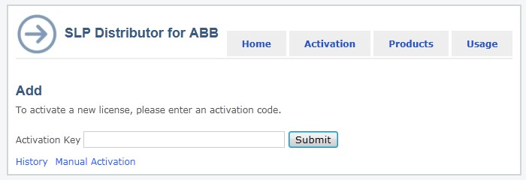

xx1300000052

**Use...**

**To...**

The

**Activation**

tab.

a

Click

**Manual**

**Activation**

.

b

Type

in

your activation key

provided by

ABB,

and

then

click

**Submit**

.

c

Save

the

file

to

a

removable

storage, such

as

a USB stick, then transfer the file to a machine

with an Internet connection.On that machine,

open

a

web

browser

and

browse

to

*ht-*

*tp://manualactivation.e.abb.com/*

and

follow

the

instructions

given.

A

license

key

file

gets

generated

and

will

be

saved.

This

file

will

be

returned

to

the

machine

which

hosts

the

in-

stallation.

d

After

receiving

the

license

file,

click

**Browse**

to

upload

and

install

the

license

file.

Your

Multi-user

license

is

now

activated.

Activate

a

Multi-user

license

manually

(

for

PCs

*without*

Internet

con-

nection)

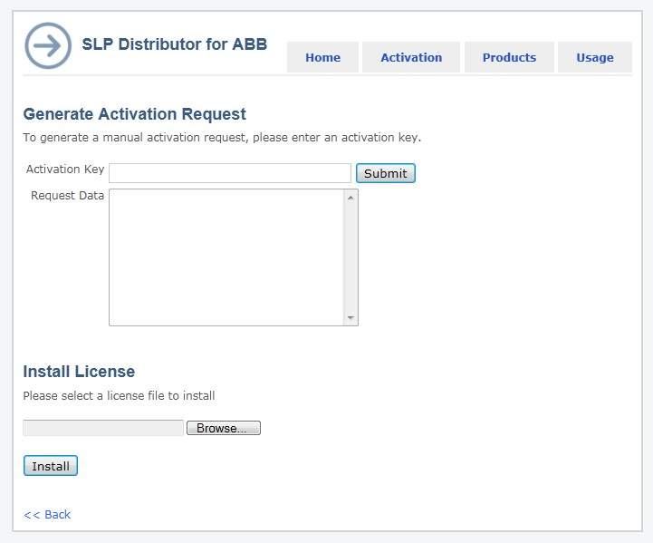

xx1300000051

In

the

**Home**

tab,

under

**Dashboard**

,

click

**Details**

.

Alternatively,

click

the

**Products**

tab.

The

**Product**

**details**

**for**

**RobotStudio**

page

opens

which

shows

the

installed

licenses

details.

View

the

installed

licenses

On

the

**Home**

tab,

under

**Dashboard**

,

click

**Usage**

.

Alternatively,

click

the

**Usage**

tab.

The

*Current*

*usage*

*of*

*RobotStudio*

page

opens

in

which

the

following

details

are

tabulated.

•

Licenses

which

are

currently

allocated

•

Client

to

which

each

license

is

allocated

to

•

Number

of

remaining

licenses

available

for

use

Each

table

row

corresponds

to

one

client

system.

View

the

usage

of

licenses

1. Set up the client for Multi-user licensing.

Use RobotStudio Activation Wizard in the client system for setting up Multi-user license. Use this procedure to set up Multi-user license for a client system.

##### Action

On

the

**File**

tab,

click

**Options**

and

go

to

**General:Licensing**

.

1

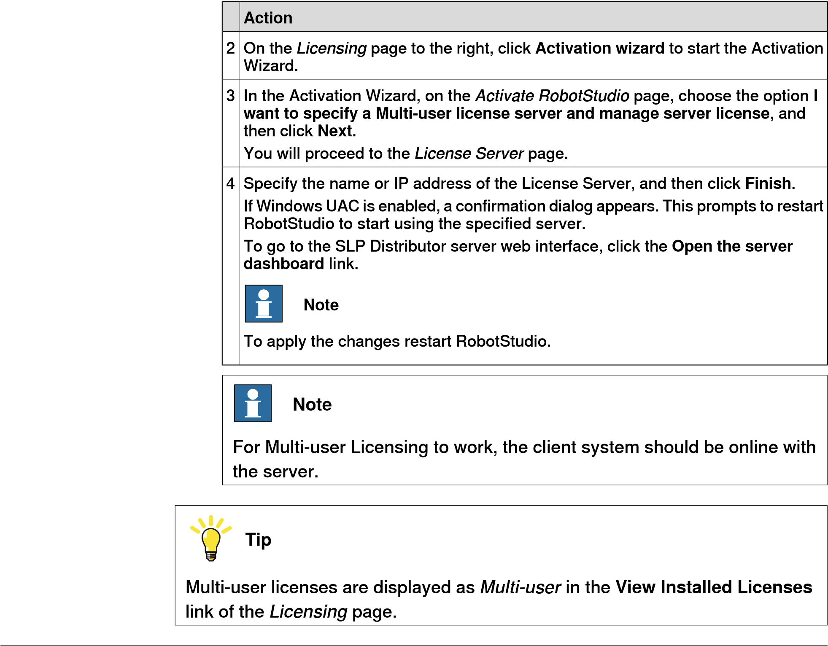

**Activating commuter licenses**

A commuter license key can be checked out if a PC has to be disconnected from the network. Normally, the PC possessing a multi-user license key must remain connected through the network to the License Server.

A commuter license key allows the PC to be disconnected from the network. The commuter license expires when the check out time expires. You may check in the license after use, and it becomes immediately available for other users.

It is not possible to check out specific features in the license. All features in a license are included when it is checked out. Use the activation wizard to check in/check out a commuter license.

##### Action

1. On the **File** menu, click **Options** and select **General: Licensing**.
2. On the *Licensing* page to the right, click **Activation wizard** to start the Activation Wizard.
3. In the Activation Wizard, on the *Activate RobotStudio* page, choose **I want to check out or check in a commuter license** and click **Next**. The *Commuter License* page opens.

##### Action

1. In the *Commuter License* page, select one of the following optionsas per the requirement:
   * + - **Check out a commuter license** - In the **Check out days** box specify the number of days for keeping the license.

This option is disabled if a commuter license has already been checked out.

* + - * **Check in a commuter license** - Choose this option to return the currently checked out license to the server.

This option is enabled only if a commuter license is already checked out. If so, the expiry date and time of the license gets displayed.

1. Click **Finish** to complete the check in/check out.

**Tip**

Multi-user licenses that are checked-out as commuter licenses will be displayed as Floating (checked out) in the *View Installed Licenses* link of the *Licensing* page.

**Verifying RobotStudio activation**

* + 1. On the **File** tab, click **Options**, and then select the **Licensing** section.
    2. Click **View Installed License Keys** to see the status of the current license. On successful activation, valid licenses for the features covered by the subscription gets displayed here.

**Activating RobotStudio®Cloud**

RobotStudio Premium license includes the RobotStudio®Cloud subscription. This must be activated directly from the **Activation Wizard**.

**Note**

To

activate

RobotStudio

®

Cloud

subscription,

user

must

have

an

account

in

the

myABB

Business

Portal,

*www.abb.com/myAB*

[*B*](http://www.abb.com/myABB)

.

Activating the RobotStudio®Cloud subscription

* + 1. Click the **File** tab, and then click the **Help** section.
    2. Under **Support**, click **Manage Licenses**. The **Options** dialog appears with the **Licensing** options.
    3. If you have not activated your RobotStudio license, click the **Activation Wizard** and follow the instructions.
    4. If your RobotStudio license includes the RobotStudio®Cloud subscription, a **Sign In** button will be visible in RobotStudio.
    5. Click the **Sign In** button, and enter your credentials in the **Sign in to your account** dialog.

If the signing in is successful, the RobotStudio *Subscription key* and your *username(email address)* gets displayed.

* + 1. Click the **Activate** button.

If the activation is successful, you can see the **Activated** icon and the **View My Cloud Projects** link. Click this link to open RobotStudio®Cloud.

Alternatively, **Activation Wizard** can be accessed using the following option.

• From the **Options** page, click **Options:General:Licensing** and then click the **Activation Wizard** button.

**Demo Stations**

RobotStudio provides a set of demo *stations* to help users. Users can open these stations for understanding the basic structure of a generic station. These stations are stored as *pack&go* files and can be downloaded. An active Internet connection is required for downloading the demo stations.

To open a trial station:

* + 1. Start RobotStudio.
    2. On the **File** tab, click **Open**, under **Samples** click **Demo Stations** to view available demo stations.
    3. Click a demo station to unpack and open. When you open a demo station for the first time, it will be downloaded.

**RobotStudio notifications**

RobotStudio's in-app notifications notify users about the new updates. These notifications include updates for RobotStudio and add-ins, new and updated simulation models and license information. User can open these notification pop-ups by clicking the Notification icon in the title bar. The icon has a blue dot if there are any new (unread) notifications.

**1.4 Connecting a PC to the controller**

**Overview**

There are two ways of physically connecting a PC to the controller, to the service port or to the factory network port.

**The service port**

The service port is intended for service engineers and programmers connecting directly to the controller with a PC. The service port is configured with a fixed IP-address, which is the same for all controllers and cannot be changed, and has a DHCP server that automatically assigns an IP-address to the connected PC.

**The factory network port**

The factory network port is intended for connecting the controller to a network. The network settings can be configured with any IP-address, typically provided by the network administrator.

**Limitations**

**Note**

The

maximum

number

of

connected

network

clients

is:

•

LAN

port:

3

•

Service

port:

1

•

FlexPendant:

1

The maximum number of applications running on the same PC which is connected

to

one

controller

has

no

built-in

maximum.

However,

for

a

controller

with

RW

7

*UAS*

limits

the

number

of

users

to

123.

For

a

controller

with

RW

6

,

*UAS*

limits

the

number

of

users

to

100.

The

maximum

number

of

concurrently

connected

FTP

clients

is

4.

1.4 Connecting a PC to the controller *Continued*

**Ports on the computer unit DSQC 639**

The illustration below shows the two main ports on the computer unit DSQC 639, the service port and the LAN port.

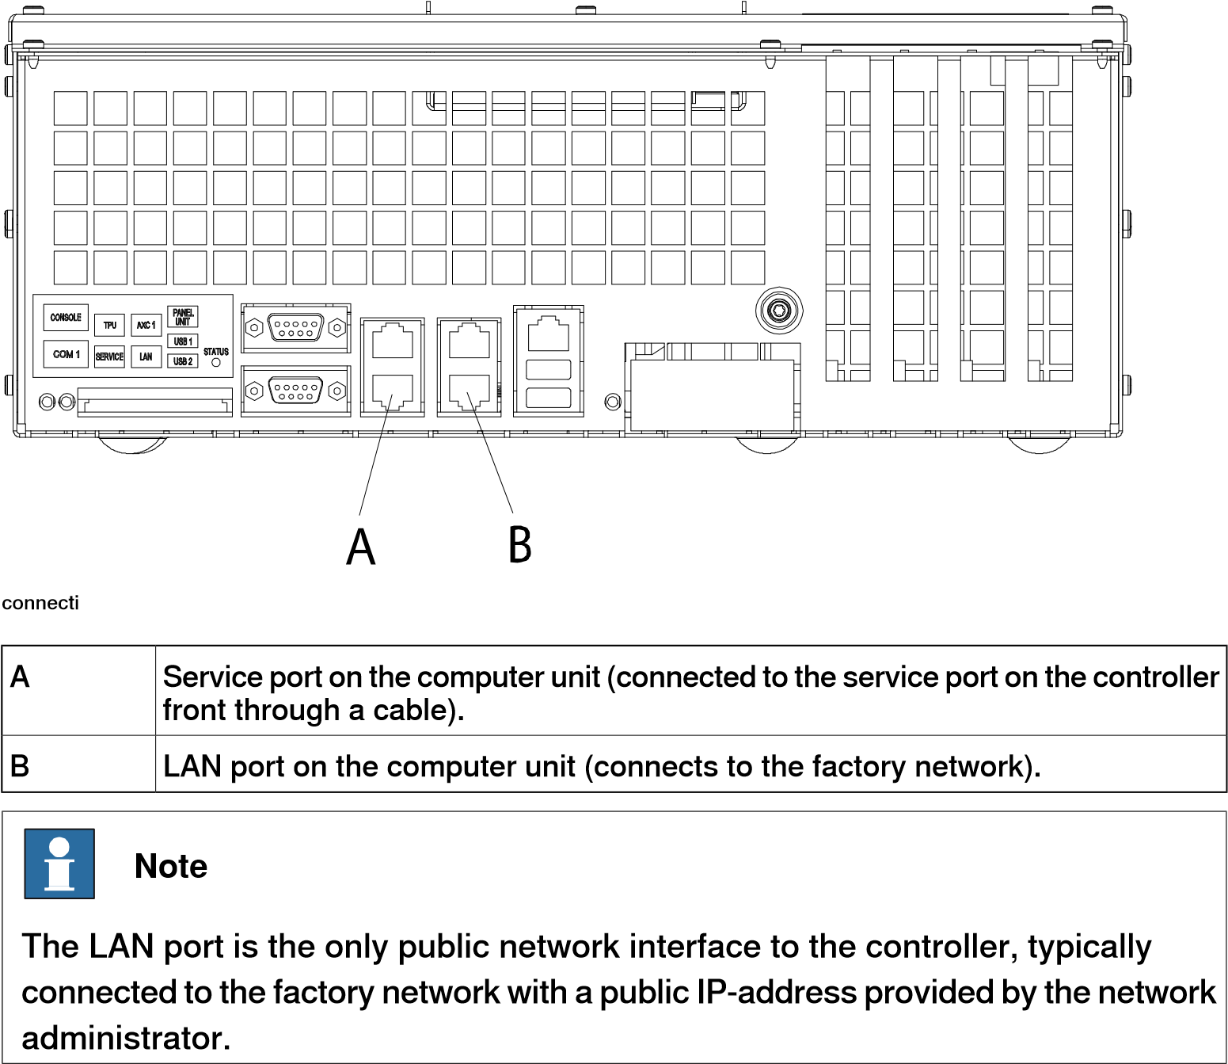

*Continued*

**Ports on the computer unit DSQC1000/DSQC1018/DSQC1024**

The illustration below shows the two main ports on the computer unit

DSQC1000/DSQC1018/DSQC1024, the service port and the WAN port.

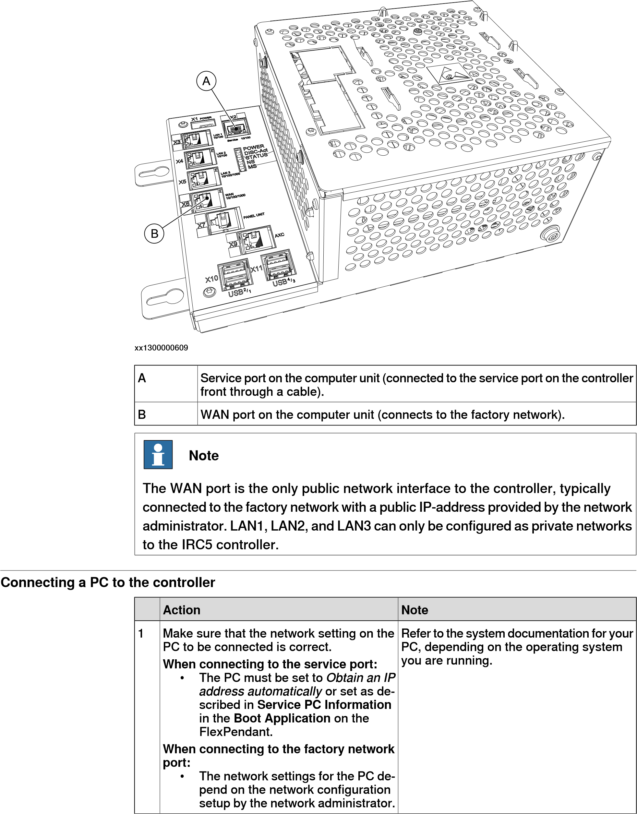

1.4 Connecting a PC to the controller

*Continued*

**Note**

Do

not

connect

another

DHCP

server

to

this

port.

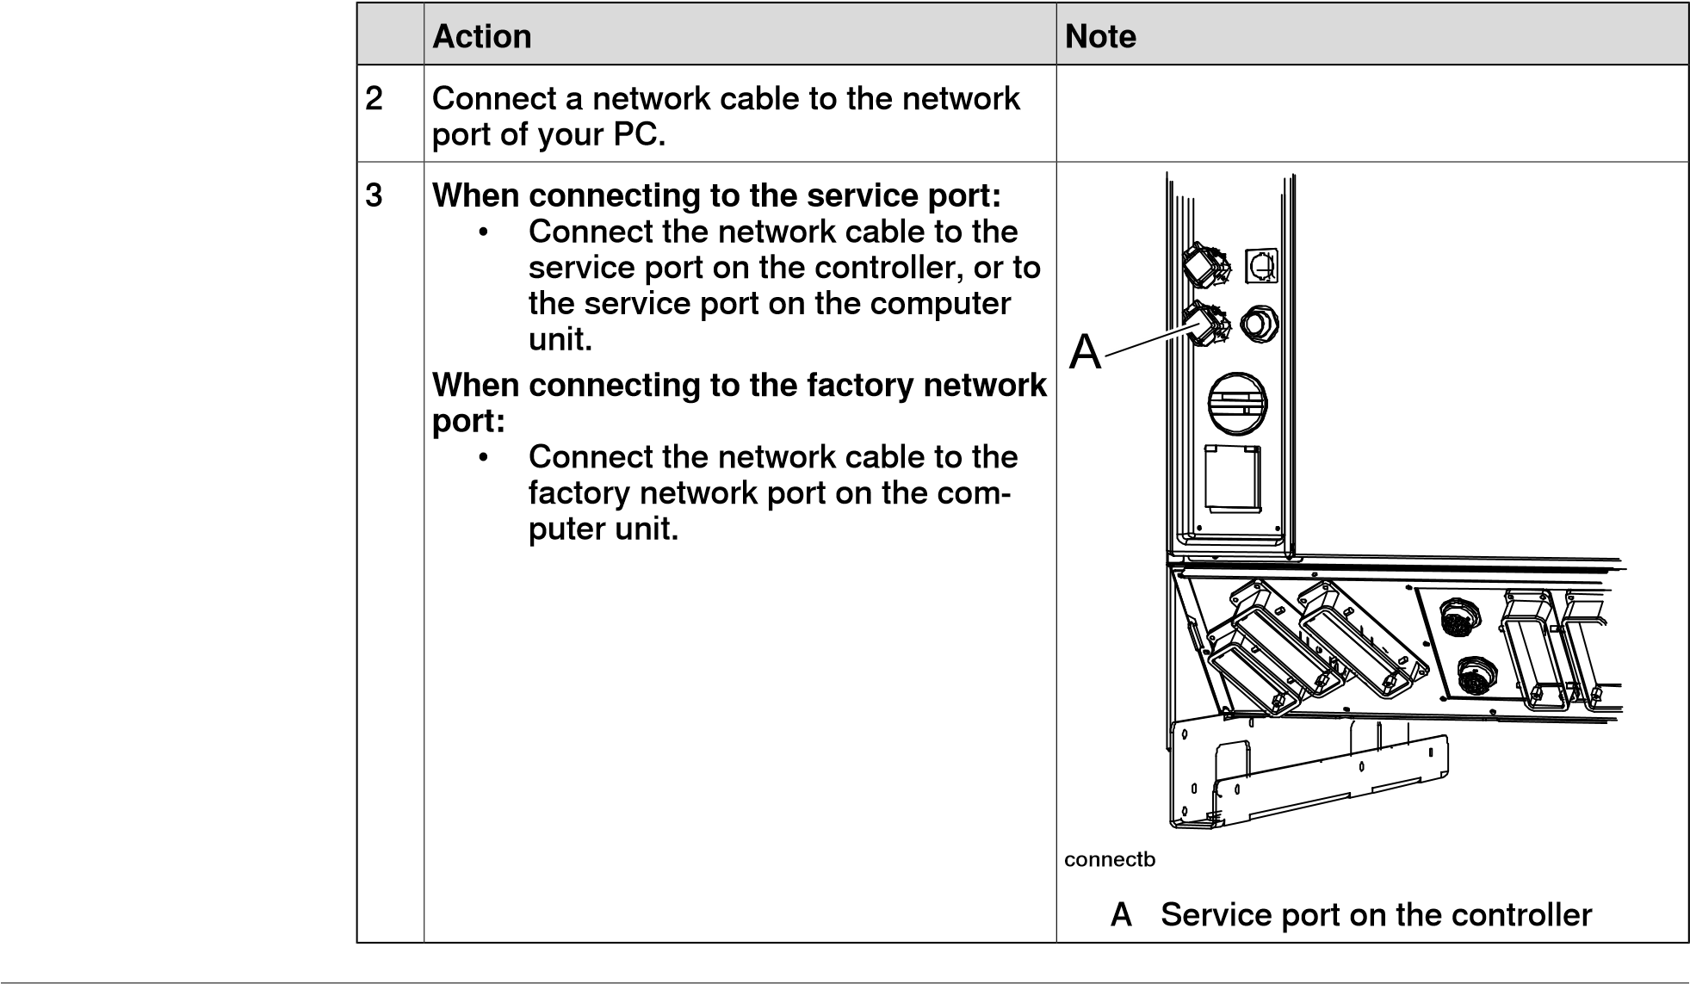

**Connecting RobotStudio to OmniCore**

Connectors in OmniCore

The following diagram shows the connectors on the front panel of the OmniCore controller.

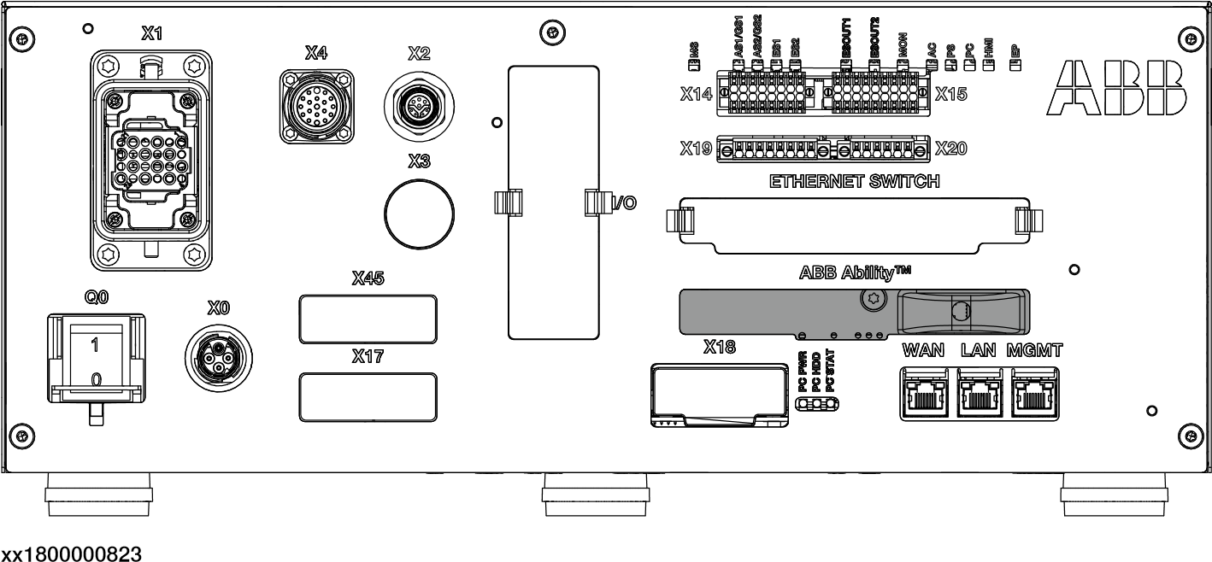

MGMT port

The MGMT port(management port) is intended for service engineers and programmers connecting directly to the controller with a PC.

The management port is configured with the fixed IP address 192.168.125.1, which is the same for all controllers and cannot be changed, and has a DHCP server that automatically assigns an IP address to the connected PC.

*Continued*

WAN port

The WAN port is a public network interface to the controller, typically connected to the factory network with a public IP address provided by the network administrator.

The WAN port can be configured with fixed IP address, or DHCP, from **RobotStudio** or the FlexPendant. By default the IP address is blank.

Some network services, like FTP and RobotStudio, are enabled by default. Other services are enabled by the respective RobotWare application.

**Note**

The WAN port cannot use any of the following IP addresses which are allocated for other functions on the controller:

* 192.168.125.0 - 255 • 192.168.126.0 - 255
* 192.168.127.0 - 255

The WAN port cannot be on a subnet which overlaps with any of the above reserved IP addresses. If a subnet mask in the class B range has to be used, then a private address of class B must be used to avoid any overlapping. Contact your local network administrator regarding network overlapping.

LAN port

The I/O Network is needed when an Industrial Ethernet network must be isolated from the Public Network. The LAN port is connected to the controller's I/O Network and is intended for connecting the robot controller to a factory wide industrial network isolated from WAN.

A factory wide I/O Network should be connected to the WAN port on the controller, or to the LAN port if the I/O network needs to be isolated from the network already connected to WAN.

1.5 Network Settings

**1.5 Network Settings**

**Prerequisites**

The PC can be connected to the controller through an Ethernet network in the following ways:

* + Local network connection
  + Service port connection
  + Remote network connection

**Local network connection**

You can connect your PC to the same Ethernet network that the controller is connected to. When the PC and the controller are connected correctly and to the same subnet, the controller will be automatically detected by RobotStudio. The network settings for the PC depend on the network configuration. Contact the network administrator for setting up the PC.

**Service port connection**

When connecting to the controller's service port, obtain an IP address for the PC automatically, or specify a fixed IP address. Contact the network administrator for setting up the service port connection.

**Automatic IP address**

The controller's service port has a DHCP server that will automatically give the PC an IP address if it is configured for this. For detailed information, see the Windows help on configuring TCP/IP.

**Fixed IP address**

Instead of obtaining an IP address automatically, you can also specify a fixed IP address on the PC you connect to the controller. Use the following settings for a fixed IP address:

**Value**

**Property**

192.168.125.2

IP

address

255.255.255.0

Subnet

mask

For detailed information about how to set up the PC network connection, see Windows help on configuring TCP/IP.

**Note**

Obtaining an IP address automatically might fail if the PC already has an IP address from another controller or Ethernet device. To ensure the accuracy of the IP address if the PC was connected to an Ethernet device, do one of the following:

* Restart the PC before connecting to the controller.
* Run the command ipconfig /renew from the command prompt after connecting the PC to the controller.

1.5 Network Settings *Continued*

**Remote network connection**

To enable connection to the controller on a remote subnet or over the local network, the relevant network traffic must be allowed through any firewall between the PC and the controller. The firewall must be configured to accept the following TCP/IP traffic from the PC to the controller:

* UDP port 5514 (unicast)
* TCP port 5515
* Passive FTP

All TCP and UPD connections to remote controllers are initiated by the PC, that is, the controller only responds on the given source port and address.

**Connecting to the controller**

1. Make sure the PC is connected to the controller's service port and that the controller is running.
2. On the **File** menu, click **Online** and then select **One Click Connect**. The **Controller** tab opens.
3. Click **Add Controller**.
4. Click **Request Write access**.

##### If the controller is in mode Then

Auto You will now get *Write Access* if it is available.

Manual A message box on the FlexPendant will allow you to

grant remote *Write Access* to RobotStudio.

1.6.1 IRC5 controller

**1.6 Managing user rights and write access on a controller**

##### 1.6.1 Managing user rights and write access on an IRC5 controller

**Overview**

*User Authorization System* (UAS) restricts user access to the controller data and functionalites. These functionalities are categorized and protected by UAS grants. There are two types of grants; controller grants and application grants. Controller grants are predefined and provided by *RobotWare*. Application grants are defined by RobotWare add-ins. These grants are managed using the **UAS Administration Tool**.

UAS grants are viewable using the UAS grant viewer. The *UAS Grant Viewer* page displays information about the grants of the current user. In the **Authenticate** menu, click **UAS Grant Viewer** to open the viewer.

Group

Group is a collection of grants that represents user roles. The available user roles are administrator, programmer, operator and user defined. User inherits the grants of the group it is associated to.

All the controllers have a preset group and preset user named *Default Group* and

*Default User* respectively. The *Default User* has an open password *robotics*. The *Default Group and User* cannot be removed and the password cannot be changed. However, the user with the user grant *Manage UAS settings* can modify the controller grants and application grants of the default user.

You can deactivate the *Default User* except for RobotWare 6.04 and earlier. Before deactivating the default user, it is recommended to define at least one user with the grant *Manage UAS settings* so as to continue managing users and groups.

Write access

Write access is required to change data on a controller. The controller accepts a single user with write access at a time. RobotStudio users can request write access to the system. If the system is running in manual mode, the request for write access is accepted or rejected on the FlexPendant. User loses write access if the mode changes from manual to automatic, or vice versa. If the controller is in manual mode, then the write access can be revoked from the FlexPendant.

**Adding a user to the administers group**

In addition to the *Default Group*, certain predefined user groups are available in the *robot controller*. The predefined groups are, *Administrator*, *Operator*, *Service* and *Programmer*. The Administrator group has the controller grant *Full access* enabled.

1. On the **Controller** tab, click **Add controller** and then click **Add Controller..**

and then select the controller from the **Add Controller** dialog.

1. On the **Controller** tab, click **Request Write Access**.
2. Click **Authenticate** and then click **Edit User Accounts**.

**UAS Administration Tool** opens.

1.6.1 Managing user rights and write access on an IRC5 controller *Continued*

1. On the **Users** tab, click **Add**. The **Add new user** dialog opens.
2. In the **User Name** and **Password** boxes, enter suitable values. Click **OK**. The new user gets added to the **Users on this controller** list.

**Note**

Valid characters that can be used for creating passwords are

*abcdefghijklmnopqrstuvwxyzA*

*BCDEFGHIJKLMNOPQRSTUVWXYZ_-1234567890,;.:!#%/\()=?*@${[]}£*, space is also a valid character.

1. Select the user, and then from the User's groups, click the **Administrator** check box.
2. Click **OK**. The new user gets added to the **Administrator** group. Use the same steps to create users for various groups.

**Note**

To

view

the

Controller/Application

grants

assigned

to

a

particular

group,

in

the

**UAS**

**Administration**

**Tool**

,

on

the

**Groups**

tab,

select

the

group

and

then

select

the

particular

category

of

grant.

**Creating a new user group**

1. In the **UAS Administration Tool**, click the **Groups** tab.
2. On the **Groups** tab, click **Add**. The **Add new group** dialog opens.
3. Enter the required details and click **OK**. The new group gets added.

**Modifying an existing user group**

1. In the **UAS Administration Tool**, click the **Groups** tab.
2. On the **Groups** tab, Select the group and then click **Edit**. Enter the required changes and click **OK**.

**Creating a new user**

1. In the **UAS Administration Tool**, click the **Users** tab, and then click **Add**. The **Add new user** dialog opens.
2. In the **User Name** and **Password** boxes, enter suitable values. Click **OK**.

The new user gets added to the **Users on this controller** list.

1. Select the user, and then from the **User's groups**, click the group to which the user must be added.
2. Click **OK**.
3. Click **OK**. The new user gets added to the **Administrator** group.

**Modifying an existing user**

1. In the **UAS Administration Tool**, click the **Users** tab.

1.6.1 IRC5 controller

1. On the **User** tab, select the group from **User's groups** and then select the required user.
2. Click **Edit**. Enter the required changes and click **OK**.

1.6.2 Managing user rights and write access on an OmniCore controller

##### 1.6.2 Managing user rights and write access on an OmniCore controller

**Overview**

The OmniCore controller is delivered with a preset user named *Default User*. This user is assigned certain grants by default and it belongs to the role *Operator*. If a new user is created with specific grants, the *Default User* can be removed. An active *Default User* has *read only* rights to the controller data even if all grants are removed. Hence, to prevent any unauthorized access to OmniCore controller data, the *Default User* must be deleted.

The OmniCore controller is delivered with a default configured user, named *Admin*. All UAS grants are assigned against this user, such as, adding, removing and modifying users. The *Admin* user belongs to the role *Administrator* by default. You can deactivate the *Admin* user. Before deactivating default users, it is recommended to define at least one user with the grant *Manage UAS settings* so as to continue managing users and roles.

**Adding a user to the Administrators group**

The predefined user roles available in the *robot controller* are *Administrator* and *Operator*. For the Administrator role the controller grant *UAS_ADMINISTRATION* is enabled by default.

1. On the **Controller** tab, click **Add controller** and then click **Add Controller..**

and then select the controller from the **Add Controller** dialog.

1. On the **Controller** tab, click **Request Write Access**.
2. Click **Authenticate** and then click **Login as Different User**. The **Login** dialog opens, enter the default credentials **User Name** and password as *Admin* and *robotics* respectively and click **Login**.
3. Click **Authenticate** and then click **Edit User Accounts**.

The **Edit User Accounts** window opens.

1. On the **Users** tab, click **Add user**.
2. Enter suitable values in the fields as required and then under **Roles** select the **Administrator** check box. Click **Apply**.

The new user gets added to the **Users on this controller** list. Use the same steps to create users for various roles.

**Creating a new user role**

1. In the **Edit User Accounts**, click the **Roles** tab.
2. On the **Roles** tab, click **Add Role**.
3. Enter the required details and click **Apply**.

The new role gets added to the selected user.

**Modifying an existing user role**

1. In the **Edit User Accounts**, click the **Roles** tab.
2. On the **Roles** tab, select the role and then click **Edit User**. Enter the required changes and click **Apply**.

1.6.2 OmniCore controller

**Creating a new user**

1. In the **Edit User Accounts**, click the **Users** tab, and then click **Add User**.
2. In the **User Name** and **Password** boxes, enter suitable values. Select the required roles and then click **Apply**.

The new user gets added to the **Users on this controller** list with the selected roles.

**Note**

Valid characters that can be used for creating passwords are

*abcdefghijklmnopqrstuvwxyz*

*ABCDEFGHIJKLMNOPQRSTUVWXYZ_-1234567890,;.:!#%/\()=?*@${[]}£*, space is also a valid character.

**1.7 Manage user interface using mouse**

**Navigating the graphics window using the mouse**

The table below shows how to navigate the graphics window using the mouse:

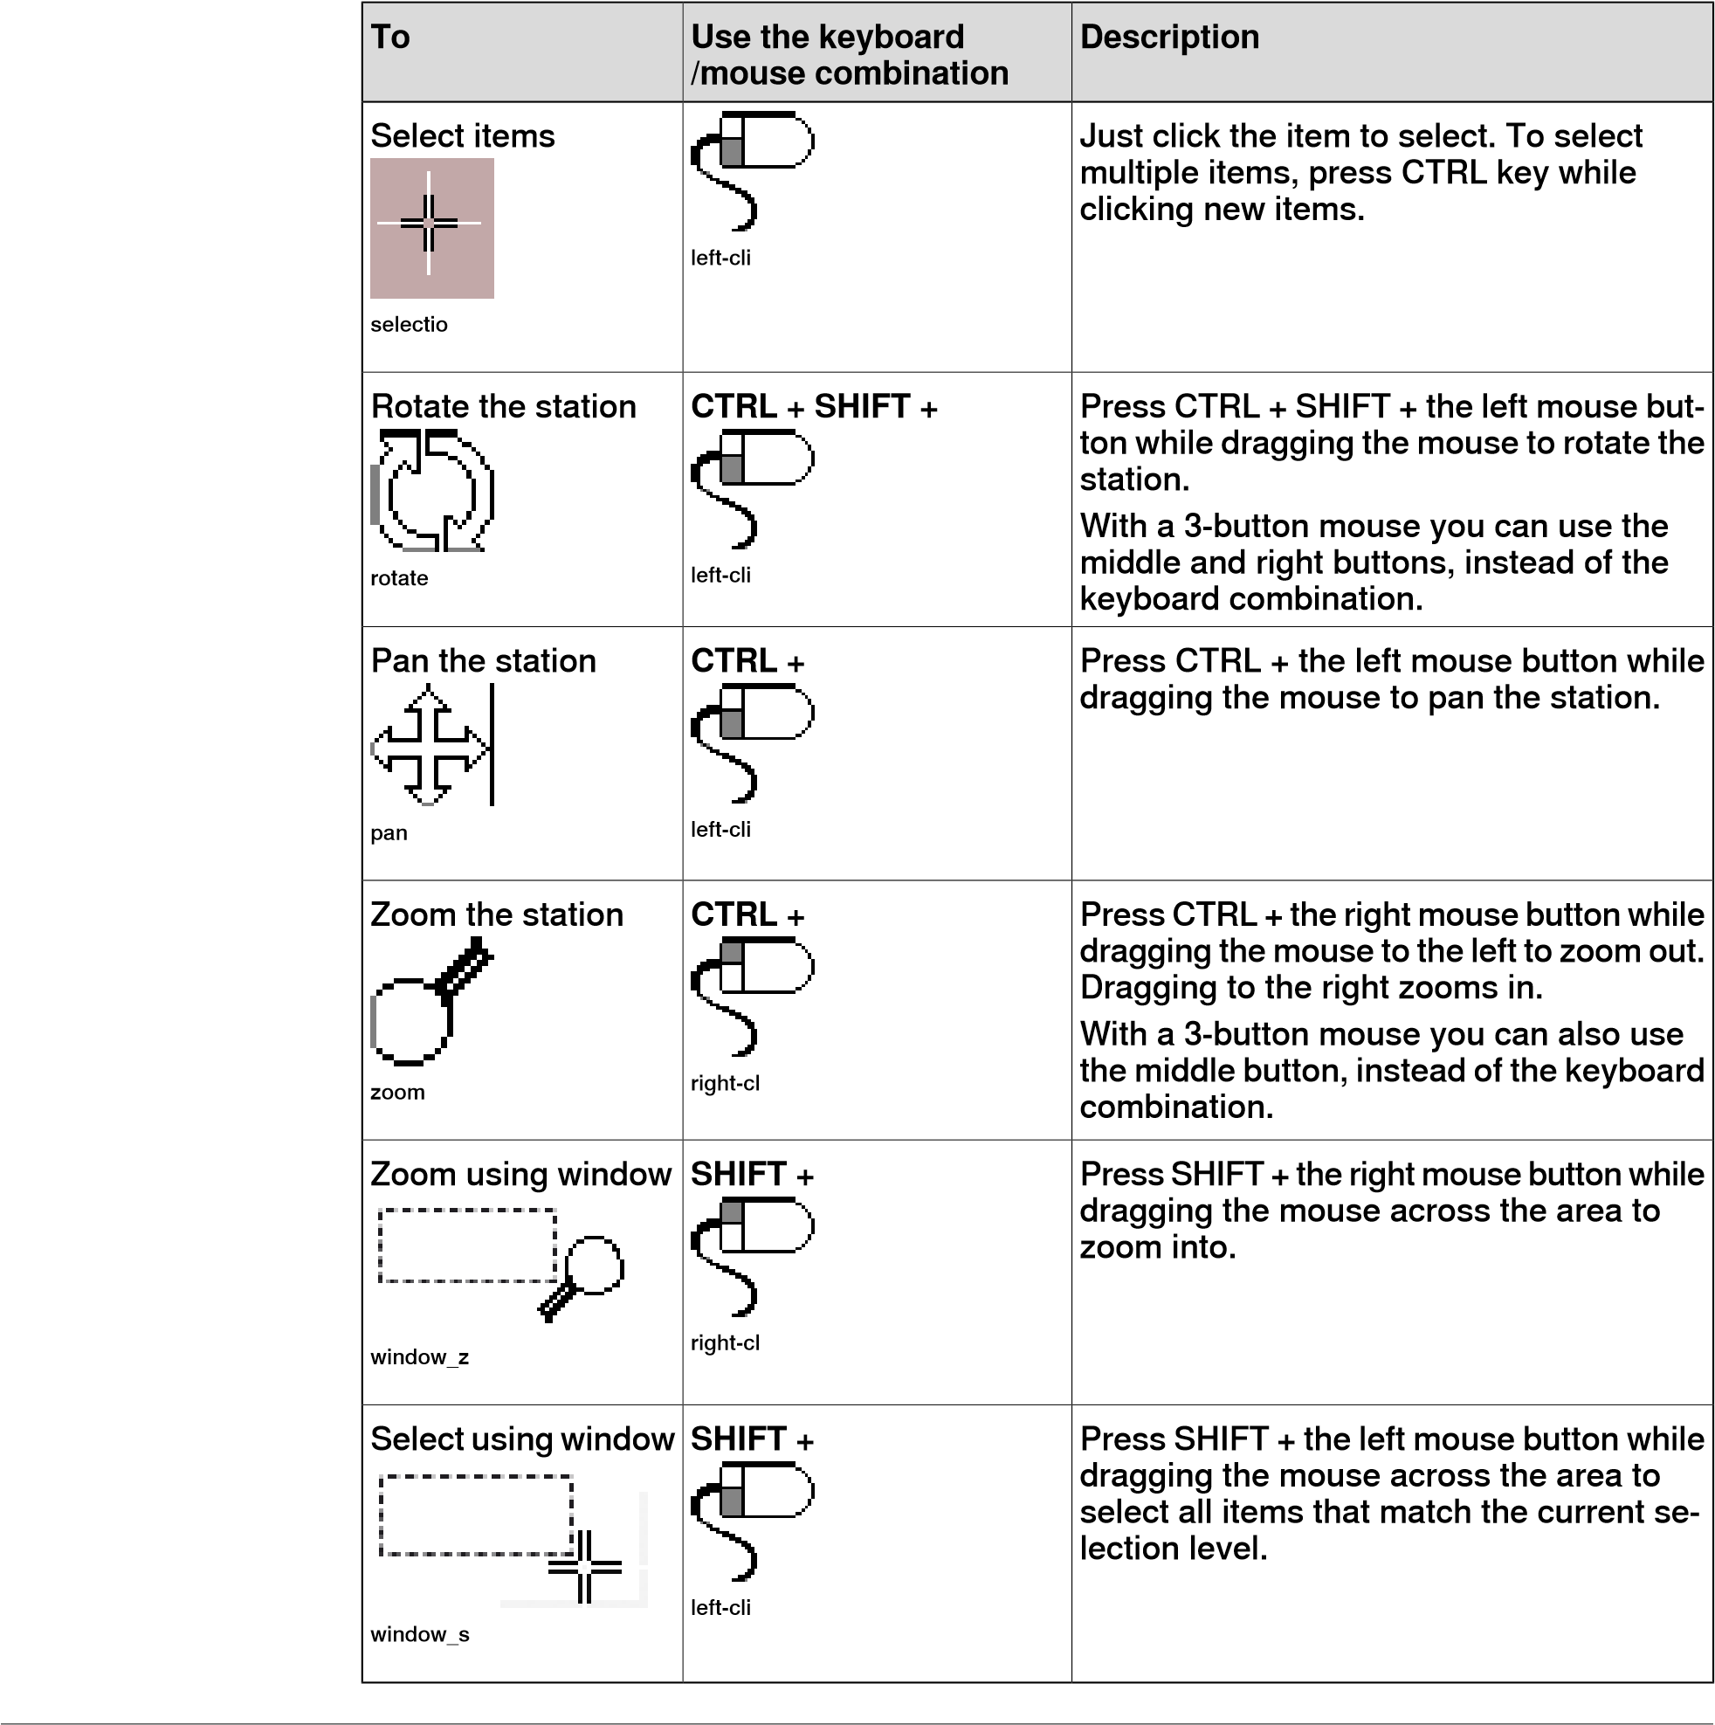

**Using a 3D mouse**

The 3Dconnexion 3D mouse has a pressure-sensitive controller cap designed to flex in all directions. The direction of movement are push, pull, twist, or tilt the cap to pan, zoom, and rotate the current view. A 3D mouse is used along with a regular mouse. Connect a 3D mouse to the RobotStudio environment to interact with the graphical environment.

It is possible to connect the programmable buttons of the 3D mouse to the commonly used RobotStudio commands by assigning the commands to custom keyboard shortcuts. The custom keyboard shortcuts are configured with the same user interface as the Quick Access Toolbar. After configuring the keyboard shortcuts in RobotStudio, connect the programmable buttons to the keyboard shortcuts in the 3D mouse applications control panel. For more information, refer the 3D mouse user manual .

The 3D mouse can move in six axes as mentioned in the following table.

**Description**

**Axes**

**Individual**

**Axis**

Moves

the

model

right

and

left.

Pan

Right/Left

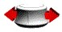

xx1500000297

Zoom

the

model

in

and

out.

Zoom

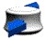

xx1500000299

Moves

the

model

up

and

down.

Pan

Up/Down

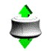

xx1500000298

Rotate

around

vertical

axis.

Spin



xx1500000301

Tilts

the

model

forwards

and

backwards.

Tilt



xx1500000300

Rolls

the

model

sideways.

Roll

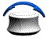

xx1500000302

It is possible to freely rotate the view while using a SpaceMouse without the *up* direction getting locked to the positive z-axis. To disable this behavior, in **Advanced Settings**, uncheck the *sideways rotation* option.

**Selection levels and snap modes**

Every item in a station can be moved to achieve the required layout using suitable selection levels. RobotStudio provides a set of selection levels which can be used to select part or specific part of an object. These selection levels are curve, surface, entity, part, mechanism, group, target/frame and path. The target/frame and path selection can be combined with other selection levels.

Open a demo station while exploring the selection levels.

1. In the **Graphics** window, click the **Part Selection** icon. Hover the mouse over the icon to view the ToolTip which contains the name and purpose of the icon.

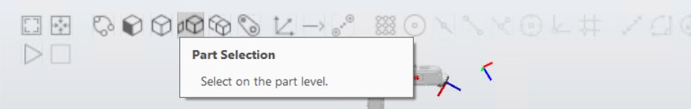

xx1900000134

1. In the **Graphics** window, click the **Snap Object** icon. This is a multi-snap mode, snapping to the closest center, edge or corner.

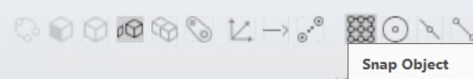

xx1900000137

Click a part in the **Graphics** view, the entire object will be highlighted. You can also see the pick point as a white star that has snapped to the closest center/edge/corner.

1. On the **Home** tab, in the **Freehand** group, click the **Jog Joint** button and then select any joint on the robot.

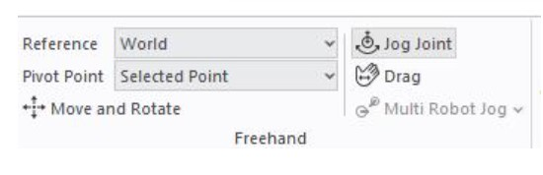

xx1900000136

By pressing the left mouse button on the joint in the **Graphics** window, the robot can be jogged in any direction.

**Moving and Rotating Objects**

Use the **Move and Rotate** tool to move and rotate objects and to jog the robot by moving its TCP.

Select an object and then on the **Home** tab, in the **Freehand** group, click the **Move and Rotate** tool.

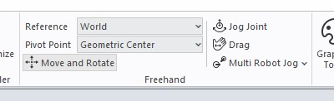

xx1900000135

The **Move and Rotate** tool with the movement handles will be displayed.

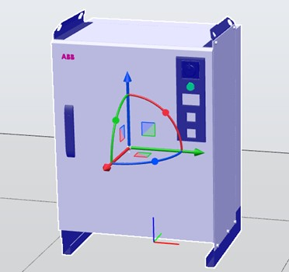

xx2300001765

The position of the tool can be altered by selecting a pivot point.

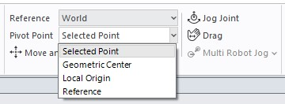

xx2300001766

The orientation of the tool’s axes can be defined by the selected reference.

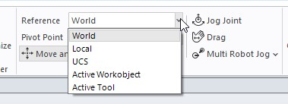

xx2300001767

When moving or rotating an object, the offset from the starting position appears aside the tool, where, precise values for the movement or rotation can be set.

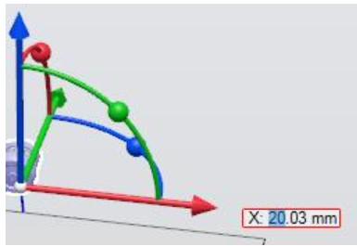

xx2300001781

Use the drop-down menu to show position relative to the selected reference.

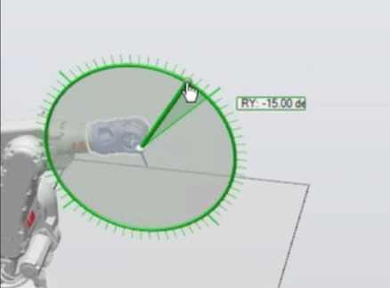

xx2300001782

While dragging an object, press and hold the CTRL button to enable movement in increments. Press CTRL + SHIFT to enable fine increments. The increment size depends on how close you have zoomed in on the object.

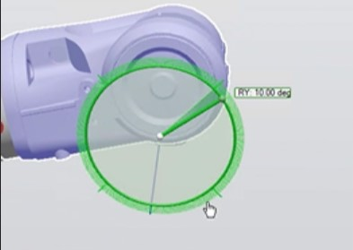

xx2300001783

Rotation increments are 5 degrees and fine increments are 1 degree.

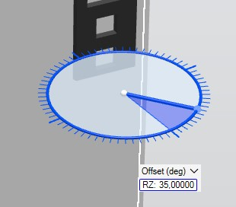

xx2300001815

As displayed in the following image, click and drag the icon to move the object along the required plane.

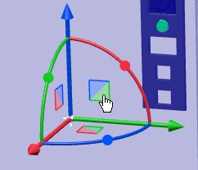

xx2300001878

Jogging a robot

Combine selection level **Part** with the **Move and Rotate** tool and then click on the robot base to move the robot, click anywhere else on the robot to move the robot TCP.

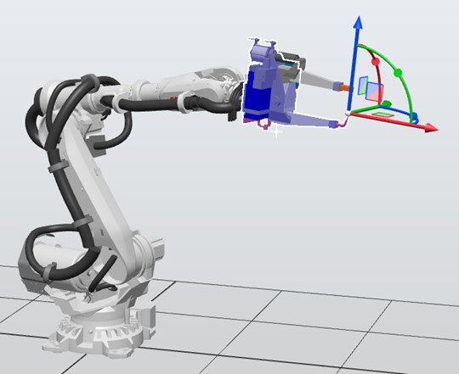

xx2300001879

With the **Mechanism** level selected, click anywhere on the robot to move the robot.

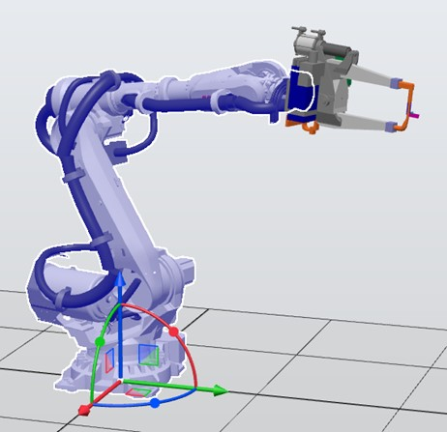

xx2300001880

**Selecting an item in the graphics window**

To select items in the **Graphics** window, follow these steps:

1. At the top of the **Graphics** window, click the desired selection level icon.
2. Optionally, click the desired snap mode icon for the part of the item you wish to select.
3. In the **Graphics** window, click the item. The selected item will be highlighted.

**Deep rectangle selection**

The Deep rectangle selection (default selection mode) is enabled if you press and hold the SHIFT key and draw a rectangle in the 3D view using the mouse. This mode selects objects covered by the selection rectangle regardless of its visibility.

**Deep rectangle selection**

To enable the deep rectangle selection (default selection mode), press and hold the SHIFT key and drag the mouse diagonally over the objects to select. This mode selects objects covered by the selection rectangle regardless of its visibility. In this selection mode, you can select multiple items in the **Graphics** window.

**Shallow rectangle selection**

To enable shallow rectangle selection, press the SHIFT + S keys and draw a rectangle in the 3D view using the mouse. In this mode, it is possible to select the currently visible object.

**Selecting an item in the browsers**

To select items in a browser, do the following:

1 Click the item. The selected item will be highlighted in the browser.

**Multiple selection of items in the browsers**

To select multiple items in a browser, follow these steps:

1. Make sure that all the items to be selected are of the same type and located in the same branch of the hierarchical structure; otherwise, the items will not be operable.
2. Do one of the following:
   * + To select adjacent items: In the browser, hold down the **SHIFT** key and click the first and then the last item. The list of items will be highlighted.
     + To select separate items: In the browser, hold down the **CTRL** key and click the items you want to select. The items will be highlighted.

**Measurement tools**

RobotStudio provides the following measurement tools for gauging the linear and angular distances between various objects in the Graphics window. Hover the mouse over these icons to see the name and purpose of these tools.

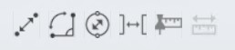

xx2000002621

* + - In the **Graphics** window, click the **Point to Point** icon to enable this tool. With the icon selected, snap two objects in the Graphics window to view the distance between these objects in millimeters.

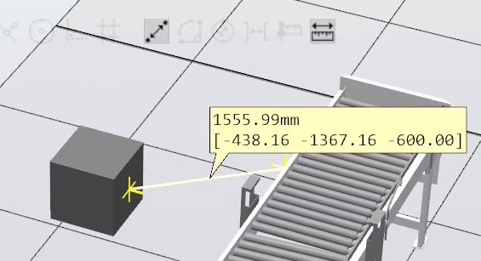

xx2000002622

* + - In the **Graphics** window, click the **Angle** icon to enable this tool. With the icon selected, snap three points to create two lines to measure the angle between them in degrees.

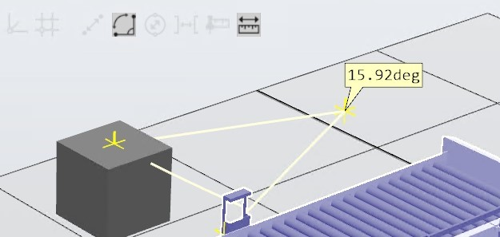

xx2000002623

* + - In the **Graphics** window, click the **Diameter** icon to enable this tool. With the icon selected, snap three points on the circumference of the surface to find the diameter in millimeters.

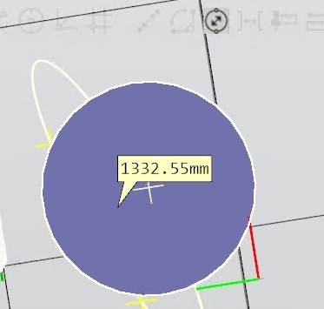

xx2000002624

* + - In the **Graphics** window, click the **Minimum Distance** icon to enable this tool. With the icon selected, click on two objects to find the minimum distance between them in millimeters.

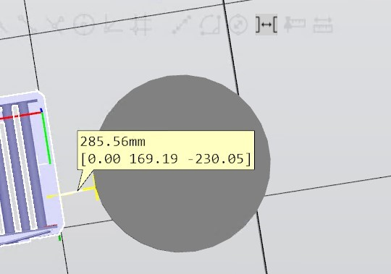

xx2000002660

* + - The **Keep measurements** and the **Track moving objects** tools are used along with other tools, when **Keep measurements** icon is selected, RobotStudio retains the mark up from the previous measurement.

When **Track moving objects** icon is selected, the mark up gets updated dynamically to reflect the movement of objects in the **Graphics** window.

1.8 Libraries, geometries and CAD files

**1.8 Libraries, geometries and CAD files**

**Overview**

Models of *work pieces* and equipment are added to RobotStudio for simulating the *station* and for further programming. RobotStudio provides *ABB library* which contains models of ABB robots and related equipment as *library files* or *geometries*. *User libraries* are imported as geometries to RobotStudio. These files can be created in RobotStudio.

**Difference between geometries and libraries**

External files are imported to a *station* as *user library* or *geometries*. Geometries are CAD files, when imported, these files are copied to a station, hence, the size of the station file increases.

When *user library* files are imported, a link gets created from the station file to the corresponding library file, hence the size of the station file remains the same.

**Components of a geometry**

A geometry consisting of several parts is called the *Component Group* in RobotStudio. 3D *Geometries* of a station are displayed in the **Layout** browser, under **Components** as *parts*. Parts contain bodies. Bodies contain faces (surfaces) or *curves*.

**Importing and converting CAD files**

Use the import function to import *geometries* from single CAD files. On the **Home** tab, click **Import Geometry** and select the CAD file to import.

If you want to re-use the CAD file from other stations or for future use, you can save it as a library file. Library files can be imported using the **Import Library** function on the **Home** tab.

**Exporting geometry**

Use the **Export Geometry** function to export component groups, parts, stations or mechanism links to CAD file. Right-click an open group, station, part or mechanism link and then select **Export Geometry** to access this command. The supported export formats vary for each entity, which can be selected while exporting.

**Supported 3D formats**

The native 3D CAD format of RobotStudio is SAT, it also supports other formats for which you need an option. The CAD support in RobotStudio is provided by the software component ACIS. The following table lists the supported formats and the corresponding options.

**Write**

**Read**

**Option**

**required**

**File**

**extensions**

**Format**

-

.3

ds

**3**

**DStudio**

X

X

-

.sat,

.sab,

.asat,

.asab

**ACIS**

X

CATIA

.model,

.exp,

.session

**CATIA**

**V4**

1.8 Libraries, geometries and CAD files

*Continued*

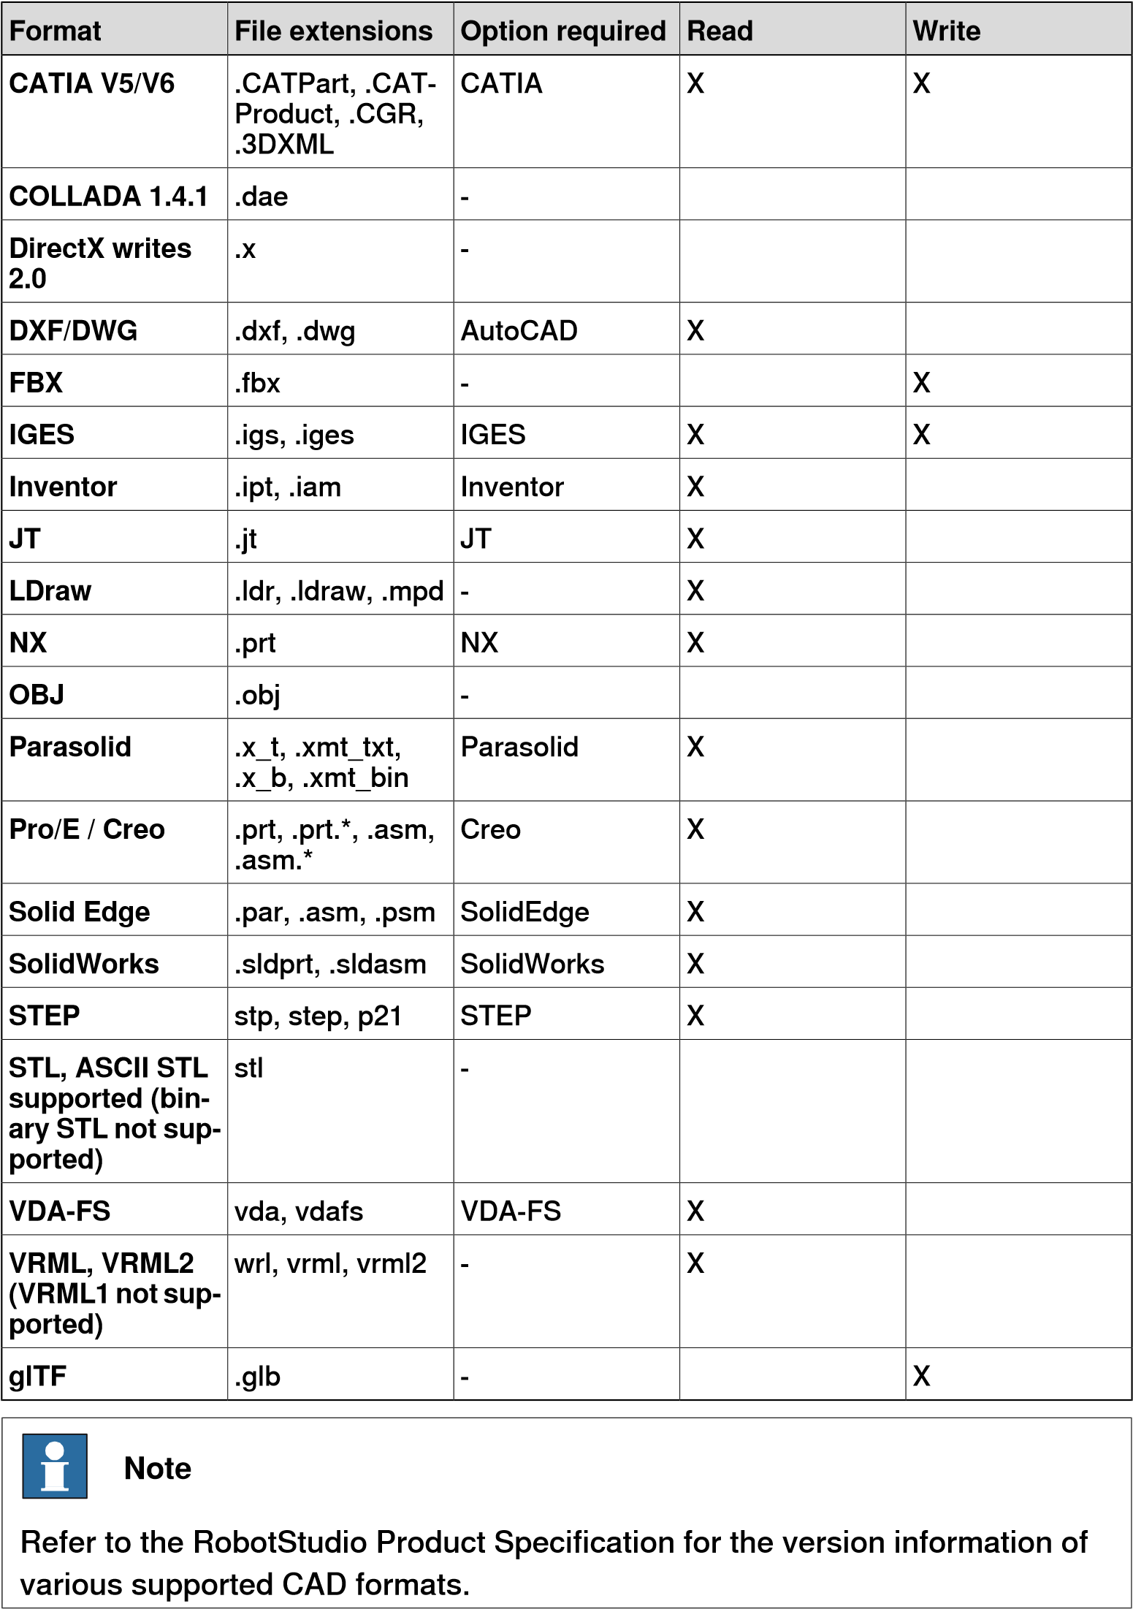

To import these files into RobotStudio, use the **Import Geometry** function.

**Mathematical versus graphical geometries**

A *geometry* in a CAD file always has an underlying mathematical representation. Its graphical representation, displayed in the *Graphics* window, is generated from the mathematical representation when the geometry is imported to RobotStudio, after which the geometry is referred to as *part*.

For this type of geometry, it is possible to set the detail level of the graphical representation. Setting the detail level reduces the *file size* and *rendering time* for

*Continues on next page*

1.8 Libraries, geometries and CAD files *Continued*

large models and improves the visual display for small models. The detail level only affects the visual display; *path*s and *curves* created from the model will be accurate both with coarse and fine settings.

A *part* can also be imported from a file that defines its graphical representation; in this case, there is no underlying mathematical representation. Some of the functions in RobotStudio, such as *snap mode* and *creation of curves from the geometry*, will not work with this type of part. To customize the detail level settings, on the **File** tab, click **Options** and then select **Options:Graphics:Geometry**.

Options:Graphics:Geometry **Detail Level**

Specify the level of detail required when importing geometries. Select **Fine**, **Medium** or **Coarse** as required.

1.9 How to install RobotWare and Add-Ins

**1.9 How to install RobotWare and Add-Ins**

**Installing RobotWare**

Use Modify Installation to create and modify systems with *RobotWare* versions 7. Use Installation Manager 6 to create and modify systems with RobotWare versions 6.0. Use System Builder to create and modify systems based on earlier versions of RobotWare.

**Installing Add-Ins**

RobotStudio *add-ins* are available in the **Gallery** window. The recommended method is to install software is from RobotStudio.

Installing Add-Ins from Gallery in RobotStudio

* 1. Start RobotStudio and open the **Add-Ins** tab. The **Gallery** window is displayed.
  2. In the **Gallery** window, use the **Search** function or **Common tags** to filter the available add-ins.
  3. Select the add-in to be installed. Additional information is displayed in the window to the right.
  4. Select **Version** and click **Add**. The add-in gets installed.

**Note**

The

default

is

the

latest

version.

Installing add-ins manually

Add-ins and additional content can be installed manually from the hard disk.

* 1. Locate the *.rspak* file in the user directory.
  2. Start RobotStudio and open the **Add-Ins** tab. Select **Install Package** from the menu bar.
  3. Navigate to the required *.rspak* file in the user directory and click **Open**. The add-in gets installed.

**Installing the Virtual FlexPendant**

RobotWare 7.0, Microsoft Windows 10 and Microsoft App Installer for Windows 10 must be available in the host PC for carrying out the following procedure.

1 In the **Add-ins** tab, in the **Add-ins** browser, expand the RobotWare 7.0 node. Right-click the **FlexPendant Apps** node and then click **Install** from the context menu.

*Continues on next page*

1.9 How to install RobotWare and Add-Ins *Continued*

1. On successful installation, the following option gets added to the tool bar.

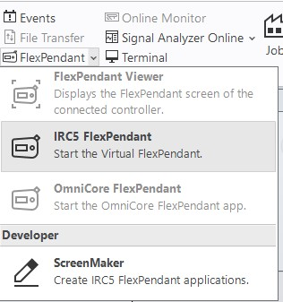

xx1900001281

1. Select the FlexPendant option to open Virtual FlexPendant.

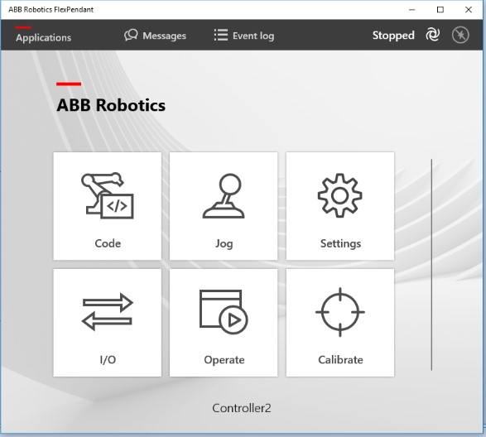

xx1900001282

This page is intentionally left blank

2.1 Understanding stations and projects

1. **Building Stations**

**2.1 Understanding stations and projects**

**Station**

Station document is a *.rsstn* file that contains data of the robot cell. It stores information about various *station components*, *station logic* including *smart components* that controls external components, 3D graphics, CAD data, and data on the graphical part of the robot program. Station document is linked to the *virtual controller* that runs the robot in a *station*. virtual controller data is external to the station document.

**Project**

*Projects* add structure to the station data. It contains folders for structuring station data so as to keep related data together. Project contains the station, that is, the station document is part of the project structure. By default, RobotStudio provides project folders. In the default project folder structure, files of similar type are stored in folders. The project structure is the recommended way for storing station files. In the project structure there are dedicated folders for, Components, Controller Data, Station, User Files, Virtual Controllers.

For a new installation of RobotStudio, the project folder contains the following subfolders.

* Components: This folder contains user library components that belong to the project.
* Controller Data: This folder contains auto-generated backups of virtual controllers, updated when the project is saved.
* Station: This folder contains graphics, geometry and other components referred to by the station.
* User Files: This folder contains files or directories that a user want to add to the project. Some examples are CAD files that belong to the project, RAPID programs that do not belong to a virtual controller or user generated backups.
* Virtual Controllers: This folder contains virtual controller generated files and folders.
* Project.rsproj : The project file *<project name>.rsproj* that makes the folder as a project. Use this file to open the project.

2.1 Understanding stations and projects *Continued*

**Pack and Go**

The *Pack and Go* file is a single file that packages the station data along with the related *virtual controllers* for archiving and for sharing station data with other users.

**Note**

A *station* file that includes references to the virtual controllers cannot be moved to a new location on the local disk. To move a station file to a different location, create a *Pack & Go* file of the station from the original location and then move this file to the new location and then unpack the file.

2.2 Preparing the computer for hosting RobotStudio

**2.2 Preparing the computer for hosting RobotStudio**

**Overview**

Laptops that are configured with switchable graphics adapters can engage higher performance graphics adapter for 3D applications, and the energy-efficient integrated graphics adapter for less demanding tasks. For a laptop with switchable graphics adapters, ensure that RobotStudio uses the adapter that handles the high performance discrete graphics. To get the best user experience, it is recommended to install the latest display drivers available.

Before installing display drivers, check the Windows® Device Manager and verify that both graphics adapters appear in the list of hardware devices and that they are enabled. When a driver is not installed for the device, either of the graphics adapters may appear under *Other Devices* as a *Generic Video Controller*. Some vendors of the graphics adapters provide configuration software for creating application specific profiles. It is recommended to create a RobotStudio specific application profile that uses the high-performance graphics adapter.

A second option is to modify the application configuration file,

*RobotStudio.exe.config* such that RobotStudio uses a specific graphics adapter.

This file is located in the installation folder of RobotStudio, *C:\Program Files (x86)\ABB\RobotStudio x.x*. It contains a certain line that controls the type of graphics adapter to use. Uncomment the following line to set a specific graphics adapter for 3D graphics, remove the initial "<!--" "-->" in the beginning and at the end of the line.

<!-- <add key="GraphicsDeviceType" value="Discrete"/> --> Valid values are *Discrete*, *Integrated*, *Warp*, or *Default*.

* + Discrete : configures the use of the high performance graphics adapter.
  + Integrated : configures the energy efficient graphics adapter to be used.
  + Default : allows the laptop to choose, but enables logging of graphics adapter information to the *Output* window.
  + Warp(Windows Advanced Rasterization Platform) : controls software rendering, for example, use CPU instead of GPU.

2.2 Preparing the computer for hosting RobotStudio

*Continued*

A third option which may or may not be applicable to the laptop, is to configure the graphics adapter to use in the BIOS, refer the user documentation of the laptop for details.

**Note**

Ensure to meet the following requirements while selecting the user name for a new virtual controller.

* + Virtual Controllers with RobotWare lower than 7.3 do not support non-Latin1 characters in the Windows filepaths.
  + If such characters are used in the Windows user name, for example, *å, ä, ö or ü*, which is part of the path to the virtual controller, the virtual controller will not start.
  + Available workarounds are to change the Windows user name to remove such characters, or save the virtual controller to a path which does not contain these characters.

**Document folders**

ABB Library contains geometries of robots and other equipments. Creating a user library and adding user geometry to those galleries allows you to directly access those *libraries* and *geometries* from the **Import Library** and **Import Geometry** galleries in RobotStudio. You can create folders with such libraries and then add references to make them appear in the user interface galleries.

Use the following steps to create a gallery for frequently used documents.

* 1. Start **RobotStudio**.
  2. On the **File** tab, click **New** and then double-click **Empty Station** to open a new empty station.

*Continues on next page*

2.2 Preparing the computer for hosting RobotStudio *Continued*

The **Documents** window is part of the default layout. If you are unable to find the **Documents** window, on the **Quick Access** menu, click **Windows** and then click **Documents**.

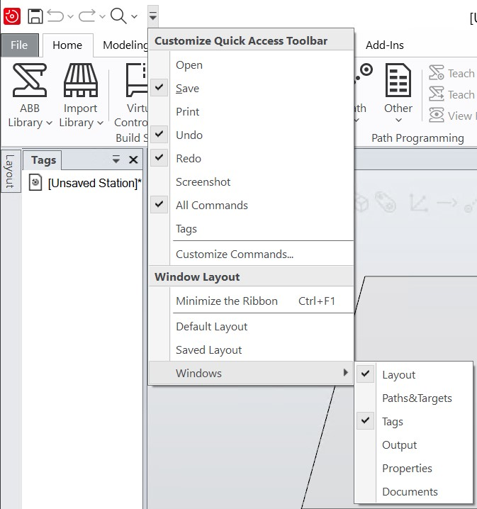

xx1800003487

* 1. In the **Documents** window, click **Locations**. The **Document Locations** dialog box opens.
  2. In the **Document Locations** dialog box, click **Add Location** and then **File System**. The **File System** dialogue box opens.
  3. In the **File System** dialog box, enter the required details and click **OK**. Library files from the selected folder will be available in the **Import Library** option.

Repeat the same step and add library for the **Import Geometry** option.

After adding these locations, it is possible to access the selected files directly from RobotStudio. Any file saved to those locations they will be automatically added to the galleries.

Use the **Search** function in the **Documents** window to search for a document by its name. The result will appear on the **Documents** window. Double-click the found item(s) to import it to the station. Alternatively, use the **Browse** function to browse to all available locations created in document locations. These functions provide easy and quick access to your documents.

**Setting the folder structure and autosave options**

It is recommended to set the autosave option to enable RobotStudio to save the current changes or progress in the program. This reduces the risk of data loss during any unexpected interrupts such as crash, freeze or user error.

2.2 Preparing the computer for hosting RobotStudio

*Continued*

To access the Autosave option, on the **File** tab, click **Options** and then select **Options:General:Autosave**.

Autosave

**Enable autosave of RAPID** This check-box is selected by default. *RAPID* programs are saved automatically in every 30 seconds.

**Enable autosave of station** Unsaved stations are saved automatically at the interval specified in the **minute interval** box.

**Enable automatic backup of** Takes multiple backup of station files as specified in the **station files Number of backups** list and saves it in a sub-folder of the

corresponding Stations folder (StationBackups). Requires a *Project*.

**Enable automatic backup of** Select this option to backup the *virtual controllers* of a pro**controllers in project** ject when saving the station. The backups are stored in the *Backups* folder of the corresponding project.

Assign default locations for storing the user data, projects and so on, by selecting **Options:General:Files & Folders**.

Files & Folders

**User Documents location** Shows the default path to the project folder.

**Local projects location** Shows the default path to the project folder.

**...** To browse to the project folder, click the browse button.

**Automaticallycreatedocu-** Select this check box to enable the creation of individual sub**ment subfolders** folders for document types.

**minute interval** Specify the interval between the savings when using *Autosave* in this box.

**Document Locations** Launches the **Document Locations** dialog box.

**Clear Recent Stations and** Clears the list of recently accessed stations and controllers.

##### Controllers

**Additional** *distribution* RobotWare 6 and related RobotWare add-ins media pools are *package* **location** distributed as distribution packages. For RobotStudio to find them, they need to be located in a specific folder. If the folder is not specified, the default location is used.

On a Windows installation with English language, the default folderis *C:\User\<user name>\AppData\Local\ABB\DistributionPackages*.

The location can be customized by entering a search path here.

**Download packages to** Select this check box to download *distribution packages* to the **this location** user defined location instead of the default folder.

**Unpacked** *RobotWare* Shows the default path to the unpacked RobotWare folder. **Location**

**Media Pool for RobotWare** This is where RobotStudio searches for RobotWare 5.xx media

**5.x** pools.

2.3 Creating the station

**2.3 Creating the station**

**Overview**

The following steps define the workflow for building a new *station*.

1. Create an empty station.
2. Import a robot model.
3. Add *positioners* and track motion.
4. Create a *virtual controller*.
5. Import a tool and attach it to the robot.
6. Create a *workobject*.
7. Define paths and targets to create a robot program graphically.
8. *Synchronize* to RAPID to create the RAPID program.

**Creating a project with an optional virtual controller**

1. Click the **File** tab. The RobotStudio Backstage view appears, click **New**.
2. Under **Project**, click **Project**.
3. Enter the name of the *project* in the **Name** box and then browse and select the destination folder in the **Location** box. The default location of the project is C:\User\<user name>\Documents\RobotStudio\Projects. The included virtual controller the name of the project.

**Note**

The

project

folder

helps

in

keeping

a

well-structured

folder

system

that

is

easy

to

navigate

through.

1. Click **Create**.

The new project gets created. RobotStudio saves this project by default.

2.4 Importing robots and related components

**2.4 Importing robots and related components**

**Importing a robot model**

1. In the **Home** tab, click **ABB Library** and select a robot model. Models that are not installed are indicated by a download icon and will be downloaded automatically.
2. Select the desired robot variant in the dialog and click **OK**.

The selected robot model is displayed in the graphic window. A robot which is not connected to a controller cannot be programmed, hence configure a *virtual controller* for the robot.

**RobotStudio Models**

Before working offline, it is recommended to download the required simulation models and Virtual Controller templates of robot models, positioners, tracks and tools.

1. On the **Add-Ins** tab, in the **Packages** group, click **Gallery**.
2. Under **Gallery**, click the **RobotStudio Models** tab to view all available robot models, positioners, tracks and tools.
3. Select the required packages and click the **Add Selected** button.

Use the **Add All** button to download all available robot models.

All downloaded models will be available in ABB Library and can be selected when creating a new Virtual Controller. Models that are not downloaded are indicated by a download icon.

**Importing and attaching a tool**

A *tool* is a RobotStudio object that operates on the work piece, for example, an arc weld gun or a gripper. For achieving correct motions in robot programs, parameters of the tool must be specified in the *tool data*. The most essential part of the *tool data* is the *TCP*, which is the position of the tool center point relative to the wrist of the robot (which is the same as the default tool, tool0).

* 1. To import a tool, in the **Home** tab, click **Import Library** and then click **Equipment** and select a tool.

The tool gets imported to the station and placed at the origin of the *world coordinate system*, thus hidden inside the robot. When imported, the tool gets added to the **Layout** browser, but will not be attached to the robot. Tool must be attached to a robot to synchronize its movements with the robot.

* 1. To attach a tool to the robot, inside the **Layout** browser, right-click the tool and then click **Attach to** and select the robot model.

Tool can be attached by dragging and dropping it on the robot in the **Layout** browser.

* 1. In the **Update position** dialog box, click **Yes**.

*Continues on next page*

2.4 Importing robots and related components *Continued*

**Importing a library**

Use this procedure for importing library files to a *station*:

* 1. On the **Home** tab, click **Import Library** and select various component libraries.
  2. Click **User Library** to select the user defined *libraries*.
  3. Click **Equipment** to import predefined ABB *libraries*.
  4. Click **Project Library** to select the predefined *Projects*.
  5. Click **Locations** to open the Document Locations window.
  6. Click **Browse for Library** to select the saved library files.

2.5 Creating a virtual controller

**2.5 Creating a virtual controller**

A robot which is not connected to a controller cannot be programed, hence configure a *virtual controller* for the robot.

* 1. In the **Home** tab, Click **Virtual Controller**.
  2. Click **From Layout** to bring up the first page of the wizard.
  3. In the **Name** box, enter the name of the virtual controller. The location of the *virtual controller* will be displayed in the **Location** box.
  4. Click **Next**.
  5. In the **Mechanisms** box, select the *mechanisms* that you want to include in the *virtual controller*. Add mechanisms such as tracks or *positioners* to your station before creating a virtual controller.

Depending on the mechanisms that are added, an appropriate RobotWare version is selected automatically.

For OmniCore controllers, the controller variant can be selected among the variants supported by the robot. The controller variant can affect motion performance of the robot.

* 1. Click **Next**.

The wizard now prompts a mapping of the *mechanisms* to a specific motion *task*, in accordance with the following rules:

* + - Only one *TCP* robot is allowed per task.
    - Up to six motion tasks may be added, but only four *TCP* robots can be used, and they must be assigned to the first four tasks.
    - The number of tasks may not exceed the number of mechanisms.
    - If the *system* contains one *TCP* robot and one external axis, they will be assigned to the same task. It is, however, possible to add a new task and assign the external axis to it.
    - If the system contains more than one *TCP* robot, any external axes will be assigned to a separate task. It is, however, possible to move them to other tasks.
    - The number of *external axes* in a task is limited by the number of available drive modules in the cabinet (one for large robots, two for medium, three for small).

If only one *mechanism* was selected in the previous page, this page will not be shown.

*Tasks* can be added and removed using the respective buttons; mechanisms can be moved up or down using the respective arrows. To map the mechanisms to tasks, follow this step:

7 Optionally, make any edits in the mapping, and then click **Next**. The **Controller Options** page appears.

*Continues on next page*

2.5 Creating a virtual controller *Continued*

1. On the **Controller Options** page, you have the option to align Task Frame(s) with the corresponding *Base Frame*(s).
   * + For single robot system, select the checkbox to align task frame with base frame.
     + For *MultiMove* Independent system, select the check box to align task frame with base frame for each robot.
     + For MultiMove Coordinated system, select the robot from the drop down list and select the check box to align task frame with base frame for the selected robot.
2. Verify the summary and then click **Finish**.

If the virtual controller contains more than one robot, the number of tasks and the base frame positions of the mechanism should be verified in the **Motion Configuration** window.

**Note**

To

create

a

system

from

layout,

all

*mechanisms*

such

as

robots,

*track*

*motions*

and

*positioners*

,

must

be

saved

as

libraries.

2.6 Synchronizing to virtual controller to create a RAPID program

**2.6 Synchronizing to virtual controller to create a RAPID program**

Movements of the robot can be programmed using *RAPID*. A robot which is not part of a task in a controller cannot be programed, hence configure a *virtual controller* for the robot before *synchronizing* to RAPID.

* + - 1. With the station open, in the **RAPID** tab, click **Synchronize**.
      2. From the options, click **Synchronize to RAPID** to match objects in the station to the RAPID code.

In the **Controller** browser, expand the tree view to find the RAPID node. Click RAPID node to view the RAPID files.

2.7 Configuring station with robot and positioner

**2.7 Configuring station with robot and positioner**

You can configure a station with robot and *positioner* using the **Virtual Controller** button.

To configure a station with a robot and positioner:

* + - 1. Click **From Layout** to bring up the first page of the wizard.
      2. In the **Name** box, enter the name of the virtual controller. The location of the virtual controller will be displayed in the **Location** box.
      3. In the **RobotWare** list, select the version of *RobotWare* you want to use.
      4. Click **Next**.
      5. In the **Mechanisms** box, select the Positioner that you want to include in the *virtual controller*.
      6. Click **Next**.

*Tasks* can be added and removed using the respective buttons; positioner can be moved up or down using the respective arrows. To map the positioner to tasks, follow this step:

* + - 1. Optionally, make any edits in the mapping, and then click **Next**.

The **Controller Options** page appears.

* + - 1. In the **Controller Options** page, you have the option to align Task Frame(s) with the corresponding *Base Frame*(s).
         * For single virtual controller, select the checkbox to align task frame with base frame.
         * For *MultiMove* Independent system, select the check box to align task frame with base frame for each robot.
         * For MultiMove Coordinated system, select the robot from the drop down list and select the check box to align task frame with base frame for the selected robot.

9 Verify the summary and then click **Finish**.

If the virtual controller contains more than one robot, the number of tasks and the baseframe positions of the positioner should be verified in the **Motion Configuration** window.

**Note**

To

create

a

system

from

layout,

all

*mechanisms*

such

as

robots,

*track*

*motions*

and

*positioners*

,

must

be

saved

as

libraries.

2.8 Configuring station with robot and Track motion

**2.8 Configuring station with robot and Track motion**

You can configure a *station* with robot and *track motion* using the **Virtual Controller** button.

To configure a station with a robot and track motion:

* + - 1. Click **From Layout** to bring up the first page of the wizard.
      2. In the **Name** box, enter the name of the system. The location of the system will be displayed in the Location box.
      3. In the RobotWare list, select the version of *RobotWare* you want to use.
      4. Click **Next**.
      5. In the Mechanisms box, select the track motion that you want to include in the *virtual controller*.
      6. Click **Next**.

Tasks can be added and removed using the respective buttons; track motion can be moved up or down using the respective arrows. To map the track motion to tasks, follow this step:

* + - 1. Optionally, make any edits in the mapping, and then click **Next**.

The System Option page appears.

* + - 1. On the **Controller Options** page, you have the option to align Task Frame(s) with the corresponding *Base Frame*(s).
         * For single virtual controller, select the check-box to align task frame with base frame
         * For *MultiMove* Independent system, select the check-box to align task frame with base frame for each robot.
         * For MultiMove Coordinated system, select the robot from the drop down list and select the check-box to align task frame with base frame for the selected robot.

9 Verify the summary and then click **Finish**.

If the virtual controller contains more than one robot, the number of tasks and the *base frame* positions of the *track motion* should be verified in the **Motion Configuration** window.

**Note**

To

create

a

system

from

layout,

all

*mechanisms*

such

as

robots,

*track*

*motions*

and

*positioners*

,

must

be

saved

as

libraries.

2.9 Configuring Conveyor tracking

**2.9 Configuring Conveyor tracking**

**Overview**

Configuring a conveyor tracking involves three steps; creating a conveyor, creating a virtual controller with the option **606-1 Conveyor Tracking** and then creating a connection between *virtual controller* and the conveyor.

**Creating a Conveyor**

* + - 1. In the **Modelling** tab, in the **Mechanism** group, click **Create Conveyor**. The **Create Conveyor** browser opens.
      2. From the **Conveyor Geometry** list, select a geometry. To add a geometry to the station, click **Import Geometry** and then select a *geometry*.
      3. In the **Reference Frame**, enter the base frame values (*Position* and *Orientation*) relative to the World/*local origin* of the selected graphic component.

The Reference Frame defines the position where objects appear on the conveyor.

* + - 1. From the **Type** list, select the type of conveyor.

Only linear conveyors are supported.

**Note**

* + - 1. In the **Conveyor length** box, enter the length of the conveyor. The **Create Mechanism** gets enabled.
      2. Click **Create** to create the conveyor.
      3. Build a new virtual controller using the **Virtual Controller** button.

In the **Controller Options** pane, scroll down to **Motion Coordination**, under **Conveyor Control Options** select **606-1 Conveyor Tracking** and then select one or more of the following options as required:

* + - * + **1552-1 Tracking Unit Interface**
        + **709-1 DeviceNet Master/Slave**
        + **Conveyor Tracking on PIB** 8 Add the new *virtual controller* to the *station*.

**Creating a new Virtual Controller**

* + - 1. In the **Home** tab, Click **Virtual Controller**.
      2. Click **From Layout** to bring up the first page of the wizard.
      3. In the **Name** box, enter the name of the virtual controller. The location of the *virtual controller* will be displayed in the **Location** box.
      4. In the RobotWare list, select the version of *RobotWare* you want to use.
      5. Click **Next**.
      6. In the **Mechanisms** box, select the *mechanisms* that you want to include in the *virtual controller*.

*Continues on next page*

2.9 Configuring Conveyor tracking *Continued*

7 Click **Next**.

The wizard now prompts a mapping of the mechanisms to a specific motion *task*, in accordance with the following rules:

* + - * + Only one *TCP* robot is allowed per task.
        + Up to six motion tasks may be added, but only four *TCP* robots can be used, and they must be assigned to the first four tasks.
        + The number of tasks may not exceed the number of mechanisms.
        + If the virtual controller contains one TCP robot and one external axis, they will be assigned to the same task. It is, however, possible to add a new task and assign the *external axis* to it.
        + If the *virtual controller* contains more than one TCP robot, any external axes will be assigned to a separate task. It is, however, possible to move them to other tasks.
        + The number of *external axes* in a task is limited by the number of available *drive modules* in the cabinet (one for large robots, two for medium, three for small).

If only one *mechanism* was selected in the previous page, this page will not be shown.

Tasks can be added and removed using the respective buttons; mechanisms can be moved up or down using the respective arrows. To map the mechanisms to tasks, follow this step:

8 Optionally, make any edits in the mapping, and then click **Next**.

The *System Option* page opens. Select the **606-1 Conveyor Tracking** option and then select one or more of the following options as required:

* + - * + **1552-1 Tracking Unit Interface**
        + **709-1 DeviceNet Master/Slave**
        + **Conveyor Tracking on PIB**
      1. On the *System Option* page, you have the option to align *Task Frame*(s) with the corresponding *Base Frame*(s).
      2. Verify the summary and then click **Finish**.

If the *virtual controller* contains more than one robot, the number of tasks and the *base frame* positions of the mechanism should be verified in the **Motion Configuration** window.

**Create connection between virtual controller and conveyor**

* + - 1. In the **Modeling** tab, click **Create Connection**.
      2. In the **Create Connection** tab, select the conveyor library in the **Conveyor** list and then select the *mechanical unit*.
      3. Set a suitable offset (base frame of the conveyor). This offset defines the location of the *base frame* of the conveyor mechanical unit in relation to the conveyor reference frame.
      4. Under the **Connection Window**, set appropriate values for **Minimum** and **Maximum distances**, and **Start Window Width**.

*Continues on next page*

2.9 Configuring Conveyor tracking *Continued*

1. Under **Base Frames**, select the following options:
   * + Select **Station Values** to update the *virtual controller* with the *station* layout values.
     + Select **Align Task Frame** to move the *task frame* to the connection (to align it with the base frame). The conveyor base frame will become zero.
     + Select **Use Controller Values** to update the station layout and the task frame to match the *virtual controller* values.
2. Click **Create**.

Delete the existing connection and create a new connection if you select another *workobject* to be used for conveyor tracking.

2.10 Configuring external axis

**2.10 Configuring external axis**

**Create a system with external axes**

1 Import the required robots, *positioners*, and track libraries into the RobotStudio *station*.

If a robot and track are selected, attach the robot to the track. 2 Create a *virtual controller* from layout.

**Note**

To

create

a

virtual

controller

with

IRBT4004,

IRBT6004,

or

IRBT7004,

the

TrackMotion

mediapool

Type

A

must

be

installed.

**Supported external axes configurations for RobotWare 5**

The following table shows a combination of different external axes configurations:

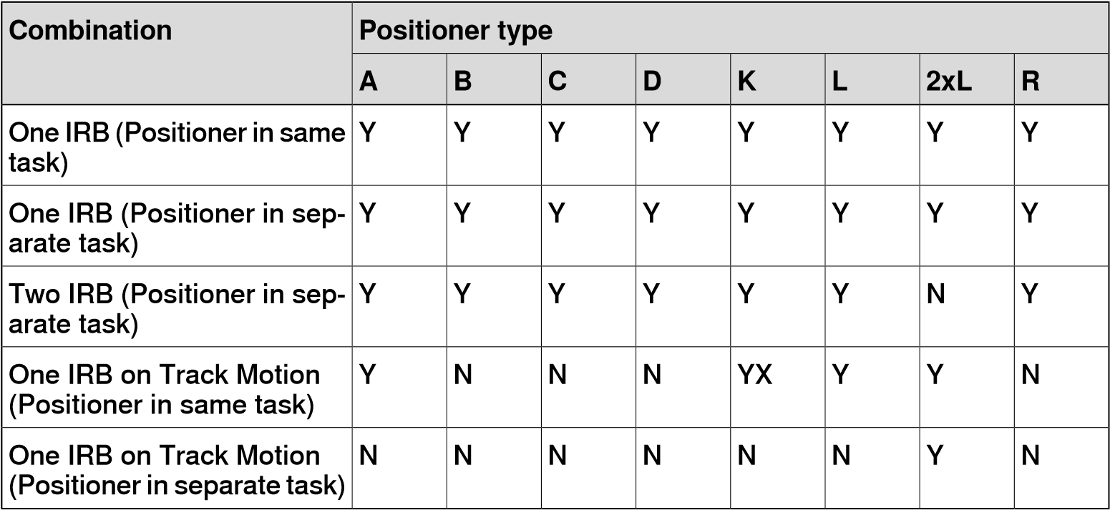

* + - * + Y - Combination is supported
        + N - Combination is not supported
        + YX - Combination is supported and manual mapping of mechanical units and joints required

**Note**

Creating a Virtual Controller from Layout only supports tracks of type RTT and IRBTx003 in combination with *positioners*. i.e. IRBTx004 is not supported in combination with the *positioners*.

*Continues on next page*

2.10 Configuring external axis *Continued*

**Supported RobotWare 6 configurations for positioners, motor units, gear units and track motions** The following table shows various *RobotWare* 6 configurations:

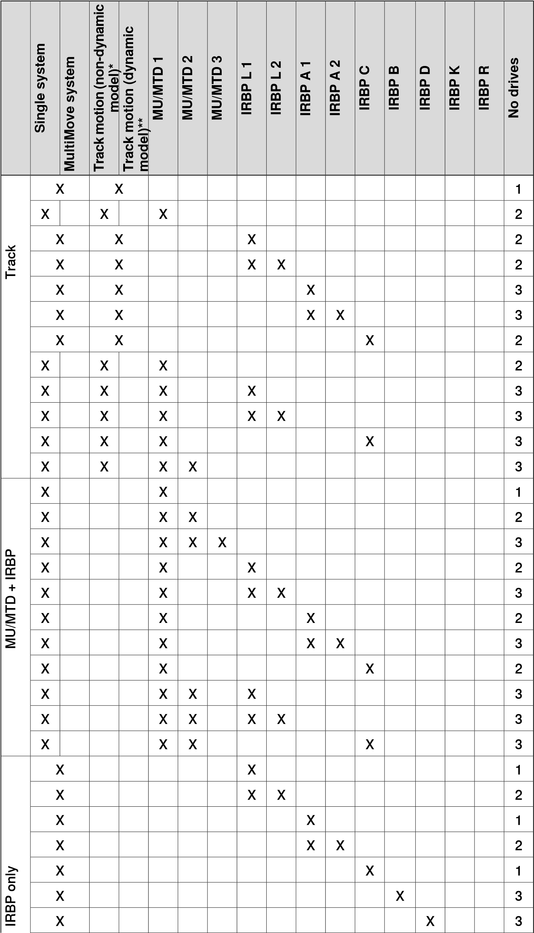

2.10 Configuring external axis

*Continued*

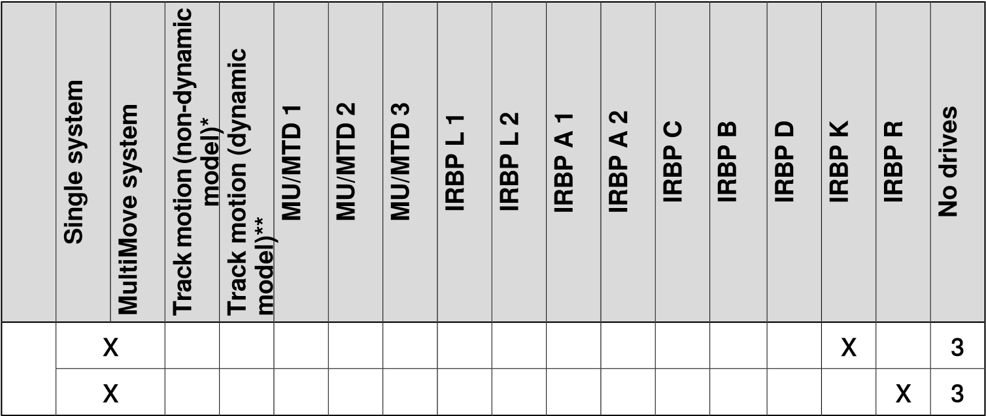

* Track motion that does not use a dynamic model, applicable for RTT.

**RobotWare *add-in* that contains a dynamic model for track motion is used, applicable for IRBT 4004, 6004, 7004 and 2005.

**Note**

You

can

configure

dynamic

(

IRBTx

004

and

IRBT2005)

tracks

only

for

T_ROB1

and

T_ROB2.

This

is

limited

by

RobotWare

add-in

for

track

motion.

MU does not support

*MultiMove*

in Virtual Controller From Layout. Dynamic tracks

cannot

be

combined

with

MU.

**Manual mapping of mechanical units and joints**

If the *virtual controller* contains more than one mechanical unit, the number of *tasks* and *base frame* positions of the *mechanism* should be verified in the virtual controller configuration.

* + - * 1. On the **Controller** tab, in the **Virtual Controller** group, click **Motion Configuration**.

This opens the **System Configuration** dialog.

* + - * 1. Select the robot from the node in the hierarchical tree.

The property page of this node contains controls for mapping and setting axes and joints.

* + - * 1. Click **Change** to open a dialog box.
        2. Manually map the mechanical unit and mechanism joints. Click **Apply**.
        3. Modify the base frame positions of the *mechanical unit*.

**2.11 Programming MultiMove systems**

**Overview**

The purpose of MultiMove is to let one controller handle several robots. This does not only save on hardware costs, it also allows advanced coordination between different robots and other mechanical units.

Here are some examples of applications

* + - * + Several robots can work on the same moving work object.
        + One robot can move a work object while other robots work on it.
        + Several robots can cooperate to lift heavy objects.

**Note**

MultiMove

was

available

as

an

integrated

feature

in

RobotStudio

till

version

2019.5.

For

later

versions

of

RobotStudio,

this

feature

is

provided

as

an

add-in

which

must

be

installed

from

**Add-Ins**

**Gallery**

.

**Workflow for setting MultiMove**

In *MultiMove* systems, a single robot or *positioner* holds the work piece and other robots operate on it.

* + - * 1. Select the robots and *paths* to use in the program.
        2. Execute motion instructions along the paths.
        3. Tune motion behavior, such as tolerances and constraints for *TCP* motion. 4 Generate the *tasks* for the robots.

For detailed information about *MultiMove* in *RobotWare* systems and *RAPID* programs, see *MultiMove application manual*.

**Selecting robots and paths**

This procedure is for selecting the robots and paths in the station that shall be used for the *MultiMove* program. All robots for the MultiMove program must belong to the same *system*.

* + - * 1. On the **Home** tab, click **MultiMove**. Click the **Setup** tab below the MutliMove work area.
        2. In the work area, click the **System config** bar for expanding the system config section.
        3. In the **Select System** box, select the system that contains the robots to program.

The robots of the selected system are now displayed in the **System grid** below the **Select system** box.

* + - * 1. For each robot that is used in the program, select the check box in the **Enable** column.
        2. For each robot that is used in the program, specify whether it carries the *tool* or the work piece using the options in the **Type** column.
        3. In the work area, click the **Path config** bar for expanding the path config section.
        4. Select the **Enable** check box for the tool robot and click the **expand** button. This displays the paths of the robot.
        5. Select the order of the paths to execute by specifying them in right order using **Path name** column.
        6. For each path that shall be included in the program, select the check box in the **Enable** column.
        7. In the **Start Position** section, select the robot in the **Select Robot that other should jump to** box, click **Apply**.
        8. When you have set up the robots and paths, continue testing the MultiMove and then tune the motion properties, if necessary.

**Executing motion instructions along paths**

This procedure is for setting the robot's start position and testing the resulting movements along the *path* sequence.

* + - * 1. Jog the robots to good start position.
        2. On the **Home** tab, click **MultiMove**. Click the **Test** tab at the bottom of the *MultiMove* tab.
        3. Optionally, select the **Stop at end** check box to make the simulation stop after moving along the *paths*. Clearing this check box makes the simulation continue in a loop until you click **Pause**.
        4. Click **Play** to simulate the motion along the paths based on the current start position.

Pause the simulation to use the following options to fine tune multimove paths.

##### Action Description

Examine the robots’ posi- Click **Pause** and then use the arrow buttons to move to tions for critical targets. one *target* at a time.

Jog the robots to new start Change in positions require new paths and configurapositions. tions. In most cases, positions near the robots’ joint limits shall be avoided.

Go to the **Motion Behavior** The default setting for the motion properties is free from tab and remove con- constraints. If this has been changed, constraints might straints. exist that limit motion more than necessary.

**Tuning the motion behavior**

Overview

Tuning the motion behavior means to set up rules for the robot’s movements, for example, constraints on the *position* or *orientation* of the *tool*. Generally, the MultiMove program will obtain the smoothest motion with the fastest cycle and process times with as few constraints as possible.

*Continues on next page*

*Continued*

Motion Behavior tab

This is used for specifying constraints and rules for how the robots shall move relative to each other. The default setting is no particular constraints, which results in the fewest joint movements. However, changing the motion behavior might be useful for:

* Locking the orientation or position of the tool.
* Optimizing cycle time or reachability by allowing tolerances.
* Avoiding collisions or singularity by restricting joint motion.

Both Joint Influence and *TCP* Constraints restrict the robot’s movements. Changes in these settings might result in lower performance or situations where it is impossible to find proper solutions. The weight values for Joint Weights and TCP Constraints set how much the setting for each joint or TCP direction shall affect the robots relative to each other. It is the difference between the weight values that matters, not the absolute values. If contradicting behaviors have been set, the one with the lowest weight value will win.

Tool Tolerance, instead of restricting, enables more motion. Therefore, tolerances may improve cycle and process times and enhance the reachability of the robots. Tolerances, too, have weight value; here is set how much the robots shall use the tolerance. A low value indicates that the tolerance will be used a lot, while a high value means that the robots will try to avoid using the tolerance.

The joint influence controls the balance of how much the robots will use their joints. Decreasing the weight value for one axis will restrict the motion for this axis, while increasing it will promote motion on this axis relative to alternative axes.

The TCP constraints control the *position* and *orientation* of the *tool*. Enabling a TCP constraint will decrease the motion of the tool and increase the motion of the work piece.

The tool tolerances control the allowed deviation between the tool and the work piece. By default, tolerances are not enabled, which means that no deviation is allowed. Enabling a tolerance, if applicable, might improve motion performance. For example, if the tool is symmetric around its Z axis, you can enable the Rz tolerance without affecting the accuracy of the generated paths.

The tool offset sets a fixed distance between the tool and the paths.

*Joint Influ-* **Select Robot** Select the robot’s joints to constrain *ence* in this box.

**Joints for Robot** Displays the robot’s joints and their

constraint weights. Each joint is presented in its own row.

**Axis** Displays which axis the constraint af-

fects.

**Influence** Specify how much the motion for the

axis is constrained. 0 means a locked axis, while 100 means no constraint relative to default constraint values.

*TCP Con-* **Active TCP** This grid displays the position and ro*straints* tations of the TCP together with their

constraint weights.

**Enable** Select this check box to activate the

constraint for this TCP pose.

**Pose** Displays the TCP pose that is affected by the constraint.

**Value** Specify the pose value to constrain at.

Either type the value, or click the Pick from TCP button to use the values of the current TCP position.

**Influence** Specify how much the motion for the

TCP value is constrained. 0 means a locked TCP at this pose, while 100 means no constraint relative to default constraint values.

*Tool Toler-* Enable Select this check box to activate the *ance* tolerance for this tool pose.

**Pose** Displays the tool pose that is affected

by the constraint.

**Value** Specify the pose value to apply the

tolerance around.

**Influence** Specify the size of the tolerance. 0

means no deviation is allowed, while 100 means all deviations are allowed.

*Tool Offset* **Enable** Select this check box to activate the

offset for this tool pose.

**Pose** Displays the tool pose that is affected

by the offset setting.

**Offset** Specify the value of the offset here.

Modifying the joint influences

The joint influence controls the balance of how much the robots will use their joints. Decreasing the weight value for one axis will restrict the motion for this axis, while increasing it will promote motion on this axis relative to alternate axes.

1. On the **Home** tab, in the **Path Programming** group, click **MultiMove**. The **MultiMove** pane opens.
2. In the **MultiMove** pane, click **Motion Behavior**.
3. Expand the **Joint Influence** group by clicking its title bar.
4. In the **Select Robot** box, select the robot whose joint influence you want to modify.

The weight values for the robot axes are now displayed in the grid.

1. For each axis whose motion you want to restrict or promote, adjust the Weight value. A lower value restricts, and a higher value promotes, motion on that axis.

Modifying the TCP constraints

The joint influence controls the balance of how much the robots will use their joints. Decreasing the weight value for one axis will restrict the motion for this axis, while increasing it will promote motion on this axis relative to alternative axes.

1. On the **Home** tab, in the **Path Programming** group, click **MultiMove**. The **MultiMove** pane opens.

*Continues on next page*

*Continued*

1. In the **MultiMove** pane, click **Motion Behavior**.
2. Expand the **TCP Constraints** group by clicking its title bar.

The directions and rotations in which you can constrain the TCP’s motion are now displayed in the grid

1. For each pose you want to constrain, select the **Enable** check box and specify the constraint values (location in the TCP coordinate system). To use the values from the current TCP position, click **Pick from TCP**.
2. Optionally, adjust the **Weight** value for the constraint. A low value results in a harder constraint, while a high value allows a larger deviation.

Modifying the tool tolerance

The joint influence controls the balance of how much the robots will use their joints. Decreasing the weight value for one axis will restrict the motion for this axis, while increasing it will promote motion on this axis relative to alternative axes.

1. On the **Home** tab, in the **Path Programming** group, click **MultiMove**. The **MultiMove** pane opens.
2. In the **MultiMove** pane, click **Motion Behavior**.
3. Expand the **Tool Tolerance** group by clicking its title bar.

The directions and rotations in which you can enable tolerances are now displayed in the grid.

1. For each offset you want to set, select the **Enable** check box.
2. In the **Value** column, specify the allowed deviation.
3. Optionally, adjust the **Weight** value for the tolerance. A low value increases the use of the tolerance, while a high value promotes motion that do not use the tolerance.

Modifying the tool offset

The tool offset sets a fixed distance between the *tool* and the *paths*.

1. On the **Home** tab, in the **Path Programming** group, click **MultiMove**. The **MultiMove** pane opens.
2. In the **MultiMove** pane, click **Motion Behavior**.
3. Expand the **Tool Offset** group by clicking its title bar.

The directions and rotations in which you can set offsets are now displayed in the grid.

1. For each offset you want to set, select the **Enable** check box.
2. In the **Offset** column, specify the offset distance.

**Creating paths**

After testing the MultiMove program, convert the temporary move instructions that MultiMove function uses to ordinary *paths*. Use the following steps to create paths for the *MultiMove* program.

1. On the **Home** tab, in the **Path Programming** group, click **MultiMove**. The **MultiMove** pane opens.
2. In the **MultiMove** pane, click **Create Paths** tab.
3. Click the title bar to expand the **Settings** group.
4. Optionally, change the settings in the following boxes:

##### Box Description

Start ID Specify the first ID number for the *synchronization* of the

instructions for the robots.

ID step index Specify the increment between ID numbers.

Sync ident prefix Specify a prefix for the syncident variable, which connects the sync instructions in the tasks for the tool robot and the work piece robot with each other.

Task list prefix Specify a prefix for the tasklist variable, which identifies the tasks for the tool robot and the work piece robot to synchronize .

5 Click the title bar to expand the **WP Robot Settings** group and then check the settings in the following boxes:

##### Box Description

WP Workobject Specify the *workobject* to which the targets generated for the workpiece robot shall belong.

WP TCP Specify which *tooldata* the work piece shall use when

reaching its targets.

Path prefix Specify a prefix for the generated *paths*.

Target prefix Specify a prefix for the generated *targets*.

6 Click the title bar to expand the **Generate path** group and then click **Create Paths**.

**Setting up MultiMove without using Multimove functions**

In addition to using the functions that calculate and create optimized MulitMove paths, you can program MulitMove manaully using a combination of the ordinary programming tools in RobotStudio and a set of tools specific for MultiMove programming.

The main actions for programming MulitMove manually are outlined below. Not all actions might be necessary, but the order in which they shall be carried out depends on the contents of the *station* and your goals.

##### Action Description

Creating Tasklists and Syncid- This data specifies the tasks and paths that shall be ents synchronized with each other.

Adding and updating ID argu- To add IDs to the intructions, you can use one of the folments to the instructions to *syn-* lowing methods:

*chronize* Using the *Recalculate ID tool* to add and update IDs for

instructions in paths that already are synchronized.

Using the Convert path to MultiMove path tool to add IDs to instructions in paths that have not yet been synchronized.

Adding and adjusting Sync in- Add SyncMoveon/Off or WaitSyncTask instructions structions to the paths. to the paths to *synchronization* and set their tasklist and Syncident parameters.

Teaching MultiMove instructions It is also possible to jog all robots to the desired positions and then teach instructions to new synchronized paths.

2.12 Replacing robot in a station

**2.12 Replacing robot in a station**

1. In the **Layout** browser, under **Mechanisms**, right-click the robot and then click **Replace Robot**.

The **Replace Robot** window opens.

1. In the **Name** list, select a robot model to replace the current robot.
2. Click **OK**.

**Note**

Robots

with

multiple

mechanisms

are

not

supported,

for

example,

IRB

14000.

2.13 Back up a system

**2.13 Back up a system**

**Overview**

When backing up a system you copy all the data needed to restore the system to its current state:

* Information about software and options installed on the system.
* System's home directory and all its content.
* All robot programs and modules in the system.
* All configuration and calibration data of the system.

**Prerequisites**

To backup a system you must have:

* Write access to the controller
* Logged on to the controller with appropriate grants.

**Creating a Backup**

To create a backup, follow these steps:

1. In the **Controller** browser, select the system you want to backup from the browser.
2. Right-click and select **Create Backup**.

The **Create Backup** dialog box appears.

1. Enter a new backup name and specify a location for the backup, or keep the default ones.

You can create backup either in the PC or in the controller disk using the following options, **Browse File System** or **Browse Controller**.

* + - To create a backup in the PC, select **Browse File System** and then select the destination folder.
    - To create a backup in the controller disk, select **Browse Controller** and then select the destination folder in the controller disk.

**Note**

Do

not

select

**Home**

folder

when

you

specify

the

destination

folder

for

backup.

1. Select the checkbox **Backup to archive file** to archive the backup as a .tar file. The backup can be archived in both the local PC and the controller disk.

**Note**

For

RobotWare

versions

prior

to

6.06

,

the

backup

is

archived

as

a

.zip

file

in

the

local

PC

alone.

1. Click **OK**.

The progress of the backup is displayed in the Output window.

*Continues on next page*

2.13 Back up a system *Continued*

**Note**

Do not create backups while performing critical or sensitive robot movements.This may affect the accuracy and performance of the movement. To make sure that no backup is requested while in critical areas, use a system input with the action value Disable Backup.

The system input signal can be set from RAPID for the parts of the code that are critical for disturbances or remove the setting otherwise. For more information, see Technical reference manual - System parameters.

**Backup folder**

When the backup is complete you will have a folder with the name of the backup in the specified location. This folder contains a set of subfolders which together comprise the backup.

**CAUTION**

If the contents of the Backup folder are changed, then it will not be possible to restore the system from backup.

##### Subfolders Description

BACKINFO Contains information necessary for re-creating the system's software and options from the mediapool.

HOME Contains a copy of the system’s home directory content.

RAPID Contains one subfolder for each task in the system’s program

memory. Each of these task folders contains separate folders for program modules and system modules.

SYSPAR Contains the system's configuration files.

**Note**

The contents of the PIB board of a IRC5P system (a controller system for painting) will not be included with the regular RobotStudio backup. Please use the backup function of the FlexPaintPendant to include the PIB content.

This page is intentionally left blank

1. **Programming robots in the 3D environment**

**3.1 Understanding offline programming**

**Overview**

This section provides an introduction to the coordinate systems used mostly for offline programming. In RobotStudio, you can either use the coordinate systems or the user-defined coordinated systems for co-relating elements and objects in the *station*.

**Hierarchy**

The coordinate systems are co-related hierarchically. The origin of each coordinate system is defined as a position in one of its ancestries. The following are the descriptions of the commonly used coordinate systems.

**Tool Center Point Coordinate system**

The tool center point coordinate system, also called TCP, is the center point of the *tool*. You can define different TCPs for one robot. All robots have one predefined TCP at the robot’s tool mounting point, called *tool0*.

When a program runs, the robot moves the TCP to the programmed position.

**RobotStudio World Coordinate system**

The RobotStudio world coordinate system represents the entire station or robot cell. This is the top of the hierarchy to which all other coordinate systems are related.

**Base Frame (BF)**

The base coordinate system is called the Base Frame (BF). Each robot in the station, both in RobotStudio and the real world has a base coordinate system which is always located at the base of the robot.

**Task Frame (TF)**

The task frame represents the origin of the robot controller world coordinate system in RobotStudio.

The following picture illustrates the difference between the base frame and the task frame.

In the picture to the left, the task frame is located at the same position as the robot base frame. In the picture to the right, the task frame has been moved to another position.

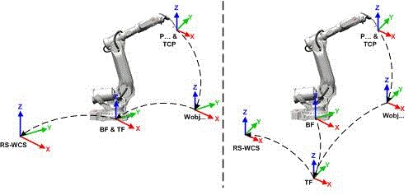

en1000001303

The following picture illustrates how a task frame in RobotStudio is mapped to the robot controller coordinate system in the real world. For example, on the shop floor.

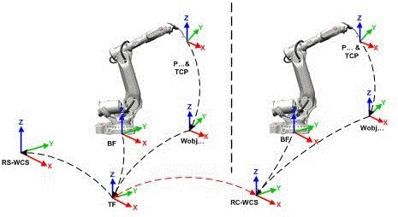

xx1900001116

World

coordinate

system

in

RobotStudio

RS-WCS

World

coordinate

system

as

defined

in

the

robot

controller.

RC-WCS

It

corresponds

to

the

task

frame

of

RobotStudio.

Robot

Base

Frame

BF

Tool

Center

Point

TCP

Robot

target

P

Task

Frame

TF

Workobject

Wobj

*Continues on next page*

*Continued*

**Stations with multiple robot systems**

For a single robot system, RobotStudio’s task frame corresponds to the robot controller *world coordinate system*. When several controllers are present in the station, the *task frame* allows the connected robots to work in different coordinate systems. That is, the robots can be located independent of each other by defining different task frames for each robot.

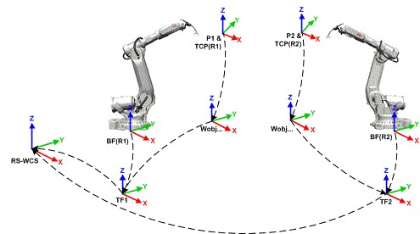

en1000001442

World

coordinate

system

in

RobotStudio

RS-WCS

Tool

Center

Point

of

robot

1

TCP(R1)

Tool

Center

Point

of

robot

2

TCP(R2)

Base

Frame

of

robot

system

1

BF(R1)

Base

Frame

of

robot

system

2

BF(R2)

Robot

target

1

P1

Robot

target

2

P2

Task

Frame

of

robot

system

1

TF1

Task

Frame

of

robot

system

2

TF2

Workobject

Wobj

**MultiMove Coordinated systems**

The *MultiMove* functions helps you create and optimize programs for MultiMove systems where one robot or *positioner* holds the work piece and other robots operate on it.

When using a robot system with the RobotWare option *MultiMove Coordinated*, it is important that the robots are working in the same coordinate system. As such, RobotStudio do not allow *task frames* of the controller to be separated.

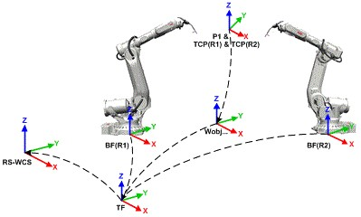

en1000001305

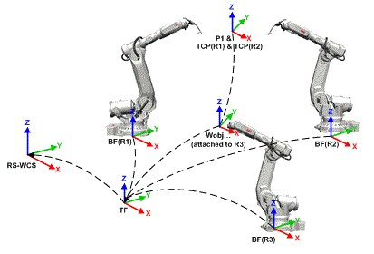

en1000001306

World

coordinate

system

in

RobotStudio

RS-WCS

Tool

Center

Point

of

robot

1

TCP(R1)

*Continues on next page*

*Continued*

Tool

Center

Point

of

robot

2

TCP(R2)

Base

Frame

of

robot

1

BF(R1)

Base

Frame

of

robot

2

BF(R2)

Base

Frame

of

robot

3

BF(R3)

Robot

target

1

P1

Task

Frame

TF

Workobject

Wobj

**MultiMove Independent systems**

For a *virtual controller* with the RobotWare option *MultiMove Independent*, robots operate simultaneously and independently while being controlled by one controller. Even though there is only one robot controller *world coordinate system*, robots often work in separate coordinate systems. To allow this setup in RobotStudio, the *task frames* for the robots can be separated and positioned independent of each other.



en1000001308

World

coordinate

system

in

RobotStudio

RS-WCS

Tool

Center

Point

of

robot

1

TCP(R1)

Tool

Center

Point

of

robot

2

TCP(R2)

Base

Frame

of

robot

1

BF(R1)

Base

Frame

of

robot

2

BF(R2)

Robot

target

1

P1

Robot

target

2

P2

Task

Frame

1

TF1

Task

Frame

2

TF2

Workobject

Wobj

**Workobject coordinate system**

The *workobject* normally represents the physical work piece. It is composed of two coordinate systems: the *User frame* and the *Object frame*, where the latter is a child to the former. When programming a robot, all *targets* (positions) are related to the object frame of a *workobject*. If no other workobject is specified, the targets will be related to the default *Wobj0*, which always coincides with the world coordinate system of the robot.

Using workobjects provide the chance to easily adjust robot programs with an offset, if the location of the work piece has been changed. Thus, workobjects can be used for calibrating *offline* programs. If the placement of the fixture or work piece relative to the robot in the real station does not completely match the placement in the offline *station*, adjust the position of the workobject.

Workobjects are also used for coordinated motion. If a workobject is attached to a *mechanical unit* (and the system uses the option for coordinated motion), the robot will find the *targets* in the workobject even when the mechanical unit moves the workobject.

In the picture below the grey coordinate system is the *world coordinate system*, and the black ones are the object frame and the user frame of the workobject. Here the user frame is positioned at the table or fixture and the object frame at the work piece.

xx0500001519

**User coordinate systems**

User coordinate systems are used for creating reference points in the *station*. For example, you can create user coordinate systems at strategic points in the station to simplify programming.

3.2 Robot axis configurations

**3.2 Robot axis configurations**

**Axis configurations**

*Targets* are defined and stored as coordinates in a *workobject* coordinate system. When the controller calculates the position of the robot axes for reaching the target, it will often find more than one possible solution to configuring the robot axes.

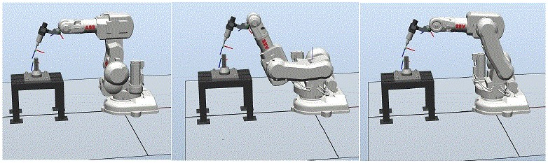

configur

To distinguish between the different configurations, all targets have a configuration value that specifies the quadrant in which each axis shall be located.

**Storing axis configurations in targets**

For targets that are taught after jogging the robot to the position, the used configuration will be stored in the *target*.

Targets created by specifying or calculating *positions* and *orientations* get a default configuration value (0,0,0,0), which might not be valid for reaching the target.

**Common problems related to robot axis configurations**

It is most likely that targets created by other ways than jogging cannot be reached at their default configuration.

Even if all targets in a path have reachable configurations, you might come across problems when running the path if the robot cannot move from one configuration to the other. This is likely to occur where an axis shifts greater than 90 degrees during linear or circular movements.

Common solutions for configuration problems

To resolve the problems described above, assign a valid configuration to each target and verify that the robot can move along each *path*. You can also turn configuration control off, that is, ignore the stored configurations and let the robot find working configurations at runtime. This must be performed carefully to avoid unexpected results.

In the absence of working configurations, reposition the work piece, reorient *targets* (if acceptable for the process) or add an *external axis* that either moves the work piece or the robot for increasing reachability.

3.2 Robot axis configurations *Continued*

**How configurations are denoted**

The robot’s axis configurations are denoted by a series of four integers, specifying in which quadrant of a full revolution significant axes are located. The quadrants are numbered from zero for positive (counterclockwise) rotation and from -1 for negative (clockwise) rotation.

For a linear axis, the integer specifies the range (in meters) from the neutral position in which the axis is located.

A configuration for a six-axis industrial robot (like IRB 140) may look like:

[0-121]

The first integer (0) specifies the position of axis 1: somewhere in the first positive quadrant (between 0 and 90 degrees rotation).

The second integer (-1) specifies the position of axis 4: somewhere in the first negative quadrant (between 0 and -90 degrees rotation).

The third integer (2) specifies the position of axis 6: somewhere in the third positive quadrant (between 180 and 270 degrees rotation).

The fourth integer (1) specifies the position of axis x, a virtual axis used for specifying the wrist center in relation to other axes.

**Configuration control**

When executing a robot program, you can choose whether to control configuration values. If configuration control is turned off, configuration values stored with the targets are ignored, and the robot will use the configuration closest its current configuration for reaching the *target*. If turned on, it will only use the specified configuration for reaching the targets.

Configuration control can be turned off and on for joint and linear movements independently and is controlled by the *ConfJ* and *ConfL* action instructions.

Turning configuration control off

Running a program without configuration control may result in different configurations each time a cycle is executed: When the robot returns to the start position after completing a cycle, it may choose a different configuration than the original.

For programs with linear move instructions this might cause a situation where the robot gets closer and closer its joint limits and eventually will not be able to reach the target.

For programs with joint move instructions this might cause sweeping, unpredictable movements.

Turning configuration control on

Running a program with configuration control forces the robot to use the configurations stored with the *targets*. This results in predictable cycles and predictable motions. In some situations, however, like when the robot moves to a target from an unknown position, using configuration control may limit the robot’s reachability.

When programming *offline*, you must assign a configuration to each target if the program shall be executed with configuration control.

*Continues on next page*

3.2 Robot axis configurations *Continued*

**Visualizing the spatial hierarchy of an object**

Spatial hierarchy refers to the hierarchy of transformations in the offline programming environment. To visualize this, On the **Home** tab, in **Graphics Tools**, click **Show/Hide** and then select **Parent Frame** to set it **Active**. With the **Parent Fram**e in **Active** state, the spatial hierarchy of the selected object with its immediate parent will be shown with an arrow in the direction of the spatial parent. The following table shows the spatial hierarchy between objects.

**Object Spatial parent** target workobject object frame

workobject object frame workobject user frame workobject user frame task frame (if not moved by a mechanism workobject user frame mechanism flange (if moved by a mechanism) tooldata robot flange (if held by robot) tooldata task frame (if not held by robot) mechanism task frame task frame world

3.3 Creating a workobject

**3.3 Creating a workobject**

1. On the **Home** tab, in the **Path Programming** group, click **Other** and select **Create Workobject**.

The **Create Workobject** dialog box appears.

1. In the **Misc Data** group, enter the values for the new *workobject*.
2. In the **User Frame** group, do one of the following:
   * Set the position of the user frame by entering values for the **Position x,y,z** and the **Rotation rx, ry, rz** for the workobject by clicking in the **Values** box.
   * Select the user frame by using the **Frame by points** dialog box.
3. In the **Object Frame** group, reposition the object frame relative to the user frame by using the following steps:
   * Set the position of the object frame by selecting values for **Position x, y, z** by clicking in the **Values** box.
   * For the **Rotation rx, ry, rz**, select **RPY (Euler XYZ)** or **Quaternion**, and enter the rotation values in the **Values** dialog box.
   * Select the object frame by using the **Frame by points** dialog box. 5 In the **Sync Properties** group, enter the values for the new workobject.

6 Click **Create**. The workobject gets created and displayed under the

**WorkObjects and Targets** node under the robot node in the **Paths&Targets** browser.

3.4 Creating a path with targets and move instructions

**3.4 Creating a path with targets and move instructions**

**Creating an empty path**

1. In the **Paths&Targets** browser, select the motion task in which you want to create the *path*.
2. In the **Home** tab, from the **Path Programming** group, click **Path** and then click **Empty Path**.
3. Right-click a workobject and select **Set as active**.
4. To set the correct motion properties for the *targets*, select the active process in the **Change Active Process** box in the **Elements** toolbar.
5. If the active template is set to **MoveAbsJoint**, then:
   * A target that is dragged into a path will be converted into a **jointtarget** (recognized by a different icon on in the browser).
   * One target can not be used as different types, for example, **MoveJoint**, but must be deleted and re-created.
   * When the target has been *synchronized* with the *virtual controller*, the joint target values will be calculated and inserted in the *RAPID* program.

It is possible to call a procedure from another procedure. In the **Paths & Targets** browser, click **Paths & Procedures** to view the folder structure. You can move procedures between folders using a drag-and-drop operation.

**Add to Path**

Creating a move instruction based on an existing target

1. Select the *target* for which to create the move instruction.
2. Right click on the selected target. and click **Add to Path**.

The move instruction will appear under the *path* node as a reference to the original *target*.

**Align TCP to UCS**

Use the following procedure to align the TCP to UCS.

1. In the **Layout** browser, right-click a robot. The context menu opens.
2. In the context menu, click **Align TCP**. The orientation of the active tool will be aligned to the UCS.

Here the axis closest to the UCS will be aligned and the remaining axes are oriented accordingly.

3.5.1 AutoPath

**3.5 Creating a path from an edge or curve**

##### 3.5.1 AutoPath

**Overview**

AutoPath helps in generating accurate paths (linear and circular) based on CAD *geometry*.

**Prerequisites**

A geometric object with edges, curves, or both must be available.

**Creating a path automatically**

Use the AutoPath feature to create paths from *curves* or along the edges of a surface. To create a path along a surface, use selection level *Surface*, and to create a path along a curve, use selection level *Curve*. When using Selection level surface, the closest edge of the selection will be picked for inclusion in the *path*. An edge can only be selected if connected to the last selected edge.

When using selection level Curve, all edges along the curve will be added to the list. When using selection level Surface, all edges on a surface can be added by holding the SHIFT button while selecting an edge. The *Approach* and *Travel* directions as defined in RobotStudio options are used to define the *orientation* of the created *targets*.

Use this procedure to automatically generate a path.

1. In the **Home** tab, click **Path** and select **AutoPath**.

The AutoPath tool appears.

1. Select the edge or curve of the geometric object for which you want to create a path.

The selection is listed as edges in the **tool** window.

**Note**

* + If in a geometric object, you select curve (instead of an edge), then all the points that result in the selected curve gets added as edges to the list in the **Graphic** window.
  + Always select continuous edges.

1. Click **Remove** to delete the recently added edge from the **Graphic** window.

**Note**

To change the order of the selected edges, select the **Reverse** check box.

*Continues on next page*

3.5.1 AutoPath *Continued*

1. You can set the following **Approximation Parameters**:

###### Select or enter values in to

MinDist Set the minimum distance between the generated

points. That is, points closer than the minimum distance are filtered.

Tolerance Set the maximum deviation from the geometric descrip-

tion allowed for the generated points.

MaxRadius Determines how large a circle radius has to be before

considering the circumference as a line. That is, a line can be considered as a circle with infinite radius.

Linear Generate a linear move instruction for each target.

Circular Generate circular move instructions where the selected edges describe circular segments.

Constant Generate points with a Constant distance.

End Offset Set the specified offset away from the last target.

Start Offset Sets the specified offset away from the first target.

The **Reference Surface** box shows the side of the object that is taken as normal for creating the *path*.

Click **More** to set the following parameters:

**to**

**Select**

**or**

**enter**

**values**

**in**

Generate

a

new

target

at

a

specified

distance

from

the

first

target.

Approach

Generates

a

new

target

at

a

specified

distance

from

the

last

target.

Depart

1. Click **Create** to automatically generate a new path.

A new path is created and move instructions are inserted for the generated *targets* as set in the Approximation parameters.

**Note**

The

targets

are

created

in

the

active

*workobject*

.

1. Click **Close**.

3.6 Creating a collision free path between two targets or move instructions

**3.6 Creating a collision free path between two targets or move instructions**

**Overview**

Use the Collision Free Path feature to create a path between two or more targets, joint targets or move instructions avoiding obstacles in the environment. The path will be generated with *MoveAbsJ* instructions and joint targets. This feature is available only with RobotStudio premium license.

In the **Home** tab, from the **Path Programming** group, click **Path** and then click **Collision Free Path**, the **Collision Free Path** tool window opens.

**Note**

External track motion is not considered when creating collision free paths.

##### Option Description

Single Path Creates a single collision free path connecting all targets.

Multiple Paths Creates collision free paths from one target to many targets.

Reverse Reverses the order of targets and thus reverses the direction

of the generated path(s). If **Multiple Paths** mode is selected, this creates collision free paths from many targets to one target.

Optimize order Optimizes the order of via targets to minimize the length of Visible when **Single Path** is the collision free path. selected.

Optimize zones Enlarges the zones of the via targets as much as possible. Visible when **Single Path** is Zones are always optimized for additional targets that are selected. added between via targets.

Return to start Makes the generated paths return to the start position. Visible when **Multiple Paths** is selected.

Add When the **Add** mode button is enabled, targets can be added

by selecting them in the **Paths&Targets** browser or in the 3D graphics view

Targets can be rearranged in the **Collision Free Path** tool window using a drag-and-drop operation. Similarly, targets can be added from the **Paths&Targets** browser to the **Collision Free Path** tool window using a drag-and-drop operation.

Clear All Clears all targets.

Minimum distance to Specify the minimum allowed distance between roobstacles bot/tool/loadand obstacles in the environmentalong the path.

Minimum robot self-collision Set the minimum allowed distance between tool, load and distance robot links.

Speed Select the speed of the TCP in the generated instructions.

* The tool window can be opened by selecting two or more targets, joint targets or move instructions and by selecting **Create Collision Free Path...** from the context menu.

*Continues on next page*

3.6 Creating a collision free path between two targets or move instructions *Continued*

* Objects can be excluded from the collision free path planning by deselecting **Include in Collision Free Path Planning** in the **Path Planning** context menu. All objects except sensors are included by default.
* The tool attached to the robot, and objects attached to the tool, are included in the collision free path planning by default.
* The path will be generated in the task, and with the work object and tool, that are selected in the **Settings** group in the **Home** tab.
* When an object (component) is selected in the **Layout** browser, its collision geometry will be highlighted in the **Graphics** window. When a group is selected, all objects in that group get their corresponding collision geometry highlighted.

Similarly, when you click on the collision geometry of an object in the **Graphics** window, the corresponding object gets selected in the **Layout** browser, which helps in identifying the object to which the collision geometry belongs to.

* **Include in Collision Free Path Planning**:

**Collision Geometry Detail Level**: Provides options to select the level of detail on the collision geometry for collision free path planning calculations, the options are **Low**, **Medium**, **High** and **Custom**.

* **Low**: Generates a collision geometry with only a single convex hull

(fast).

* **Medium**: Generates a collision geometry that contains multiple convex hulls, but fewer than the **High** option. This option provides a balance between accuracy and performance compared to the **Low** and **High** options.
* **High**: Generates collision geometry with high detail level (slow).
* **Custom**: Generates a collision geometry based on the **Number of convex hulls** and **Resolution** parameters. A higher **Resolution** value enhances the accuracy of the collision geometry. Generating collision geometry with a higher resolution is a compute-intensive feature, which can slow down the collision geometry generation.
* **Show Collision Geometries**: All collision geometries that are selected to be part of the path planning will be generated and displayed.
* **Use Group's Collision Geometry**: When this option is selected, a single collision geometry is generated for a Component Group instead of a collision geometry for each contained part. This is useful to improve collision free path planning performance when a Component Group contains many parts close to each other.
* **Visualizing Collision Free Path results**: When the collision free path creation fails, error messages are listed in the **Collision Free Path** tab in the **Output** window. Hover over a collision related error message, the tooltip displays a probable workaround to avoid the error. Double-click a collision error message or right-click and then click **Visualize**, robot moves to the target and the collision geometry gets highlighted. When the target is out of reach, double-click or right-click the error item to visualize the errors.

3.7 Configuring a stationary tool

**3.7 Configuring a stationary tool**

Stationary tool is a device that stands in a fixed location. The robot manipulator picks up the work piece and brings it to the device to perform specific tasks, such as gluing, grinding or welding. In this configuration, the robot holds the *workobject* and hence is attached to the robot whereas the *tool* is set as stationary.

* + - 1. On the **Home** tab, in the **Path Programming** group, click **Other** and select **Create Workobject**.

The **Create Workobject** dialog box appears.

* + - 1. In the **Misc Data** group, enter the values for the new workobject.
* Set **Robot holds workobject** to *True*.
* In **Moved by mechanical unit**, select the robot, for example, *ROB_1*.
* Set **Programmed** to *False*.

If the workobject is attached to the robot using the **Attach to** option, then these settings get applied automatically.

* + - 1. On the **Home** tab, in the **Path Programming** group, click **Other** and select **Create Tooldata**.

The **Create Tooldata** dialog box appears.

* + - 1. In the **Misc Data** group, enter the values for the new *tooldata*.

Set **Robot holds tool** to *False*.

3.8 Define arm configurations for the targets

**3.8 Define arm configurations for the targets**

**Auto Configuration**

The Auto Configuration function runs through the *path* and optimizes the configurations with respect to their preceding *target*. There are two options, either all of the configurations can be optimized, or only the configurations for linear and circular move instructions. Use the *Configurations tool* on the individual joint targets to change the configuration of intermediate joint move instructions.

In the **Paths&Targets** browser, right-click a path, and select **Auto Configuration**.

The robot now steps through each *target* in the path and sets the configurations.

**Auto Configuration for a dual-arm robot**

A normal robot arm has six axis or degrees of freedom of movement whereas a dual-arm robot has seven degrees of movement. Hence by configuring its arm angles, a dual-arm robot can adapt several ways to reach a *target*. You can set the arm angle while applying auto configuration.

3.9 Testing positions and motions

**3.9 Testing positions and motions**

**Jumping to a target**

* + - 1. In the **Paths&Targets** browser, browse to the target to jump to through the **Controller**, **Tasks** and **WorkObjects** nodes.
      2. Click **Jump to target**.

If the *target* has a valid configuration for the robot axes stored, the active *TCP* of the robot will immediately be positioned at the target. If no valid configuration is stored, right click on the target and select configuration the **Configuration** dialog box is displayed.

* + - 1. In the **Configuration** dialog box, select a suitable configuration solution and click **Apply**. The selected configuration is now stored with the *target*.

**Note**

Deactivate

the

configuration

check

while

using

**Jump**

**to**

**target**

.

The

robot

uses

the

configuration

solution

that

is

closest

to

the

current

position

for

reaching

the

target.

**Copying TCP target values**

It is possible to copy the current coordinates of the active TCP to the Windows clipboard. These coordinates are copied in relation to the active work object as a RAPID robtarget declaration. Values of the active external axis are included, for example, while using this feature to copy the current TCP of a robot placed on a track, the external axis values are also included in the robtarget declaration.

To use this feature, in the **Layout** browser, right-click the object and then click **Copy TCP as robtarget**.

**Copying position as jointtarget**

The current joint values of the robot and external axis can be copied to the Windows clipboard as a RAPID jointtarget declaration.

To use this feature, in the **Layout** browser, right-click the object and then click **Copy Pose as jointtarget**. The copied values can be pasted from the clipboard to a RAPID module as jointtarget text.

3.10 Generating the RAPID program

**3.10 Generating the RAPID program**

**Synchronizing to the station**

1. On the **RAPID** tab, in the **Access** group, click the arrow next to the **Synchronize** icon, and then click **Synchronize to Station**.
2. Select the paths to be *synchronized* to the *station* from the list.
3. Click **OK**.

The message **Synchronization to Station completed** is displayed in the **Output** window.

*RAPID* can be synchronized from the files of the HOME folder as an alternative:

RAPID procedures without parameters only can be synchronized to RobotStudio.

* In the **Controller** browser, under **Home** folder, right-click any file and then click **Synchronize to Station** to synchronize data and procedures of the selected file into the station.
* In the **Controller** browser, under **Home** folder, right-click any file and then click **Synchronize to File** to synchronize data and procedures from the station into the selected file.

Before selecting this option, you must synchronize the selected file to the station. Using the **Synchronize to File** option can conflict with the synchronize to RAPID option.

3.11 Modifying target orientations

**3.11 Modifying target orientations**

1. In the **Paths&Targets** browser, right-click a target and select **Modify Target**.
2. Select **Set Position**, the **SetPosition** browser opens.
3. From the **Reference** list, select a *coordinate* system. This will be used as a reference for *position* and orientation values.
4. Select **RPY angles (Euler ZYX)**, and enter the new *orientation* values.
5. Click **Apply**.
6. In the **RAPID** tab, click **Synchronize** and then select **Sychronize to RAPID** to update the *RAPID* program.

**Replicating position and orientation to multiple objects**

It is possible to copy the position and orientation of any object in a station and apply the same to another object. The position and orientation of the object can be copied either relative to the world coordinate system or relative to its parent’s position and orientation. The same reference will be used when applying the position and orientation to another object.

1 In the Layout browser, right-click an object, from the context menu click **Position** and then click **Copy Position and Orientation**.

This option is also available in the **Paths&Targets** browser, right-click the object and then click **Copy Position and Orientation** from the context menu. 2 Click **Relative World** or **Relative Parent** as required.

1. Select the object(s) where position or orientation must be applied, click **Apply Position and Orientation** .
2. Select the required **Position and Orientation**, **Position** or **Orientation** as required to apply the copied values to the selected object.

**Note**

This

option

is

not

available

for

path

and

face.

4.1 Working with RAPID editor

1. **Understanding RAPID editor**
   1. **Working with RAPID editor**

**Overview**

The *RAPID* tab provides tools and functionalities for creating, editing, and managing RAPID programs. You can manage RAPID programs which are *online* on a *robot controller*, *offline* on a *virtual controller*, or standalone programs. Use RAPID editor to view and edit programs loaded into a robot controller, both robot and virtual. The integrated RAPID editor is useful for editing all robot *tasks* other than robot motion. Use RAPID editor to edit the RAPID code of the RAPID *modules*.

**General RAPID Editor features**

The following are the general features of the RAPID Editor:

* + - **Read-only documents** - If the document is read-only (for example, write access unavailable), then the background of the editor area will be light gray instead of the normal white. Typing in an editor that is in the read-only state results in a dialog asking you whether RobotStudio should acquire write access.
    - **Context-sensitive help** - Pressing F1 when the cursor is on a RAPID programming construct, such as an instruction, opens the related section in the RAPID reference manual, instead of the main RobotStudio help.
    - **Auto-indent cursor on return** - When you press Enter, the cursor is automatically indented by the appropriate amount on the following line. For example, after typing a PROC header, pressing ENTER will indent the cursor one tab (or the corresponding number of spaces, depending on settings).
    - **Completion list** - When you type in code in the editor, a pop-menu which lists possible code suggestion maybe displayed depending on the kind of RAPID code construct being written. The suggestions listed also depend on where in the document the cursor is.

Pressing comma (,), semi-colon (;), colon (:), equal sign (=), Spacebar, Tab, or Enter keys automatically inserts the selected item. Press Esc to cancel the list.

* + - **Collapsible regions** - All regions of the code can be collapsed. In the **RAPID** tab, click **Outlining** to access this functionality. You can either collapse or expand all regions or can select a particular region to collapse or expand.
    - **Zooming in and out** - In the RAPID editor you can zoom in and zoom out of the code display. Click the plus (+) and minus (-) buttons at the top right corner of the RAPID editor window to zoom in and zoom out.

**Tip**

The

Zoom

in

Zoom

out

feature

is

also

present

in

the

*RAPID*

*Tasks*

,

*Rapid*

*Editor*

,

*Configuration*

*Editor*

,

*Event*

*viewer*

,

and

*I/O*

windows.

4.1 Working with RAPID editor

*Continued*

* + - **Cut, copy, paste and drag and drop** - These standard commands for clipboard handling of text are supported.
    - **Comment and Uncomment** - You can use the keyboard shortcut (Ctrl+Q) to comment and (Ctrl+Shift+Q) to uncomment the selected block of RAPID code. These commands are also available in the context menu.
    - **Undo and redo** - Standard commands for undo and redo operations are supported.
    - **Selection modes** - You can select text by character, row and column.
    - **Line numbers** - Line numbers for the RAPID code lines are displayed in the left margin of the editor.
    - **Keyboard shortcuts** - For keyboard shortcuts in the RAPID Editor.

**Compare**

Use the compare function to compare between folders, files, controller and editor versions of files. Unlike common text editors, the comparison function in RobotStudio is designed to include RAPID specific advanced filtering wherein you can choose to exclude Backinfo, PERS variables, comments and so on. The following filters are available:

* + - The **BackInfo** option excludes the timestamp of the *Backinfo.txt* file during comparison.
    - The **PERS variables** option excludes changes in PERS variables during comparison. A persistent variable retains the last assigned value during restart by writing the value in the RAPID code. Hence the results of comparison can still show differences even though there are no changes in code. Select this option to narrow down comparison to view code changes alone.
    - The **Comments**,**Character case** and **White space** options exclude changes in them during comparison.
  1. RAPID editor intellisense

**4.2 RAPID editor intellisense**

**Overview**

RAPID editor provides various code editing features and commands for performing actions on the code.

**Syntax highlighting**

Text is highlighted in different colors depending on their token classification (such as keyword, identifier and so on). You can configure these colors in the *File* tab, under *Options:Robotics:Text Editor*. In addition to token classification, the editor also shows different colors for built-in and installed identifiers (such as MoveL) and also for identifiers declared in user code.

**Quick-Info tooltips**

When you hover the mouse pointer over a symbol (such as a data declaration or procedure call), a tooltip is displayed describing the symbol. For many built-in symbols (such as MoveJ) a short description is also displayed. For symbols corresponding to a data declaration, the current value is also displayed.

**Auto-completion**

After typing or completing a procedure call (such as MoveJ), pressing the Tab key will fill in all required parameters. Note that this is only available for certain built-in procedures, such as those listed in the *Insert Instruction* menu.

**Argument information**

While typing in procedure calls and function calls, tooltips showing argument information are displayed.

**Error highlighting**

Red squiggly lines appear under errors in the code. All syntax errors and a subset of semantic errors are indicated in this manner.

**Quick Find**

Enter the search string in the **Quick find** box and then press Enter or F3. If an instance is found, it is highlighted. Press F3 again to search for the next instance.

**Go to line**

Enter a line number in the **Go to line** box and press Enter. The cursor moves to the corresponding line in the RAPID editor. When multiple tasks are open in the editor, and if you select the procedure name in the list box, the cursor moves to the task that contains the specified name.

**Jump To**

The Jump To list has an item for each routine and data declaration in the program module. Click an item to move to its location in the code.

4.2 RAPID editor intellisense *Continued*

**Find or Replace**

Click **Find/Replace** to open the **Find/Replace** dialog. This dialog provides standard find/replace functionality and the following options.

* Enter the string to search in the **Find what** list.
* In the **Look in** list, select the option to specify the location to look for. The various options are **Current Document**, **Current System**, **Current Task**, or a folder in your PC (you can browse to a folder to specify it).

The **Search Results** window displays the results of the find operation. Double-click a search result to go to the corresponding instance in the RAPID editor. If the instance is from a module which is not in the RAPID editor, then the module opens in the editor.

**Go To Definition**

The **Go To Definition** command is enabled for an identifier in the RAPID Editor context menu if the source code for the corresponding symbol definition is available. Click **Go To Definition** to move the cursor to (and select) the corresponding symbol definition. This action detects symbol definitions such as routine declarations, data declarations and record definitions.

**Navigate forward/backward**

Use the **Navigate Backward** button to move to previous locations of the RAPID modules being edited, and the **Navigate Forward** button to return to more recent locations.

**Find Unused References**

Click **Find unused references in Task** to see all data declarations in the task of the active module document that are not used anywhere. The results are shown in the *Search Results* window. Click **Find unused references in Module** to see unused data declarations in the current module.

**Find All References**

The **Find All References** command is enabled for identifiers in the editor code.

For a given identifier, click **Find All References** to search through the entire task for uses of the same identifier (including its definition). Note that this is not just a string search. It takes RAPID scoping rules into account. For PERS and syncident data, this function searches the other tasks for a matching global symbol and return the uses of those.

4.3 Manage RAPID modules and programs

**4.3 Manage RAPID modules and programs**

**Overview**

RobotStudio allows editing of standalone modules, that are in memory of the controller or that are available in the disk. When connected to *virtual* or *robot controller*, these standalone files can be edited in the *Home* folder. RAPID code of the controller is structured into *modules*. A module contains several routines of type procedure, function or trap. Modules are of two types system and program.

System module contains code related to robot installation, such as, surrounding equipment, calibration equipment, feeders and service routines. Program module contains RAPID code related to a particular process or parts that the robots are working on. Program modules of a particular task constitute a RAPID program which is handled as a unit. A program, when saved to disk saves each module as independent to each other along with a header file (*pgf) containing references of these modules.

**Creating a standalone RAPID module**

1. On the **File** tab, click **File**.
2. Click **New**, then under **Files**, click **RAPID Module File**.

Three types of RAPID *modules* are available, blank, main and system.

1. Under **RAPID Module File**, click the required option, a module with the default name *New Module* opens in the RAPID editor.

**Creating a RAPID program from virtual controller**

*Synchronizing* the *station* with virtual controller creates the RAPID program in the RAPID editor. Synchronizing ensures that the RAPID program in the virtual controller corresponds to the programs in RobotStudio. You can synchronize both from RobotStudio to the *virtual controller* and vise versa.

In a RobotStudio station, robot *positions* and movements are defined by *targets* and move instructions in *paths*. These correspond to data declarations and RAPID instructions in the *modules* of the RAPID program. By synchronizing the station to the virtual controller, you create RAPID code out of the data in the station. By synchronizing the virtual controller to the station, you create paths and targets out of the RAPID program in the virtual controller.

Synchronizing the station to the virtual controller updates the RAPID program of the virtual controller with the latest changes in the station. This is useful to do before performing a simulation, saving a program to files on the PC or copying or loading RobotWare systems.

1. On the **RAPID** tab, in the **Access** group, click the arrow next to the **Synchronize** icon, and then click **Synchronize to RAPID**.
2. Select the elements to be synchronized from the list.
3. Click **OK**.

The message **Synchronization to RAPID completed** is displayed in the Output window.

4.3 Manage RAPID modules and programs

*Continued*

**Note**

This

function

is

also

present

in

the

**Controller**

group

on

the

**Home**

tab.

**Loading a RAPID program**

You can load a RAPID program to a robot controller either from the PC disk or from the controller disk. For a *virtual controller* you can only load a program from the PC disk.

1. On the **RAPID** tab, in the **Controller** group, click **Program** icon and then select **Load Program** to load a RAPID program from the virtual controller and select **Load Program from Controller** to load a RAPID program from the controller.

Alternatively, in the **Controller** browser, right-click the active *task* under the *station*, and click **Load Program**.

1. In the **Open** dialog box that appears, browse to the location of the program to be loaded to your station and click **Open**.

**Saving a program**

Save a RAPID program either in the *virtual controller* or in the controller disk. You need write access for saving a program.

1. On the **RAPID** tab, in the **Controller** group, click **Program** icon and then click **Save Program As** to save the RAPID program in the system and click **Save Program to Controller** to save a program in the controller disk.

Alternatively, in the **Controller** browser, right-click the active *task* under the *station*, and select **Save Program As**.

1. In the *Save As* dialog box that appears, browse to the location where you want to save your program, and click **Save**.

**Renaming a program**

Write access is required for renaming a program.

1. On the **RAPID** tab, in the **Controller** group, click **Program** icon and then click **Rename Program**.

Alternatively, in the **Controller** browser, right-click the active *task* under the *station*, and select **Rename Program**.

1. In the *Rename* dialog box that appears, enter a new name for your program, and click **Ok**.

|  |  |
| --- | --- |
| **Deleting a program**  Write  1 | access is required for deleting a program.  On the **RAPID** tab, in the **Controller** group, click **Program** and select **Delete Program**.  A confirmation dialog is displayed. |
| 2  *Continues on next page* | Click **Yes**.  The selected program is deleted. |

* 1. Manage RAPID modules and programs *Continued*

To delete the entire program under a*task* in a *station*, in the **Controller** group, click **Program** and then click **Delete Program**.

Alternatively, in the **Controller** browser, right-click the task under the station and then click **Delete Program**.

* 1. Adding code snippets

**4.4 Adding code snippets**

**Adding code snippets**

Code Snippets are pieces of code which you can insert into the RAPID Editor. To view and select a code snippet, in the **Insert** group, click **Snippet**.

The list which appears show two kinds of code snippets:

* Predefined code snippets
* User defined code snippets

The following are the predefined code snippets in RobotStudio:

* Array of num, 2x2x4 • Array of num, 2x4
* Array of num, 2x4x2
* Array of num, 4x2
* Module header
* Procedure with parameters
* Procedure with error handler
* Robtarget declaration
* Tooldata declaration
* Workobject declaration

You can also create your own code snippets or save a section of existing code from the RAPID editor as a code snippet. Such user created code snippets are also listed along with the predefined snippets. To save a section of existing code, from the RAPID editor, as a code snippet:

1. Select the code that must be saved as a snippet.
2. In the **Insert** group, click the arrow next to the **Snippet** icon, and then click **Save Selection as Snippet**.

The *Save As* dialog box appears. Specify a name for the snippet and save it. The RobotStudio *\*.snippet* files are saved in the following folder.

*C:\<Documents and Settings>\<user name>\RobotStudio\Code Snippets*

**Note**

The

folder

*<*

*Documents*

*and*

*Settings>*

may

be

configured

with

different

names,

for

example,

*Data*

.

It

may

also

be

translated

on

localized

versions

of

Windows.

Snippets

can

also

be

edited

in

an

XML

editor

such

as

Microsoft

Visual

Studio.

For

information

on

creating

customized

code

snippets,

see

*http://msdn.microsoft.com/*

.

**Inserting**

**a**

**code**

**snippet**

**in**

**a**

**RAPID**

**module**

1. Click the **File** tab.
2. Click **Open**, then under **Local**, click **Open** and select the required RAPID file. The file opens in the RAPID editor.
3. Place the cursor in the required line, then, in the **Insert** group click **Snippet**.

*Continues on next page*

4.4 Adding code snippets *Continued*

1. From the drop down menu, select the required option, for example, **Procedure with parameters**. The following code snippet gets inserted in the file.

PROC myProcedure(\switch doThis | switch doThat, INOUT num numRepeats, PERS num dataList{*})

ENDPROC

* 1. Inserting instructions from the list

**4.5 Inserting instructions from the list**

**Inserting instructions in a RAPID module**

To insert a predefined instruction into the code:

* + 1. Place the cursor at the required point in the RAPID code.
    2. In the **Insert** group, click **Instruction**.

A list of pre-defined instructions gets displayed.

The instruction is inserted into the code where the cursor is placed. RobotStudio generates and inserts default arguments to the instruction, using similar rules as the FlexPendant.

A large number of instructions that are divided into several categories are available by default. Most common instructions are listed under the default category,

*Common*. You can create three personalized lists using the system parameters of the type *Most Common Instruction* in the topic *Man-machine Communication*. The system parameters are described in Technical reference manual - System parameters

**Example**

* + 1. Click the **File** tab. The backstage view opens.
    2. Click **Open**, then under **Local**, click **Open** then select the required RAPID file. The file opens in the RAPID editor.
    3. Place the cursor in the required line, then, in the **Insert** group click **Instruction**.
    4. From the drop down menu, select the required option, for example, **Common > MoveAbsJ**. The following instruction gets inserted in the file.

MoveAbsJ <ARG>\NoEOffs,v1000,z50,tool0\WObj:=wobj0;

* 1. Editing standalone files and backups

**4.6 Editing standalone files and backups**

**Starting the RAPID Editor**

To open a RAPID module in the RAPID editor, in the **Controller** browser, right-click on a RAPID module, and then click **RAPID Editor**.

The RAPID code of the module opens in the editor window.

**Tip**

You

can

view

the

graphical

layout,

without

closing

the

editor,

by

clicking

the

graphics

window

tab.

**Managing RAPID files**

* + 1. In the Files browser, right-click the **File** node and then click **Open**. The **Open File** dialog box appears,
    2. In the **Open File** dialog browse and open system module (*\*.sys*), RAPID modules (*\*.mod*), and Configuration files (*\*.cfg*) from the PC or on a network.

**Note**

The content of the *HOME* folder of the connected *virtual* or *robot controller* is visible in the **Controller** browser. Both RAPID and configuration files can be edited as text files.

For virtual controllers, RAPID modules can be *synchronized* to the graphics environment of the *station* using the context menu of the RAPID module file. To synchronize any changes back to the RAPID module, use the command **Synchronize to file**.

* + 1. A RAPID or system module file opens in the RAPID editor. The system parameters file (*\*.cfg*) opens in a notepad-like editor.
    2. Click the **Save** button on the Quick Access Toolbar to save the changes.

**Note**

The

RAPID

editor

displays

syntax

errors

in

standalone

RAPID

module

when

the

variable

declarations

exist

in

another

*module*

.

**Managing system backups**

Right-click **Backup** and click **Browse**, to select and open system backups.

The structure of the backup is reflected in the **Files browser** under the *Backups* node. There is one node for each *task* defined in the *virtual controller*. The RAPID modules of each task are shown as its child nodes in the tree view. The editor will find data declared in other *modules* and mark the code as being syntactically and semantically correct.

The contents of the *HOME* folder are displayed in a separate folder. RAPID modules of the *HOME* folder are edited in the standalone mode, that is, which means that

*Continues on next page*

* 1. Editing standalone files and backups

*Continued*

the editor will not find data declared in other modules. The reason is that the editor cannot know in which context (task) the module should be treated. The *SYSPAR* folder will show the configuration files.

**Note**

There

is

no

syntax

check

or

intellisense

for

editing

configuration

files.

* 1. RAPID Data Editor
  2. **RAPID Data Editor**

**RAPID Data Editor overview**

The RAPID Data Editor allows direct access to RAPID data values to view and edit. To open the RAPID Data Editor, on the **RAPID** tab go to the **Controller** browser, right-click a RAPID module, and then click **RAPID Data Editor**. This opens the Data window which shows the data declarations in that particular *module*.

Data declarations are grouped according to their data types. All data declarations belonging to a data type are shown in a table below it. Each row corresponds to a data declaration and shows the contents of the declaration.

**Using the RAPID Data Editor**

* + - Editing the values of a row opens the changed value in the RAPID Editor window. The new value is shown in both the Data editor and also the RAPID editor. This means that the changes made in the RAPID data editor are seen in the RAPID editor, and vice-versa.

An asterisk (*) on the window tab indicates unsaved changes.

**Tip**

* + - Select multiple cells and edit them together.
    - Create, edit or delete a data declaration from the RAPID Data Editor.
    - To delete a data declaration, select the row and click the **Delete** button beside it.
    - To add a new declaration, click **New Declaration** next to the required data type. This adds a new row to the table below it having some default properties and values, which can be edited. However, you cannot add a data type declaration that is not already present in the *module*. In such cases, you must add the declaration manually to the module using the RAPID Editor.
    - To view the orientation of *robtargets* in angles, select the **Show quaternions as RPY angles** checkbox in the RAPID Data Editor. *Orientations* can be represented in angles and quaternions, set the default representation in the

RobotStudio Options.

**Note**

The RAPID Data Editor only shows data declarations that contain editable values.

* 1. Creating custom instructions using Instruction Template

## 4.8 Creating custom instructions using Instruction Template

**Overview**

RobotStudio provides certain set of default instructions. To create instructions for custom applications such as paint, dispensing etc, the Instruction Template feature can be used. You can manually define the instruction templates for RAPID motion instructions other than the default instructions such as MoveL, and MoveC. Custom instructions created using the instruction template feature can be saved as template files and shared with other PCs.

The instruction templates can be saved in the *C:\Users\<user name>\Documents\RobotStudio\Instruction Templates* in XML format and reused later. These files can be used in the same way as any other pre-defined XML files that are imported and used for robot controllers with appropriate RobotWare options.

**Creating instruction template**

1 Create a custom procedure which accepts arguments such as *robtarget*, *tooldata*, and an optional *wobjdata* as move instructions.

The procedure can include additional arguments such as *speeddata* and *zonedata* or other process related parameters.

Example 1

PROC MyMoveL(robtarget ToPoint, PERS tooldata Tool,\wobjdata

Wobj) MoveL ToPoint,v100,fine,Tool,\Wobj:=wobj0;

ENDPROC

Example 2

PROC MyMoveJ(robtarget ToPoint, PERS tooldata Tool,\wobjdata

Wobj) MoveJ ToPoint,v100,fine,Tool,\Wobj:=wobj0;

ENDPROC

**Note**

It is helpful to use the standard naming convention for arguments and instructions. The last letter of the instruction defines the type of the instruction, for example, MoveL implies linear movement, similarly, MoveC and MoveJ implies, circular and joint movements respectively. Following naming conventions helps RobotStudio to interpret the instructions faster, which reduces user input while defining the instruction template. The robtarget must be named *ToPoint*, incase of circular instruction the via point must be named *ViaPoint* according to the naming convention.

*Continues on next page*

4.8 Creating custom instructions using Instruction Template *Continued*

1. Open Instruction Template window.

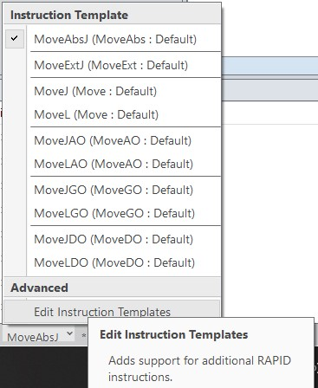

xx1900001270

1. In the Instruction Template window, select the instruction and then click the **Add** button.

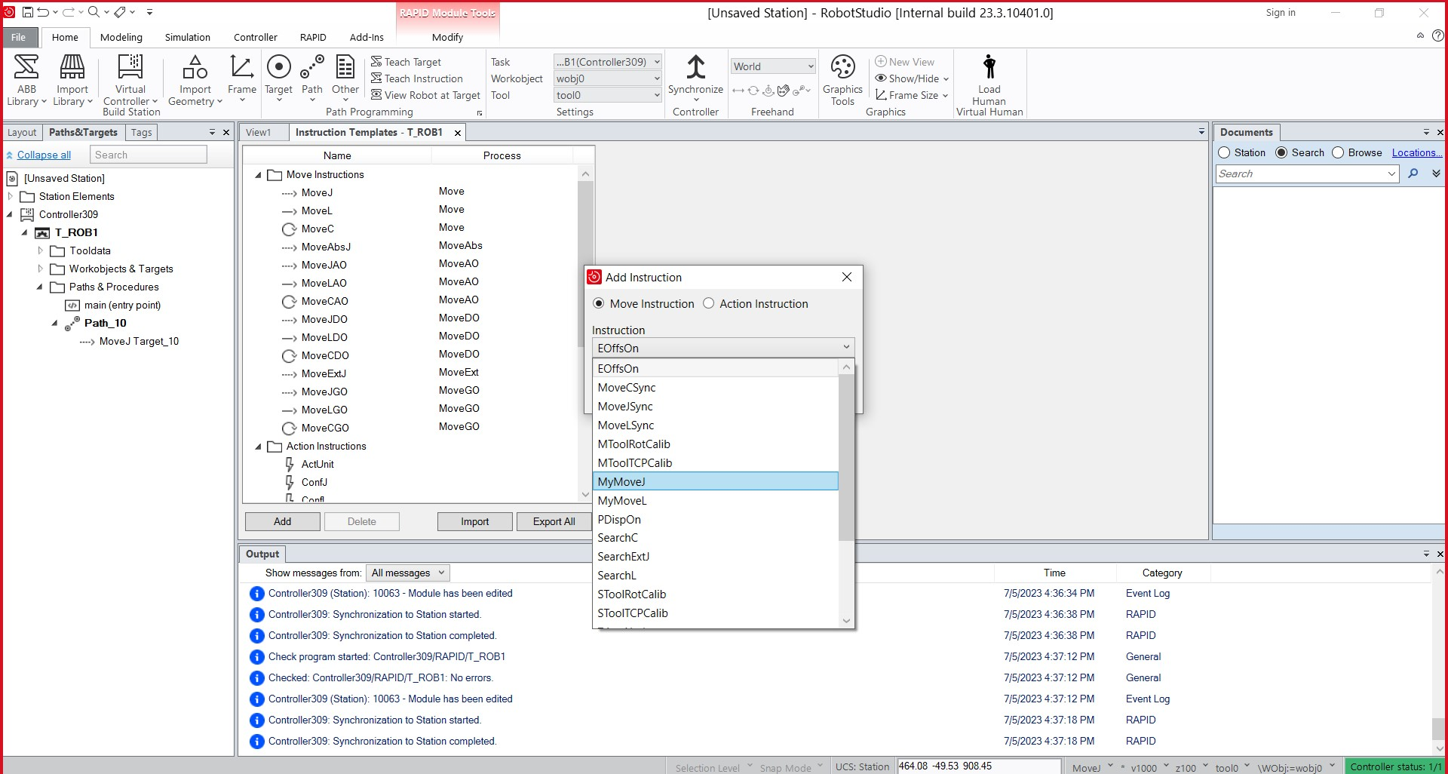

xx1900001271

Repeat this step for all instructions. The instructions are grouped according to the process name (for example, *MyMove*). Adjustments to the *Motion Type*, *Point Mapping* and default parameters are possible at this phase as required. *Motion type* defines how RobotStudio traces the path preview. *Point Mapping* defines how RobotStudio interprets robtarget.

4.8 Creating custom instructions using Instruction Template

*Continued*

1. Select the new instruction templates and then click **Export Selection** button and then the **Save** button to save the file as XML in the Instruction Template folder.

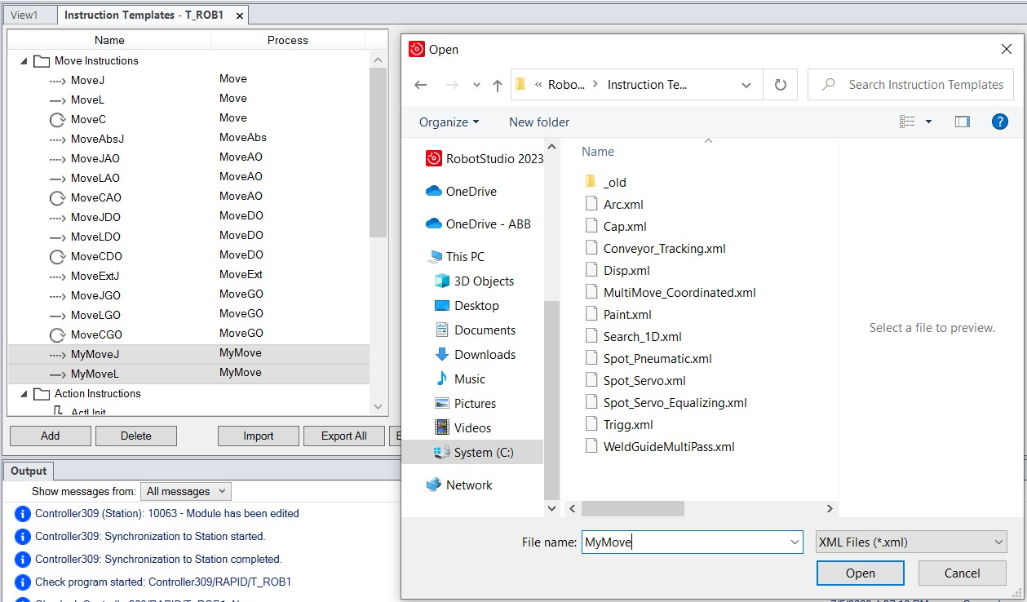

xx1900001273

The instruction template file must be exported for sharing the file with other users or for using it in the RAPID Path editor. To export the file, use the

**Export Selection** button. Import this file to the PC for using it in a station.

4.9 RAPID Path Editor

## 4.9 RAPID Path Editor

**Overview**

Use RAPID Path editor to graphically view and edit programs loaded into a controller. The RAPID program is displayed in a 3D structure in the RAPID Path Editor that allows editing of multiple *robtargets*. The edits made in the graphical RAPID program gets updated in the corresponding RAPID Editor and the RAPID Data Editor simultaneously.

**Using the RAPID Path Editor**

In the **RAPID** tab, right-click the **Module** or the **Path** to open the **RAPID Path Editor and the Properties** window. Select any target in the RAPID Editor and the corresponding visualization gets displayed in the RAPID Path editor. Any change in the position of a target using the freehand tool in the RAPID Path Editor, gets reflected in the corresponding RAPID program. Also its properties change to the new *position* of the *target*.

* Editing target definition: Use **Properties** tab to edit target definition such as position, orientation and *external axes*.
* Editing move instruction: Edit a move instruction using the **Properties** tab that includes the values for arguments.
* Editing a Jointtarget: Edit the joint values in a Jointtarget using the external Axes in the **Properties** tab. However, a jointtarget has no corresponding graphical representation.

Changes to the graphical representation of the RAPID program gets reflected in the **Properties** tab and vice-versa.

**Using the Path Editor tab**

Use the **RAPID Path Editor** tab to import a work piece or a *tool* to the graphical representation of the RAPID program.

* Importing a work piece: To visualize a work piece in the Path editor, import it from a *geometry* or library file.
* To set the position of the imported work piece, click **Set position** or choose a *wobj* from the list of *wobj* defined in the program.
* Importing a tool: Add a tool to the visualization by using the tool option. Import a tool from *ABB library* or *user library* (.rslib).

**Creating custom move instructions in the path editor.**

RAPID Path Editor supports generic move instructions. It is possible to view and create such move instructions in the 3D environment of a robot station and in the RAPID Path Editor. The following procedure describes how to view an instruction template file in the RAPID Path Editor.

The required instruction template file must be imported to the host PC before starting this procedure.

1. Copy the required instruction template file to the *C:\Users\<user name>\Documents\RobotStudio\Instruction Templates* folder in the computer.

4.9 RAPID Path Editor

*Continued*

The search path depends on how the RobotStudio documents folder is configured.

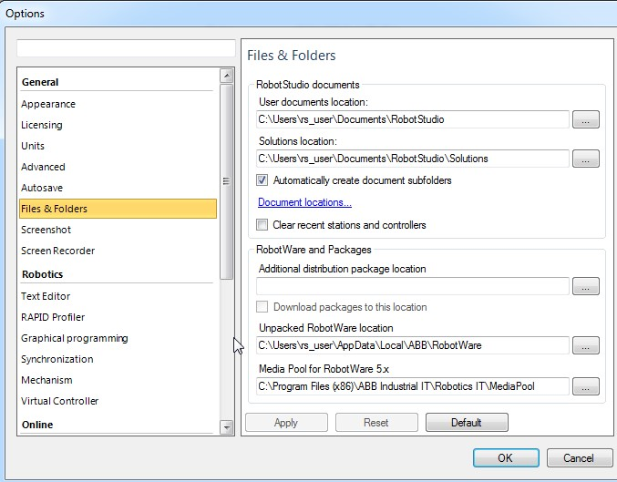

xx1900001274

1. Open the RAPID Path Editor to view and edit the custom move instruction in RobotStudio like a standard move instruction.

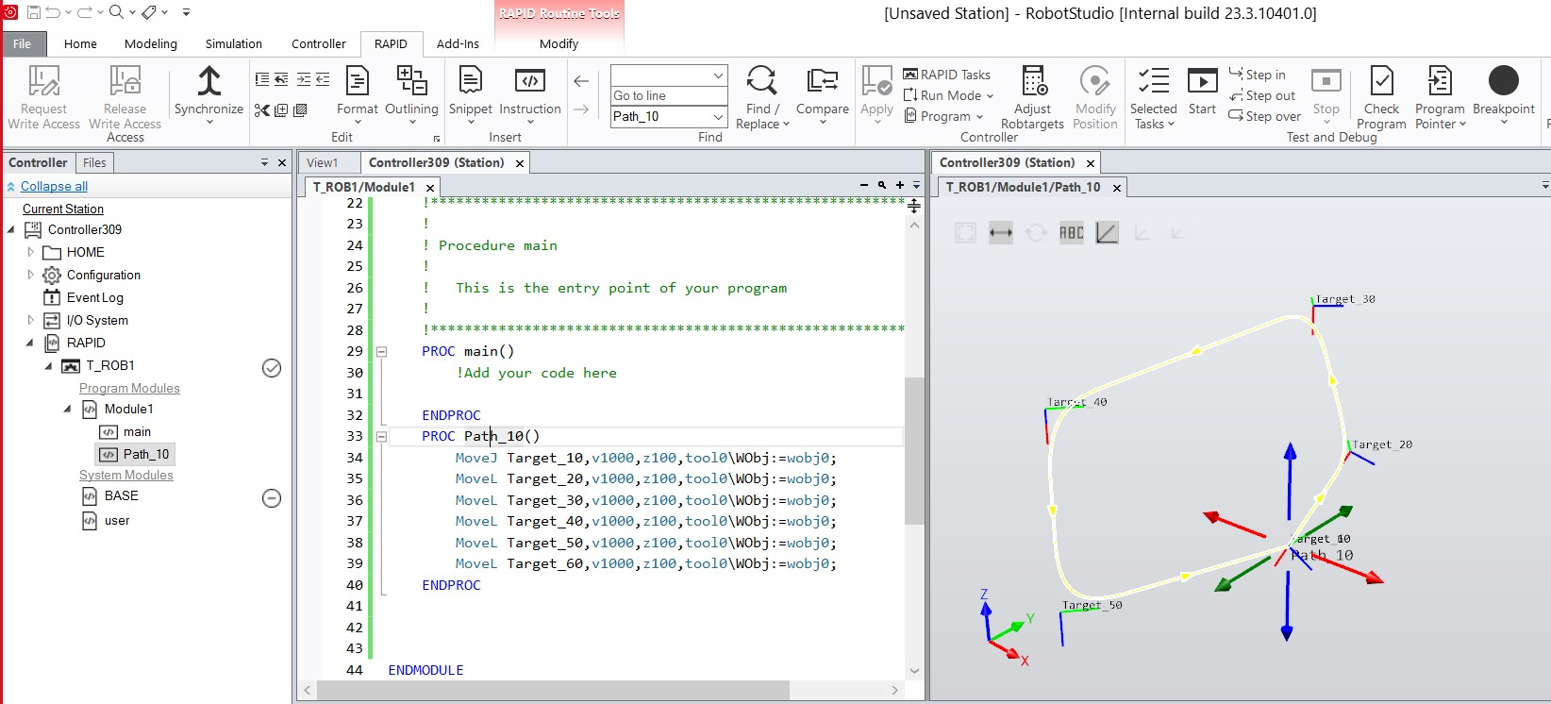

xx1900001275

4.10 Applying and verifying the edits

## 4.10 Applying and verifying the edits

**Applying and verifying the edits**

To apply the changes made in the editor to the *virtual controller* and also to check the program, In **RAPID** tab, go to the **Controller** group, and click the arrow next to the **Apply** icon, perform any of the following steps:

* To apply only the changes made in the *module*, currently displayed in the editor, click **Apply Changes**.

Alternatively, click the **Apply** icon

* To apply the changes made in all modified modules, click **Apply All**.

**Note**

The Apply commands are enabled only for unsaved changes. RobotStudio commits the changes without losing the program pointer. If this is not possible, you will be asked if it is OK to lose the program pointer.

To verify the syntactic and semantic correctness of the modules, in the **Test and Debug** group, click **Check Program**.

**Synchronizing to station**

*Synchronize* the *virtual controller* to *station* for applying the changes performed on the RAPID program to the virtual station. This applies to virtual robots only.

**Synchronize to station** is available only for the virtual controller.

**Note**

1. On the **RAPID** tab, in the **Access** group, click the arrow next to the **Synchronize** icon, and then click **Synchronize to Station**.
2. Select the paths to be synchronized to the station from the list.
3. Click **OK**.

The message **Synchronization to Station completed** is displayed in the **Output** window.

RAPID can be synchronized from the files of the *HOME* folder as an alternative:

* In the **Controller** browser, under **Home** folder, right-click any file and then click **Synchronize to Station** to synchronize data and procedures of the selected file into the station.
* In the **Controller** browser, under **Home** folder, right-click any file and then click **Synchronize to File** to synchronize data and procedures from the station into the selected file.

Before selecting this option, you must synchronize the selected file to the station. Using the **Synchronize to File** option can conflict with the synchronize to RAPID option.

4.10 Applying and verifying the edits *Continued*

Limitations

* *Robtargets* that are local to a procedure are not supported by **Synchronize to Station**. Only robtargets that are local to a module are supported.
* RobotStudio does not fully support instructions using *Offs* or *RelTool* functions. These are synchronized and will appear in the element browser, but commands such as *View Tool at Target* and *Locate Target* will not work. *Targets* used in the instructions will not be visible in graphics. However, instructions can be programmed and edited using the RAPID Editor and can be simulated using the virtual controller.
* RobotStudio does not support RAPID programs containing arrays of *tooldata*, robtargets and *workobjects*. These programs will not be synchronized to the *station*.
* Workobjects and tooldata that are shared between several *tasks* must be specified in RAPID with its full value for each task when programming offline with RobotStudio. This will trigger a warning *Initial value for PERS not updated* in the controller event log. You may ignore this warning. However, ensure that the RAPID variable definitions are the same in all tasks, otherwise you may get unexpected behavior.

5.1 Debugging a task

# 5 Testing and Debugging RAPID

## 5.1 Debugging a task

**Overview**

Debugging involves locating and correcting code errors in a *task*. Debugging is part of the code testing and is an integral part of the entire software development. RAPID editor provides several debugging features for testing and perfecting your code. Some of them are introducing *breakpoints* for tracking a particular instruction, using call stack window to monitor program pointer and so on.

**Selecting, Starting and stopping a task for RobotWare 6.xx**

A task can be selected, started, and stopped from the RAPID editor:

* In the **Controller** group, click the **Selected tasks** button to view the list of tasks. You can select the required foreground task(Normal) or background task (Semistatic/Static) from the list.
* In the **Controller** group, click the **Start** button to start executing the selected task.
* In the **Controller** group, click the **Stop** button to stop executing the selected task.

You can monitor the status of execution in the **Output** window.

**Task execution state for RobotWare 5.xx and 6.xx**

A task can be activated, started, and stopped from the **Controller** browser with the following limitations:

* + Motors must be in *ON* state for the *Start* operation.
  + Need *Write access* to the controller and the grants *Execute program* or *Full access*. While performing *Start* or *Stop* operations in Auto, the *Remote Start Stop in Auto* grant is required.
  + Normal tasks alone can be activated and deactivated. Background tasks are activated automatically.
  + Background tasks of type *Static* and *Semistatic* with the TrustLevel set to NoSafety only can be started and stopped.

For detailed information about the different TrustLevel values, see the *Technical reference manual - system parameters*.

The following table shows cases where task execution state cannot be changed.

**Activating, starting and stopping tasks in RobotWare 5.xx**

To activate a task, right-click the task in the **Controller** browser and then turn on the **Active** command. If the prerequisites are met, you can operate the task, such as start and stop the task, move the Program Pointer to main and set the run mode.

5.1 Debugging a task

*Continued*

To start a task, right-click the task in the **Controller** browser and then click **Start Task**. You can start Normal tasks, but you can only start a *Static* or *Semistatic* task if the TrustLevel is set to NoSafety.

**CAUTION**

When starting a task, the manipulator axes may move very quickly and sometimes in unexpected ways! Make sure no personnel is near the manipulator arm!

To stop a task, right-click the task in the Controller browser and then click **Stop**

**Task**. You can stop Normal tasks, but to stop a *Static* or *Semistatic* task the TrustLevel must be set to NoSafety. This method of starting and stopping tasks is applicable only for RobotWare version **5.15.xx** and below.

5.2 Understanding program pointer

## 5.2 Understanding program pointer

**Overview**

*RAPID* instructions are executed in the controller for carrying out various operations. These instructions are grouped into various tasks and these tasks are further grouped into *motion* and *non-motion* tasks. A *non-motion* task affects a logical part of the controller operation such as handling of signals, whereas a motion task controls the movement of a mechanical equipment, for example, a manipulator. A task is a collection of RAPID instructions that are executed line by line. Every task has a program pointer. During execution, program pointer points to the current line of code in a task. The program pointer indicates the instruction with which the program will start execution or rather the program execution continues from the instruction where the program pointer is located.

The motion pointer indicates the instruction of the *motion* task that the robot is currently executing. A *motion* task has both motion pointer and program pointer. Program pointer is ahead of the motion pointer for preparing the controller for motion execution. A motion pointer is normally located at one or more instructions after the program pointer. This allows the system to execute and calculate the robot path faster before the robot moves. The motion pointer is represented as a small robot icon placed to the left margin in the RAPID Editor.

A task can further be classified into, Normal, *Static* and *Semistatic*. A motion task must always be Normal. But a non-motion task can be Normal, Static or Semistatic. Execution of Static and Semistatic tasks start when the controller is powered on. But a Normal task start only when the **Play** button is pressed. In a Semistatic task, when the controller restarts, the program execution starts from the beginning of the task. But the program execution of a Static task starts from the last position of the program pointer before restart.

**How the program pointer helps**

During program execution, the program pointer points to the line of code that is currently executing. The function **Follow Program Pointer** keeps the program pointer visible during program execution by automatically scrolling the RAPID editor window according to the movements of the program pointer. To enable the function, in the **Test and Debug** group on the **RAPID** tab, click the arrow next to the program pointer icon and then select **Follow Program Pointer**.

**Note**

During program execution, you can view the movement of program pointer across all open modules. Hence, keep all required modules open.

The other commands in the Program Pointer menu are:

* Go To Program Pointer – To show the current location of the program pointer in the RAPID editor
* Go To Motion Pointer – To show the current location of the motion pointer in the RAPID editor

5.2 Understanding program pointer

*Continued*

* To set the program pointer at a particular line of code or code segment and then start program execution from that point, use the **Set Program Pointer** options. You can choose from the following options:
  + - Set Program Pointer to Main in all tasks
    - Set Program Pointer to Cursor
    - Set Program Pointer to Routine

**Maintaining the program pointer**

The RAPID code can only be edited when the controller is not running, that is when it is in state *Ready* or *Stopped*. In *Ready* state the program pointer is not set, but in *Stopped* state the program pointer is set to a specific location of the program. For limited changes to the RAPID code of a controller in *Stopped* state, the current location of the program pointer can be maintained. After such an edit, you can resume program execution from where it was without having to reset the program pointer.

**Note**

If

the

edit

is

too

large

for

the

program

pointer

to

be

maintained

then

a

warning

message

is

displayed

to

convey

this.

The program pointer cannot be maintained, for example, when editing the line of code at which the program pointer is located. Editing that line of code results in resetting the program pointer. In effect, the program will start from the beginning when the controller is started after the edit.

**WARNING**

After resetting program pointer, when the program execution starts, the robot can move along the shortest path from its current location to the first point of the program.

5.3 Working with RAPID breakpoints

## 5.3 Working with RAPID breakpoints

**Using breakpoints**

*Breakpoints* are used to stop program execution at a certain point or line of code. Set breakpoints to stop program execution to monitor the state of code variables or to view the call stack. You can set a breakpoint in the source code by clicking in the left margin of a file. When you run this code, execution stops whenever the breakpoint is hit, that is, before the code on that line is executed. Press the **Start** button to resume execution.

When a RAPID program is run from RobotStudio using the **Play** button, the program execution includes breakpoints and stops execution at breakpoints. Breakpoint functionality is available only in RobotStudio. When the program is run from FlexPendant, breakpoints are ignored. Breakpoints can be viewed in the **RAPID Breakpoints** window. Double-click a certain breakpoint to view the particular line of code.

5.4 Navigate through your program using RAPID Call Stack window

## 5.4 Navigate through your program using RAPID Call Stack window

**Using the Call Stack window**

A call stack stores information about the active subroutines of a RAPID program. Use the **Call Stack** window to view the routine call currently on the stack. This feature is useful especially for tracking program pointer during the execution of nested routines.

The following example shows a nested routine where Procedure 1 calls Procedure 2 which then calls Procedure 3 and so on. The **Call Stack** window tracks program pointer and shows the trail of execution.

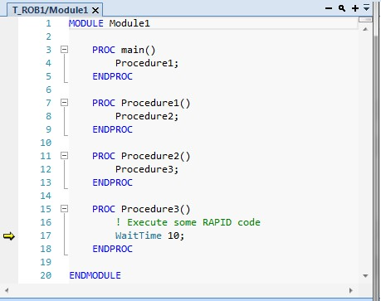

xx1800000961

The **Call Stack** window displays the name of the task, module, routine and line number that shows the trail of program pointer during program execution. Call Stack will not be refreshed automatically during program execution, and it gets refreshed automatically when the execution completes. To refresh call stack during program execution, click the **Refresh** button.

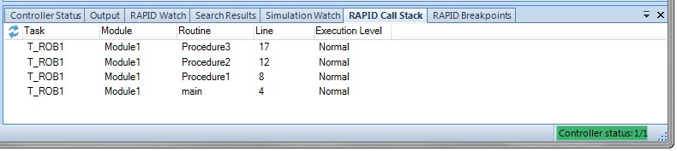

xx1800000878

5.5 Using RAPID Watch window for debugging your RAPID code

## 5.5 Using RAPID Watch window for debugging your RAPID code

**Viewing variables and I/O signals**

The RAPID Watch window displays details such as name, value, datatype and system name of selected variables and I/O signals during program execution. You can view and edit RAPID data of variables in the **RAPID watch** window, during program execution and after the controller stops. I/O signals can only be viewed and not edited in the **RAPID watch** window. To view a variable or I/O signal in the **RAPID watch** window, it must be added to the window. In the RAPID editor, right-click the required variable or I/O signal, and then click **Add Watch**.

By default, during program execution, values of variables are automatically refreshed in the **RAPID watch** window every 2 seconds. You can also manually refresh these values. To enable or disable automatic refresh, in the context menu, select or clear the **Auto Refresh** command. To do a manual refresh, in the context menu, click **Refresh** (keyboard shortcut F5).

**Note**

CONST

variables

cannot

be

edited.

Variables

and

signals

added

to

the

**RAPID**

**watch**

window

gets

removed

when

RobotStudio

closes.

This page is intentionally left blank

6.1.1 Simulation Setup

# 6 Simulating programs

## 6.1 Playing Simulation

### 6.1.1 Simulation Setup

**Overview**

The Simulation Setup dialog box is used to perform the following two main tasks.

* Setting up the sequence and *entry point* in the robot program.
* Creating simulation scenarios for different simulated objects.

You can create simulation scenarios containing different simulated objects and connect each scenario with a predefined state to ensure that the correct state is applied to all project objects before running the scenario. If you want to simulate a specific part or segment of the cell where not all simulated objects in the cell are included, you can set up a new scenario and add only the objects needed for simulation.

**Prerequisites**

To set up a simulation, the following conditions must be met:

* At least one *path* must have been created in the *station*.
* The paths to be simulated must be synchronized to the *virtual controller*.

**Setup simulation pane**

From this pane, you can perform the combined task of configuring the program sequence and program execution such as *entry point*, and running the execution mode.

The **Setup simulation** pane consists of the following:

###### Option Description

Active Simulation scen- Lists all active station scenarios. ario • Add: Click to add a new scenario.

* Remove: Click to delete the selected scenario.
* Rename: Click to rename the selected scenario.

Initial state Initial state of the simulation.

Manage states Opens the **Station Logic** pane.

Simulated objects Displays all objects that can be part of a simulation. Objects that

utilize simulation time can be part of a simulation. For example, *virtual controllers* and *Smart Components*. When you create a new scenario, all objects are selected by default.

Virtual time mode • Time slice: This option makes RobotStudio always use the *time slice mode*.

* Free run: This option makes RobotStudio always use the *free run mode*.

|  |  |
| --- | --- |
| **Setting up a simulation** |  |
| 1 | Click **Simulation Setup** to bring up the **Simulation Setup** pane. |

*Continues on next page*

6.1.1 Simulation Setup

*Continued*

1. Select the tasks to be active during simulation in the **Select Active Tasks** box.
2. Select the run mode as either **Continuous** or **Single Cycle**.
3. From the **Simulated Objects** list select the task.
4. Select the entry point from the **Entry point** list.
5. Click **Edit** to open the RAPID program where the user can edit the procedure.

**Creating simulation scenarios**

Verify the productivity of certain solutions, check collision in robot cell, ensure that robot program is free of any motion error.

1. Click **Simulation Setup** to bring up the **Setup Simulation** pane.
2. Under **Active Simulation Scenario** ,
   * Click **Add** to create a new scenario in the **Simulated objects** box.
   * Click **Remove** to delete the selected scenario from the **Simulated objects** box.
3. Select a saved state for the scenario from the **Initial state** list.

6.1.2 Simulation Control

### 6.1.2 Simulation Control

**Running**

**a**

**simulation**

1

In

the

**Simulation**

**Control**

group,

**to...**

**Click...**

start

and

resume

the

simulation.

•

The

**Pause**

button

is

enabled

once

you

start

the

simulation.

•

The

**Play**

button

is

changed

to

**Resume**

once

you

pause

the

simulation.

•

Click

**Resume**

to

resume

the

simulation.

**Play**

/

**Resume**

Start

the

simulation

and

to

record

it

to

a

*Export*

*Viewer*

.

**Play**

and

select

**Record**

**to**

**Viewer**

The

**Save**

**As**

dialog

box

appears

where

the

simulation

is

saved.

Pause

and

step

the

simulation.

•

The

**Pause**

button is changed to

**Step**

once you start

the

simulation.

•

Click

**Step**

to

run

the

simulation

in

steps.

You

can

set

the

simulation

time

step.

**Pause**

/

**Step**

Reset

the

simulation

to

its

initial

state.

**Reset**

**Note**

When

running

a

simulation

in

time

slice

mode,

all

breakpoints

set

in

the

RAPID

editor

windows

will

be

deactivated

temporarily.

**Note**

During

the

simulation

play,

if

a

user

does

not

want

more

objects

to

be

added

to

the

conveyor,

in

**Layout**

browser,

expand

the

conveyor

node,

then

right-click

the

object

source

and

clear

the

**Enabled**

option.

**Resetting simulation**

1. In the **Simulation Control** group, click **Reset** to reset the simulation.
2. Click **Reset** and select **Save Current state** to store states of objects and *virtual controllers* to be used in a simulation scenario.
3. Click **Reset** and select **Manage states** to start *Station Logic*.

6.2 Detecting Collision

## 6.2 Detecting Collision

**Overview**

With RobotStudio you can detect and log collisions between objects in the *station*. The basic concepts of *collision detection* are explained below.

**Collision sets**

A *collision set* contains two groups, *Objects A* and *Objects B*, in which you place the objects to detect any collisions between them. When any object in *Objects A* collides with any object in *Objects B*, the collision is displayed in the graphical view and logged in the **Output** window. You can have several collision sets in the station, but each collision set can only contain two groups.

A common use of collision sets is to create one collision set for each robot in the *station*. For each collision set you then put the robot and its tool in one group and all objects you do not want it to collide with in the other. If a robot has several tools, or holds other objects, you can either add these to the robot’s group as well or create specific collision sets for these setups.

Each collision set can be activated and deactivated separately.

**Collisions and near-misses**

In addition to collisions, the collision detection can also watch for *near-misses*, which is when an object in *Objects A* comes within a specified distance from an object in *Objects B*.

**Recommendations for collision detection**

In general, the following principles are recommended to facilitate *collision detection*:

* Use as small *collision sets* as possible, split large parts and collect only relevant parts in the collision sets.
* Enable coarse detail level while importing *geometry*.
* Limit the use of *near-miss*.
* Enable last collision detection, if the results are acceptable.

To customize the collision settings, on the **File** tab, click **Options** and then select **Options:Simulation:Collision**.

Options:Simulation:Collision

**Perform collision detec-** Select if collision detection is to be performed during simulation **tion** or always. Default value: always.

**Pause/stop simulation at** Select this check box if you want the simulation to stop at a **collision** collision or at a near miss. Default value: cleared.

**Log collisions to Output** Select this check box if you want the collisions to be logged to **window** the output window. Default value: selected.

**Log collisions to file:** Select this check box if you want to log the collisions to a file. Browse for the file to log in by clicking the browse button. Default value: cleared.

6.2 Detecting Collision *Continued*

**Enablefastcollisiondetec-** Select this check box to enhance the performance by detecting

**tion** collisions between geometrical bounding boxes instead of

geometrical triangles. This might result in falsely reported collisions, since the triangles are the true geometry and the bounding boxes always are larger. All true collisions will, however, be reported. The larger the object, the greater the number of false collisions that are likely to be detected.

**View** Click this button to open the log file specified in the file box in

Notepad.

**Clear** Click this button to delete the log file specified in the file box.

**...** Click this button to browse for the file in which you want to log

the collisions.

|  |  |
| --- | --- |
| **Creating a collision set** |  |
| 1 | Click **Create Collision Set** to create a collision set in the **Layout** browser. |
| 2 | Expand the collision set and then drag one of the objects to the **ObjectsA** node to check for collisions.  If you have several objects you want to check for collisions with objects in the **ObjectsB** node, for example, the tool and the robot, drag all of them to the **ObjectsA** node. |
| 3 | Drag the objects to the **ObjectsB** node to check for collisions.  If you have several objects you want to check for collisions with objects in the **ObjectsA** node, for example, the work piece and the fixture, drag all of them to he **ObjectsB** node. |

**Tip**

Selecting

a

collision

set

or

one

of

its

groups

(

*Objects*

*A*

or

*Objects*

*B*

)

highlights

the

corresponding

objects

in

the

graphical

window

and

the

browser.

Use

this

feature

to

quickly

check

what

objects

have

been

added

to

a

collision

set

or

to

one

of

its

groups.

**Results of creating a collision set**

After you have created a *collision set*, RobotStudio will check the positions of all objects and detect when any object in *ObjectsA* collides with any object in *ObjectsB*. Activation of detection and display of collisions depend on how the collision detection is set up.

If the collision set is active, RobotStudio will check the positions of the objects in the groups, and indicate any collision between them according to the current color settings.

**Collision detection**

Collision detection checks whether robots or other moving parts collide with equipment in the *station*. In complex stations, you can use several *collision sets* for detecting collisions between several groups of objects.

After *collision detection* has been set up, it does not need to be started, but automatically detects collisions according to the setup.

*Continues on next page*

6.2 Detecting Collision *Continued*

**Setting the objects for collision detection**

To set the objects for *collision detection*, follow these steps:

1. Make sure that the objects for collision detection are placed correctly in collision sets.
2. Make sure that the *collision set* for the objects is activated, which is indicated by an icon in the **Layout** browser:

**Description**

**Icon**

Active.

Collisions

between

objects

in

this

set

will

be

detected.



xx050033

Not active. Collisions between objects in this set will not be detected.



xx050007

To activate or deactivate collision sets, continue with the following steps:

1. Right-click the collision set to change and then click **Modify Collision set** to bring up a dialog box.
2. Select or clear the **Active** check box and then click **Apply**.

**Setting near-miss detection**

Near-misses occur when objects in collision sets are close to colliding. Each collision set has its own near-miss settings. For setting near-miss detection, follow these steps:

1. In the **Layout** browser, right-click the collision set to change and then click **Modify Collision set** to bring up a dialog box.
2. In the **Near miss** box, specify the maximum distance between the objects to be considered a near-miss and then click **Apply**.

**Setting logging options**

In addition to the graphical display of collisions, you can also log the collisions to the **Output** window or a separate log file:

1. On the **File** menu, click **Options**, under **Simulation**, click **Collision**.
2. On the **Navigation** pane to the left, select **Simulation: Collision**.
3. On the *Collision* page to the right, select **Log collisions to Output window** check box.

The collision log is displayed in the **Output** window.

1. On the *Collision* page to the right, select **Log collisions to file** check box and enter the name and *path* to the log file in the box.

A separate file for logging collisions is created below the check box.

**Modifying a collision set**

To modify a collision set, follow these steps:

1. Right-click the collision set and then select **Modify Collision set** from the context menu. The **Modify Collision set** dialog box opens.

6.2 Detecting Collision *Continued*

1. Select or enter the required values in various fields provided in the dialog box.
2. Click **Apply**.

The **Modify Collision set** dialog box provides the following options:

##### Options Description

Active Collisions between objects in this set will be detected.

Near miss(mm) Specifies the maximum distance between the objects to be considered a near miss.

Higlight colliding Lets the user select the colliding object (part, body, or sur-

face) that must be highlighted when two objects collide. It also creates a temporary markup at the point of collision or near miss.

Collision color Displays the collision in the selected color.

Near miss color Displays the near miss in the selected color.

Show markup at collision Shows markup at collision or near miss.

Detectcollisionsbetweeninvis- Detect collisions even if the objects are invisible. ible objects

## 6.3 Collision Avoidance

**Overview**

The *Collision Avoidance* function monitors the *geometries* of the robot and its *work envelope* and stops the robot from a possible collision. The static geometry surrounding the robot can also be included in the configuration. This is useful where object positions are dynamically created during runtime by cameras or sensors. The predicted collision can be visualized in the RobotStudio Online Monitor. Collision Avoidance is active during jogging and program execution.

The Collision Prediction supports convex geometries such as points, line segments, and convex polygons. Non-convex objects must be split into smaller parts that can be approximated. The Convex Hull has two parameters for controlling the complexity of the collision model, **Max outside tolerance** and **Max inside tolerance**. The **Max outside tolerance** allows inclusion of a bigger approximated object than the original geometry. The **Max inside tolerance** allows the approximated object to be smaller than the original geometry.

**Note**

A

premium

license

of

RobotStudio

is

required

to

load

a

geometrical

object

of

type

*\*.SAT*

. The corresponding CAD converter option is required for other formats.

Only

polygon

models

can

be

loaded

in

the

Basic

version.

**CAUTION**

*Collision*

*Avoidance*

shall

not

be

used

for

safety

of

personnel.

**Activating Collision Avoidance**

This feature can be activated from the **Controller** tab.

* In the **Controller** tab, in the **Configuration** group, click **Collision Avoidance** and select **Activate Collision Avoidance**.
* Alternatively, in the **Controller** browser, right-click any controller and from the context menu, click **Collision Avoidance** and select **Activate Collision Avoidance**.

**Configuring collision avoidance**

1. In the **Configuration** group, select **Collision Avoidance** > **Configure**.

The **Collision Avoidance** window appears.

1. Under **Objects** group, click **Add**, and select **Station object**, **Primitive**, or **Load geometry...** from the drop-down list.

6.3 Collision Avoidance *Continued*

This option allows you to create collision models for predicting collision.

Smart Gripper fingers Add smart gripper fingers (only applicable for YuMi)

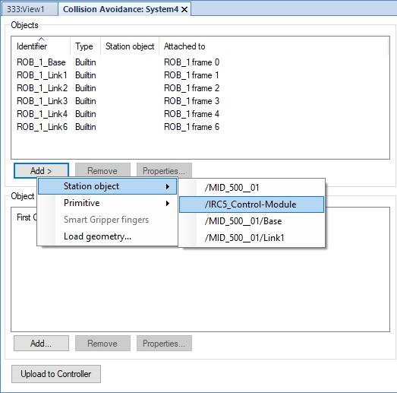

xx1800002593

**To**

**Select**

**the**

**option**

Add

an

existing

object

or

modify

its

properties

Station

object

Add

an

object

and

modify

its

properties

Primitive

Load

geometry

Add a CAD geometry and modify its properties

1. The **Collision Object Properties** dialog box opens, set and modify the **Properties**, **Convex Hull**, and **Position** of the object.
2. Under **Properties**, additional I/O features can be selected and configured.

Activation Any collision object can be configured with an activation signal that signal controls whether the object is *Active* or not. This signal is useful while modelling several tools where only one tool is *Active* at a time. It can also be useful for modelling objects that may be present in the robot cell, such as a pallet.

The signal must correspond to a digital input.

Stop-active Any non-moving collision object can be configured with a stop-active signal signal. This signal determines whether the stopping functionality of the zone is *Active* or not. If the signal is low, then the robot will not stop when it comes in contact with this zone/collision object. The signal must correspond to a digital input.

*Continued*

Any non-moving collision object can be configured with a trigger signal.

The

value

of

the

trigger

signal

indicates

the

robots

that

are

in

contact

with

the

collision

object

at

a

time.

Trigger

sig-

nal

The

value

of

a

trigger

signal

should

be

interpreted

as

a

bit

pattern,

where

bit

*k*

is

high

if

robot

*k*

is

in

contact

with

the

collision

object.

Trigger

signals

can

be

used

to

implement

safe

workspace

sharing

between

multiple

robots.

The

user

can

specify

the

timing

behavior

of

the

signal

in

a

number

of

ways.

The

signal

must

map

to

a

group

signal

in

a

MultiMove

system,

other-

wise

it

can

be

a

digital

output.

5

Click

**OK**

,

to

add

the

object

to

the

**Objects**

list.

**Note**

A

maximum

of

10

objects

can

be

added.

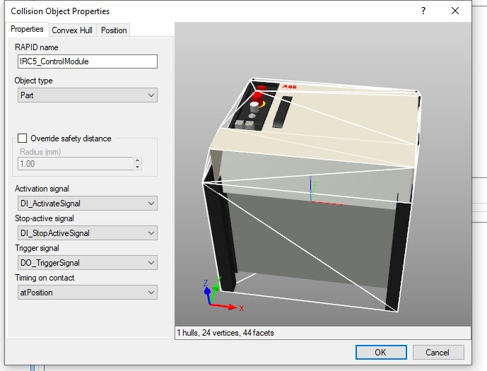

xx1800002592

To easily configure multiple objects, they can be paired.

6.3 Collision Avoidance *Continued*

1. Under **Object Pairs** group, click **Add**, the **Collision Pair properties** dialog box opens.

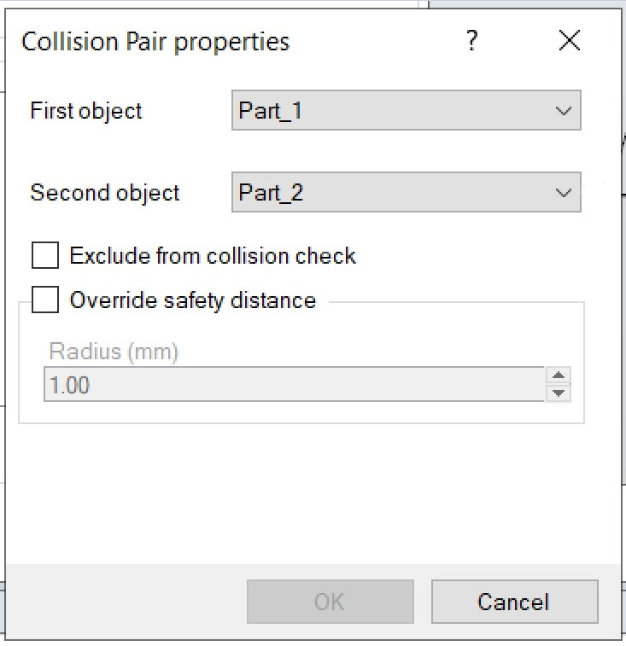

xx1800002594

1. Select the objects to be paired for collision avoidance from their respective drop-down lists.
2. Select the **Exclude from collision check** checkbox, to exclude the paired object from the collision check.
3. Select the **Override safety distance** checkbox, to override the preset safety distance.
4. Click **Ok**, to pair the objects and add it to the **Object Pairs** list.
5. Click **Upload to Controller**, to upload the configuration to the robot controller. Using the **File Transfer** feature a collision avoidance file can be transferred from the **HOME** folder of the *virtual controller* to the robot controller.

**Limitations**

* For RobotWare 6, *Collision Avoidance* is a function included in the option *Collision Detection*.
* Paint robots, IRB 6620LX, and delta robots are not supported.
* *Collision Avoidance* cannot be used in manual mode together with responsive jogging. The system parameter *Jog Mode* must be changed to *Standard*.
* Only stationary/non-moving objects can be configured with a trigger signal. A trigger signal must correspond to a group signal. Furthermore, each collision object must have its own trigger signal.
* There is no support for applications that do corrections to the path, such as conveyor tracking, WeldGuide, Force Control, SoftMove, SoftAct etc.

*Continued*

* The *Collision Avoidance* functionality between 2 robots (or more) can only be achieved when using a MultiMove system.

6.4 I/O Simulation

## 6.4 I/O Simulation

**Setting I/O signals using the I/O Simulator**

The I/O Simulator is used to view and edit I/O signals that are involved in the simulation. Using the I/O simulator window, you can view and manually set existing signals, create lists during program execution, and simulate or manipulate signals. 1 In Monitor group, click **I/O Simulator**. This opens the I/O simulator.

1. If the *station* contains several *virtual controllers*, select the appropriate one in the **Select Controller** list.
2. In the **Filter** list and **I/O Range** list, make selections that display the signals to set. Depending on the filter used, you might also set a filter specification. 4 To change the value of a digital I/O signal, click it.

To change the value of an analog signal, type the new value in the value box.

6.4 I/O Simulation *Continued*

**The I/O Simulator window**

The I/O simulator window displays the signals for one *virtual controller* at a time, in groups of 16 signals. For handling large sets of signals, you can filter which signals to display and also create custom lists with favorite signals for quick access.

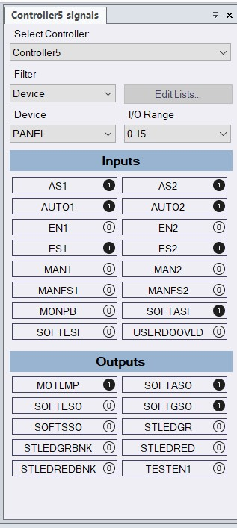

xx2000000008

**Description**

**Part**

**Select**

**System**

.

Select

the

required

virtual

controller

to

view

the

signals.

1

*Continues on next page*

* 1. I/O Simulation

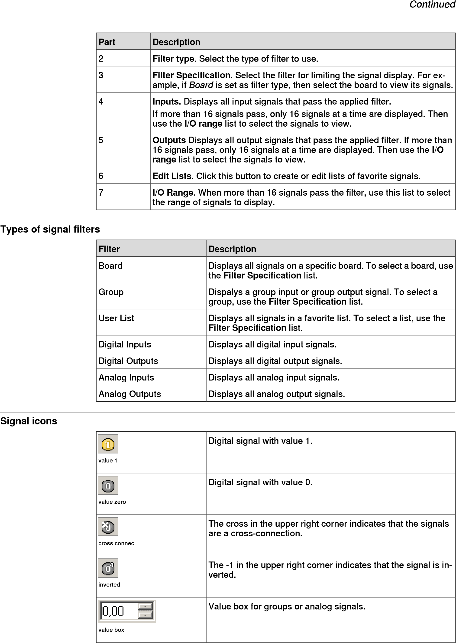

* 1. Simulation time measurement

## 6.5 Simulation time measurement

**Stopwatch for measuring process time**

The Stopwatch feature is used for measuring the time taken between two trigger points in a simulation, and also for the simulation as a whole. The two trigger points are called the Start Trigger and the End Trigger. When a stopwatch is setup, the timer starts when the Start Trigger occurs, and stops when the End Trigger occurs. The status bar shows the simulation time during the simulation.

**Setting up a Stopwatch**

1. On the **Simulation** tab, in the **Monitor** group, click **Stopwatch**.

The Stopwatch settings dialog appears.

1. Click Add button, and specify a **Name** for the stopwatch.
2. Select a **Start Trigger** and an **End Trigger** for the stopwatch.

The following parameters are listed for selection as triggers:

* + - Simulation Start
    - Simulation Stop
    - Target Changed

Additionally, specify the mechanical Unit and the target.

* + - I/O Value

Additionally, specify the source *mechanical unit* from where the signal comes, the type of I/O signal and the value of the signal.

6.6 Understanding TCP trace

## 6.6 Understanding TCP trace

**Overview**

*TCP* trace displays the movement of the robot in a simulation, it traces the movement of the TCP. This data provides an overview of certain parameters. A typical example is using TCP trace to monitor TCP speed. The TCP trace can be colored by the speed of the robot to get the qualitative overview of the variation in speed throughout robot motion. This data can be used to find issues in speed calculations and for optimizing the program.

**Tracing continuous signals**

1. On the **Simulation** tab, in the **Monitor** group, click **TCP Trace**. The **TCP trace** browser opens.
2. Select the robot form the **Robot** drop down option.
3. Select **Enable TCP Trace** check box to enable tracing.
4. Select **Color by signal** check box and then click **..** button. The **Select Signal** dialog opens.
5. Open the **Mechanical Units** node and then select **Speed In Current Wobj** in the **TCP** node and click **OK**.

**Note**

The color assigned to the trace gets displayed when the signal value meets

the

specified

conditions.

1. Select the **Use color scale** box, and enter the values in the **From** and **To** boxes.

**Note**

The **Use color scale** defines how the trace shall be colored. As the signal changes between the values defined in the **From** and **To** boxes, the color of the trace also varies according to the color scale.

1. In the **Simulation Control** group, click **Play** to view the color of the trace when the speed signal is used in the simulation.

**Tracing discrete signals**

1. In the **TCP Trace** browser, select **Enable TCP Trace** check box to enable tracing.
2. Select **Color by signal** check box and then click **..** button. The **Select Signal** dialog opens.
3. Open the **I/O System** node and then select **DRV1K1** in the **DRV_1** node and click **OK**.
4. Select the **Use secondary color:** box and then select high/low in the **when signal is** drop-down.

6.6 Understanding TCP trace

*Continued*

1. In the **Simulation Control** group, click **Play** to view the trace with the change in signal strength.

**Visualizing events along trace**

1. In the **TCP Trace** browser, select **Show events** check box, and then click **Select events** to open the list of events.
2. In **Select events** dialog, select the events that must be monitored. Click **OK**.
3. In the **Simulation Control** group, click **Play**. The selected events gets displayed along trace as *markups* during simulation.

**Visualizing TCP stop positions along the path**

*TCP* stop position indicates the final stopping position of the TCP when a *category 0 stop* or *category 1 stop* occurs.

1. In the **TCP Trace** browser, select **Enable TCP Trace** and **Show stop position** check boxes, and then select category 0 stop or category 1 stop and color.
2. In the **Simulation Control** group, click **Play**, the category 0 or category 1 stop positions are displayed along the path.

Here the TCP trace gets marked in the primary color and the TCP stop positions in the selected color. At regular intervals along the path, programmed TCP positions are connected to the corresponding TCP stop positions with straight lines.

**WARNING**

The measurement and calculation of overall stopping performance for a robot must be tested with its correct load, speed, and tools, in its actual environment, before the robot is taken into production, see *ISO 13855:2010*.

7.1.1 Smart Component

# 7 Advanced RobotStudio simulations

## 7.1 Understanding SmartComponents

### 7.1.1 Smart Component

**Overview**

Smart Components are RobotStudio objects with built-in properties and logic for simulating components that are not part of the *virtual controller*. RobotStudio, by default, offers a set of Base Smart Components for basic motion, signal logic, arithmetic, parametric modeling, sensors and so on.

Base Smart Components can be used to build user defined Smart Components with more complex properties. Some examples are gripper motion, objects moving on conveyors, logic and so on. Smart Components can be saved as library files for reuse.

**Purpose of Smart Components**

Smart Components provide a graphical programming interface for creating complex components that can be part of stations and simulations. RobotStudio provides

Base Smart Components that are required for all possible simulation scenarios. If the property of a certain component is complex and it cannot be simulated by using the Base Smart Components, then code behind can be used. With code behind, it is possible for a developer to program a .NET assembly within the component to customize the *Smart Component*.

**Note**

Refer

http://developercenter.robotstudio.com/robotstudio

for

more

details.

**Accessing the Base Smart Components**

The Smart Component Editor allows you to create, edit, and aggregate Smart Components using a graphical user interface. On the **Modelling** tab, in the **Create** group, click **Smart Component** or right click on the smart component present on the context menu and select **Edit Component**. The **Smart Component Editor** window appears.

It is possible to protect a Smart Component from being edited. To create a *protected smart component*, right-click the smart component, and then click **Protected**. You can also optionally specify a password that will be required to unlock the component for edits.

**Note**

Information

about

Base

Smart

Components

are

listed

against

the

selection

in

the

Smart

Component

editor.

7.1.1 Smart Component *Continued*

**Building blocks of a Smart Component**

**Properties and Bindings**: Properties represent the collection of various parameters that define a *Smart Component*. The property of a Smart Component is significant while designing complex Smart Components from Base Smart Components. Consider the example of the Smart Component, *Line Sensor*, which detects if any object intersects a line between two points.

Properties of *Line Sensor* that are considered in the following example are *Start point, End Point* and *Sensed Part*. Here, the Start and end points set the distance where the *Line Sensor* is in *Active* state. The *Sensed Part* decides which object the *Line Sensor* detects, for example, a box that moves on a belt conveyor.

When the *Line Sensor* senses the box , the property *Sensed Part* detects the box.

If you want the box to be picked by another Smart Component, for example, a *Gripper*, the property of the *Line Sensor* must be connected to the *Gripper* such that it is ready to grip the box. This is achieved using property bindings. Property bindings connect the value of one property to the value of another property.

**Signals**: Signals are the property of the Smart Component that has a value, type and direction (input/output). These signals are analogous to the I/O signals on a robot controller. During simulation, the signal values control the responses of the Smart Component. Connections create a tunnel for information to move from the signal of one component to the a signal of another component.

It is possible to rename Smart Component signals and properties in the **Station Logic Design** tab. To rename a signal, right-click the signal and then click **Properties**, the **Edit** dialog opens, type-in the changes and click **OK**.

**Asset**: These are other files embedded into a Smart Component for perfecting its execution, such as external data files or 3D models.

**State**: State refers to the parameter values of various components in the Smart Component at a given time. These parameters are, I/O Signal value, Property value and so on.

**Grouping signals and properties of Smart Components**

Properties and signals of Smart Components can be organized and combined into groups for a filtered view. This feature is useful when working with complex Smart Components consisting of many properties and signals where similar properties or signals can be categorized into groups.

Use the following procedure to create a group and add properties to the group.

1. In the **Smart Component Editor**, click the **Properties and Bindings** tab and then click **Add Dynamic Property**.
2. In the **Add Dynamic Property** window, enter a valid name in the **Group** box and then click **OK**. A new group gets created in the Smart Component **Properties** browser.
3. To add an existing property to a group, with the property selected, click **Edit** and then in the edit dialog, select the Group and click **OK**.

In the **Smart Component Editor**, click the **Signals and Connectors** tab and then follow the same procedure to create a group for signals and to add signals to groups.

### 7.1.2 Basic Smart Components

**Overview**

The base components represent a complete set of basic building block components. They can be used to build user defined Smart Components with more complex behavior.

**Signals and Properties**

LogicGate

The signal Output is set by the logical operation specified in Operator of the two signals InputAand InputB, with the delay specified in Delay.

**Description**

**Properties**

The

logical

operator

to

use.

Operator

The

following

lists

the

various

operators:

•

AND

•

OR

•

XOR

•

NOT

•

NOP

Time

to

delay

the

output

signal.

Delay

**Description**

**Signals**

The

first

input.

InputA

The

second

input.

InputB

The

result

of

the

logic

operation.

Output

LogicExpression

Evaluates a logic expression.

**Description**

**Properties**

Expression to evaluate. Supports logic oper-

ators AND, OR, NOT, XOR. Input signals are

automatically

added

for

other

identifiers.

Expression

**Description**

**Signals**

Contains

the

result

of

the

evaluation.

Result

LogicMux

Output is set according to: Output = (Input A * NOT Selector) + (Input B * Selector)

**Description**

**Signals**

Set

to

0

to

select

first

input,

1

to

select

second

input.

Selector

Specifies

the

first

input.

InputA

Specifies

the

second

input.

InputB

Specifies

the

result

of

the

operation.

Output

LogicSplit

The LogicSplit takes Input and sets OutputHigh to the same as Input, and OutputLow as the inverse of Input.

PulseHigh sends a pulse when Input is set to high, and PulseLow sends a pulse when Input is set to low.

**Description**

**Signals**

Specifies

the

input

signal.

Input

Goes

high

(1)

when

input

is

1.

OutputHigh

Goes

high

(1)

when

input

is

0.

OutputLow

Sends

pulse

when

input

is

set

to

high.

PulseHigh

Sends

pulse

when

input

is

set

to

low.

PulseLow

LogicSRLatch

TheLogicSRLatch has one stable state.

* When Set=1, Output=1 and InvOutput=0
* When Reset=1, Output=0 and InvOutput=1

**Description**

**Properties**

Specifies

the

X-value

of

Vector.

X

**Description**

**Signals**

Sets

the

output

signal.

Set

Resets

the

output

signal.

Reset

Specifies

output

signal.

Output

Specifies

Inverse

output

signal.

InvOutput

Converter

Converts between property values and signal values.

**Description**

**Properties**

Converts

to

AnalogOutput.

AnalogProperty

Converts

to

DigitalOutput.

DigitalProperty

Converts

to

GroupOutput.

GroupProperty

Converts

from

DigitalInput

and

to

DigitalOutput.

BooleanProperty

**Description**

**Signals**

Converts

to

DigitalProperty.

DigitalInput

Converted

from

DigitalProperty.

DigitalOutput

Converts

to

AnalogProperty.

AnalogInput

Converted

from

AnalogProperty.

AnalogOutput

Converts

to

GroupProperty.

GroupInput

Converted

from

GroupProperty.

GroupOutput

VectorConverter

Converts between Vector3 and X, Y,and Z values.

**Description**

**Properties**

Specifies

the

Y-value

of

Vector.

Y

Specifies

the

Z-value

of

Vector

Z

Specifies

the

vector

value.

Vector

Expression

The Expression consists of numeric literals (including PI), parentheses, mathematical operators +,-,*,/,^ (power) and mathematical functions sin, cos, sqrt, atan, abs. Any other strings are interpreted as variables, which are added as additional properties. The result is displayed in Result.

**Description**

**Signals**

Specifies

the

expression

to

evaluate.

Expression

Specifies

the

result

of

evaluation.

Result

Comparer

The Comparer compares First value with Second value, using Operator. Output is set to 1 if the condition is met.

**Description**

**Properties**

Specifies

the

first

value.

ValueA

Specifies

the

second

value.

ValueB

Specifies

the

comparison

operator.

Operator

The

following

lists

the

various

operators:

•

==

•

!=

•

>

•

>=

•

<

•

<=

**Description**

**Signals**

Goes

high

(1)

if

the

comparison

evaluates

to

true.

Output

Counter

Count is increased when the input signal Increase is set, and decreased when the input signal Decrease is set. Count is reset when the input signal Reset is set.

**Description**

**Properties**

Specifies

the

current

count.

Count

**Description**

**Signals**

Set

to

high

(1)

to

increase

the

count.

Increase

Set

to

high

(1)

to

decrease

the

count.

Decrease

Set

to

high

(1)

to

reset

the

count

to

zero.

Reset

Repeater

Pulses Output signal Count number of times.

**Description**

**Properties**

Number

of

times

to

pulse

Output.

Count

**Description**

**Signals**

Set

to

high

(1)

to

pulse

Output

Count

times.

Execute

Output

pulse.

Output

Timer

The Timer pulses the Output signal based on the given interval.

If Repeat is unchecked, one pulse will be triggered after the time specified in Interval. Otherwise, the pulse will be repeated at the interval given by Interval.

###### Properties Description

StartTime Specifies the time to pass before the first pulse.

Interval Specifies the simulation time between the pulses.

Repeat Specifies if the signal should be pulsed repeatedly or only once.

Current time Specifies the current simulation time.

###### Signals Description

Active Set to high (1) to activate the timer.

Output Goes high (1) and then low (0) at the specified interval.

Reset Set to high (1) to reset the current time.

StopWatch

The StopWatch measures time during simulation (TotalTime). A new lap can be started by triggering the Lap input signal. LapTime shows the current lap time. The time is only measured when Active is set to 1. The times are reset when the input signal Reset is set.

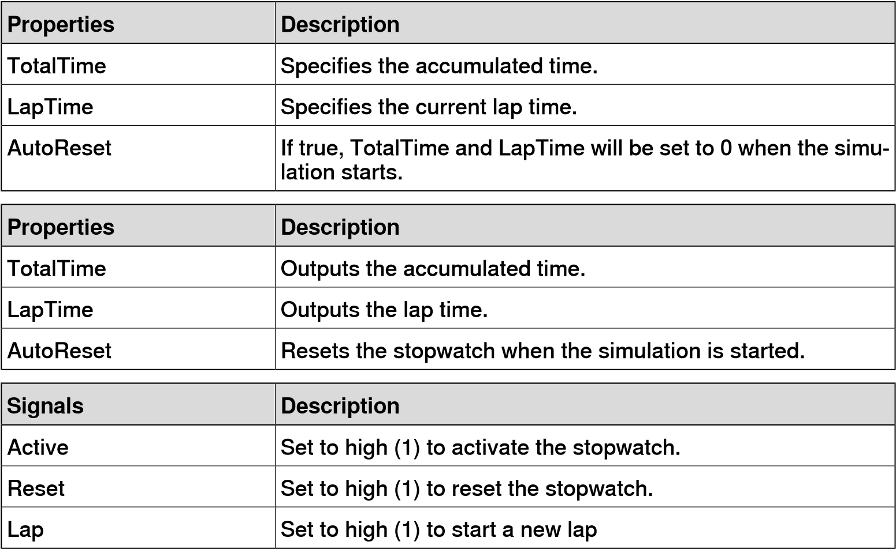

MultiTimer

The Timer pulses digital signals at specified times during simulation.

**Description**

**Properties**

Specifies

the

number

of

signals.

Count

Outputs

the

current

time.

CurrentTime

Time

when

the

corresponding

output

is

pulsed.

Time1

**Description**

**Signals**

Set

to

high

(1)

to

activate

the

timer.

Active

Set

to

high

(1)

to

reset

the

current

time.

Reset

Goes

high

(1)

and

then

low

(0)

at

the

specified

time.

Output1

StringFormatter

Formats a string from input properties.

**Description**

**Properties**

Format string. Supports variables like {id:type}, where type can

be

d

(

double),

i

(

int),

s

(

string),

o

(

object

).

Format

Formatted

string.

Result

**Parametric Primitives**

ParametricBox

The ParametricBox generates a box with dimensions specified by length, width, and height.

###### Properties Description

SizeX Specifies the length of the box in the X-axis direction. SizeY Specifies the length of the box in the Y-axis direction.

SizeZ Specifies the length of the box in the Z-axis direction GeneratedPart Specifies the generated part.

KeepGeometry False to remove the geometry data from the generated part. This can make other components such as Source execute faster.

###### Signals Description

Update Set to high (1) to update the generated part.

ParametricCylinder

The ParametricCylinder generates a cylinder with the dimensions given by Radius

and

Height.

**Description**

**Properties**

Specifies

the

radius

of

the

cylinder.

Radius

Specifies

the

height

of

the

cylinder.

Height

Specifies

the

generated

part.

GeneratedPart

**Description**

**Properties**

False

to

remove

the

geometry

data

from

the

generated

part.

This

can

make

other

components

such

as

Source

execute

faster.

KeepGeometry

**Description**

**Signals**

Set

to

high

(1)

to

update

the

generated

part.

Update

ParametricLine

The ParametricLine generates a line with a given end point or a given length. If either of them is changed, the other one will be updated accordingly.

**Description**

**Properties**

Specifies

the

end

point

for

the

line.

EndPoint

Specifies

the

length

of

the

line.

Length

Specifies

the

generated

part.

GeneratedPart

Specifies

the

generated

wire

object.

GeneratedWire

False

to

remove

the

geometry

data

from

the

generated

part.

This

can

make

other

components

such

as

Source

execute

faster.

KeepGeometry

**Description**

**Signals**

Set

to

high

(1)

to

update

the

generated

part.

Update

ParametricCircle

The ParametricCircle generates a circle with a given radius.

**Description**

**Properties**

Specifies

the

radius

of

the

circle.

Radius

Specifies

the

generated

part.

GeneratedPart

Specifies

the

generated

wire

object.

GeneratedWire

False

to

remove

the

geometry

data

from

the

generated

part.

This

can

make

other

components

such

as

Source

execute

faster

KeepGeometry

**Description**

**Signals**

Set

to

high

(1)

to

update

the

generated

part.

Update

LinearExtrusion

The LinearExtrusion extrudes SourceFace or SourceWire along the vector given

by

Projection.

**Description**

**Properties**

Specifies

the

face

to

extrude.

SourceFace

Specifies

the

wire

to

extrude.

SourceWire

Specifies

the

vector

to

extrude

along.

Projection

Specifies

the

generated

part.

GeneratedPart

###### Properties

KeepGeometry False to remove the geometry data from the generated part. This can make other components such as Source execute faster.

###### Signals Description

Update Set to high (1) to update the generated part.

LinearRepeater

The LinearRepeater creates a number of copies of Source, with the spacing and direction given by Offset.

**Description**

**Properties**

Specifies

the

object

to

copy.

Source

Specifies

the

distance

between

copies.

Offset

Specifies

the

distance

between

the

copies.

Distance

Specifies

the

number

of

copies

to

create.

Count

MatrixRepeater

The MatrixRepeater creates a specified number of copies in three dimensions, with the specified spacing of the object in Source.

###### Properties Description

Source Specifies the object to copy.

CountX Specifies the number of copies in the X-axis direction. CountY Specifies the number of copies in the Y-axis direction.

CountZ Specifies the number of copies in the Z-axis direction.

OffsetX Specifies the offset between the copies in the X-axis direction.

OffsetY Specifies the offset between the copies in the Y-axis direction. OffsetZ Specifies the offset between the copies in the Z-axis direction.

CircularRepeater

The CircularRepeater creates a number of given copies of Source around the center of the SmartComponent with a given DeltaAngle.

**Description**

**Properties**

Specifies

the

object

to

copy.

Source

Specifies

the

number

of

copies

to

create.

Count

Specifies

the

radius

of

the

circle.

Radius

Specifies

the

angle

between

the

copies.

DeltaAngle

**Sensors**

CollisionSensor

The CollisionSensor detects collisions and near miss events between the First object and the Second object. If one of the objects is not specified, the other will be checked against the entire station. When the Active signal is high and a collision or a near miss event occurs and the component is active, the SensorOut signal is set and the parts that participate in the collision or near miss event are reported in the first colliding part and second colliding partof the Property editor.

**Description**

**Properties**

The

first

object

to

check

for

collisions.

Object1

The

second

object

to

check

for

collisions.

Object2

Specifies

the

near

miss

distance.

NearMiss

The

part

of

First

object

that

has

a

collision.

Part1

The

part

of

Second

object

that

has

a

collision.

Part2

•

None

•

Near

miss

•

Collision

CollisionType

**Description**

**Signals**

Set

to

high

(1)

to

activate

the

sensor.

Active

Goes

high

(1)

when

a

collision

or

near

miss

occurs.

SensorOut

LineSensor

The LineSensor defines a line by the Start, End, and Radius. When an Active signal is high, the sensor detects objects that intersect the line. Intersecting objects are displayed in the ClosestPart property and the point on the intersecting part that is closest to the line sensors start point is displayed in the ClosestPoint property. When intersection occurs the SensorOut output signal is set.

**Properties Description** Start Specifies the start point.

End Specifies the end point.

Radius Specifies the radius.

SensedPart Specifies the part that intersects the line sensor.

If several parts intersect, then the part that is closest to the Start point is listed.

SensedPoint Specifies the point on the intersecting part, closest to the Start point.

Length Specifies the distance between the sensor start and end points.

The Length property can be used to adjust the length of the sensor after the direction has been specified with the start and end points. When the Length property is changed, the end point is updated accordingly along the direction of the sensor automatically.

Tag When a tag is specified, the sensor detects only objects with

the same tag.

###### Signals

Active Set to 1 to activate the sensor.

SensorOut Goes high (1) when an object intersects the line.

PlaneSensor

The PlaneSensor defines a plane by Origin, Axis1, and Axis2. When the Active input signal is set the sensor detects objects that intersect this plane. Intersecting objects are displayed in the SensedPart property and when intersection occurs the SensorOut output signal is set.

**Description**

**Properties**

Specifies

the

origin

of

the

plane.

Origin

Specifies

the

first

axis

of

the

plane.

Axis1

Specifies

the

second

axis

of

the

plane.

Axis2

Specifies

the

part

that

intersects

the

PlaneSensor.

SensedPart

If

several

parts

intersect,

then

the

one

listed

first

in

the

Layout

browser

is

selected.

When

a

tag

is

specified,

the

sensor

detects

only

objects

with

the

same

tag.

Tag

**Description**

**Signals**

Set

to

high

(1)

to

activate

the

sensor.

Active

Goes

high

(1)

when

an

object

intersects

the

plane.

SensorOut

VolumeSensor

The VolumeSensor detects objects that are inside or partly inside a box-shaped volume. The volume is defined by a Corner Point, the Length, Height, and Width of the sides and the orientation angles.

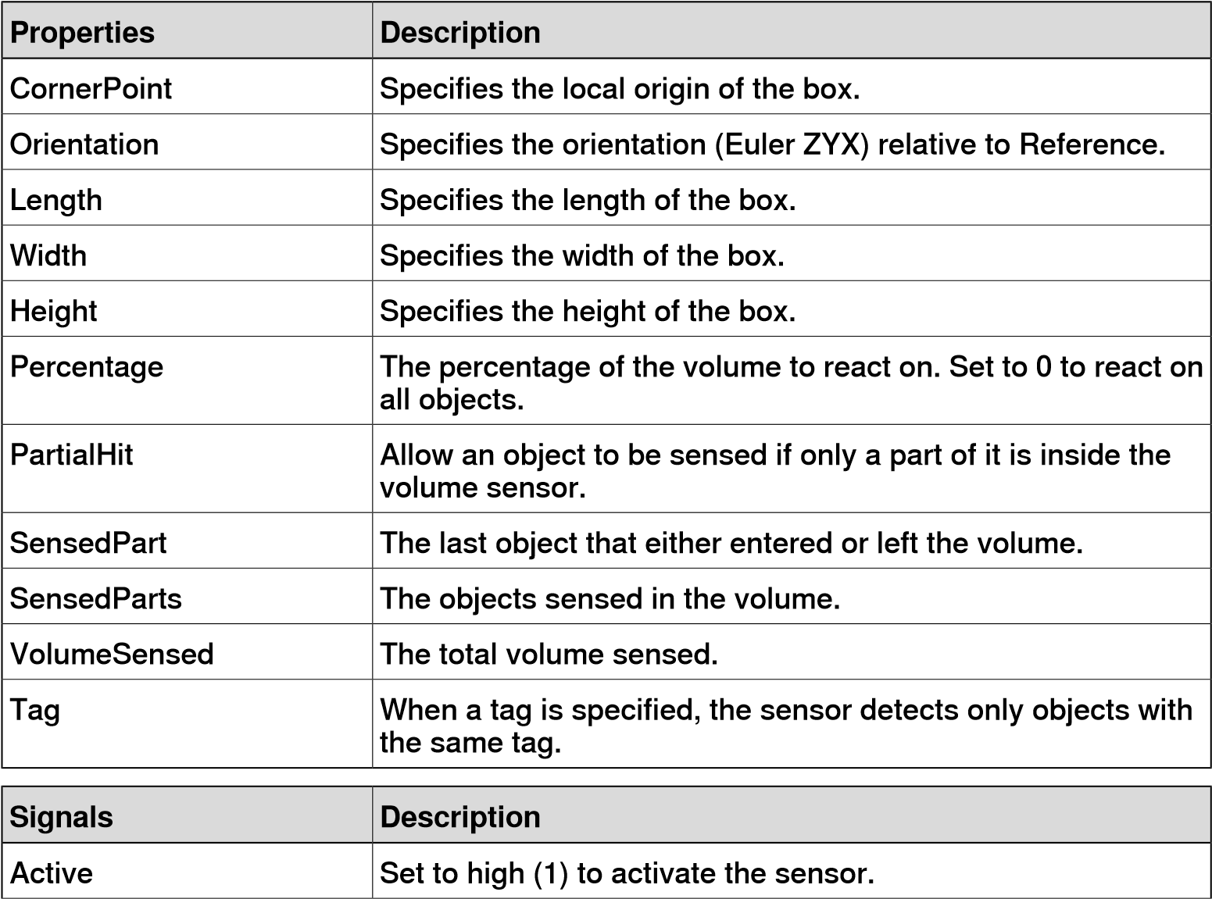

###### Signals

SensorOut Goes high (1) when an object is detected.

PositionSensor

The PositionSensor monitors the position and orientation of an object.

The position and orientation of an object is updated only during the simulation.

###### Properties Description

Object Specifies the object to monitor.

Reference Specifies the reference coordinate system (Parent or Global).

ReferenceObject Specifies the reference object, if Reference is set to Object.

Position Specifies the position of the object relative to Reference.

Orientation Specifies the orientation (Euler ZYX) relative to Reference.

###### Signals Description

SensorOut Goes high (1) when Position or Orientation have changed.

ClosestObject

The ClosestObject defines a Reference object or a Reference point. When the

Execute signal is set, the component finds the ClosestObject, ClosestPart, and the Distance to the reference object, or to the reference point if the reference object is undefined. If RootObject is defined, the search is limited to that object and its descendants. When finished and the corresponding properties are updated the Executed signal is set.

###### Properties Description

ReferenceObject Specifies the object to get the closest object to.

ReferencePoint Specifies the point to get the closest object to.

RootObject Specifies the object whose children to search.

Empty means entire station.

ClosestObject Specifies the object closest to Reference object or Reference

point.

ClosestPart Specifies the part closest to Reference object or Reference

point.

Distance Specifies the distance between the Reference object and the Closest object.

###### Signals Description

Execute Set to high (1) to set find the closest object.

Executed Goes high (1) when the operation is completed.

JointSensor

Monitors mechanism joint values during simulation

**Description**

**Properties**

Specifies

the

mechanism

to

monitor.

Mechanism

###### Signals Update

Set

to

high

(1)

to

update

the

joint

values.

GetParent

The GetParent returns the parent object of the input object. The executed signal is triggered if a parent is found.

**Description**

**Properties**

Specifies

the

object

to

whose

parent

is

to

be

found.

Child

Specifies

the

parent

of

the

child

Parent

**Note**

The

**Child**

list

for

**Properties:GetParent**

does

not

show

every

part

or

object

in

the station. However, if you do not find the required part or object in the list, then

add

it

from

the

browser

or

graphic

window

by

clicking

it.

**Actions**

Attacher

The Attacher will attach Child to Parent when the Execute signal is set. If the Parent is a mechanism, the Flange to attach to must also be specified. When the input Execute is set, the child object is attached to the parent object. If Mount is checked, the child will also be mounted on the parent, with the Offset and Orientation specified. The output Executed will be set when finished.

**Description**

**Properties**

Specifies

the

object

to

detach.

Child

**Description**

**Properties**

Specifies

the

object

to

attach

to.

Parent

Specifies

the

Index

of

mechanism

flange

to

attach

to.

Flange

Specifies

the

object

to

attach.

Child

If

true,

the

object

to

attach

mounts

on

the

attachment

parent.

Mount

Specifies

the

position

relative

to

the

attachment

parent

when

using

Mount.

Offset

Specifies the orientation relative to the attachment parent when

using

Mount.

Orientation

**Description**

**Signals**

Set

to

high

(1)

to

create

the

attachment.

Execute

Goes

high

(1)

when

the

operation

is

complete.

Executed

Detacher

The Detacher will detach the Child from the object it is attached to when the Execute signal is set. If Keep position is checked, the position will be kept. Otherwise the child is positioned relative to its parent. When finished, the Executed signal will be set.

###### Properties

KeepPosition If false, the attached object is returned to its original position.

**Description**

**Signals**

Set

to

high

(1)

to

remove

the

attachment.

Execute

Goes

high

(1)

when

the

operation

is

complete.

Executed

Source

The Source property of the source component indicates the object that should be cloned when the Execute input signal is received. The parent of the cloned objects is specified by the Parent property and a reference to the cloned object is specified by the Copy property. The output signal Executed signifies that the clone is complete.

**Properties Description** Source Specifies the object to copy.

Copy Specifies the copied object.

Parent Specifies the parent to the copy.

If not specified, the copy gets the same parent as the source.

Position Specifies the position of the copy relative its parent.

Orientation Specifies the orientation of the copy relative its parent.

Transient Marks the copy as transient if created during simulation. Such copies are not added to the undo queue and are automatically deleted when the simulation is stopped. This is used to avoid increased memory consumption during simulation.

PhysicsBehavior Specifies the physics behavior of the copy.

###### Signals Description

Execute Set to high (1) to create the copy.

Executed Goes high (1) when the operation is complete.

Sink

The Sink deletes the object referenced by the Object property. Deletion happens when the Execute input signal is received. The Executed output signal is set when the deletion is finished.

**Description**

**Properties**

Specifies

the

object

to

remove.

Object

**Description**

**Signals**

Set

to

high

(1)

to

remove

the

object.

Execute

Goes

high

(1)

when

the

operation

is

complete.

Executed

Show

When the Execute signal is set, the object referenced in Object appears. When finished, Executed signal will be set.

**Description**

**Properties**

Specifies

the

object

to

show.

Object

**Description**

**Signals**

Set

to

True

to

show

the

object.

Execute

Sends

a

pulse

when

completed.

Executed

Hide

When the Execute signal is set, the object referenced in Object will be hidden. When finished, Executed signal will be set.

**Description**

**Properties**

Specifies

the

object

to

hide.

Object

**Description**

**Signals**

Set

to

True

to

hide

the

object.

Execute

Sends

a

pulse

when

completed.

Executed

SetParent

Sets the parent of a graphic component.

**Description**

**Properties**

The

graphic

component

whose

parent

is

to

be

set.

Child

New

parent.

Parent

To

keep

the

position

and

orientation

of

the

child

object.

KeepTransform

**Description**

**Signals**

Set

to

high

(1)

to

move

the

child

object

to

the

new

parent.

Execute

**Manipulators**

LinearMover

The LinearMover moves the object referenced in the Object property with a speed given by the Speed property in the direction given by the Direction property. The motion starts when the Execute input signal is set and stops when Execute is reset.

###### Properties Description

Object Specifies the object to move.

Direction Specifies the direction to move the object.

Speed Specifies the speed of movement.

Reference Specifies the coordinate system in which values are specified. It can be Global, Local, or Object.

ReferenceObject Specifies the reference object, if Reference is set to Object.

###### Signals

Execute Set to high (1) to start moving the object.

LinearMover2

The LinearMover moves an object a specified distance.

**Description**

**Properties**

Specifies

the

object

to

move.

Object

Specifies

the

direction

to

move

the

object.

Direction

Specifies

the

distance

to

move

the

object.

Distance

Specifies

the

time

for

the

movement.

Duration

Specifies the coordinate system in which values are specified.

It

can

be

Global,

Local,

or

Object.

Reference

Specifies

the

Reference

object.

ReferenceObject

**Description**

**Signals**

Set

to

high

(1)

to

start

the

movement.

Execute

Goes

high

(1)

during

the

movement.

Executing

Goes

high

(1)

when

the

movement

is

completed.

Executed

Rotator

The Rotator rotates the object referenced in the Object property with an angular speed given by the Speed property. The axis of rotation is given by CenterPoint and Axis. The motion starts when the Execute input signal is set and stops when the Execute is reset.

**Description**

**Properties**

Specifies

the

object

to

rotate.

Object

Specifies

the

point

to

rotate

around.

CenterPoint

Specifies

the

axis

of

the

rotation.

Axis

Specifies

the

speed

of

the

rotation.

Speed

Specifies the coordinate system in which values are specified.

It

can

be

Global,

Local,

or

Object.

Reference

Specifies the object which are relative to CenterPoint and Axis,

if

Reference

is

set

to

Object.

ReferenceObject

**Description**

**Signals**

Set

to

high

(1)

to

start

rotating

the

object.

Execute

Rotator2

The Rotator rotates an object a specified angle around an axis.

**Description**

**Properties**

Specifies

the

object

to

rotate.

Object

Specifies

the

point

to

rotate

around.

CenterPoint

Specifies

the

axis

of

the

rotation.

Axis

Specifies

the

angle

to

rotate

Angle

**Description**

**Properties**

Specifies

the

time

for

the

movement.

Duration

Specifies the coordinate system in which values are specified.

It

can

be

Global,

Local,

or

Object.

Reference

Specifies

the

Reference

object.

ReferenceObject

**Description**

**Signals**

Set

to

high

(1)

to

start

the

movement.

Execute

Goes

high

(1)

during

the

movement.

Executing

Goes

high

(1)

when

the

movement

is

completed.

Executed

PoseMover

The PoseMover has a Mechanism, a Pose, and Duration as properties. When the Execute input signal is set the mechanism joint values are moved to the given pose. When the pose is reached the Executed output signal is set.

**Description**

**Properties**

Specifies

the

mechanism

to

move

to

a

pose.

Mechanism

Specifies

the

Index

of

the

pose

to

move

to.

Pose

Specifies

the

time

for

the

mechanism

to

move

to

the

pose.

Duration

**Description**

**Signals**

Set

to

True,

to

start

or

resume

moving

the

mechanism.

Execute

Pauses

the

movement.

Pause

Cancels

the

movement.

Cancel

Pulses

high

when

the

mechanism

has

reached

the

pose.

Executed

Goes

high

during

the

movement.

Executing

Goes

high

when

paused.

Paused

JointMover

The JointMover has a Mechanism, a set of Joint Values and a Duration as properties. When the Execute input signal is set the mechanism joint values are moved to the given pose. When the pose is reached the Executed output signal is set. The GetCurrent signal retrieves the current joint values of the mechanism.

**Description**

**Properties**

Specifies

the

mechanism

to

move

to

a

pose.

Mechanism

Specifies

if

J1-Jx

are

relative

to

the

start

values,

rather

than

absolute

joint

values.

Relative

Specifies

the

time

for

the

mechanism

to

move

to

the

pose.

Duration

**Description**

**Signals**

Retrieve

current

joint

values.

GetCurrent

Set

to

True

to

start

moving

the

mechanism.

Execute

Pauses

the

movement

Pause

Cancels

the

movement

Cancel

Pulses high when the mechanism has reached the pose.

**Signals**

Executed

Executing

Goes

high

when

paused.

Paused

Goes high during the movement.

Positioner

The Positioner takes an Object, Position, and Orientation as properties. When the Execute signal is set the object is repositioned in the given position relative to the Reference. When finished the Executed output is set.

###### Properties Description

Object Specifies the object to position.

Position Specifies the new position of the object.

Orientation Specifies the new orientation of the object.

Reference Specifies the coordinate system in which values are specified. It can be Global, Local, or Object.

ReferenceObject Specifies the object which are relative to Position and Orientation, if Reference is set to Object.

###### Signals Description

Execute Set to high (1) to set the position.

Executed Goes high (1) when the operation is completed.

MoveAlongCurve

Moves an object along a geometric curve (using a constant offset).

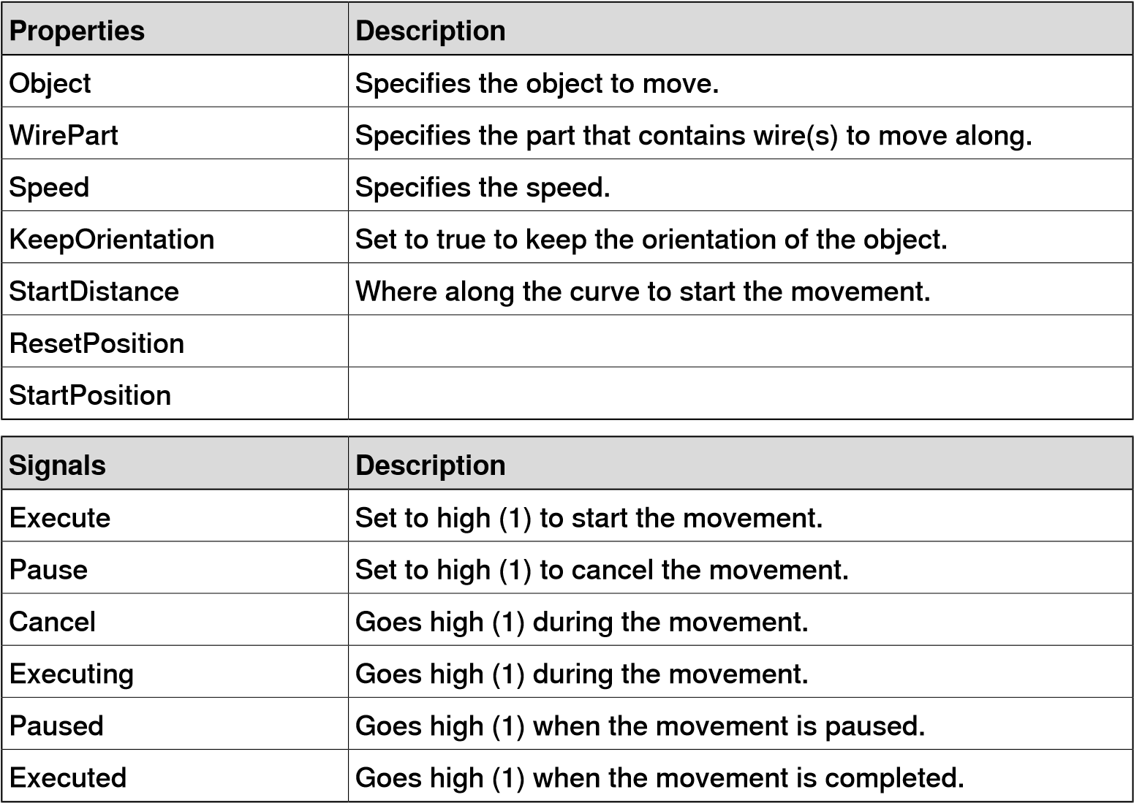

**Controller**

RapidVariable

Sets or gets the value of a RAPID variable.

**Description**

**Properties**

RAPID datatype of the variable to get or set (bool, num, dnum,

string,

pos,

orient,

or

pose)

DataType

The

virtual

controller

that

contains

the

variable.

Controller

The

RAPID

task

that

contains

the

variable.

Task

The

RAPID

module

in

which

the

variable

is

defined.

Module

The

name

of

the

RAPID

variable

Variable

The

variable

value

and

the

type

depends

on

DataType.

Value

**Description**

**Signals**

Set

to

high

(1)

to

get

the

value.

Get

Set

to

high

(1)

to

set

the

value.

Set

Is

pulsed

when

the

value

is

updated.

Executed

**Physics**

PhysicsControl

Controls the physics related properties of parts or component groups.

**Description**

**Properties**

Specifies

the

object

to

control.

Object

Determines the behavior of the object in the physics simulation.

Behavior

Sets

the

surface

velocity.

Surface

Velocity

**Description**

**Signals**

Set

to

high

(1)

to

enable

physics

behavior.

Enabled

Set

to

high

(1)

to

enable

surface

velocity.

SurfaceVelocityEnabled

PhysicsJointControl

Controls properties of a physics joint.

**Description**

**Properties**

Sets

the

speed

of

a

motorized

joint.

MotorSpeed

The

joint

to

control.

Joint

**Description**

**Signals**

Enables

or

disables

the

joint

motor.

MotorEnabled

**PLC**

OpcUaClient

An OPC UA client.

###### Properties Description

ServerAddress The IP address and the port number to the OPC UA server.

UseSecurity Enables encrypted connection and requires a trusted server

certificate.

AutoConnect Enables automatic connection when loading the station and

after a connection failure.

Blocking When enabled the simulation will wait for the OPC UA commu-

nication to complete in each time step.

Authentication Enables choosing authentication type for connecting to the OPC UA server.

Following signals are available as commands in the context menu.

###### Commands Description

Connect Connect to the OPC UA server.

Disconnect Disconnect from the OPC UA server.

ChangeUser Connect to the OPC UA server with a different user.

Configure Configure the mapping between OPC UA server nodes and

RobotStudio signals.

ImportConfiguration Import the mapping between OPC UA server nodes and Robot-

Studio signals.

ExportConfiguration Export the mapping between OPC UA server nodes and RobotStudio signals.

SIMITConnection

Siemens

SIMIT

connection

via

Shared

Memory.

**Description**

**Properties**

SIMIT

Shared

Memory

name.

SharedMemoryName

Following

signals

are

available

as

commands

in

the

context

menu.

**Description**

**Commands**

Connect

to

SIMIT.

Connect

Disconnect

from

SIMIT.

Disconnect

**Virtual**

**Reality**

VrHandController

A component that moves with a hand controller in VR

**Description**

**Properties**

Left

or

right

hand.

Hand

Selects

if

the

tip

or

the

base

of

the

hand

controller

is

tracked.

TrackTip

**Description**

**Signals**

Goes

to

high

(1)

when

the

primary

trigger

is

pressed.

TriggerDown

VrSession

Adds custom buttons to a VR menu pane, and signals when the user exits or enters VR

**Description**

**Properties**

Number

of

commands

to

add.

NumCommands

**Description**

**Signals**

Pulsed

when

the

user

starts

VR.

SessionStarted

Pulsed

when

the

user

exits

VR.

SessionEnded

VrTeleporter

Teleports the VR user to the location of the component

**Description**

**Signals**

Set

to

high

(1)

to

execute

the

teleport.

Execute

**Other**

Queue

The Queue represents a FIFO (first in, first out) queue. The object in Back is added to the queue when the signal Enqueue is set. The front object of the queue is shown in Front. The object in Front is removed from the queue when the signal Dequeue is set. If there are more objects in the queue, the next object is shown in Front. All objects in the queue are removed from the queue when the signal Clear is set.

If a transformer component (such as LinearMover) has a queue component as its Object, it will transform the contents of the queue, rather than the queue itself.

Specifies the object to enqueue.

**Description**

**Properties**

Back

Specifies

the

first

object

in

queue.

Front

Specifies

the

number

of

objects

in

the

queue.

NumberOfObjects

**Description**

**Signals**

Adds

the

object

in

Back

to

the

end

of

the

queue.

Enqueue

Removes

the

object

in

Front

from

the

queue.

Dequeue

Removes

all

objects

from

the

queue.

Clear

Removes

the

object

in

Front

from

the

queue

and

from

the

sta-

tion.

Delete

Clears

the

queue

and

removes

all

objects

from

the

station

DeleteAll

ObjectComparer

Sets a digital signal as a result of an object comparison. Determines if ObjectA is the same as ObjectB.

**Description**

**Properties**

Specifies

the

first

object

to

compare.

ObjectA

Specifies

the

second

object

to

compare.

ObjectB

**Description**

**Signals**

Goes

high

(1)

if

the

objects

are

equal.

Output

GraphicSwitch

Switches between two parts, either by clicking on the visible part in the graphics or by setting and resetting the input signal.

**Description**

**Properties**

Displayed

when

the

signal

is

high.

PartHigh

Displayed

when

the

signal

is

low.

PartLow

**Description**

**Signals**

Input

signal.

Input

Output

signal

high

(1)

when

PartHigh

is

displayed,

and

low

(0)

when

PartLow

is

displayed.

Output

Highlighter

The Highlighter temporarily sets the color of the Object to the RGB-values specified in Color. The color is blended with the original color of the objects as defined by Opacity When the signal Active is reset, Object gets its original colors.

**Description**

**Properties**

Specifies

the

object

to

highlight.

Object

Specifies

the

RGB-values

of

the

highlight

color.

Color

Specifies

the

amount

to

blend

with

the

object's

original

color

(0-255).

Opacity

**Description**

**Signals**

Set to high (1) to change the color, low (0) to restore the original

color.

Active

MoveToViewPoint

Moves to the selected viewpoint in the given time, when the input signal Execute is set. The output signal Executed is set when the operation is completed.

**Description**

**Properties**

Specifies

the

viewpoint

to

move

to.

Viewpoint

Specifies

the

time

to

complete

the

operation.

Time

**Description**

**Signals**

Set

to

high

(1)

to

start

the

operation.

Execute

Goes

high

(1)

when

the

operation

is

completed.

Executed

Logger

Prints a message in the output window.

**Description**

**Properties**

Format

string.

Format

Supports variables like {id:type}, where type can be d (double),

i

int),

(

s

string),

(

o

(

object

)

Formatted

message.

Message

Message

severity:

0

Information),

(

1

Warning),

(

2

(

Error

).

Severity

**Description**

**Signals**

Set

to

high

(1)

to

print

the

message.

Execute

SoundPlayer

Plays the sound specified by Sound Asset when the input signal Execute is set.

The asset must be a .wav file

**Description**

**Properties**

Specifies

the

sound

file

that

should

be

played.

Must

be

a

.wav

file.

SoundAsset

Set

to

true

to

loop

the

sound.

Loop

**Description**

**Signals**

Set

to

high

(1)

to

play

the

sound.

Execute

Goes

high

(1)

when

the

sound

is

played.

Executed

Set

to

high

(1)

to

stop

playing.

Stop

Random

Random generates a random number between Min and Max in Value when Execute is triggered.

**Description**

**Properties**

Specifies

minimum

value.

Min

Specifies

maximum

value.

Max

Specifies

a

random

number

between

Min

and

Max.

Value

**Description**

**Signals**

Set

to

high

(1)

to

generate

a

new

random

number.

Execute

Goes

high

(1)

when

the

operation

is

completed.

Executed

StopSimulation

Stop a running simulation when the input signal Execute is set.

**Description**

**Signals**

Set

to

high

(1)

to

stop

the

simulation.

Execute

TraceTCP

Enables or disables TCP trace for a robot.

**Description**

**Properties**

Specifies

the

robot

to

trace.

Robot

**Description**

**Signals**

Set

to

high

(1)

to

enable

TCP

trace.

Enabled

Set

to

high

(1)

to

clear

the

TCP

trace.

Clear

SimulationEvents

Pulses signals when the simulation starts and stops.

**Description**

**Signals**

Pulsed

when

the

simulation

starts.

SimulationStarted

Pulsed

when

the

simulation

stops.

SimulationStopped

LightControl

Controls a light source.

**Description**

**Properties**

Specifies

the

light

source.

Light

Sets

the

color

of

the

light.

Color

Enables

the

light

to

cast

shadows.

CastShadows

Sets

the

ambient

intensity

of

the

light.

AmbientIntensity

Sets

the

diffuse

intensity

of

the

light.

DiffuseIntensity

Sets

the

specular

intensity

of

the

light.

HighlightIntensity

Sets

the

angle

of

the

spotlight

cone.

SpotAngle

Sets

the

maximum

range

of

the

light.

Range

**Description**

**Signals**

Enables

or

disables

the

light

source.

Enabled

MarkupControl

Controls properties of graphical Markup.

**Description**

**Properties**

Specifies

the

Markup

to

control.

Markup

Specifies

text

on

the

markup.

Text

True

if

the

markup

is

visible.

Visible

Specifies

the

position

of

the

markup

arrow.

Position

Specifies

the

background

color

of

the

markup.

BackColor

Specifies

the

text

color

of

the

markup.

ForeColor

Specifies

the

text

size

of

the

markup.

FontSize

If

true

the

markup

will

not

be

obscured

by

other

objects.

Topmost

###### Signals Description

GetValues Set to high (1) retrieve property values for the selected Markup.

ApplicationWindowPanel

Controls a light source.

**Description**

**Properties**

Specifies

the

name

of

the

application

executable

to

capture.

ApplicationName

Title

of

the

main

window

to

capture.

ApplicationTitle

Panel

width.

Width

Panel

height.

Height

Pixels

to

clip

from

the

left

edge.

ClipLeft

Pixels

to

clip

from

the

right

edge.

ClipRight

Pixels

to

clip

from

the

top

edge.

ClipTope

Pixels

to

clip

from

the

bottom

edge.

ClipBottom

ColorTable

Stores a list of colors.

**Description**

**Properties**

Specifies

the

number

of

colors

in

the

list.

NumColors

The

index

of

the

currently

selected

color

in

the

list.

SelectedColorIndex

The

currently

selected

color.

SelectedColor

Color0

Color1

ConveyorControl

Controls a Conveyor with I/O signals.

**Description**

**Properties**

Specifies

the

Conveyor

to

control.

Conveyor

**Description**

**Signals**

Stops

the

conveyor.

Stop

Sets

the

velocity

of

the

conveyor.

Velocity

Sets

the

acceleration

of

the

conveyor

Acceleration

DataTable

Stores a list of objects.

###### Properties Description

DataType The item data type. Supports Numeric, Text, Color and Object.

NumItems The number of items in the list.

SelectedIndex The index of the currently selected item in the list.

SelectedItem The value of the currently selected item

ExecuteCommand

Executes a RobotStudio command.

**Description**

**Properties**

Specifies

the

ID

of

the

command

to

execute.

CommandID

**Description**

**Signals**

Executes

the

command,

if

it

is

enabled.

Execute

PaintApplicator

Applies paint to a part.

**Description**

**Properties**

Specifies

the

Part

to

be

painted.

Part

Specifies

the

paint

color.

Color

True

if

a

preview

paint

cone

should

be

displayed.

ShowPreviewCone

The

amount

of

paint

to

add

each

time

step.

Strength

Angle

of

the

paint

cone.

Angle

Range

(

max

distance)

of

the

paint

cone.

Range

Maximum

width

of

the

covered

area.

Width

Maximum

height

of

the

covered

area.

Height

**Description**

**Signals**

Set

to

high

to

enable

painting

during

simulation.

Enabled

Clears

all

paint.

Clear

## 7.2 The Infeeder example

**Overview**

A typical application of Smart Components is in the material handling scenario, for example, simulating an infeeder. You can create dynamic objects which move in a straight line until they arrive at a picking position. A gripper attached to a robot picks the object and places it. When an object is removed from the picking position, a new object gets created automatically. You can save the components associated with an infeeder as a Smart Component library for reuse.

To access the *pack&go* files for this infeeder station, click **File** tab, click **Open** and then under **Samples** click Demo Stations. Click the tiles, *SC Infeeder example* and *SC Infeeder finished*. Open the *SC Infeeder example* before starting this example.

**Note**

RobotStudio provides several sample stations to help users. To download these

stations

click

**File**

tab,

click

**Open**

and

then

click

**Samples**

.

**Prerequisites**

All basic components required for material handling must be imported to the *station*.

These components are a box, belt conveyor, robot, stop, and pallet.

**Note**

The

station

in

this

example

is

Physics

enabled.

|  |  |
| --- | --- |
| **Workflow**  1 | Create a station with a robot, belt conveyor, robot, stop, and pallet. Add the required I/O signals to the *virtual controller*. |
| 2 | Create the Infeeder Smart Component, this involves creating a work piece, moving work pieces on the conveyor, placing a line sensor on the Stop, setting up I/O connections between the Smart Components using bindings and then saving this Smart Component as a library file. |
| 3 | Create a Smart Component for the Gripper. |
| 4 | Create a Smart Component for the pallet. |
| 5 | Setup I/O connections and create bindings between the Smart Components and the virtual controller. |
| 6 | Connect all Smart Components of the *station* in the *Station logic*. |
| **Generating work pieces** 1 | On the **Modeling** tab, in the **Create** group, click the **Smart Component** button. The Smart Component Editor opens and a new Smart Component gets created in the **Layout** browser. |
| 2 | In the **Layout** browser, double-click the Smart Component and change the name to *SC_Infeeder*.  *Continues on next page* |

1. In the **Smart Component** editor, click the **Compose** tab and then click the **Add component** button.
2. Click the **Actions** gallery and then click **Source**. The **Source** gets added as a child component.

**Note**

This

*Smart Component*

creates copies of the selected GraphicComponent,

for

example,

box.

1. Right-click **Source** and then click **Properties**.
2. In the **Properties** browser, select **Source** as box and **Physics Behavior** as **Dynamic** to allow the gravity of the box to control the response of the box during the simulation.
3. Select **Transient** so that the boxes are generated only during simulation and they are deleted automatically when the simulation stops.
4. Click **Apply**.

While creating Smart Components, to minimize the risk of making mistakes, it must be tested as often as possible.

To test the Smart Component, start the simulation and then, click **Execute**.

New box gets generated.

**Moving work pieces on the conveyor**

1. In the **Layout** browser, drag and drop the **Belt Conveyor** on the *SC_Infeeder*.
2. Right-click the **Belt Conveyor** and from the context menu, select **Physics** and then set the behavior to **Fixed**.

If you want to test the Smart Component at this point, start the simulation and then, click **Execute** in the **Source: Properties** browser. The box gets created and it will be placed on the conveyor. Stop the simulation before continuing the procedure.

1. Right-click the **Belt Conveyor** and from the context menu, select **Physics** and then click **Surface Velocity** to enable surface velocity and to set the direction of movement and speed of the belt.
2. In the **Layout** browser, right-click **Source** and then click **Properties**.
3. To test the Smart Component, start the simulation and then, click **Execute**.

You can see the box moving on the conveyor and moving through the Stop and Pallet.

1. To prevent boxes from moving through the Stop and the Pallet, in the **Layout** browser, right-click the Stop and from the context menu, select **Physics** and then set the behavior to **Fixed**. Repeat the same step for the Pallet.

**Placing the Line Sensor on the Stop**

1. Right-click the Stop and from the context menu select **Modify** and then ensure that the **Detectable by Sensors** check box is not selected.

If the **Detectable by Sensors** is selected then the sensor will detect the Stop as an object. In that case the sensor will not detect any other object.

1. In the Smart Component editor, click **Add component** and from the context menu, click **Sensors** and then click **LineSensor**. The **LineSensor** gets added to the Smart Component.
2. Place the **Line Sensor** at the center of the Stop using the the snap mode **Snap Center**.
3. In the **Layout** browser, right-click **LineSensor** and then click **Properties**. Enter the length and direction of the sensor and click **Apply**.

Line Sensor has two signals *Active (Digital) - Set to 1 to activate the sensor* and *SensorOut (Digital) - Goes high (1) when an object intersects the line*. When the Line Sensor detects a part the property *SensedPart* gets populated.

1. It is possible to view how these signals and properties get activated during simulation:
   1. In the **Properties: LineSensor** browser, click the down arrow next to the close button and select **Tear Off** to separate **Properties: LineSensor** from the **Layout** browser.
   2. Start the simulation and click **Execute** in the **Properties: Source** browser. The box gets created and starts to move on the conveyor.

Observe the change in the signal and property values of the LineSensor in the **Properties: LineSensor** window. When the Line Sensor detects the box, the **Sensed Part** field gets populated with the box object and the **SensorOut** signal becomes active.

**Configuring the I/O signals for the SC_Infeeder Smart Component**

The digital output from the Infeeder Smart Component can be connected to the digital input of the *virtual controller*.

1. In the Smart Component editor, click the **Signals and Connections** tab and then click **Add I/O Signals**.
2. In the **Add I/O Signals** window, select the **Type of Signal** as *DigitalOutput* and enter a suitable name for the **Signal Base Name**, for this example, type in, *doBoxInPos* and click **OK**.
3. Add a connection between the Line Sensor's *SensorOut* property to the output signal of the *SC_Infeeder*.

In the Smart Component editor, click the **Signals and Connections** tab and then click **Add I/O Connection**.

1. In the **Add I/O Connection** window, Select the **Source Object** as *Line Sensor*, **Source Signal** as *SensorOut*, **Target Object** as *SC_Infeeder* and **Target Signal or Property** as *doBoxInPos* and click **OK** .

The logic behind this binding is that when the *LineSensor* senses the box, the *SensorOut* signal becomes active and this sends an I/O signal to the SC_Infeeder's output signal *doBoxInPos*. This output can eventually be connected to the virtual controller such that the robot picks the box when the *LineSensor* senses the box or when the box is in the picking position and is ready to be picked.

1. In the **Smart Component** editor, click **Add component** and from the context menu, select **Signals and Properties** and then add **LogicGate**.
2. In the **Properties: LogicGate**, in the Operator drop-down, select **NOT**.

The Smart Component *LogicGate* performs logical operations on digital signals. The logic gate used in this example is a **NOT** gate or the inverter. For an inverter the output is exactly the opposite of the input, so if the input is 0, the output is 1 and vice versa.

1. In the **Smart Component** editor, click the **Signals and Connections** tab and then click **Add I/O Connection**.
2. In the **Add I/O Connection** window, perform the following connections.

**SourceOb- Source Target Target Description**

**ject Signal Object Signal or**

**Property**

LineSensor SensorOut LogicG- InputA When the *LineSensor* senses the

ate [NOT] box, its output signal is high. The robot gets the *doBoxInPos* signal and it picks the box. Then the *LineSensor* does not have any object to sense, hencethe *SensorOut* signalbecomes zero, which is the InputA to the *LogicGate*. The *LogicGate* eventually inverts the signal and sends the Output to the Source.

LogicGate Output Source Execute The Source upon receiving the signal

[NOT] from *LogicGate*, triggers *Execute*

signal to create a new box.

This binding will ensure steady inflow of objects on the conveyor. 9 Save the Smart Component SC_Infeeder as a library for reuse.

**Picking and placing work pieces with a robot**

Overview

The *Vacuum Tool* Smart Component requires the following components.

* CAD geometry of the *Vacuum Tool*.
* Attacher Smart Component
* Detacher Smart Component
* Logical Gate (NOT)
* LogicSRLatch

Creating the Vacuum Tool Smart Component

1. On the **Modeling** tab, in the **Create** group, click the **Smart Component** button. The Smart Component editor opens and a new Smart Component gets created in the Layout browser.
2. In the **Layout** browser, double-click the Smart Component and change the name to *SC_VacuumTool*.
3. Add the CAD geometry of the *Vacuum Tool* to the new Smart Component.
4. In the **Smart Component** editor, in the **Compose** tab, right-click the Vacuum Tool and select **Set as Role**.

With this option, the *tooldata* of the *Vacuum Tool* will be visible when it is attached to the robot.

1. Right-click the *Vacuum Tool* and from the context menu select **Modify** and then ensure that the **Detectable by Sensors** check box is not selected.

If the **Detectable by Sensors** is selected then the sensor will detect the *Vacuum Tool* as an object. In that case the sensor will not detect any other object.

1. In the Smart Component editor, click **Add component** and from the context menu, click **Sensors** and then click **LineSensor**. The **LineSensor** gets added to the Smart Component.
2. Place the *LineSensor* at the center of the *Vacuum Tool* using the the snap mode **Snap Center**.
3. In the **Layout** browser, right-click *LineSensor* and then click **Properties**. Enter the length and direction of the sensor and click **Apply**.

It is recommended to extend the length of the *LineSensor* beyond the vacuum cup of the *Vacuum Tool*.

1. Configure I/O signals for the Smart Component to establish communication between the robot and the *Vacuum Tool*.

**Name Signal Type Value Description**

diAttach DigitalInput 0 This signal gets active when the robot sends the *doVacuum* signal to the *Vacuum Tool*.

doAttached DigitalOutput 0 This signal gets active when the *Vacuum Tool* picks the box, or when the *LineSensor* in the *Vacuum Tool* detects the box.

Adding the Attacher and Detacher

1. In the Smart Component editor, click **Add component** and from the context menu, click **Actions** and then click **Attacher**.

Repeat the same step and add the **Detacher** Smart Component. These Smart Components are added to attach an object to the *Vacuum Tool* and then to detach the same object.

1. In the **Properties: Attacher**, in the **Parent** drop-down, select the **Vacuum Tool(SC_VacuumTool)**.

The Attacher must pick any object the Line Sensor senses, to achieve the same, add the following binding.

##### Source Ob- Source Target Target Description ject Property Object Property

**or Signal**

LineSensor_2 Sensed- Attacher Child The *Sensed Part* property of the

Part *LineSensor* is connected as the

child of the *Attacher*, hence it picks any object that the *Sensed Part* senses.

Attacher Child Detacher Child The *Detacher*'s child property is

connected to the *Attacher*'s child property such that the *Detatcher* detaches the object the attacher is attached to.

Configuring the I/O signals

1. In the **Smart Component** editor, click **Add component** and from the context menu, select **Signals and Properties** and then add **LogicGate**.

Repeat the same step to add the *LogicalSRLatch*.

1. In the **Properties: LogicGate**, in the Operator drop-down, select **NOT**.

The Smart Component *LogicGate* performs logical operations on digital signals. The logic gate used in this example is a **NOT** gate or the inverter. For an inverter the output is exactly the opposite of the input, so if the input is 0, the output is 1 and vice versa.

1. Add the following signals and connections.

##### Source Ob- Source Target Object Target Description or Property

**ject Signal Signal**

SC_Vacu- diAttach LineSensor_2 Active When the input signal *diAttach* of umTool theSC_VacuumToolis1,thenthe

*Line Sensor* gets activated.

LineSensor_2 SensorOut Attacher Ex- When the *LineSensor* senses the ecute object,the *SensorOut* signalgoes high. Then the *Attacher* sendsthe *Execute* signal to the Smart

Component to attach the object.

SC_Vacu- diAttach LogicG- InputA When the sensor senses the obumTool ate2[NOT] ject the *diAttach* is high, this sig-

nal is send to the *Logical gate2[NOT]* which inverts the signal.

LogicG- Output Detacher Ex- The inverted signal is send to the ate2[NOT] ecute *Detacher* whichthenactivatesthe

*Execute* signal.

The purpose of this connection is to make the *Detacher* to detach the object.

Attacher Executed LogicalSR- Set When the attacher attaches an

Latch object it sends the Set signal to

the *LogicalSRLatch*.

Detacher Executed LogicalSR- Reset When the detacher detaches the

Latch object it sends the *Executed* sig-

nal to the *LogicalSRLatch*.

SR latch has two inputs, set and reset. The S input is used to produce high on the output signal. The R input is used to produce low on the output signal. An SR latch always holds the steady output.

The purpose of using a SR Latch is to provide a steady output form the *SC_Vacuum Tool*. The output signals from the Attacher and Detacher are infrequent. Using SRLatchensuresasteadyoutput from the *SC_VacuumTool*.

**Description**

**Target**

**Signal**

**or**

**Prop-**

**erty**

**Target Object**

**Source**

**Signal**

**Source**

**Ob-**

**ject**

The

output

signal

from

the

Latch

is send to the output signal of the

*SC_VacuumTool*

.

doAt-

tached

SC_Vacu-

umTool

Output

LogicalSR-

Latch

4 Save the Smart Component as a library for reuse.

**Deleting work pieces from a station**

1. On the **Modelling** tab, in the **Create** group, click the **Smart Component** button. The **Smart Component** editor opens.
2. In the **Layout** browser, double-click the Smart Component and change the name to *SC_OutPallet*.

Drag and drop the CAD *geometry* of the pallet to add it to the *SC_OutPallet*.

1. Right-click the Pallet and from the context menu select **Modify** and then ensure that the **Detectable by Sensors** check box is not selected. If the **Detectable by Sensors** is selected then the sensor will detect the Pallet as an object. In that case the sensor will not detect any other object.
2. In the **Smart Component** editor, click **Add component** and from the context menu, click **Sensors** and then click **PlaneSensor**. The **PlaneSensor** gets added to the Smart Component.
3. In the **Layout** browser, right-click the **PlaneSensor** and then click **Properties**. Select the origin and axes such that the *Plane Sensor* covers the entire surface of the pallet. Click **Apply**. *Plane Sensor* detects any object that intersects the defined surface.

The *Plane Sensor* has two signals *Active (Digital) - Set to 1 to activate the sensor* and *SensorOut (Digital) - Goes high (1) when an object intersects the line*. When the Plane Sensor detects a part the property *SensedPart* gets populated.

6

Click

the

**Actions**

gallery

and

then

click

**Sink**

.

**Note**

This Smart Component removes the selected GraphicComponent from the

view,

for

example,

box.

7 Add the following binding between the Plane Sensor and the Sink. In the **Smart Component** editor, click the **Properties and Bindings** tab and then click **Add Binding**.

##### Source Ob- Source Target Target Prop- Description ject Property Object erty or Signal

PlaneSensor SensedPart Sink Object This binding connects the

*SensedPart* property of the *Plane Sensor* to the Object property of the *Sink* such that it deletes the sensed part.

If the *Plane Sensor* and *Sink* Smart Components are connected at this stage, the box gets removed as soon as the *Plane Sensor* detects it. But it is possible to add a time delay between the sensor sensing the box and the box getting deleted.

1. In the **Smart Component** editor, click **Add component** and from the context menu, select **Signals and Properties** and then add **LogicGate**.
2. In the **Properties: LogicGate**, select the **NOP Operator** and set the time **Delay** in seconds.

The Smart Component *LogicGate* performs logical operations on digital signals. The logic gate used in this example is a **NOP** gate, it delays the subsequent operation by the selected time.

1. In the **Smart Component** editor, click the **Signals and Connections** tab and then click **Add I/O Connection**.
2. In the **Add I/O Connection** window, perform the following connections.

##### Source Ob- Source Target Ob- Target Sig- Description

**ject Signal ject nalorProp-**

**erty**

PlaneSensor SensorOut LogicGate InputA When the *Plane Sensor* senses

[NOP] the box, its output signal is high,

the *SensorOut* signal is sent to the *LogicGate*. The *LogicGate* delays the *Execute* property of the Sink.

LogicGate Output Sink Execute The Sink upon receiving the sig[NOP] nal from *LogicGate*, triggers *Ex-*

*ecute* signal to delete the box.

12 Save the Smart Component as a library for reuse.

**Configuring the station logic for the Infeeder**

Adding and exposing I/O signals in the virtual controller

Before configuring the *station logic* of the Infeeder, add the required I/O signals to the controller, for example, *diBoxInPos*, *diVacuum* and *doVacuum*.

1. In the **Controller** browser, expand the **Configuration** node and then double-click **I/O System**.
2. In the **Configuration-I/O System** window, under **Type**, right-click **Signal** and then add the required signals in the **Instance Editor**.

The controller must be restarted for executing the changes.

The signals added to the *virtual controller* using the **Instance editor** must be exposed in the **Design** view of the Station logic window for creating connection graphically between various station elements and the virtual controller.

In the **Station Logic** window, click the **Design** tab and then click the arrow in the virtual controller and then select the signal that must be exposed.

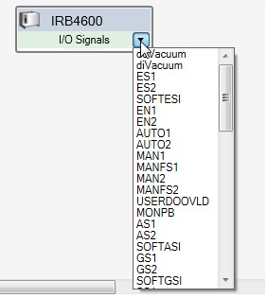

xx1800002954

|  |  |
| --- | --- |
| Configuring Station Logic |  |
| 1 | On the **Simulation** tab, in the **Configure** group, click **Station Logic**. The **Station Logic** window opens. This window displays all the components that are part of the *station*. |
| 2 | Click the **Signals and Connections** tab, and then click **Add I/O Connection**. In the **Add I/O Connections** window, create the following connections. |

##### Source Ob- Source Target Ob- Target Sig- Description

**ject Signal ject nal or Prop-**

**erty**

SC_InFeed- doBoxIn- IRB4600 diBoxInPos When the *Line Sensor* detects er Pos the box, the Infeeder sends the

output signal *diBoxInPos* to the virtual controller.

IRB4600 doVacuum SC_Vacu- diAttach The virtual controller sends the umTool *doVacuum* signal to the

*SC_VaccumTool*. The *SC_VaccumTool* simulates the vacuum and attaches the part.

SC_Vacu- doAttached IRB4600 diVacuum The *SC_VacuumTool* grips the

umTool object and sends the signal to

the virtual controller.

**Tip**

Alternatively, these signals can be configured in the **Design** view of the **Station Logic** window.

3 Use the following piece of code for simulating the Infeeder.

MODULE Module1

CONST robtarget

pPick:=[[300.023,150,209.481],[0,-0.707106781,0.707106781,0],[0,0,0,0],

[9E+09,9E+09,9E+09,9E+09,9E+09,9E+09]];

!*********************************************************** !

! Procedure main ! ! Smart Component example, Pick and Place application. ! !*********************************************************** PROC main()

WHILE TRUE DO

PickPart;

ENDWHILE ENDPROC

PROC PickPart()

!** *The robot moves to a wait position 200 mm above the pick position.* **

MoveJ Offs(pPick,0,0,200),v500,z1,tVacuum\WObj:=wobjInFeeder;

!** *The robot waits for a box to pick at the infeeder stop.*

**

WaitDI diBoxInPos,1;

!** *The robot goes to the pick position.* **

MoveL pPick,v100,fine,tVacuum\WObj:=wobjInFeeder;

!** *To attach the box, the robot turns on the digital output signal "doVacuum" which is connected to the*

*Smart Component "SC_VacuumTool".* **

SetDO doVacuum,1;

!** *The robot waits for the digital input signal "diVacuum" to go high, which comes from "SC_VacuumTool*" *and indicates that the box is attached.* ** WaitDI diVacuum,1;

!** *The robot moves up from the infeeder.* **

MoveL Offs(pPick,0,0,200),v500,z1,tVacuum\WObj:=wobjInFeeder;

!** *The robot moves to the drop position above the pallet.* **

MoveL

Offs(pPick,0,-800,200),v500,fine,tVacuum\WObj:=wobjInFeeder;

!** *To detach the box, the robot turns off the digital output signal "doVacuum" which is connected to the*

*Smart Component "SC_VacuumTool*". **

SetDO doVacuum,0;

!** *The robot waits for the digital input signal "diVacuum" to goes low, which comes from "SC_VacuumTool" and indicates that the box is detached.* ** WaitDI diVacuum,0;

!** *The wait time simulates the time it takes for a real vacuum gripper to loose the vacuum.* **

WaitTime 0.5; ENDPROC

ENDMODULE

7.3 Cable Simulation using Physics

## 7.3 Cable Simulation using Physics

**Overview**

In a station, the cable connecting robots undergo extensive wear and tear which reduces its life span. RobotStudio's physics enabled cable simulation helps in selecting the right material of the cable and accurately designing the length, radius and mounting height of the cable to optimize its performance.

**Creating a cable**

1. In the **Modelling** tab, in the **Create** group, click **Cable** to create a cable, the **Create Cable** pane opens, set cable properties like length, radius, material and so on here.

You can also create a cable from the **Physics** contextual tab.

1. Click in the station/robot to add the start and end points of the cable .
2. Select a point on the cable, and drag it to add a control point. You can also set the control point in the **Create Cable** pane. The control point can be any **Free Point** or an **Attached Point**. You can attach the cable to any objects using the **Attached to** list box in the **Create Cable** pane.
3. Click **Create**, the new cable gets displayed in the **Layout** browser.

**Setting the properties of materials**

Select one of the following options to set/edit the material of cable.

* In the **Physics** contextual tab, click **Material**. The **Material Properties** pane opens.

You can choose the material either from the standard material list or can use custom material. Click the **Edit Materials** option to edit material properties.

* In the **Modelling** browser, right-click a part and then click **Physics\Material\ Material Properties** to open the **Physics Material** pane.

You can select your material either from the standard material list or can use custom material. Click the **Edit Materials** option to edit material properties.

**Modifying length of a cable**

1. In the **Layout** browser, right-click cable, then click **Modify Cable**. The **Modify Cable** pane opens.
2. Edit the required parameter and click **Apply**.

Click options **Shorter** or **Longer** to stretch or skew the cable.

**Applying Behavior to objects**

Use the behavior feature to set various motion related characteristics to a

RobotStudio object. A physics object follows the rules of physics during simulation. In the **Layout** browser, right-click a part and then select **Physics** to set various behavior options. The following settings are available.

* Inactive: This object will not interact with other objects during simulation.
* Fixed: The position of the object remains fixed during simulation.
* Kinematic: During simulation, RobotStudio controls the motion of the object.

7.3 Cable Simulation using Physics *Continued*

* Dynamic: During simulation the object follows rules of physics while in motion. Similarly any joint created using the **Physics Joint** options will follow rules of physics. These options are **Rotational joint**, **Prismatic joint**, **Ball joint** and **Lock joint**.

**Material selection in Physics simulation**

RobotStudio includes a number of default materials for adding their material properties in the simulation. You can create a copy of one of the default materials and then manipulate its properties to influence the behavior of items in the simulation.

##### Property Description

Density Mass per volume.

Young's modulus A mechanical property that measures the stiffness of a solid material.

Poisson's ratio Poisson's ratio is a measure of the contraction that happens when an object is stretched.

Coefficient of restitution Ratio of the final to initial relative velocity between two objects

after they collide. It normally ranges from 0 to 1, where 1 would be a perfectly elastic collision.

Roughness (friction) Friction is the force resisting the relative motion of solid surfaces sliding against each other.

Cable properites Cables are internally modelled as solid bodies attached with springs. These springs can create a damping effect on the cable and its stiffness may vary.

In addition to the standard properties, cables are affected by the spring damping (contact damping) and stiffness (Young's modu-

lus)

**Collision geometry in physics modelling**

Tuning the motion behavior of a robot for simulation depends a lot on the physical properties of the participants in the simulation. Properties such as mass, density, friction between the surfaces, and effects of gravity can deviate the predicted behavior of objects in the *station*. RobotStudio uses collision geometry of objects for collision calculations. Creating collision geometry is a computationally intensive feature for the PC as it uses more CPU resources for collision calculations. Hence it is recommended that static objects in the station must be excluded in collision calculations.

RobotStudio uses *collision geometry* in physics simulations and regular *geometry* for collision detection.

7.4 Physics joints

## 7.4 Physics joints

Joints define the geometrical relationship between one rigid body relative to the world or, two or more rigid bodies relative to each other, that should be met under certain conditions. Each joint is build upon elementary joints or *links* that defines the geometrical relationship. Acting upon these elementary joints can be secondary order joints such as motors, limits or locks. The available joints in RobotStudio are rotational, *Prismatic* , *Cylindrical*, *ball* and *Lock* joints.

## 7.5 Virtual commissioning using the SIMIT Smart Component

**Overview**

The SIMIT *SmartComponent* enables signal communication between SIEMENS SIMIT Simulation Platform and RobotStudio to perform virtual commissioning. SIMIT uses Shared Memory to communicate with RobotStudio. This shared memory is created in SIMIT. Input signals are written by SIMIT to the memory area and output signals are read by SIMIT from the memory area. The schematic overview of the setup:

**Note**

Refer

to

the

SIMITConnection

Smart

Component

section

to

know

its

Properties

and

Signals.

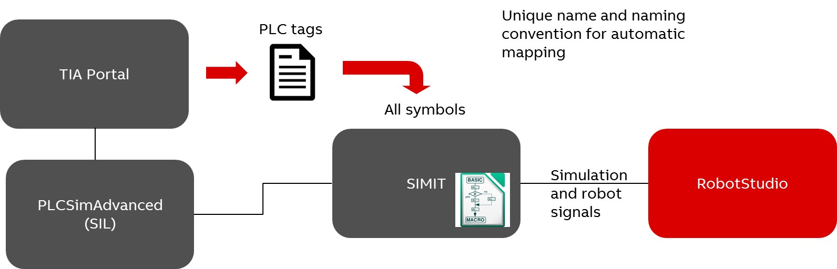

xx1900000807

**Prerequisites**

RobotStudio 2019 and SIMIT ULTIMATE 9.1 and higher versions must be installed on the same computer.

**Signals/Symbols**

The SIMITConnection Smart Component recognizes three *symbol* types based on a naming convention. These symbols are Robot, Station and Process. Robot symbols are robot controller signals. Station symbols (non-robot signals) control the connection between the PLC and various *station components* such as sensors and actuators during simulation. Process symbols are internal signals that reside only in SIMIT and are not passed to RobotStudio.

**Workflow**

Use the following workflow to configure, start and execute the exchange of signals between SIMIT and RobotStudio.

1. Configure TIA project in SIMIT. While configuring *symbols*, ensure that each symbol has a unique name in the TIA project.
2. Export the symbols from TIA portal as an Excel symbol document.
3. Import the symbol document to SIMIT.
4. A coupling gets created between SIMIT and the PLC simulator (PLCSim, *PLCSimAdvanced*, OPC or other programs).
5. A shared memory coupling gets created to be used from RobotStudio.
6. The Process symbol only resides in SIMIT and must be handled through SIMIT macros, UI and so on.
7. Import the Robot and Station symbols into the shared memory and perform the following setting.

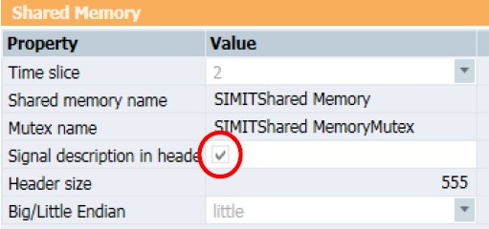

xx1900000805

* **Time slice**: Set the cycle at which the coupling exchanges data. Time slice 2 is the default, corresponding to a cycle of 100 ms.
* **Shared Memory name**: Enter the name with which the shared memory area can be addressed.
* **Signal description in header**: Choose whether or not SIMIT will create an extended header area. Signal description in header must be checked.
* **Big/Little Endian**: Little endian denotes that the least significant byte (the lowest memory address) is stored first. This must be selected.

1. Start the simulation in SIMIT.
2. Connect the SIMITConnection *SmartComponent* in RobotStudio.
   1. In RobotStudio, on the **Simulation** tab, in the **Configure** group, click **Station logic**.
   2. In the **Station Logic** window, click **Add component**, then select the **SIMIT Connection** Smart Component under **PLC**.
   3. In the **Layout** browser, right-click **SIMITConnection**, and click

**Properties**, enter the Shared memory name. Since RobotStudio and SIMIT connects through the shared memory, it is important that the shared memory name must be identical in both SIMIT and in RobotStudio.

* 1. Start the SIMIT simulation, switch to RobotStudio and in the **Layout** browser, right-click **SIMIT Connection** and then click **Connect** to establish the connection between SIMIT and RobotStudio. 10 Start simulation in RobotStudio.

**Note**

Only virtual controllers in the project (or station) can be used by the SIMITConnection Smart Component. It is not possible to use real robot controllers or virtual controllers that are not part of the project (or station).

**Time synchronization**

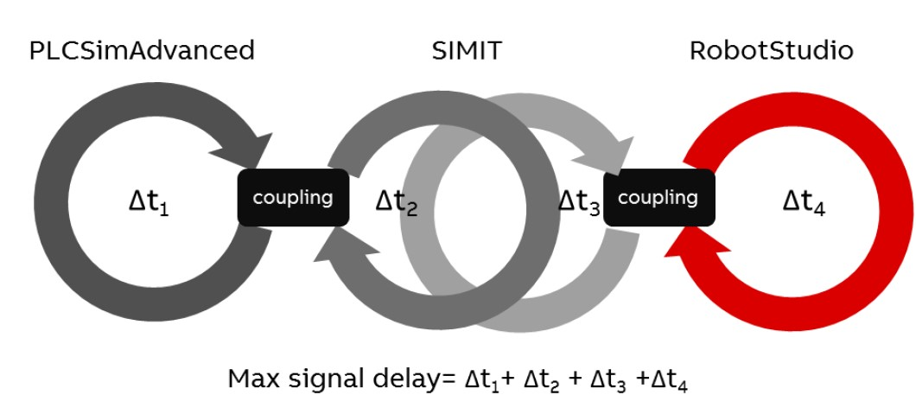

xx1900000808

The maximum signal delay is the sum of the *cycle time* of individual products. After the cycle the coupling exchanges data. This delay will affect the total cycle time of the production cell. Usually connection gets established between the PLC and the devices of the cell such that the signal delay will be duplicated since it is a set and wait signal before continuing the simulation. This significantly affects the total simulated cycle time.

**Retrieving robot joint values from RobotStudio to SIMIT**

Naming convention for joint signals

It is possible to retrieve the joint values from RobotStudio to the SIMIT shared memory. These values get updated at every 24 milliseconds in the simulation (12ms for picker robots). When simulation is not running, RobotStudio updates joint values to SIMIT only twice per second.

The joint signals (data type REAL) must abide to the following naming conventions

in the shared memory. The joint symbol must be named either

*Joint[joint_index]symbol_id* or

*Joint[system_name][mech_unit][joint_index]symbol_id*.

##### Joint symbol naming conven- Description tion

*Joint[joint_index]symbol_id* • *[joint_index]* is an integer 1-7. By this convention only one robot with a single mechanical unit can be used.

• *symbol_id* is an optional arbitrary identifier that can be used to give a descriptive name to the *joint*. The *symbol_id* is an optioned field which can be excluded. For example, to retrieve data from axis 3 of a single robot in RobotStudio, the symbol name in SIMIT is *[Joint[3]]*.

##### Joint symbol naming conven- Description tion

Joint[sys- • *[system_name]* is a unique id of the robot system,

tem_name][mech_unit][joint_in- therefore joint values from several robots can be dex]symbol_id retrieved from RobotStudio.

* *[mech_unit]* is the mechanical unit of the robot.
* *[joint_index]* is an integer 1-7.
* *symbol_id* is an optional arbitrary identifier that can be used to give a descriptive name to the joint. The *symbol_id* is an optional field which can be excluded. For example, to retrieve data from axis 3 of mechanical unit *ROB_1* of the robot with system name *System1* in RobotStudio, the symbol name in SIMIT is *Joint[System1][ROB_1][3]*.

Procedure

This procedure requires an active *virtual controller*.

1. Create a project in SIMIT, In the **Project** tree view, right-click **Coupling** and then select **Shared Memory**.
2. In the **Output** window, enter the names of joint symbols. The joint symbol names used in this example follows the required naming convention.

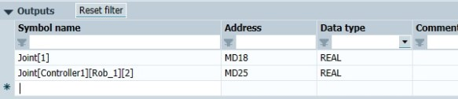

xx1900000810

1. In the **Shared Memory** window, perform the following setting.

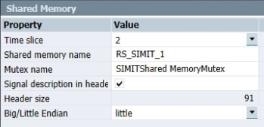

xx1900000809

1. In RobotStudio, on the **Simulation** tab, in the **Configure** group, click **Station logic**.
2. In the **Station Logic** window, click **Add component**, then select the **SIMIT Connection** Smart Component under **PLC**.
3. In the **Layout** browser, right-click **SIMIT Connection**, and click **Properties**, enter the Shared memory name. Since RobotStudio and SIMIT connects through the shared memory, it is important that the shared memory name must be identical in both SIMIT and RobotStudio, for example, *RS_SIMIT_1*.
4. Start the SIMIT simulation, switch to RobotStudio and in the **Layout** browser, right-click **SIMIT Connection** and then click **Connect** to establish the connection between SIMIT and RobotStudio. On successful connection, the joint values get displayed in SIMIT.

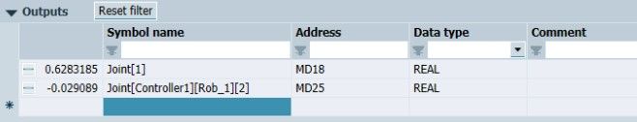

xx1900000811

**Coupling robot signals with SIMIT**

Naming convention for robot signals

The SIMIT *SmartComponent* can synchronize a set of SIMIT symbols with the input or output data of a device in the robot controller EIO configuration based on the following conditions.

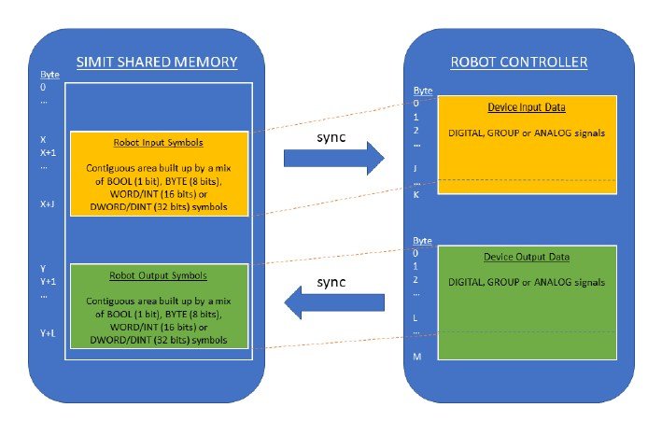

xx1900000832

* The robot input or output symbols for a specific EIO device must contain contiguous shared memory.

In the following example a digital input signal with Device Mapping 17 is represented in SIMIT. To ensure continuity in the shared memory, a dummy symbol of datatype WORD is used here. A symbol of type WORD is represented by 16 bits in SIMIT. The shared memory area mapped to the device *[Dev123]* starts at the first byte, for example, "1" in *MW1*. The *Robot[Controller1][Dev123]Dummy1* symbol occupies two bytes. That is why the *RobotSignalInput* is mapped to the first bit of the third byte *M3.1*. This will ensure the absence of memory gaps in the shared memory.

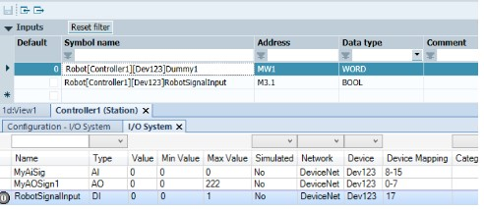

xx1900000837

* The robot input or output symbol area can start at any address in the shared memory, but always map it to the beginning of the EIO device input or output data.
* The start and end of a robot symbol area is determined by the first and last robot symbol for a specific robot system and EIO device.
* The size of the robot input or output symbol area in the shared memory must be less than or equal to the size of the input or output data area of the EIO device.
* The robot *symbols* can belong to any of the datatypes: BOOL (1 bit), BYTE (8 bits), WORD/INT (16 bits) or DWORD/DINT (32 bits). If a BOOL symbol is used, all bits in the byte must be assigned to a BOOL symbol, unless it is the last byte where the last bits can be left unassigned. REAL type is not supported for robot symbols.
* The robot symbols in SIMIT need not correspond to (or must have the same size as) the individual I/O signals in the robot controller. Examples:
* One BYTE (8 bits) robot symbol could map to the device data for 8 digital I/O signals in the robot controller.
* 2 WORD (16 bits each) robot symbols could map to a 32-bit group signal in the robot controller.

It is possible to create robot symbols that exactly correspond to a specific symbol, for example, a *BOOL* (1 bit) robot symbol could be created to correspond to a digital I/O signal in the robot controller.

##### Robotsymbolnamingconven- Description tion

Robot[sys- • The *[system_name]* is a unique id of the robot sys-

tem_name][device_name]sym- tem, which makes it possible to connect signals from bol_id several robots to the PLC.

* The *[device_name]* is the name of the device in the robot controller EIO configuration.
* The *[symbol_id]* is an arbitrary identifier to make the different robot symbols unique in SIMIT.

For example, the first input data symbol of the PLC EIO device in the robot system *System1* could have thesymbolname *Robot[System1][PLC]_IN1*inSIMIT.

Procedure

This example requires an active virtual controller with a DeviceNet device.

1. In the **Configuration Editor**, create I/O signals for the Device(or any device), for example, *RobotSignalOutput* and *RobotSignalinput*.
2. In RobotStudio, on the **Simulation** tab, in the **Configure** group, click **Station logic**.
3. In the **Station Logic** window, click **Add component**, then select the **SIMIT Connection** Smart Component under **PLC**.
4. In the **Layout** browser, right-click **SIMITConnection**, and click **Properties**, enter the Shared memory name. Since RobotStudio and SIMIT connects through the shared memory, it is important that the shared memory name must be identical in both SIMIT and in RobotStudio, for example, *RS_SIMIT_1*.
5. Switch to SIMIT, add **Inputs** and **Outputs** symbols as per the required naming convention.
6. Start the SIMIT simulation, switch to RobotStudio and in the **Layout** browser, right-click **SIMITConnection** and then click **Connect** to establish the connection between SIMIT and RobotStudio. On successful connection, the

I/O signals in SIMIT get auto-connected to the SIMITConnection *Smart Component*.

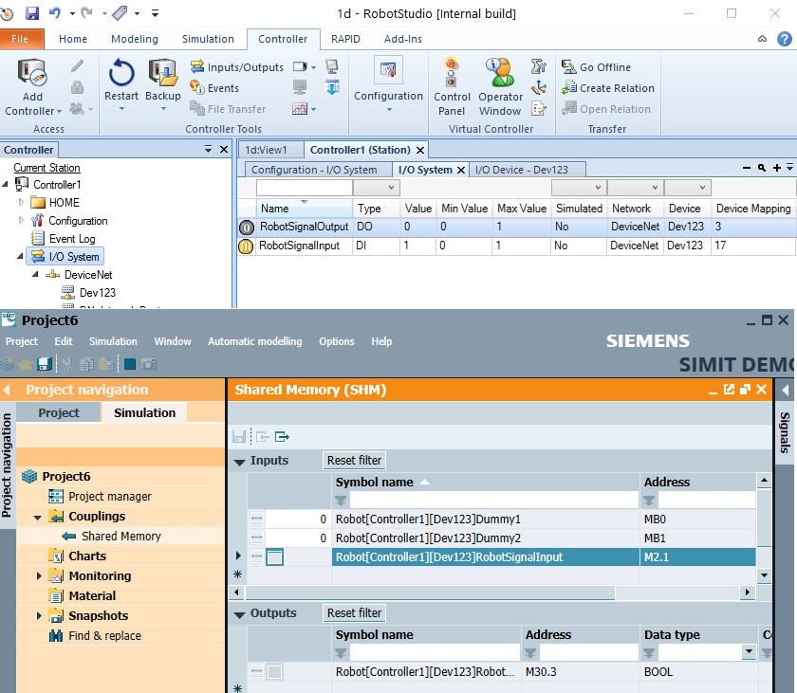

xx1900000831

**Coupling station signals with SIMIT**

Naming convention for station signals

During simulation, station signals control the connection between the PLC and various station elements such as sensors and actuators. *Smart Components* replicate these station elements in RobotStudio and expose I/O signals that must be connected to the PLC. Station signals can use any of the symbol types in SIMIT. BOOL symbols are assigned to digital signals in RobotStudio, REAL symbols changes to analog signals, similarly BYTE, WORD, INT, DWORD and DINT symbols get converted to group signals.

To automatically map the PLC and other Smart Components in the Station Logic, the signal names must be identical in PLC and in the SmartComponent. This unique name helps RobotStudio to find the correct Smart Component and map the corresponding *symbol* in the PLC. If there are multiple components using the same signal name, the user must perform a manual mapping in the *Station Logic*.

Procedure

This example requires an active *virtual controller*.

1. In RobotStudio, on the **Simulation** tab, in the **Configure** group, click **Station logic**.
2. In the **Station Logic** window, click **Add component**, then select the **SIMIT Connection** Smart Component under **PLC**.
3. In the **Layout** browser, right-click **SIMIT Connection**, and click **Properties**, enter the Shared memory name. Since RobotStudio and SIMIT connects through the shared memory, it is important that the shared memory name must be identical in both SIMIT and RobotStudio, for example, *RS_SIMIT_1*.
4. Switch to SIMIT and add I/O signals under **Inputs** and **Outputs** for example, *Stn_Attach* and *Stn_Attached*.
5. Start the SIMIT simulation, switch to RobotStudio and in the **Layout** browser, right-click **SIMIT Connection** and then click **Connect** to establish the connection between SIMIT and RobotStudio. On successful connection, the I/O signals in SIMIT get auto-connected to the SIMITConnection smart component.

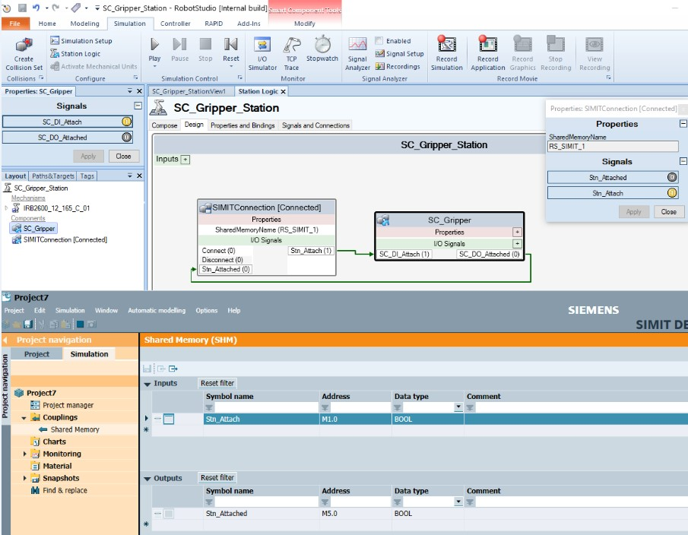

xx1900000830

## 7.6 Virtual commissioning using the OPC UA Client Smart Component

**Overview**

The OPC UA Client *Smart Component* enables signal communication between RobotStudio and other simulation environments that implement an OPC UA server such as B&R Automation Studio.

*OPC UA* Smart Component can be used for virtual commissioning of robot cells that include PLCs. To achieve communication between the two simulation environments, station and robot signals need to be mapped to the OPC UA Nodes in the PLC.

**Note**

Refer

to

the

OpcUaClient

Smart

Component

section

to

know

its

Properties

and

Signals.

**Prerequisites**

A simulation environment that implements an OPC UA Server, such as B&R Automation Studio.

**Mapping of signals to OPC UA Nodes**

OPC UA Nodes

An *OPC UA* Node is an entity representing information on an OPC UA Server. Nodes are identified by a unique *NodeId*. The *NodeId* consists of 3 parts; *Namespace*, *Identifier Type*, and *Identifier*.

An OPC UA Server exposes Nodes which can be read or written by OPC UA clients. The OPC UA Client Smart Component maps RobotStudio signals to OPC UA Nodes of the *Variable NodeClass*. For more information on the *Variable NodeClass*, refer to the *OPC UA Specifications, OPC Unified Architecture, Part 3: Address Space Model*.

Robot signals

Robot signals are I/O signals that are mapped to the input or output memory area of a device in the *virtual controller*. The OPC UA Smart Component synchronizes the entire input or output memory area of the device to an OPC UA Node, hence all signals on the device are synchronized together without the need to map individual signals. Robot signals are not visible on the OPC UA Client Smart Component.

* The OPC UA Node must be a byte array of the same length as the I/O memory area of the device. The data type of the OPC UA Node must be a subtype of Byte (Identifier 3) with the *ValueRank* set to 1 (OneDimension) and the *ArrayDimensions[0]* set to the same value as *Input Size* or *Output Size* of the I/O device. Refer to the *Technical reference manual - System parameters* for more information about *Input Size* and *Output Size* parameters of the device.
* The bits of the OPC UA Node must have the same meaning as the bits in the device mapping on the robot controller. For example, a digital signal with device mapping 17 in the controller corresponds to bit 1 of byte 2 (zero indexed) in the OPC UA node.

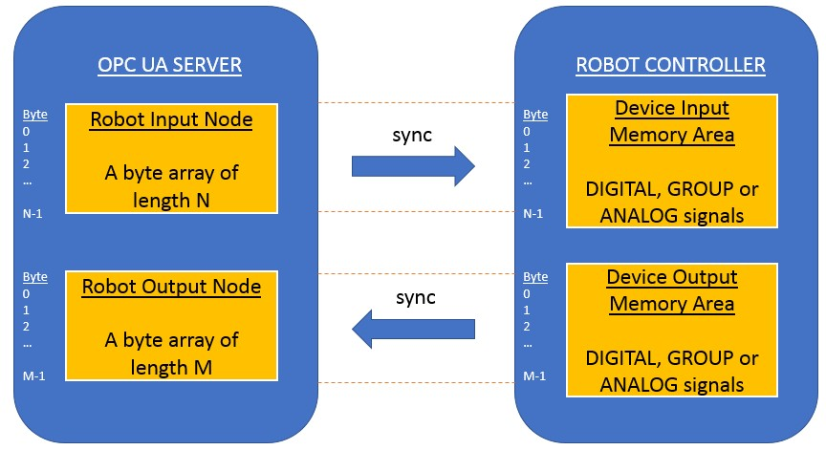

xx2100000249

Station signals

Station signals are non-robot signals that connect the PLC and various *station components* such as sensors and actuators during virtual commissioning. The OPC UA Client Smart Component synchronizes the station signals between RobotStudio and the PLC. These signals are visible on the OPC UA Client Smart Component in the **Station Logic** window.

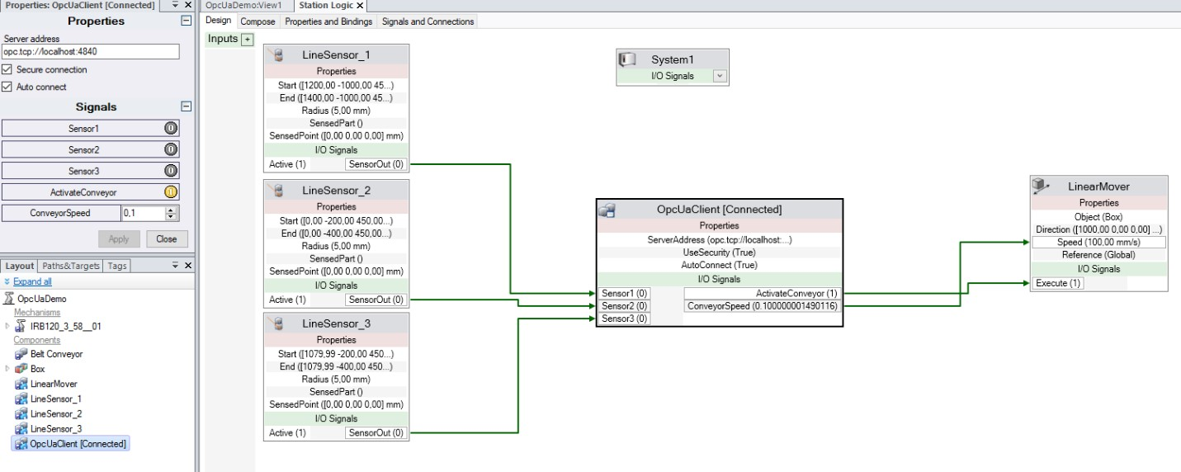

xx2100000289

In the above figure, *Sensor1*, *Sensor2*, *Sensor3* and so on, are station signals synchronized by the OPC UA Client Smart Component.

Station signals can be mapped to a specific subset of the OPC UA data types as shown in the following table.

**OPC**

**UA**

**data**

**type**

**Type**

**of**

**station**

**signal**

*Boolean*

**Digital**

*Float*

,

*Double*

**Analog**

##### Type of station signal OPC UA data type

**Group** *SByte*, *Byte*, *Int16*, *UInt16*, *Int32*, *UInt32*, *Int64* or *UInt64*

**Note**

A *Group* signal in RobotStudio is a 32 bit unsigned integer. A mismatch in bit sizes can result in overflow while reading or writing signals between RobotStudio and the OPC UA server.

OPC UA Client Configuration dialog

Use the OPC UA Client Configuration dialog to configure the mapping between nodes in the OPC UA Server and RobotStudio signals. In the **Station Logic** window, right-click the **OpcUaClient** Smart Component and then click **Configure...** to open this dialog.

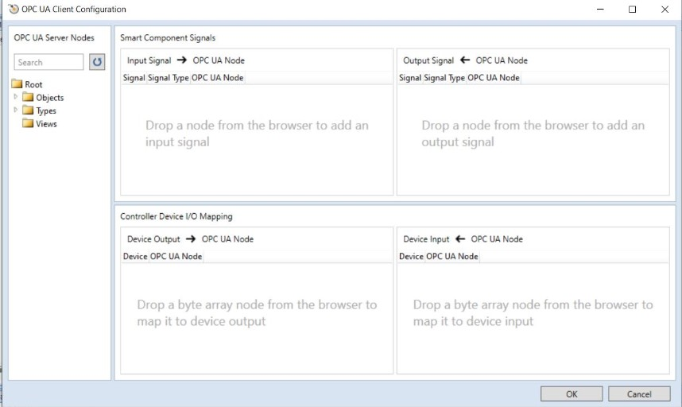

xx2100000510

**Description**

**Item**

Displays

the

nodes

from

the

connected

OPC

UA

server

in

a

tree

structure.

The

**OpcUaClient**

Smart

Component

must

be

connected

to

the

OPC

UA

server

to

view

the

nodes.

**OPC**

**UA**

**Server**

**Nodes**

**browser**

Station (Smart Component) signals can be mapped to nodes with data

types

*Boolean*

,

*Float*

,

*Double*

or

any

integer

type.

In

the

**OPC**

**UA**

**Server**

**Nodes**

browser,

hover

over

the

node

to

view

its

details

in

the

tooltip.

**Smart**

**Component**

**Signals**

Add

the

required

OPC

UA

node

for

configuring

to

the

**Input**

**Signal**

or

**Output**

**Signal**

lists

from

the

**OPC**

**UA**

**Server**

**Nodes**

browser

using

the

drag-and-drop

operation

or

by

using

the

options

**Map**

**to**

**input**

**signal**

or

**Map**

**to**

**output**

**signal**

from

the

context

menu.

##### Item Description

**Controller Device** The input/output of a device in the Robot Controller can be mapped

**I/O Mapping** to a byte array in the OPC UA Node here. In the **OPC UA Server Nodes** browser, hover over the node to view its details in the tooltip.

Add the required OPC UA node for configuring to the **Device Output** or **Device Input** lists from the **OPC UA Server Nodes** browser using the drag-and-drop operation or by using the options **Map to controller device input** or **Map to controller device output** from the context menu.

Configuration file

The purpose of the configuration file (*.csv) is to export or import the mapping between the *OPC UA* Server nodes and RobotStudio signals. These files can be viewed with a text editor like Notepad or a spreadsheet program like Microsoft Excel. The configuration file stores data in a tabular format as follows.

##### Data field Description

**NamespaceUri** Specifies the *Namespace URI* of a Node on the OPC UA server.

**IdentifierType** Specifies the type of the *Identifier* (any of the values *Numeric*, *String*, *Guid* or *Opaque*).

**Identifier** The *Identifier* part of a *NodeId*.

**ReadWrite** Specifies if the OPC UA Node value shall be read or written (possible values *Read* or *Write*).

For station signals, the value *Read* creates an output signal on the Smart Component while *Write* creates an input signal.

For robot signals, *Read* specifies that the data read from the OPC UA Node will be written to the robot input signals (to the device input memory area), while *Write* specifies that that robot output signals (from the device output memory area) will be read and written to the OPC UA Node.

**Signal** The name of the signal that will be created in the Smart Component. Must be empty when mapping robot signals to an OPC UA Node.

**SignalType** The type of the signal that will be created in the Smart Component(possible values *Digital*, *Analog* or *Group*).

Must be empty when mapping robots signals to an OPC UA Node.

**Controller** Specifies the name of the virtual controller. Must be empty for station signals.

**Device** The name of a device on a bus in the virtual controller specified by Controller. Used to map an OPC UA Node to robot signals. Must be empty for station signals.

**Properties of OPC UA Client Smart Component**

##### Property Description

**Server address** Address of the OPC UA Server, for example, *opc.tcp://ipaddress:portnumber*

* *ipaddress* refers to the IP address of the OPC UA server.
* *portnumber* refers to the port number that identifies the OPC UA server.

**Secure connection** The **Secure connection**check-boxis selectedby default and ensures that the OPC UA server certificate is trusted and that the connection is encrypted.

##### Property Description

**Auto connect** Select this check-box to ensure automatic connection of the client to the specified **Server address** when loading the station and for reconnecting to the server after a connection failure.

**Server/Client Certificates**

The Smart Component generates a client certificate automatically. A server security certificate must be accepted when connecting the OPC UA Client Smart Component to an OPC UA Server. This process ensures a secure connection between the client and server. When **Secure connection** is enabled, the communication between the server and client will be encrypted using their certificates.

**Note**

The OPC UA Client Smart Component supports anonymous and username authentication when it connects to the OPC UA server, the credentials for username authentication can be stored and retrieved from the Windows Credentials Manager.

The OPC UA client certificate that is used to connect to the server is stored in:

*%localappdata%\ABB\RobotStudio\OPC UA Certificates\own\certs*

**Note**

The

OPC

UA

Server

must

be

configured

to

trust

the

OPC

UA

client

certificate.

**Time synchronization**

During simulation the signals are synchronized every time-step, that is, 24 milliseconds by default, which can be altered using the RobotStudio Option **Simulation:Clock**. When simulation is not running, the signals are synchronized every 500 milliseconds.

**Workflow**

1. Set up a PLC project in any simulation environment with an OPC UA server.
2. Connect the OPC UA Client *Smart Component* in RobotStudio.
   1. In RobotStudio, on the **Simulation** tab, in the **Configure** group, click **Station logic**.
   2. In the **Station Logic** window, click **Add component**, then select the **OpcUaClient** Smart Component under **PLC**.
   3. In the **Layout** browser, right-click **OpcUaClient**, and click **Properties**, enter the OPC UA Server URL in **Server address**.

The **Secure connection** check-box will be selected by default. Select the **Auto connect** check-box to automatically connect the client to the specified **Server address** when loading the station or for reconnecting to the server after a connection failure.

* 1. Connect to the OPC UA Server by right-clicking the Smart Component and click **Connect**.
  2. Accept the security certificate to establish connection with the OPC UA Server.

1. Configure OPC UA nodes and RobotStudio signals in the **OPC UA Client Configuration** dialog. 4 Start simulation.

**Coupling robot signals with OPC UA nodes**

Prerequisites

This following example requires an active virtual controller with a PROFINET device with I/O memory area size of 64 bytes. This example also uses a B&R Automation Studio project with a simulated PLC and configured OPC UA server.

Procedure

1. In the **Configuration Editor** in RobotStudio, create I/O signals for the device, for example *RobotSignalOutput* and *RobotSignalInput*.
2. In **RobotStudio**, on the **Simulation** tab, in the **Configure** group, click **Station Logic**.
3. In **Station Logic**, click **Add component**, then select the **OpcUaClient** Smart Component under **PLC**.
4. Switch to B&R Automation Studio, add variables corresponding to the I/O signals, for example *RobotSignalOutput* and *RobotSignalInput*.
5. Add two byte array variables with the same size as the robot controller device's memory area, for example *RobotOutput* and *RobotInput* of type *USINT[0..63]*. .

**Note**

Output signal from the the robot is the input to the PLC, so *RobotInput* must be of the same size as the device output memory area and *RobotOutput* must be of the same size as the device input memory area.

1. Configure *RobotInput* and *RobotOutput* variables to be available as nodes in the OPC UA server.
2. In the PLC program read from the *RobotInput* variable into the variables corresponding to the robot output signals, for example *RobotSignalOutput*.

Write the variables corresponding to the robot input signals to the *RobotOutput* variable.

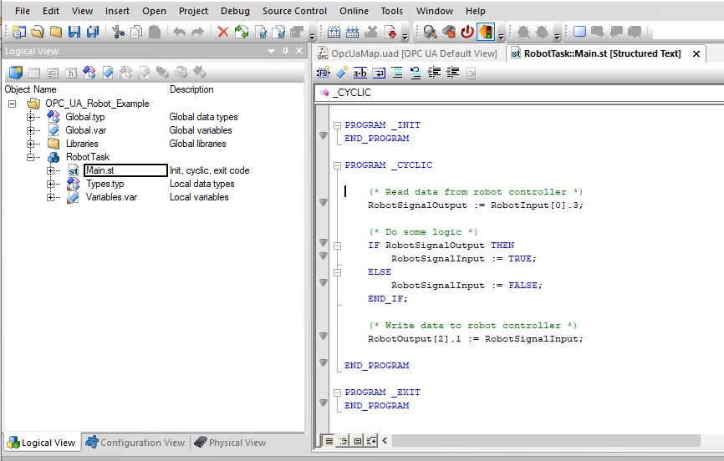

xx2100000238

1. Build the configuration in Automation Studio and transfer it to the PLC runtime, and start the runtime.
2. Switch to RobotStudio, right-click the **OpcUaClient** and click **Properties**. Enter the **Server address** and select **Auto connect** to connect to the OPC UA server.
3. In the **Layout** browser, right-click **OpcUaClient** and click **Configure...** to open the **OPC UA Client Configuration** dialog.
4. In the **OPC UA Server Nodes** browser, find the *RobotInput* node and drag it to the **Device Output**. In the **Device** drop-down, click the PROFINET device.

Similarly, drag the *RobotOutput* node to the **Device Input** and then click the PROFINET device in the **Device** drop-down.

On successful configuration, the signals will be continuously synchronized between PLC simulation in Automation Studio and virtual controller in RobotStudio.

**Coupling Station signals**

Prerequisites

This example requires a B&R Automation Studio project with a simulated PLC and configured OPC UA server.

Procedure

1. In RobotStudio, on the **Simulation** tab, in the **Configure** group, click **Station Logic**.
2. In the **Station Logic** window, click **Add component**, then select the **OpcUaClient** Smart Component under **PLC**.
3. Right-click the **OpcUaClient** and click **Properties**. Enter the **Server address** and select **Auto connect** to connect to the OPC UA server.
4. Switch to B&R Automation Studio, add variables corresponding to the I/O signals as required, for example two Boolean variables *SensorActivated* and

*ActivateConveyor*. Configure the variables to be available as nodes in the OPC UA server.

1. In the PLC program read and write from the variables as needed.

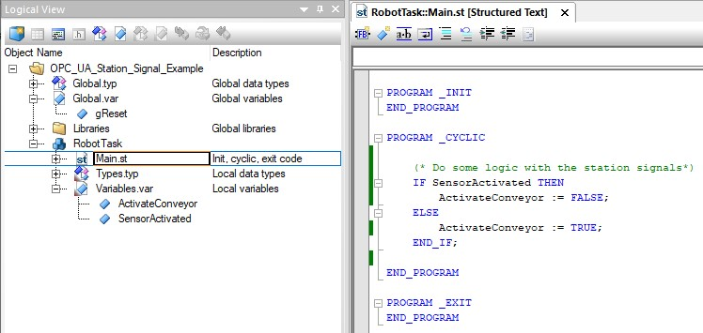

xx2100000244

1. Build the configuration in Automation Studio and transfer it to the PLC runtime. Start the runtime.
2. In the **Layout** browser, right-click **OpcUaClient** and click **Configure...** to open the **OPC UA Client Configuration** dialog.
3. In the **OPC UA Server Nodes** browser, find the *SensorActivated* node and drag it to the **Input Signal** list. Similarly, drag the *ActivateConveyor* node to the **Output Signal** list. Click **OK**, the new signals appear on the **OpcUaClient** Smart Component.

**Note**

The

imported

configuration

file

overwrites

the

existing

configuration.

1. Connect the I/O signals on the OPC UA Client Smart Component to other Smart Components in RobotStudio. On successful connection, the I/O signals are continuously synchronized between the PLC simulation and RobotStudio.

**Exporting and importing configuration file to the Smart Component**

An **OpcUaClient** configuration can be exported from a station and imported to other stations.

* To export a configuration file, in the **Layout** browser, right-click the **OpcUaClient** Smart Component and click **Export configuration...** and save the configuration file.
* To import a configuration file, in the **Layout** browser, right-click the **OpcUaClient** Smart Component and click **Import configuration…**, browse to the required folder and select the configuration file.

The signals from the configuration file will be displayed as inputs and outputs on the **OpcUaClient** Smart Component.

This page is intentionally left blank

8.1 Saving and loading RAPID programs and modules

# 8 Deploying and Sharing

## 8.1 Saving and loading RAPID programs and modules

**Overview**

One of the purposes of creating simulations in RobotStudio is to create a robot program that can be transferred to the *robot controller*. RAPID programs are stored in the *virtual controllers* of the respective *station*. You can save entire programs or specific modules.

These programs can be shared with destination controllers in three different ways, save program as a file in the host computer and transfer these files to the destination controllers, create a backup and then restore the file in the destination controller or transfer the file by using the transfer function.

8.2 Sharing a station

## 8.2 Sharing a station

**Overview**

Use the **Pack & Go** feature to create a package (*.rspag) of an active station. The **Unpack & Work** feature can be used to unpack the *Pack & Go* file on another computer. The Pack & Go file excludes *RobotWare*, but RobotWare *add-ins* that are part of the station are included in the Pack&Go file. The required RobotWare must be installed in the target computer, but any required RobotWare add-ins are included/distributed with the Pack&Go file.

The *Pack & Go* format is the recommended mode for sharing the RobotStudio *stations*.

**Packing a station**

1. On the **File** tab, under **Share**, click **Pack and Go**. The **Pack & Go** dialog opens.
2. Enter the name of the package and then browse and select the location of the package.
3. Optionally, select the **Password protect the package** check box.
4. Type in the password in the **Password** box to protect your package.
5. Click **OK**.

**Unpacking a station**

1. On the **File** tab, click **Open** and browse the folder and select the *Pack&Go* file, the **Unpack & Work** wizard opens.
2. In the **Welcome to the Unpack & Work Wizard** page, click **Next**.

**Note**

A

password-protected

Pack&Go

file

asks

for

a

password

for

loading

the

station.

1. In the **Select package** page, click **Browse** and then select the **Pack & Go file to unpack** and the **Target folder**. Click **Next**.
2. In the **Library handling** page select the target library. Two options are available, **Load files from local PC** or **Load files from Pack & Go**. Click the option to select the location for loading the required files, and click **Next**.

**Note**

The station file in the Pack& Go uses library file (*.rslib). If the PC has a later version of the library file, then select the option **Load files from local PC** for loading the PC version of the library file.

1. In the **Virtual Controller** page, select the **RobotWare version** and then click **Locations** to access the **RobotWare Add-in** and Media pool folders.

Optionally, select the check box to automatically restore backup. Click **Next**. 6 In the **Ready to unpack** page, review the information and then click **Finish**.

*Continues on next page*

8.2 Sharing a station *Continued*

7 In the **Unpack & Work finished** page, review the results and then click **Close**.

**Note**

During an unpack operation, if you select the **Copy configuration files to SYSPAR folder** option, the configuration (CFG) files of the back up virtual controller inside the *Pack& Go* file gets copied to the SYSPAR folder of the new *virtual controller*. This is to avoid any loss of configuration data during an I- start. Select this option for complex configurations like the paint system.

8.3 Capturing the selected screen

## 8.3 Capturing the selected screen

**Overview**

Screen capture entails two functions useful for demonstrations and training purposes:

* The Screenshot function which allows you to capture an image of the application.
* The Record Movie function which allows you to make a recording of your work in RobotStudio, either of the entire GUI or just the **Graphics** window.

**Taking screenshots**

Use Screenshot feature to capture an image of the entire application or an active document window such as the **Graphics** window. Screenshot can be taken by using the keyboard shortcut *CTRL + B* or by using the **Screenshot** button on the Quick Access Toolbar.

To enable the Screenshot command in the Quick Access toolbar:

1. Click the **Quick Access Toolbar**, and then click **Customize Commands** from the drop down menu. Options:General:Screenshot.

The Customize Commands and Quick Access Toolbar dialog opens.

1. In the **Show Commands from** box , select **Other Commands** and then select **Screenshot**.
2. Click the **Add>>** button to add this option to the **Quick Access Toolbar** and then click **Close**.

The Screenshot icon gets added to the toolbar.

1. On the Quick Access Toolbar, click **Screenshot**, the screenshot gets saved to C:\Users\<user name>\Pictures folder.

**Recording movies**

Overview

RobotStudio provides three options for recording movies, **Record Simulation**, **Record Application** and **Record Graphics**. The **Record Application** option records the entire user interface of RobotStudio including the curser and mouse-clicks of the simulation. These recordings are used for demonstrating certain features. The **Record Simulation** option is similar to the **Record Application**, but records in virtual time.

Recording the screen

1. On the **Simulation** tab, in the **Record Movie** group, click **Record application** to capture the entire application window, or **Record graphics** to capture just the **Graphics** window.
2. After recording, click **Stop Recording**.
3. Click **View Recording** to playback the latest capture.

8.4 Recording a simulation

## 8.4 Recording a simulation

Records the graphics view only and it uses the virtual time for recording the frames. The advantage here is that the recording will not be affected by the PC configuration or the load on the PC at the time of recording as the frames are recorded with the virtual timestamp.

1. In the **Record Movie** group, click **Record Simulation** to record the next simulation to a video clip.
2. After recording, click **Stop Recording**.

The simulation is saved in a default location which is displayed in the **Output** window.

1. Click **View Recording** to playback the recording.

8.5 Creating a 3D animation of your simulation

## 8.5 Creating a 3D animation of your simulation

**Overview**

The Project Viewer can playback a station in 3D on computers that do not have RobotStudio installed. It packages the station file together with files needed to view the station in 3D. It can also play recorded simulations.

**Prerequisites**

These prerequisites are applicable only when the project viewer is saved in *\*.exe* format.

* Visual C++ Redistributable for Visual Studio 2015-2022.
* .NET Framework 4.8 must be installed on the playback computer.

**Creating and loading a project viewer**

Use the following steps to create and save the project viewer as a file to the local PC and then open this file in a 3D Viewer.

1. • To create a project viewer without simulation.

On the **File** tab, click **Share** and then click **Export Viewer** .

• To create a project viewer with simulation.

On the **Simulation** tab, in the Simulation Control group, click **Export Viewer**.

1. The **Export Viewer** dialog opens. In the **Location** group, select **This PC**.
2. Click the **...** button to browse and select a folder for saving the project.
3. Select the file format from the **Save as type** list. This project viewer can be saved in *\*.exe*,*\*.glb* (gITF file) or *.rsstnv (Station Viewer file).
4. Click **Create**.

Simulation control buttons are enabled when the Project Viewer contains a recorded simulation. When a simulation starts, the movements and visibility of objects are recorded. This recording can be included in the Project Viewer. 6 To load Project Viewer, double-click the package file. The results are displayed in the **Output** window and the embedded project file is automatically loaded and presented in a 3D viewer.

**Note**

The project viewer inherits the default settings of RobotStudio, to customize these settings on the **File** tab, click **Options** to edit the settings.

8.6 Deploying a RAPID program to a robot controller

## 8.6 Deploying a RAPID program to a robot controller

**Overview**

Use transfer function to transfer *RAPID* programs that are created *offline* in a virtual controller to a robot controller in the shop floor or to another virtual controller. As part of the transfer function, you can also compare the data present in the *virtual controller* with that present in the *robot controller* and then select the data to be transferred.

**Relations for transfer of data**

To transfer data, a **Relation** must be defined between the two controllers. A Relation defines the rules for transferring data between two controllers.

**Creating a Relation**

When two controllers are listed in the Controller browser, a Relation can be created between them. To create a Relation:

1. On the **Controller** tab, in the **Transfer** group, click **Create Relation**.

The **Create Relation** dialog box opens.

1. Enter a **Relation Name** for the relation.
2. Specify the **First Controller**, from the list.

The First Controller, also called the Source, owns the data being transferred.

1. Specify the **Second Controller**, from the list. This can either be a *robot controller* or another *virtual controller*.

The Second Controller, also called the Target, receives the data being transferred.

1. Click **OK**.

The relation between the controllers is now created.

The *Relation* dialog box opens, here you can configure and execute the transfer. Relations of a controller are listed under the Relations Node in the Controller browser.

**Note**

The

properties

of

the

relation

are

saved

in

a

XML

file

under

INTERNAL

in

the

system

folder

of

the

first

controller

(

source

).

**Transferring data**

You can configure the details of the transfer of data and also execute the transfer, in the *Relation* dialog box.

*Continues on next page*

8.6 Deploying a RAPID program to a robot controller

*Continued*

To open the *Relation* dialog box, double-click a relation. Alternatively, select a relation in the **Controller** browser, and then in the **Transfer** group, click **Open Relation**.

Configuring the transfer

Before executing a transfer, configure the data to be transferred, under the *Transfer Configuration* heading. Use the following guidelines to configure transfer.

* Use the check boxes in the *Included* column to include or exclude the corresponding items shown in the tree structure. All items in a module that are included will be transferred. Other non-listed items of a module such as comments, records and so on will be automatically included in the transfer.
* The *Action* column shows a preview of the result of the transfer operation, based on the items included or excluded.
* If a module exists both in the source and the target controllers, and the *Action* column shows *Update*, then click **Compare** in the Analyze column. This opens the *Compare* box which shows two versions of the *module* in different panes. The affected lines are highlighted and you can also step through the changes. You can choose one of the following options for the comparison:
  + **Source with target** - Compares the source module with the target module
  + **Source with result** - Compares the source module with the module that will be the result of the transfer operation
* BASE (module), wobjdata and tooldata are excluded by default.
* wobjdata wobj0, tooldata tool0, and loaddata load0 of the BASE module are unavailable for inclusion.

A task can be transferred only if:

* + - Write access to the target controller is present (must be manually retrieved).
    - Tasks are not running.
    - Program execution is in the stopped state.

Executing the transfer

Under the *Transfer* heading, the Source and Target *modules* are shown along with the arrow showing the direction of the transfer. You can change the direction of the transfer by clicking **Change Direction**. This also switches the source and target modules.

To execute the transfer, click **Transfer now**. A dialog showing a summary of the transfer appears. Click **Yes** to complete the transfer. The result of the transfer is displayed for each module in the **Output** window.

The **Transfer now** button is disabled if:

* + - None of the included *tasks* can be transferred.
    - Write access is required but not held.

*Continues on next page*

8.6 Deploying a RAPID program to a robot controller *Continued*

**Note**

If one of the several modules fail, then the following error message is displayed.

Module xxx.zzz has failed. Do you want to continue?

This page is intentionally left blank

9.1.1 About Installation

# 9 Installing robot controller software

## 9.1 Installation

### 9.1.1 About Installation

**Overview**

This section describes how to create, modify, and copy systems to run on *robot* and *virtual controllers* using the Installation feature.

**Note**

Use

Modify

Installation

to

create

and

modify

systems

with

*RobotWare*

versions

7.

Use

Installation

Manager

6

to

create

and

modify

systems

with

RobotWare

versions 6.0. Use System Builder to create and modify systems based on earlier

versions

of

RobotWare.

**About real and virtual systems and license files**

When using real license files to create a robot controller, the license files contain the options that the user has ordered, and in most cases no additional configuration is required. Real *license files* can both be used to create *robot* and *virtual controllers*.

When using virtual license files to create a virtual controller, all options and robot models are available, which is useful for evaluation purposes, but requires more configuration while creating the virtual controller. Virtual license files can only be used to create virtual controllers.

**Products**

*Product* is the collective name for the different software such as RobotWare, RobotWare add-ins, third party software and so on. Products are either free or licensed, licensed products require a valid license file.

**Deployment packages and the repository**

Modify Installation can be used to create an installation or update package offline on a USB-stick, which later can be installed from the FlexPendant. The repository is the storage where all files needed to create and modify *RobotWare systems* are placed.

**Prerequisites**

The following are the prerequisites for creating a system:

* A *RobotWare license* file for the system, when creating a system to run on a robot controller. The license file is delivered with the controller.
* A virtual license file for creating a system for virtual use. All *products* are delivered with a virtual license file.
* Installing on a *robot controller* requires a connection from the computer to the service or Ethernet port of the controller.

### 9.1.2 Using Modify Installation for RobotWare 7

**Updating an existing RobotWare system**

Description

The most frequent RobotWare system update use case is updating one or more software, for example, RobotWare and add-ins. This is a frequent operation during the commissioning time, especially on large installations.

**Note**

To perform a RobotWare system update, the controller must be in the RobotWare

system

mode.

System update changes the configuration of the currently installed RobotWare system. There are different types of configuration changes, such as:

* Adding or removing licenses
* Upgrading, removing installed software or adding new software
* Activating or deactivating optional features

Before performing a system update, it is recommended to:

* create a backup of the system (user data) and store it on an external storage media.
* create a snapshot of the current system state.

Upgrading a software in the RobotWare system

The following procedure provides the steps involved during the update of the RobotWare system.

**CAUTION**

Do not turn off the controller while system update is in progress. Doing this may in worst case lead to data corruption in the RobotWare system, in which case it needs to be reinstalled.

1. Access the **Modify Installation** view in RobotStudio.
2. Select **Software > Included**.
3. The **Included Software** window displays the software that is included in the current RobotWare system.
4. Select the product that should be upgraded and tap **Update**.
5. In the **Update Software** window, select the software version to be used and tap **OK**.
6. The **Summary** tab shows an overview of all the changes.
7. Continue to modify the system, or select **Apply/Apply and reset** to confirm and save the changes.

**Note**

The **Modify Installation** dialog will be closed during the controller update. When the update process is finished, check the event log for information about the update results. A successful update will be indicated in the event log, and if the update has failed, one or more error logs will be generated.

Adding/removing software

The following procedure provides the steps involved during the update of the RobotWare system.

**CAUTION**

Do not turn off the controller while system update is in progress. Doing this may in worst case lead to data corruption in the RobotWare system, in which case it needs to be reinstalled.

1. Access the **Modify Installation** view in RobotStudio.
2. Select **Software > Included**.
3. The **Included Software** window displays the software that is included in the current RobotWare system. Select one of the following:
   * Select the product box for the software that should be added to the system.
   * Deselect the product box to remove the product from the system.

**Note**

Products may have dependences to certain versions of other products. A product may only be removed if all products that are dependent on it are removed as well.

1. The **Summary** tab shows an overview of all the changes.
2. Continue to modify the system, or select **Apply/Apply and reset** to confirm and save the changes.

**Note**

The **Modify Installation** dialog will be closed during the controller update. When the update process is finished, check the event log for information about the update results. A successful update will be indicated in the event log, and if the update has failed, one or more error logs will be generated.

Adding/removing add-in packages

The following procedure provides the steps involved during the update of the RobotWare system.

**CAUTION**

Do not turn off the controller while system update is in progress. Doing this may in worst case lead to data corruption in the RobotWare system, in which case it needs to be reinstalled or recovered from a snapshot.

1. Access the **Modify Installation** view in RobotStudio.
2. Select one of the following:
   * To add add-in packages, select **Software > Available** and tap **Include**.
   * To remove add-in packages, select **Software > Included** and tap **Remove**.

RobotWare is mandatory and cannot be removed from the system.

**Note**

Products

may

have

dependences

to

certain

versions

of

other

products.

A

product

may

only

be

removed

if

all

products

that

are

dependent

on

it

are

removed

as

well.

**Note**

1. The **Summary** tab shows an overview of all the changes.
2. Continue to modify the system, or select **Apply/Apply and reset** to confirm and save the changes.

**Note**

The **Modify Installation** dialog will be closed during the controller update. When the update process is finished, check the event log for information about the update results. A successful update will be indicated in the event log, and if the update has failed, one or more error logs will be generated.

Changing the software installation order when adding/removing RobotWare add-ins

When adding and removing RobotWare add-ins to/from the system, sometimes it is necessary to manually adjust the installation and initialization order or the included add-ins.

1. Access the **Modify Installation** view in RobotStudio.
2. Select **Software > Included**.
3. In the **Included Software** window, tap the **Installation order** button to open the **Change Installation Order** window. Select a product and use the up and down arrows to change the installation order. Select **Done**.
4. The **Summary** tab indicates that the installation order has been updated.
5. Continue to modify the system, or select **Apply/Apply and reset** to confirm and save the changes.

**Note**

The

**Modify Installation**

dialog

will

be

closed

during

the

controller

update.

When

the

update

process

is

finished,

check

the

event

log

for

information

about the update results. A successful update will be indicated in the event

log,

and

if

the

update

has

failed,

one

or

more

error

logs

will

be

generated.

**Working**

**with**

**option**

**selections**

Overview

The following categories of system features can be updated:

* System options
* Controllers
* Robots
* FlexPendant

**Note**

Some features extend, showing more options upon selection. For example, in the group controller variant, you get the option of choosing variant type only when a controller first is selected. The additional drive units work similarly, some are unavailable until you select a different drive system type. This means options can be locked behind selections.

Turning options on/off

**CAUTION**

Do not turn off the controller while system update is in progress. Doing this may in worst case lead to data corruption in the RobotWare system, in which case it needs to be reinstalled.

1. Access the **Modify Installation** view in RobotStudio.
2. Select the tab **Options**.
3. Select the option category to be updated, and the corresponding **Options** that should be activated/deactivated for the system.

**Note**

Linked

options

will

be

selected

automatically.

Conflicting

options

cannot

be

selected.

4

The

**Summary**

tab

shows

an

overview

of

all

the

changes.

5 Continue to modify the system, or select **Apply/Apply and reset** to confirm and save the changes.

**Note**

The **Modify Installation** dialog will be closed during the controller update. When the update process is finished, check the event log for information about the update results. A successful update will be indicated in the event log, and if the update has failed, one or more error logs will be generated.

Adding licenses to enable additional option access

**CAUTION**

Do not turn off the controller while system update is in progress. Doing this may in worst case lead to data corruption in the RobotWare system, in which case it needs to be reinstalled.

1. Access the **Modify Installation** view in RobotStudio.
2. Select the tab **Options**.
3. Select **Edit** to access the **Edit License files** window. Select one of the following:
   * Select **Add** to browse for a new license to be added.
   * Select an existing license and tap **Remove**.
4. The **Summary** tab shows an overview of all changes.
5. Continue to modify the system, or select **Apply/Apply and reset** to confirm and save the changes.

**Note**

The

**Modify Installation**

dialog

will

be

closed

during

the

controller

update.

When

the

update

process

is

finished,

check

the

event

log

for

information

about the update results. A successful update will be indicated in the event

log,

and

if

the

update

has

failed,

one

or

more

error

logs

will

be

generated.

**Exporting**

**and**

**importing**

**option**

**selections**

**CAUTION**

Do

not

turn

off

the

controller while

system update

is

in

progress. Doing

this

may

in

worst

case

lead

to

data

corruption

in

the

RobotWare

system,

in

which

case

it

needs

to

be

reinstalled.

1. Access the **Modify Installation** view in RobotStudio.
2. Select the tab **Options**.
3. Select one of the following:
   * Select **Export** and browse to the location where the exported option selections should be saved. Select **Save**.

The current option selections will be saved to an RSF file that can be imported or added to other systems.

* + Select **Import** and browse to the location of the configuration file, and then select **Open**.

All current selections will first be cleared.

**Note**

* + Select **Add** and browse to the location of the configuration file, and then select **Open**.

**Note**

Existing

selections

are

kept,

and

options

that

are

not

currently

selected

will

be

added.

1. Continue to modify the system, or select **Apply/Apply and reset** to confirm and save the changes.

**Note**

The

**Modify Installation**

dialog

will

be

closed

during

the

controller

update.

When

the

update

process

is

finished,

check

the

event

log

for

information

about the update results. A successful update will be indicated in the event

log,

and

if

the

update

has

failed,

one

or

more

error

logs

will

be

generated.

**Drive system types**

The following matrix describes the existing drive system types and some examples of compatible products:

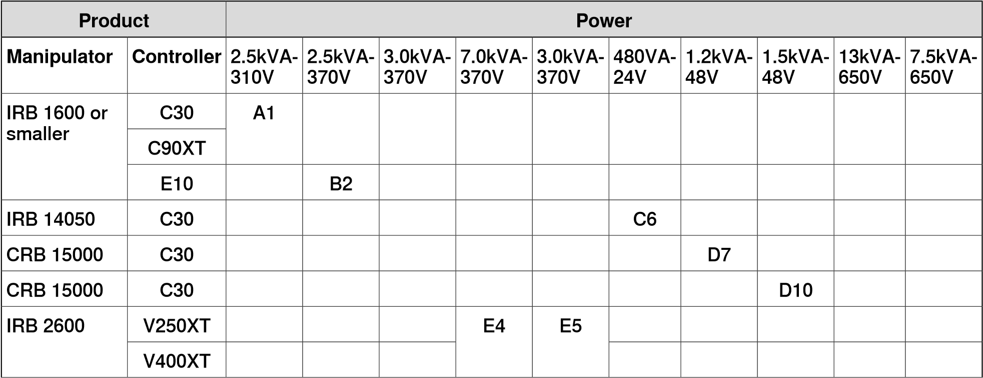

**Power**

**Product**

E9

E8

V250XT

IRB

4600

or

larger

V400XT

**Installing a new RobotWare system**

Description

Before installing a new RobotWare system on the controller, it is required to:

* create a virtual controller.
* create an installation package.

Create a virtual controller

1. Start RobotStudio.
2. Select **Add Controller > Connect to Controller** in the **Controller** ribbon. 3 In the **Connect to Controller** window, select the **Virtual Controllers** tab.
3. Select **New Controller**.
4. In the **New Virtual Controller** dialog, select option **Create New** and complete the following:
   * **Name**

Give the new system a valid name. If you enter an invalid name you will not be able to proceed.

**Note**

The system name can contain between 1 to 55 characters. Allowed characters are "A–Z", "a–z", "0–9", and "-" (hyphen). Hyphen "-" is only allowed between characters.

* + **Location**
  + **Robot model**
  + **RobotWare**
  + **Controller**

**Note**

Selecting option **Create from backup** can be used to create a system based on the configuration found in the selected Backup. This means that the same set of SW products (RobotWare and add-ins), licenses and options will be used.

Note, however that the software referred to by the Backup is not included in the Backup itself and must be previously downloaded to your computer by using the RobotStudio **Add-Ins** page.

Note also that this procedure will not automatically include RAPID programs and system parameters to your new system. If needed, they can be loaded to the new system by restoring the Backup once the new system is installed and started.

1. Select **OK** to continue.
2. Continue with creating an installation package.

**Creating a new installation package**

**Overview**

The installation package is a software package that consists of predefined directory structure and number of files, used for purpose of re-deploying RobotWare System on a robot controller. The installation package is created in RobotStudio and is deployed on the controller using RobotWare Installation Utilities on the FlexPendant. RobotWare Installation Utilities is a small package of installation related utilities that is always present on each robot controller and cannot be removed. It is used to deploy and re-deploy RobotWare system which is the operating system of the robot controller. When in RobotWare Installation Utilities mode, the robot cannot be moved using the FlexPendant and robot programs cannot be written or executed. **Prerequisites**

The following prerequisites must be met before you can start creating an installation package:

* Latest version of RobotStudio must be installed.
* License files for products to be installed must be available. Licenses are included in the RobotWare system at purchase, but can also be retrieved from a backup of the RobotWare system currently deployed on the controller, or exported from the controller via RobotWare Installation Utilities.

**Note**

Virtual

licenses

can

also

be

used.

* Product versions to be installed must be available in RobotStudio or in a custom location.

These versions can be made available by selecting a RobotWare distribution package (.rspak file) from RobotStudio (tap **Install Package** in the **Add-Ins** tab). All products that are installed this way, have matched versions and correct dependencies to each other.

* A virtual controller must be created.

**Create installation package** 1 Start RobotStudio.

1. Select **Add Controller > Connect to Controller** in the **Controller** ribbon.
2. In the **Connect to Controller** window, select the controller and tap **OK**.
3. Request write access.
4. Launch the **Modify Installation** dialog from the **Controller** ribbon.
5. Select the tab **Software**.
6. Select **Create Package** to create an installation package based on the virtual controller configuration.

**Note**

If the virtual system has been built using virtual licenses, these will not be included in the installation package.

If virtual licenses are used, the selected feature configuration will be matched against the real licenses present in the controller and the installation will stop if some licenses are missing. This situation can be avoided if real licenses from the controller are exported and imported into the virtual system when it is built.

1. In the **Create Installation Package** dialog, define the following:

* **Package Name**

Enter a name for the installation package.

* **Location**

Browse and select the output folder (for example, a USB-stick) for the installation package.

Select **OK**.

1. The window **Installation Package created** is displayed. The installation package for the selected system has been created. Select **OK**.
2. Continue with installing the package on the controller.

9.1.3.1 Startup and settings

### 9.1.3 Using Installation Manager for RobotWare 6

#### 9.1.3.1 Startup and settings

**Starting Installation Manager**

On the **Controller** tab, in the **Configuration** group click **Modify Installation** to start the **Installation Manager** application.

This window provides two options. Select **Network** to create systems for *robot controllers* and **Virtual** to create systems for *virtual controllers*.

**Setting application preferences**

Before creating a system using Installation Manager, it is recommended to set the path to the desired location where *products*, *licenses*, and backups are located and where virtual systems will be created.

1. On the **Controller** tab, in the **Configuration** group click **Modify Installation**.
2. In the **Installation Manager** window, click **Preferences**. The **Preferences** window opens.
3. Browse and select folders for **Product path(s)**, **License path(s)**, **Virtual systems path(s)**, and **Backup path(s)** in respective lists.

The **User name** and **Password** boxes are populated with the default credentials provided to you with your RobotStudio license. These credentials are applicable only for a robot controller.

1. In the **Default System Name** box, enter the default system name. When you create a new system, this name will be assigned by default.
2. Click **OK** to set the preferences.

Advanced users can select the location to install virtual controllers. Select the **Virtual products installation path(s)** check box and then click **Browse** to select the folder. You can see the selected path in the drop-down list box. Clear the check box to enable the default path.

**Settings file**

Settings file contains the selected options. When Installation Manager connects to the robot controller, it reads options from the *Settings* file. Any change in the options are mapped in the file.

Use the **Settings** buttons to perform the following tasks with the settings file.

Buttons Description

**Export settings** Click this button to export the current settings of the robot controller.

**Import settings** Click this button to import settings to the robot controller. The current settings of the system will be cleared before performing this operation.

**Add settings** Click this button to add settings to the current setup of the robot controller.

**Revert** Click this button to revert to the current settings of the robot controller.

9.1.3.2 Building a new robot controller

#### 9.1.3.2 Building a new robot controller

**Creating a new system for a robot controller**

1. In the **Installation Manager** window, click **Controllers**, and then click the **Network** tab.

The **Network** tab shows the name and IP address of all the available controllers on the LAN network and/or any controller attached through the service port.

1. Select your controller in the controller list and click **Open**. Installation Manager fetches information from the controller.
2. Click **New**. The **Create New** pane appears.
3. In the **Create New** pane, in the **Name** box, enter the name of the new system.
4. Click **Next**. The **Products** tab gets selected.
5. Click **Add**, the **Select Product** window opens. Select the product manifest file and click **OK**.

If you want to add more products such as Add-ins, click **Add** again and select the product. To find a product that is not in the list, click **Browse** and then select the file from the particular folder.

**Note**

The product install order shows the order in which products and Add-ins are installed on the controller. Installing products in the required sequence is important when products are dependent on each other. The product order is assigned to products automatically based on the sequence in which the products must be installed on the controller. This is independent of the order in which products are added to the system.

1. Click **Next**. The **Licenses** tab gets selected.
2. Click **Add**, the **Select License** window opens. Select the license file and click **OK**.

Repeat the step to add multiple license files to your system.

1. Click **Next**, the **Options** tab gets selected. This pane shows the **System Options**, **Drive Modules** and **Applications**. Here you are able to customize your options.
2. Click **Next**, the **Confirmation** tab gets selected and shows an overview of the system options.
3. Click **Apply**, the system gets created on the controller.

Once the installation completes, a **Restart Controller** dialog appears, click **Yes** to restart the controller. Click **No** to manually restart controller later, the controller

9.1.3.2 Building a new

stores the new system or the changed system and these changes will take effect during the next restart.

**Note**

Changing

the

*RobotWare*

version

needs

*BootServer*

update.

Controller

must

be

restarted

for

BootServer

update.

Hence,

the

controller

will

be

restarted

automatically

when

you

change

the

RobotWare.

**Creating a new system for a virtual controller**

1. In the **Installation Manager** window, click **Controllers**, and then click the **Virtual** tab.
2. Click **New**. The **Create New** pane opens.
3. In the **Create New** pane, in the **Name** box, enter the name of the new system.
4. Click **Next**. The **Products** tab gets selected.
5. Click **Add**, the **Select Product** window opens. Select the product manifest file and click **OK**.

If you want to add more products such as *Add-ins*, click **Add** again and select the product. To find a product that is not in the list, click **Browse** and then select the file from the particular folder.

**Note**

The product install order shows the order in which products and add-ins are installed on the controller. Installing products in the required sequence is important when products are dependent on each other. The product order is assigned to products automatically based on the sequence in which the products must be installed on the controller. This is independent of the order in which products are added to the system.

1. Click **Next**. The **Licenses** tab gets selected.
2. Click **Add**, the **Select License** window opens. Select the license file and click **OK**.

Repeat the same step to add multiple license files to your system.

1. Click **Next**, the **Options** tab gets selected. This pane shows the **System Options**, **Drive Modules** and **Applications**. Here you are able to customize your options.
2. Click **Next**, the **Confirmation** tab gets selected and shows an overview of the system options.
3. Click **Apply**, the system gets created.

9.1.3.3 Modifying a robot controller

#### 9.1.3.3 Modifying a robot controller

**Modifying a system for a robot controller**

1. In the **Installation Manager** window, select **Controllers** and then select the **Network** tab.
2. Select your controller in the controller list and click **Open**. Installation Manager fetches information from the controller.
3. Select the particular system that you want to modify.

The **Overview** pane displays the system options of the selected system.

To be able to modify a system it must first be activated. Select the system you want to modify and press the activate button.

**Note**

1. Click **Next**. The **Products** tab gets selected. All products and add-ins that were part of the selected system will be displayed here.
   * To upgrade/downgrade a product select the product and click **Replace**.
   * To remove a product select the product and click **Remove**.

It is not possible to remove the RobotWare product.

**Note**

1. Click **Next**. The **Licence** tab gets selected. The license details of the selected system will be displayed here. Here you are able to add/remove licenses.
2. Click **Next**. The **Options** tab gets selected. Here you are able to customize your options.
3. Click **Next**, the **Confirmation** tab gets selected and shows an overview of the system options.
4. Click **Apply** for the changes to take place.

Once the installation completes, a **Restart Controller** dialog appears, click **Yes** to restart the controller. Click **No** to manually restart controller later, the controller stores the new system or changed system and these changes will take effect during the next restart.

**Note**

Any change in the

*RobotWare*

version needs a

*BootServer*

update, which requires

a

controller

restart.

The

controller

will

be

restarted

automatically.

**Modifying a system for virtual controller**

1. In the **Installation Manager** window, select **Controllers** and then select the **Virtual**. Here you are able to view the list of all virtual systems.
2. Select the particular system that you want to modify.

The **Overview** pane will display the system options of the selected system.

9.1.3.3 Modifying a

1. Click **Next**. The **Products** tab gets selected. All products and add-ins that were part of the selected system will be displayed here.
   * To upgrade/downgrade a product select the product and click **Replace**.
   * To remove a product select the product and click **Remove**.

It is not possible to remove the *RobotWare* product.

**Note**

1. Click **Next**. The **Licence** tab opens. The license details of the selected system will be displayed here. Here you are able to add/remove licenses.
2. Click **Next**. The **Options** tab opens. This pane shows the **System Options**, **Drive Modules** and **Applications**. Here you are able to customize your options.
3. Click **Next**, the **Confirmation** tab gets selected and shows an overview of the system options.
4. Click **Apply** for the changes to take place.

**Deleting a system from a robot controller**

1. In the **Installation Manager** window, select **Controllers** and then select the **Network** tab.
2. Select your controller in the controller list and click **Open**. Installation Manager fetches information from the controller.
3. Select the system you want to delete and then click **Remove**. The selected system gets deleted.

**Note**

The

active

system

cannot

be

deleted.

First

activate

a

different

system,

or

deactivate

the

system

by

using

the

restart

mode

**Start**

**Boot**

**Application**

.

**Deleting a system from virtual controller**

1. In the **Installation Manager** window, select **Controllers** and then select the **Virtual** or **Network** tab. Here you are able to view the list of all virtual systems.
2. Select the system you want to delete and then click **Remove**. The selected system gets deleted.

**Note**

When you create a system for *virtual controller*, corresponding products are installed in the user APPDATA folder, and many virtual controller systems point to these *products*. Hence, products are not deleted while deleting a system from virtual controller.

9.1.3.4 Copying a robot controller

#### 9.1.3.4 Copying a robot controller

**Copying a system from a virtual controller to a robot controller**

To be able to copy a *virtual controller* to a *robot controller*, the virtual controller must have been created with real license files.

1. In the **Installation Manager** window, select **Controllers** and then select the **Network** tab.
2. Select your controller in the controller list and click **Modify**. Installation Manager fetches information from the controller.
3. Click **New**. The **Create New** pane opens.
4. Enter the name of the virtual controller in the **Name** box, and then click the **virtual system** option under **Create new from**.
5. Click **Select**, the **Select Virtual System** pane opens, select the particular system and then click **OK**.
6. Click **Next**. The **Products** tab gets selected. All products and add-ins that were part of the selected virtual controller will be displayed here.
7. Click **Next**. The **Licenses** tab gets selected. The license details of the selected virtual controller will be displayed here.
8. Click **Next.** The **Options** tab gets selected. Here you are able to select/deselect options to customize them.
9. Click **Next**, the **Confirmation** tab gets selected and shows an overview of the system options.
10. Click **Apply**, the system gets created.

Once the installation completes, a **Restart Controller** dialog appears, click **Yes** to restart the controller. Click **No** to manually restart controller later, the controller stores the new or changed virtual controller and these changes will take effect during the next restart.

**Copying a virtual controller**

1. In the **Installation Manager** window, select **Controllers** and then select the **Virtual** tab. Here you are able to view the list of all virtual systems.
2. Click **New**, the **Create New** pane opens.
3. Enter the name of the virtual system in the **Name** box, and then click the **virtual system** option under **Create**.
4. Click **Select**, the **Select Virtual System** pane opens, select the particular system and then click **OK**.
5. Click **Next**. The **Products** tab gets selected. All products and add-ins that were part of the selected system will be displayed here.
6. Click **Next**. The **Licence** tab gets selected. The license details of the selected system will be displayed here.
7. Click **Next**. The **Options** tab gets selected. Here you are able to select/deselect options to customize them.
8. Click **Next**, the **Confirmation** tab gets selected and shows an overview of the system options.

9.1.3.4 Copying a

1. Click **Apply** for the changes to take place.

9.1.3.5 Creating a robot controller from backup

#### 9.1.3.5 Creating a robot controller from backup

**Creating a robot controller from backup for a robot controller**

1. In the **Installation Manager** window, select **Controllers** and then select **Network** tab.
2. Select your controller in the controller list and click **Open**. Installation Manager fetches information from the controller.
3. Click **New**, the **Create New** pane opens.
4. Enter the name of the robot controller in the **Name** box, and then click **backup** option under **Create**.
5. Click **Select**, the **Select Backup** pane opens, you can select the particular backup system and then click **OK**. If the right RobotWare already exists, then the version will be selected.

**Note**

In the folder hierarchy of the backup path, the name of the valid backup system folder that must be selected will be set in bold. Similarly, names of all valid backup systems will be marked in bold in the folder hierarchy. User must select one of the valid backup folders for further system creation.

1. Click **Next**. The **Products** tab gets selected. All products and add-ins that were part of the backup will be displayed here. You can add new/other product(s) and/or replace RobotWare version if needed.
2. Click **Next**. The **Licenses** tab gets selected. The license details of the backup will be displayed here. You are able to view the license(s) from the backup. Here you can add new/more licenses.
3. Click **Next** the **Options** tab gets selected, select/deselect options to customize them.
4. Click **Next**, the **Confirmation** tab gets selected and shows an overview of the system options.
5. Click **Apply**, the system gets created.

Once the installation completes, a **Restart Controller** dialog appears, click **Yes** to restart the controller. Click **No** to manually restart controller later, the controller stores the new system or changed system and these changes will take effect during the next restart.

**Creating a robot controller from backup for a virtual controller**

1. In the **Installation Manager** window, select **Controllers** and then select the **Virtual** tab. Here you are able to view the list of all virtual systems.
2. Click **New**, the **Create New** pane opens.
3. Enter the name of the system in the **Name** box, and then click **backup** option under **Create**.
4. Click **Select**, the **Select Backup** pane opens, you can select the particular backup system and then click **OK**.

9.1.3.5 Creating a robot controller from backup *Continued*

If the right RobotWare already exists, then the version will be selected. If the RobotWare does not exist, click **Replace** to select the RobotWare.

**Note**

In the folder hierarchy of the backup path, the name of the valid backup system folder that must be selected will be set in bold. Similarly, names of all valid backups will be marked in bold in the folder hierarchy. User must select one of the valid backup folders for further system creation.

1. Click **Next**. The **Products** tab gets selected.

All *products* and *add-ins* that were part of the backups will be displayed here. You can add new/other product(s) and/or replace RobotWare if needed.

1. Click **Next**. The **Licenses** tab gets selected. Here you are able to view the license details of the backup.
2. Click **Next**, the **Options** tab gets selected, select/deselect options to customize them.
3. Click **Next**, the **Confirmation** tab gets selected and shows an overview of the system options.
4. Click **Apply**, the virtual controller gets created.

9.1.3.6 Renaming a robot controller

#### 9.1.3.6 Renaming a robot controller

**Renaming a robot controller**

You can rename a robot controller without re-installation.

1. In the **Installation Manager** window, select **Controllers** and then select **Network** tab.
2. Select the active system which must be renamed.
3. Click **Rename**. The **Rename System** dialog appears.
4. In the **Enter the new name for the system** box, type in the new name.
5. Click **Rename**.

9.2.1 About System Builder

## 9.2 Using System Builder for managing RobotWare 5

### 9.2.1 About System Builder

**Overview**

This section describes how you create, build, modify and copy systems to run on virtual and robot controllers. These systems may even be converted to boot media and downloaded to a robot controller.

The system points out the robot models and options to use; it also stores configurations and programs for the robots. Therefore, it is good practice to use a unique system for each station even if the stations use the same basic setup. Otherwise, changes in one station may accidently overwrite data used in another station.

**Note**

Use

System

Builder

to

create

and

modify

systems

based

on

RobotWare

5

.xx.

Use Installation Manager to create and modify systems with RobotWare versions

6.0

and

later.

**About virtual and real systems**

The system you run on virtual controllers can either be a real system built on real RobotWare keys or a virtual system built on virtual keys.

When using real systems, the RobotWare keys define which options and robot models shall be used, thus helping you to configure the system correctly. Real systems can be run both on virtual controllers and real IRC5 controllers. When using virtual keys, all options and robot models are available, which is useful for evaluation purposes, but requires more configuration when creating the system. Systems built on virtual keys can only be run on virtual controllers.

**Prerequisites**

Creating a system entails applying a predefined template to a station, reusing an existing system or letting RobotStudio propose a system based on a layout.

To create a system, the following conditions must be met:

* The RobotWare media pool must be installed on your PC.
* You must have a RobotWare key for the system, if creating a system to run on a robot controller. The RobotWare key is a license key that determines which robot models to use and which RobotWare options to run on the controller. The license key is delivered with the controller.
* If you want to create a system for virtual use only, you can use a virtual key instead. Virtual keys are generated by the wizard. When using virtual keys, you select the robot models and options to use in the *Modify Options* section of the wizard.
* Downloading to the robot controller requires a direct connection from your computer to the service or Ethernet port of the controller.

9.2.2 Viewing system properties

### 9.2.2 Viewing system properties

**Overview**

All systems you create with the System Builder are stored locally on your computer. It is recommended that you store them in one or more dedicated system directories.

**Viewing system properties**

To view system properties and add comments, follow these steps:

1. In the **System Builder** dialog box, select a system from the **Systems** box.

If necessary, in the **System directory** list, you can navigate to the folder in which your systems are stored.

1. The system properties are then displayed in the **System Properties** box.

Optionally, type a comment in the **Comments** box, and click **Save**.

9.2.3 Building a new

### 9.2.3 Building a new system

**Overview**

The **New Controller System Wizard**, used for building a new system, is launched from the System Builder.

**Starting the wizard**

To start the wizard, follow these steps:

1. Click **System Builder** to bring up a dialog box.
2. In the **Actions** group, click **Create New**. This starts the wizard.
3. Read the information on the welcome page and click **Next**.

**Specifying the name and location**

To determine where on your computer to store the system you are creating, follow these steps:

1. In the **Name** box, enter a name for the system you are creating.
2. In the **Path** box, enter the path to the system directory in which you will store the system.

You can also click the **Browse** button and browse to the system directory. 3 Click **Next**.

**Entering the RobotWare keys**

The RobotWare keys determine which RobotWare versions and parts to use in the system.

Creating a system to run on either IRC5 controllers or virtual controllers requires at least two keys: one for the controller module and one for each drive module in the cabinet. The keys are delivered together with the controller.

For creating a system to run on virtual controller only (for example, in Virtual IRC5), you can use virtual keys. Virtual keys give access to all options and robot models, but limits the use of the system to virtual controllers only.

To enter the key for the controller module, follow these steps:

1. In the **Controller Key** box, enter the controller key. You can also click **Browse** and browse to the key file. If creating a system for virtual use only, select the **Virtual Key** check box, and the controller key will be generated by the wizard.
2. In the **Media Pool** box, enter the path to the media pool. You can also click **Browse** and browse to the folder system.
3. In the **RobotWare Version** list, select which version of the RobotWare you want to use. Only RobotWare versions that are valid for the used key are available.
4. Click **Next**.

9.2.3 Building a new system *Continued*

**Entering the drive keys**

To enter the keys for the drive modules:

1. In the **Drive Key** box, enter the key for the drive module. You can also click the **Browse** button and browse to the key file. If you used a virtual controller key, a virtual drive key is already generated by the wizard.
2. Click the right arrow button next to the **Drive Key** box. The key now appears in the **Added drive keys** list.

For real systems the drive key determines the connected robot model. For virtual systems you select the robot model in the *Modify Options* page. The default model is IRB140.

1. If you have a MultiMove system, repeat steps 1 and 2 for each drive key to add.

If you have a MultiMove system, make sure that the keys are numbered in the same way as their corresponding drive modules are connected to the controller module. Use the up and down arrows to rearrange the drive keys, if necessary.

1. If you want to create the system as it is now, click **Finish**.

If you want to modify options, or add options, parameter data or additional files to the home directory, click **Next**.

**Adding additional options**

Here you can add options, such as external axes and dispense applications, that are not included in the basic system. Options require a license key and must be first imported to the media pool. To add additional options, follow these steps:

1. In the **Key** box, enter the option key. You can also click the **Browse** button and browse to the option's key file.
2. Click the **Arrow** button.

The option that the key unlocks is now displayed in the **Added Options** list.

**Note**

If several versions of an additional option exists, only the latest version can be selected. To use an older version, remove the other versions of the additional option from the Mediapool.

System Builder can modify a system only when all referenced additional options and RobotWare mediapool are placed in the same folder. It is not possible to modify a system that uses a mediapool embedded in a Pack and Go file. You must copy the mediapool to a common mediapool folder and create a system from backup.

1. Repeat steps 1 and 2 for all options you want to include.
2. Choose whether you want to create the system as it is now, or to continue with the wizard.

If you want to create the system as it is now, click **Finish**.

*Continues on next page*

9.2.3 Building a new

*Continued*

If you want to modify options, or add parameter data or additional files to the home directory, click **Next**.

**Modifying options**

Here you can set up and configure the options in your system. For virtual robot systems, you also select the robot models to use. To modify any options, follow these steps:

1. In the **Option** tree, expand the option folders to the level where you find the option you want to modify.

Only the options unlocked by the used keys are available.

1. Modify the option.
2. Repeat steps 1 and 2 for all options you want to modify.
3. Choose whether you want to create the system as it is now, or to continue with the wizard.

If you want to create the system as it is now, click **Finish**.

If you want to add parameter data or additional files to the home directory, click **Next**.

**Adding parameter data**

Parameter data is stored in the parameter data files (.cfg files). Each parameter topic has its own parameter file. You can add only one parameter file for each topic. To add parameter data, follow these steps:

1. In the **Parameter data** box, enter the path to the folder for the parameter data files. You can also click the **Browse** button and browse to the folder.
2. In the list of parameter data files, select the file you want to include and press the **Arrow** button. Repeat for all files you want to include.

The included parameter data files will now appear in the **Added parameter data files** list.

Repeat steps 1 and 2 for each parameter data file you want to add.

1. Choose whether you want to create the system as it is now, or to continue with the wizard.

If you want to create the system as it is now, click **Finish**.

If you want to add additional files to the home directory, click **Next**.

**Adding files to the home directory**

You can add any type of file to the system’s home directory. When the system is loaded to a controller, these files will also be loaded. To add files to the system's home directory, follow these steps:

1. In the **Files** box, enter the path to the folder for the files you want to include. You can also click the **Browse** button and browse to the folder.
2. In the list of files, select the file to add and click the **Arrow** button. Repeat for all files you want to add.

The added files will now appear in the **Added files** list.

9.2.3 Building a new system

*Continued*

1. Choose whether you want to create the system as it is now, or to continue with the wizard.

If you want to create the system as it is now, click **Finish**.

If you want to read a summary before you create the system, click **Next**.

**Completing the New Controller System Wizard**

To complete the wizard, follow these steps:

1. Read the system summary.
2. If the system is OK, click **Finish**.

If the system is not OK, click **Back** and make modifications or corrections.

9.2.4 Modifying

### 9.2.4 Modifying a system

**Overview**

The **Modify Controller System Wizard**, used to modify existing systems, is launched from the System Builder. The wizard helps you with tasks like changing robots, adding and removing external axes and other options. A system that is running must be first shut down before modification.

**Starting the wizard**

To start the wizard when creating a new station:

1. If the system is currently running, on the **Controller** menu, point to **Shutdown** and then click **Shutdown**.
2. On the **Controller** menu, click **System Builder** to bring up a dialog box.
3. In the **System directory** list, enter or browse to the system directory. Select a system from the list beneath, review the system properties and add and save any comments.
4. In the **Actions** group, click **Modify**. This starts the wizard.
5. Read the information on the welcome page and click **Next**.

**Modifying the program revision**

The RobotWare versions that are available for the system are determined by the controller key. The key is essential to the system and cannot be modified.

To use another RobotWare version than the available ones, create a new system with another key.

To optionally modify the program revision, follow the appropriate step or steps:

1. To keep the current RobotWare version, select **Yes** and then click **Next**.
2. To replace the current RobotWare version, Select **No, replace it**.
3. In the **Media pool** box, enter the path to the media pool. You can also click the **Browse** button and browse to the folder.
4. In the **New program revision** box, select which version of RobotWare you want to use. Only RobotWare versions that are valid for the RobotWare key are available. 5 Click **Next**.

**Adding or removing drive keys**

The drive key corresponds to the drive modules in your controller. For MultiMove systems, you have one drive module (and one key) for each robot. The keys for your system are delivered together with the controller.

The system is created with a virtual robot controller key, virtual drive keys are generated by the wizard. When you have added one virtual drive key for each robot, you select which robot to use for each key on the *Modify Options* page.

To optionally add or remove the keys for the drive modules, follow these steps:

1. To add a key for a drive module, enter the key in the **Enter Drive Key** box.

You can also click the **Browse** button and browse to the key file.

9.2.4 Modifying a system

*Continued*

1. Click the right arrow button. The key now appears in the **Added drive key** list.

If you have a MultiMove system, repeat steps 1 and 2 for each drive key to add.

1. To remove a drive module, select the corresponding key in the **Added drive key** list and click **Remove drive key**.

If you have a MultiMove system, repeat step 3 for each drive key to remove.

1. If you have a MultiMove system, make sure that the keys are numbered in the same way as their corresponding drive modules are connected to the controller module. Use the up and down arrows to rearrange the drive keys, if necessary.
2. Choose whether you want to create the system as it is now, or to continue with the wizard.

If you want to create the system as it is now, click **Finish**.

If you want to modify options, parameter data or add files to or remove files from the home directory, click **Next**.

**Adding or removing additional options**

To optionally add or remove additional options:

1. To add an add-in, in the **Enter Key** box, enter the option key. You can also click the **Browse** button and browse to the option's key file.
2. Click the **Arrow** button.

The option that the key unlocks is now displayed in the **Added Options** list.

**Note**

If several versions of an additional option exists, only the latest version can be selected. To use an older version, remove the other versions of the additional option from the Mediapool.

1. Repeat steps 1 and 2 for all options you want to include.
2. To remove an add-in, In the additional options, in the Added options list, select the add-in you want to remove.
3. Click **Remove**.
4. Choose whether you want to create the system as it is now, or to continue with the wizard.

If you want to create the system as it is now, click **Finish**.

If you want to modify parameter data or add files to or remove files from the home directory, click **Next**.

**Modifying options**

To optionally modify any options, follow these steps:

1. In the **Option** tree, expand the option folders to the level where you find the option you want to modify.

Only the options unlocked by the used keys are available.

*Continues on next page*

9.2.4 Modifying *Continued*

1. Modify the option.
2. Repeat steps 1 and 2 for all options you want to modify.
3. Choose whether you want to create the system as it is now, or to continue with the wizard.

If you want to create the system as it is now, click **Finish**.

If you want to modify parameter data or add files to or remove files from the home directory, click **Next**.

**Adding or removing parameter data**

Parameter data is stored in the parameter data files (.cfg files). Each parameter topic has its own parameter file. You can add only one parameter file for each topic. To add or remove parameter data, follow these steps:

1. To add parameter data, in the **Parameter data** box, enter the path to the folder for the parameter data files. You can also click the **Browse** button and browse to the folder.
2. In the list of parameter data files, select the file you want to include and press the **Arrow** button. Repeat for all files you want to include.

The included parameter data files will now appear in the **Added parameter data files** list.

Repeat steps 1 and 2 for each parameter data file you want to add.

1. To remove parameter data, in the **Added parameter data files** list, select the parameter data file to remove.
2. Click **Remove**.
3. Choose whether you want to create the system as it is now, or to continue with the wizard.

If you want to create the system as it is now, click **Finish**.

If you want to add to or remove files from the home directory, click **Next**.

**Add files to or remove files from the home directory**

You can add any type of file to the system’s home directory, or remove files from it. When the system is loaded to a controller, these files will also be loaded. To optionally add files to or remove files from the system's home directory, follow these steps:

1. To add files, in the **Files** box, enter the path to the folder for the files you want to include. You can also click the **Browse** button and browse to the folder.
2. In the list of files, select the file to add and click the **Arrow** button. Repeat for all files you want to add.

The added files will now appear in the **Added files** list.

1. To remove files, in the **Added files** list, select the file to remove.
2. Click **Remove**.
3. Choose whether you want to create the system as it is now, or to continue with the wizard.

If you want to create the system as it is now, click **Finish**.

9.2.4 Modifying a system

*Continued*

If you want to read a summary before you create the system, click **Next**.

**Complete the Modify Controller System wizard**

To complete the wizard, follow these steps:

1. Read the system summary.
2. If the system is OK, click **Finish**.

If the system is not OK, click **Back** and make modifications or corrections.

**Result**

Modifications will take effect when the wizard is completed.

If the system has been downloaded to a controller, it must be downloaded again before the modifications will take effect on the controller.

If the system is used by a virtual controller, restart the controller using the restart mode **Reset controller** for the changes to take effect.

**Deleting a system**

To delete a system, follow this steps:

1 From the **System Builder** dialog box, select the system and then click **Delete**.

9.2.5 Copying

### 9.2.5 Copying a system

**Copy a system**

To copy a system, follow these steps:

1. From the **System Builder** dialog box, select the system and then click **Copy** to bring up a dialog box.
2. Enter a name for the new system and a path, and then click **OK**.

9.2.6 Creating a system from backup

### 9.2.6 Creating a system from backup

**Overview**

The **Create System from Backup Wizard**, which creates a new system from a controller system backup, is launched from the System Builder. In addition, you can change the program revision and options.

**Starting the wizard**

To start the wizard, follow these steps:

1. From the **System Builder** dialog box, click **Create from Backup**. This starts the wizard.
2. Read the information on the welcome page and click **Next**.

**Specifying the name and location**

To specify the destination folder, follow these steps:

1. In the **Name** box, enter a name for the system you are creating.
2. In the **Path** box, enter the path to the system directory in which you will store the system.

You can also click the **Browse** button and browse to the system directory. 3 Click **Next**.

**Locating the backup**

To locate a system from backup, follow these steps:

1. In the **Backup folder** box, enter the path to the backup folder. Alternatively, click the **Browse** button to browse to it. Click **Next**.
2. In the **Media Pool** box, enter the path to the media pool containing the appropriate RobotWare program. Confirm the backup information that now appears in the wizard. Click **Next**.

9.2.7 Downloading a system to a controller

### 9.2.7 Downloading a system to a controller

**Overview**

All systems you access from the System Builder are stored on your computer. If you wish to run a system on a robot controller, you must first load it to the controller, which then requires a restart.

**Load a system**

To load a system to a controller, follow these steps:

1. From the System Builder dialog box, select a system and then click **Download to Controller** to bring up a dialog box.

**Note**

Systems with incompatible hardware versions will not be displayed in the **Download to Controller** dialog box.

1. Specify the Destination Controller for the system.

**You can select by using the... if...**

**Select controller from list** option the controller has been detected automatically.

**Specify IP address or controller name** your PC and the robot is connected to the option same network.

You can only use the controller name in DHCP networks.

**Use service port** option your PC is directly connected to the con-

troller's service port.

1. Optionally, click **Test Connection** to confirm that the connection between the computer and the Controller is OK.
2. Click **Load**.
3. Answer **Yes** to the question **Do you want to restart the controller now?**

Yes The controller restarts immediately and the downloaded system

starts automatically.

No The controller does not restart immediately.

To start using the downloaded system, you have to:

a Restart the controller using the restart mode **Start Boot Application**. b Select the system manually.

Cancel The downloaded system is removed from the controller.

9.2.8.1 A system with support for one robot and one positioner external axis

##### 9.2.8 Examples using the System Builder when offline

###### 9.2.8.1 A system with support for one robot and one positioner external axis

**Overview**

In this example we will use the System Builder to create an offline system to use in a new RobotStudio station with one IRB1600 robot and one IRBP 250D positioner external axis.

**Prerequisites**

When creating systems for positioner external axes, you need the media pool and the license key file for that specific positioner. In this example we will use a media pool and license key file for a demo positioner.

Paths to files and folders assume that RobotStudio and the RobotWare media pool have been installed at their default locations on Windows XP. If not, adjust the paths accordingly.

**Starting the New Controller System Wizard**

To create a system like the one described above, follow these steps:

1. Click **System Builder** to bring up a dialog box.
2. In the dialog box, click **Create New** to bring up the **New Controller System Wizard**.
3. Read the welcome text, and click **Next** to continue to the next page.

|  |  |
| --- | --- |
| **Entering the controller key**  1 | Select the **Virtual key** check box. A virtual controller key now appears in the Controller Key box. In this example we will use the default media pool and RobotWare version. |
| 2 | Click **Next** to continue to the next page. |
| **Entering drive keys** 1 | Click the **Right Arrow** button next to the **Enter Drive key** box to create one drive key for the robot. |
| 2 | Click **Next** to continue to the next page. |

**Adding options**

This is where we point out the key file for the positioner.

1. Next to the **Enter key** box, click the browse button and select the key file.

*Continues on next page*

9.2.8.1 A system with support for one robot and one positioner external axis *Continued*

In this example, browse to and select the file *extkey.kxt* in the folder *C:\Program Files\ABB Industrial IT\Robotics IT\MediaPool\3HEA-000-00022.01*.

**Tip**

In the *MediaPool* folder media pools for several standard positioners are installed. They are named by the positioner’s article number, with a suffix that indicates if it is configured for single-robot or MultiMove systems.

1. Click the *Right Arrow* button next to the **Enter key** box to add the key for the positioner.
2. Click **Next** and continue to the next page of the wizard.

**Modifying options**

When creating robot systems from real robot keys, the key sets the options. But since we are using a virtual key, we have to set the options manually. To set the options necessary for a positioner, follow these steps:

1. Scroll down to the **RobotWare / Hardware** group and select the **709-x DeviceNet** check box.

This option is for the communication between the controller and the track external axis.

1. Scroll down to the **DriveModule1 / Drive module application** group and expand the **ABB Standard manipulator** option. Select the **IRB 1600** option. This option sets the robot to an IRB 1600-5/1.2.
2. Scroll down to the **DriveModule1 > Drive module configuration** group; select the **Drive System 04 1600/2400/260** option; expand the **Additional axes drive module** group and select the **R2C2 Add drive** option.

a Expand the **Drive type in position Z4** group and select the **753-1 Drive**

**C in pos Z4** option b Expand the **Drive type in position Y4** group and select the**754-1 Drive**

**C in pos Y4** option c Expand the **Drive type in position X4** group and select the**755-1 Drive C in pos X4** option

*Continues on next page*

9.2.8.1 A system with support for one robot and one positioner external axis

*Continued*

This option adds drive modules for the positioner axes.

**Note**

When using the latest drive system, do the following:

Scroll down to the **DriveModule1 > Drive module configuration** group; select the **Drive System 09 120/140/1400/1600 Compact** option; expand the **Power supply configuration** group and select **1-Phase Power supply** or **3-Phase Power supply** (as applicable) > **Additional axes drive module**

> **Additional drive** a Expand the **Drive type in position X3** group and select the **Drive**

**ADU-790A in position X3** option b Expand the **Drive type in position Y3** group and select the **Drive**

**ADU-790A in position Y3** option c Expand the **Drive type in position Z3** group and select the **Drive ADU-790A in position Z3** option

4 Click **Finish** and the system will be created. When starting the system in a RobotStudio station, you have to set up the system to load a model for the positioner and to get the motions to work properly.

9.2.8.2 Options settings for systems with positioners

###### 9.2.8.2 Options settings for systems with positioners

**Overview**

This is an overview of the RobotWare options to set when creating a system for positioner external axes. Note that besides setting the RobotWare options, you must add an additonal option key for the positioner.

**Media pools and option keys for the positioners**

If you have the media pool and option key for your positioner, you can use these files.

If not, media pools for standard positioners are installed with RobotStudio. The path to these media pools in a default installation is: *C.\program files\ABB Industrial IT\Robotics IT\MediaPool*. In this folder a media pool for each positioner is located. These are named by the article number of the positioner, with a suffix that indicates if it is configured for a single-robot or a MultiMove system.

In the **Additional option** page of the **System Builder**, you should add the option for the positioner by opening the mediapool folder for the positioner to add and selecting the *extkey.kxt* file.

**Options for positioners in single-robot systems**

When adding a positioner to a single-robot system, the positioner will be added to the same task as the robot. Below, the options to set on the **Modify Options** page of the **System Builder** for such a system are listed:

* **RobotWare** > **Hardware** > **709-x DeviceNet** > **709-1 Master/Slave Single**
* Optionally, for using the system with ArcWare also add **RobotWare** > **Application arc** > **633-1 Arc**
* **DriveModule 1** > **Drive module configuration** > **Drive System 04**

**1600/2400/260** > **RC2C Add drive** > **753-1 Drive C in pos Z4** > **754-2 Drive T in pos Y4** > **755-3 Drive U in pos X4**

**Options for positioners in MultiMove robot systems**

When adding a positioner to a MultiMove robot system, the positioner shall be added to a task of its own (thus you also have to add a drive key for the positioner). Below, the options to set on the **Modify Options** page of the **System Builder** for such a system are listed:

* **RobotWare** > **Hardware** > **709-x DeviceNet** > **709-1 Master/Slave Single**
* **RobotWare** > **Motion coordinated part 1** > **604-1 MultiMove Coordinated** Optionally, expand the MultiMove Coordinated option and select process options for the robots.
* Optionally, for using the system with ArcWare, add **RobotWare** > **Application Arc** > **633-1 Arc**
* **DriveModule 1** > **Drive module configuration** > **Drive System 04**

**1600/2400/260** > **RC2C Add drive** > **753-1 Drive C in pos Z4** > **754-2 Drive T in pos Y4** > **755-3 Drive U in pos X4**. For the other drive modules, no additional axes should be configured.

9.3.1 Creating a coordinated system using System Builder

**9.3 A MultiMove system with two coordinated robots**

##### 9.3.1 Creating a coordinated system using System Builder

**Overview**

In this example we will use the System Builder to create a coordinated offline system with one IRB2400 and one IRB1600 robot to use in a new RobotStudio station.

**Starting the New Controller System Wizard**

To create a system like the one described above, follow these steps:

1. Click **System Builder** to bring up the dialog box.
2. In the dialog box, click **Create New** to bring up the **New Controller System Wizard**.
3. Read the welcome text, and click **Next** to continue to the next page.

**Entering the name and path**

1. In the **Name** box, enter the name of the system. The name must not contain blank spaces or non-ASCII characters.

In this example, name the system *MyMultiMove*.

1. In the **Path** box, enter the path for the folder to save the system in, or click the **Browse** button to browse to the folder or create a new one.

In this example, save the system in *C:\Program Files\ABB\RobotStudio\ABB Library\Training Systems*.

1. Click **Next** to continue to the next page.

**Entering the controller key**

1. Select the **Virtual key** check box. A virtual controller key now appears in the Controller Key box. In this example we will use the default media pool and RobotWare version.
2. Click **Next** to continue to the next page.

**Entering drive keys**

1. Click the **Right Arrow** button next to the **Enter Drive key** box twice to create one drive key for each robot.
2. Click **Next** to continue to the next page.

**Adding options**

This system does not require any additional option keys. Click **Next** and continue to the next page of the wizard.

**Modifying options**

When creating robot systems from robot keys, the key sets the options. But since we are using a virtual key, we have to set the options manually.

*Continues on next page*

9.3.1 Creating a coordinated system using System Builder *Continued*

When creating a system for several manipulators (up to four), you must include either of the RobotWare options **MultiMove Independent**, or **MultiMove Coordinated** for the related motion tasks to start.

**Note**

It is recommended to use the **System From Layout** function when you create robot systems for RobotStudio. Then the MultiMove option gets added automatically.

To set the options necessary for a MultiMove, follow these steps:

1. Scroll down to the **RobotWare / Motion Coordination part 1** group and select the **MultiMove Coordinated** check box.
2. Scroll down to the **RobotWare/ Engineering Tools** group and select the **Multitasking** check box.

**Note**

The

option

**Advanced RAPID**

is

included

in

RobotWare-

operating

system

from

RobotWare

5.60

and

later.

1. Scroll down to the **DriveModule1 / Drive module application** group and expand the **ABB Standard manipulator** option. Select the **IRB 2400 Type A** option, manipulator variant **IRB 2400L Type A**.
2. Scroll down to the **DriveModule2 / Drive module application** group and expand the **ABB Standard manipulator** option. Select the **IRB 1600** option, manipulator variant **IRB 1600-5/1.2**.
3. Click **Finish** and the system will be created.

9.3.2 Creating a coordinated system using Installation Manager

##### 9.3.2 Creating a coordinated system using Installation Manager

**Overview**

In this example we will use the Installation Manager to create a coordinated *offline* system to use in a new RobotStudio *station*.

**Creating a coordinated system**

To create a system like the one described above, follow these steps:

1. In **Installation Manager**, in the **Controllers** page select a system and click **Next**.
2. In the **Product** page, click **Add**, the **Select Product** dialog box is displayed.
3. Select the required product and click **OK**.
4. Select the added product and click **Next**.
5. In the **Licenses** page, select the required license and click **Next**.
6. In the **Options** page, under the **System Options** tab, select the **Motion Coordination > Multimove Options > 604-1 MultiMove Coordinated** check box. The **Engineering Tools** option will auto-expand.
7. Under the **Engineering Tools** option, select the required check boxes and click **Next**.
8. In the **Confirmation** page, review the system configuration and click **Apply**, to create the system.

10.1 System parameters

1. **Working with system parameters**

**10.1 System parameters**

**Overview**

The controller configuration is a collection of six topics, each describing a configuration area of the controller. A controller is configured at the factory as per the *RobotWare* options that are selected at the time of delivery. The factory default configuration is altered only during an update or any alteration processes. The configuration parameters can be saved as text files *(*.cfg)* that lists the values of system parameters. If the parameter is assigned the default value, then it will not be listed in the configuration file.

When creating a backup of the controller, the configuration files will be stored in the *SYSPAR* folder of the backup file structure. The configuration files will be loaded into the controller memory when the backup is restored.

The controller system folder contains the *SYSPAR* folder in

...\MySystem\SYSPAR\ location. The configuration files in this folder gets loaded when the controller resets. Note that changes to the configuration and *RAPID* will be discarded during a controller reset. Configuration changes which are related to the installation and independent of the program being executed can be loaded from the *SYSPAR* folder. Examples of folders that can be loaded are configuration of background *tasks* and the corresponding RAPID *modules*.

**Topic: Configuration area: Configuration file:**

Communication Communication protocols and devices SIO.cfg

Controller Safety and RAPID specific functions SYS.cfg

I/O I/O boards and signals EIO.cfg

Man-machine Functions to simplify working with the *vir-* MMC.cfg communication *tual controller*

Motion The robot and *external axes* MOC.cfg

Process Process specific tools and equipment PROC.cfg

A topic is a collection of system parameters of the same type. It represents a configuration area of the controller. A separate configuration file is saved for each topic, it can also be generated while creating a backup. Type holds the parameter definition. The parameter values are normally predefined at delivery. The values are restricted to data type, and sometimes to be within an interval. An instance is a user defined variable of the selected type. In some cases system parameters, depending on their values, are further structured into subparameters, also called

*Continues on next page*

10.1 System parameters

*Continued*

arguments or action values. The following image shows the details of the I/O signal, *di2*.

en0800000183

System parameters are configured using RobotStudio or the FlexPendant.

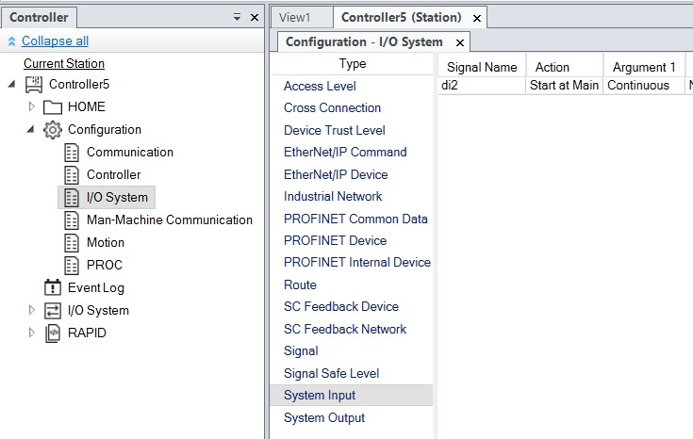

xx1800003052

**Viewing configurations**

* 1. To view the topics of a controller, from the **Controller** tab, expand the **Configuration** node of the controller.

All topics are now displayed as child nodes of the Configuration node.

* 1. To view the types and instances of a topic, double-click the required topic node.

The **Configuration Editor** opens and lists all types of the topic in the **Type name** list. In the **Instance** list, rows display the selected type and columns display parameter values of the instances.

* 1. To view detailed parameter information of an instance, double-click the instance.

The instance editor displays the current value, restrictions and limits of each parameter in the instance.

*Continues on next page*

10.1 System parameters *Continued*

**Note**

Virtual networks, devices and signals contained in the EIO.cfg file can be viewed the I/O System node in the Controller browser.

10.2 Adding instances

**10.2 Adding instances**

Use the **Configuration Editor** to select a configuration type and to create a new instance of the type, for example, adding a new instance of the type *Signal* creates a new signal in the virtual controller.

* 1. In the **Controller** tab, expand the **Controller** and the **Configuration** node and double-click the topic that contains the type to add an instance. This opens the Configuration Editor.
  2. In the **Type name** list, select the type to add an instance.
  3. Double-click the type, the corresponding window opens to the right hand side.
  4. Right-click any element, and click **Edit Tasks**.
  5. On the **Controller** menu, point to **Configuration** and click **Add type** (the word type is replaced by the type that was selected earlier).

Right-click anywhere in the configuration editor and then select **Add type** from the shortcut menu.

A new instance with default values gets added and displayed in the **Instance Editor** window.

6 Click **OK** to save the new instance.

The values in the new instance are now validated. If the values are valid, the instance gets saved, else a notification on the incorrect parameter values gets displayed. Certain changes take effect only after a controller restart.

10.3 Copying an instance

**10.3 Copying an instance**

* 1. In the **Controller** tab, expand the **Controller** and the **Configuration** node and double-click the topic that contains the instance to copy. This opens the Configuration Editor.
  2. In the **Type name** list of the Configuration Editor, select the type to copy an instance.
  3. Right--click the selected row, and then click **Copy** and change the name of the instance. Click **OK**.
  4. To select multiple instances, in the **Instance** list, select several instances to copy.

The parameter values of all selected instances must be identical, else the default values will be absent in the parameters of the new instances.

* 1. On the **Controller** menu, point to **Configuration** and click **Copy Type** (the word type is replaced by the type that was selected earlier).

Right-click the instance to copy and then select **Copy Type** from the shortcut menu.

A new instance with the same values as the one that was copied gets added and displayed in the **Instance Editor** window.

6 Change the name of the instance and click **OK** to save the new instance.

The values in the new instance are now validated. If the values are valid, the instance gets saved, else a notification on the incorrect parameter values gets displayed. Certain changes take effect only after a controller restart.

10.4 Deleting an instance

**10.4 Deleting an instance**

* 1. In the **Controller** tab, expand the **Controller** and the **Configuration** node and double-click the topic that contains the type of which you want to delete an instance. This opens the Configuration Editor.
  2. In the **Type name** list of the Configuration Editor, select the type of which you want to delete an instance.
  3. In the **Instance** list, select the instance to delete.
  4. On the **Controller** menu, point to **Configuration** and then click **Delete type** (the word type is replaced by the type you selected previously).

You can also right-click the instance to delete and then select **Delete type** from the shortcut menu.

* 1. A message box is displayed, asking if you want to delete or keep the instance. Click **Yes** to confirm that you want to delete it.

The values in the new instance are now validated. If the values are valid, the instance gets saved, else a notification on the incorrect parameter values gets displayed. Certain changes take effect only after a controller restart.

10.5 Save one configuration file

**10.5 Save one configuration file**

The system parameters of a configuration topic can be saved to a configuration file, stored on the PC or any of its network drives.

The configuration files can then be loaded into a controller. They are thereby useful as backups, or for transferring configurations from one controller to another.

* 1. In the **Controller** tab, expand the **Configuration** node and select the topic to save to a file.
  2. On the **Controller** menu, point to **Configuration** and select **Save Parameters**. You can also right-click the topic and then select **Save System Parameters** from the shortcut menu.
  3. In the **Save As** dialog box, browse for the folder to save the file in.
  4. Click **Save**.

10.6 Saving several configuration files

**10.6 Saving several configuration files**

* 1. In the **Controller** tab, select the **Configuration** node.
  2. On the **Controller** menu, point to **Configuration** and click **Save System Parameters**.

You can also right-click the configuration node and then click **Save System Parameters**.

* 1. In the **Save System Parameters** dialog box, select the topics to save to files. Then click **Save**.
  2. In the **Browse for Folder** dialog box, browse for the folder to save the files in, and then click **OK**.

The selected topics will now be saved as configuration files with default names in the specified folder.

10.7 Loading a configuration file

**10.7 Loading a configuration file**

A configuration file contains the system parameters of a configuration topic. They are thereby useful as backups, or for transferring configurations from one controller to another. When loading a configuration file to a controller, it must be of the same major version as the controller. For instance, you cannot load configuration files from an S4 system to an IRC5 controller.

* 1. In the **Controller** tab, select the **Configuration** node.
  2. On the **Controller** menu, point to **Configuration** and select **Load Parameters**.

Alternatively, right-click the configuration node and then select **Load Parameters** from the context menu. This opens the **Select mode** dialog box. 3 In the **Select mode** dialog box, select the following options:

* + - Select **Delete existing parameters before loading** to replace the entire configuration of the topic with the one in the configuration file.
    - Click **Load parameters if no duplicates** to add new parameters from the configuration file to the topic, without modifying the existing ones.
    - Click **Load parameters and replace duplicates** to add new parameters from the configuration file to the topic and update the existing ones with values from the configuration file. Parameters that exist only in the controller and not in the configuration file will remain.
  1. Click **Open** and browse to the configuration file to load. Then click **Open** again.
  2. In the information box, click **OK** to load the parameters from the configuration file.
  3. After loading the configuration file, close the **Select mode** dialog box.

Certain changes take effect only after a controller restart.

This page is intentionally left blank

11.1 Signal analyzer

1. **Monitoring robot signals**
   1. **Signal analyzer**

**Overview**

Signal Analyzer is used to record robot signals from *robot* or *virtual controllers*. The version of Signal Analyzer used for robot controllers is called Signal Analyzer Online.

* + - To open Signal Analyzer, on the **Simulation** tab, in the **Signal Analyzer** group, click **Signal Analyzer**.
    - To open Signal Analyzer Online, on the **Controller** tab, in the **Controller Tools** group, click **Signal Analyzer Online**.

**Significance of signal analyzer**

The data from the Signal Analyzer can be used to fine-tune robot behavior for optimizing robot performance during production. For example, if the robot is working with a continuous process where constant speed is the critical parameter, then the Signal Analyzer can be used to monitor the speed signals from the robot motion system. Constant monitoring helps in identifying any speed fluctuations which can be traced to the corresponding line in the RAPID code that causes the speed fluctuations. After identifying the root cause of the fluctuations, the robot program can be edited to rectify these issues.

Another example where Signal Analyzer can be used is cable simulation, where the physics signals monitor the cable tension, length and twist. These signals can be used for identifying the wear and tear of cables. Based on these signal data, the cable (routing, length) and the program can be altered to reduce wear.

* 1. Monitored signals

**11.2 Monitored signals**

Signal analyzer can only monitor a group of selected signals. This selection varies for robot controller and virtual controller. The following table provides the list of signals for robot and virtual controllers that can be monitored in signal analyzer.

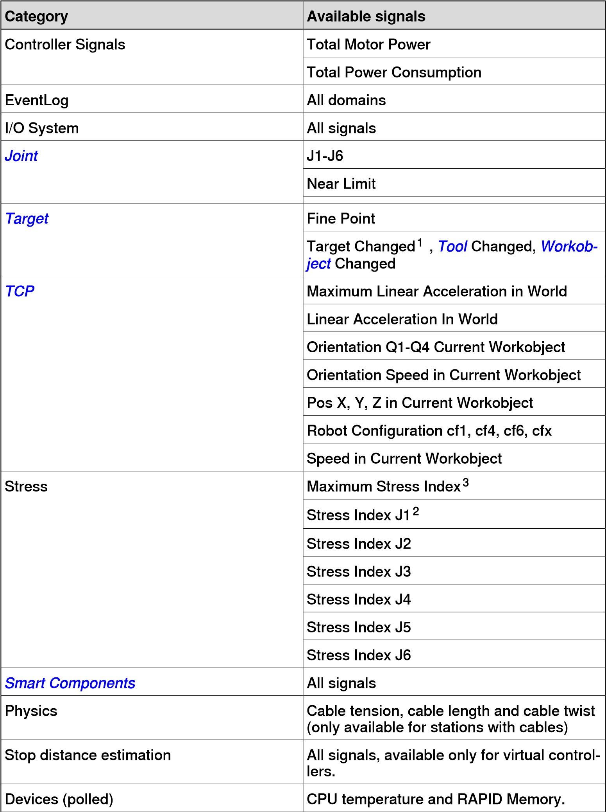

*Continues on next page*

11.2 Monitored signals *Continued*

##### Category Available signals

1. *The Target Changed event data do not represent the current target, instead it representsthe subsequent target.*
2. *Signal for assessing the amount of stress that the joints are subjected to. Monitoring this signal helps in comparative analyses between different options of cycles to reduce the mean value of the signal rather than removing individual maximum values. This signal can also be used to compare the same cycle on different robots. This signal has no unit of measurement and depends on how hard the robot is run relative to the gear on the axis. For a stationary axis, the Stress Index signal value is zero. The maximum value of Stress Index signal is 110.*
3. *The Maximum Stress Index signal has the value of the Stress Index Jx signal with the highest value at each point in time.*

Stop distance estimation

These signals show the stop distance of the robot during a *category 0 stop* or *category 1 stop*. For example, if the stop distance signal for joint J1 is 7 degrees at time=48 ms, it means that J1 will move 7 degrees in positive direction if the robot is stopped at t=48 ms.

**WARNING**

The measurement and calculation of overall stopping performance for a robot must be tested with its correct load, speed, and tools, in its actual environment, before the robot is taken into production, see *ISO 13855:2010*.

Total Motor Power

The Total Motor Power signal shows the total instantaneous power for each *joint*. It may be positive or negative.

The instantaneous power for a specific joint is positive when it accelerates and negative when it decelerates. If one joint is accelerating at the same time as another joint is decelerating, then the negative energy from the decelerating joint is reused by the accelerating joint. If the sum of the instantaneous power of all joints is negative then the power surplus is either fed back to grid or burned off in the bleeder.

For a virtual robot the signal is based on a nominal robot during typical conditions, for a robot the signal is based on the torque for that particular robot in the actual conditions. For a robot the value of the motor power signal depends on various factors, for example, the temperature of the robot and the length of the cables.

**Note**

Total Motor Power signal represents the power consumed by the mechanical robot arm and not the power that is fed into the controller cabinet from the power network. The power used by the controller cabinet is excluded.

*Continues on next page*

11.2 Monitored signals *Continued*

Total Motor Energy

The Total Motor Energy signal is the integration of the power over time. The Total Motor Energy signal includes negative Total Motor Power signal when the controller supports refeeding of power.

**Note**

* For OmniCore controllers with version earlier than 7.10, Total Motor Energy signal is not decreased in RobotStudio even if there is a power surplus.
* For OmniCore controllers with version 7.10 or later, Total Motor Energy signal is decreased in RobotStudio when there is a power surplus.

Purpose of signals

The purpose of the Total Motor Power and Total Motor Energy signals is to provide an estimate of the power and energy used by the robots. For virtual robots, these signals can be used to identify peaks in the power usage to enable the robot programmer to adjust the robot program with the aim to reduce the power consumption. For robots, the signals can be used to compare the power usage of different robot individuals running the same robot program, to see if any robot differs significantly from the others. Any such deviation may indicate that the robot needs maintenance.

Near Limit

Near Limit checks the distance to the closest limit for each *joint*. If any joint is less than 20 degrees from a limit, the Near Limit signal will show the current value. Otherwise, the value of the signal will be constant at 20 degrees. If more than one joint is below 20 degrees from a limit, then the one that is closest will be looked at.

11.3 Recording signals

**11.3 Recording signals**

**Recording signals for a virtual controller**

Before starting signal analyzer, choose the signals that must be recorded in the **Signal Setup** window.

1. Load a *station* with a *virtual controller*.
2. In the **Simulation** tab, in the **Signal Analyzer** group, click **Signal Setup**. The **Signal Setup** window appears.
3. In the **Signals** view, select the signals to be recorded during simulation.

The selected signals are added to the **Selection** view.

1. The signal recording can be set to start with the simulation. To enable signal recording during simulation, in the **Signal Analyzer** group, select **Enabled**.
2. The signal data from each signal recording session is saved. To view the signal recording, in the **Signal Analyzer** group, click **Recordings**.

To add the joint position signals of mechanical units to the signal recording, select **Signal Setup** and then select **Quick add position signals**. Use the **Recording Playback** feature to view the recorded signals.

**Recording signals for a robot controller**

RobotStudio must be connected to a robot controller for using the following procedure.

1. On the **Controller** tab, in the **Controller Tools** group, click **Signal Analyzer Online** and then click **Signal Setup**. The **Signal Setup** window opens.
2. In the **Signals** view, select the signals that must be recorded during simulation.

The selected signals are added to the **Selection** view.

1. Start the simulation, and then in the **Controller Tools** group, click **Signal Analyzer Online** and then click **Start Recording**.
2. To stop recording, in the **Controller Tools** group, click **Signal Analyzer Online** and then click **Stop Recording**.
3. The signal data from each signal recording session is saved. To view the signal recording, in the **Signal Analyzer** group, click **Recordings**.

11.4 Recordings

**11.4 Recordings**

**Overview**

The saved signal recordings of the current station are stored in the following locations.

* In the RobotStudio documents folder:

C:\Users\<user

name>\Documents\RobotStudio\SignalAnalyzer\Stations for a virtual controller and C:\Users\<user name>\Documents\RobotStudio\SignalAnalyzer\Online for a robot controller.

* In the Project folder for the respective project:

C:\Users\<user name>\Documents\RobotStudio\Projects\<Project folder>\SignalAnalyzer.

The signal recordings can be exported in the following formats:

* RobotStudio Signal Recording (*\*.rssigdata*).
* Excel Workbook (*\*.xlsx*).
* Text (Tab delimited) (*\*.txt*).

The signal recordings can be imported in the RobotStudio Signal Recording (*\*.rssigdata*) format.

**Using the recording play back feature**

It is possible to record and view the joint position signals of mechanical units. Use the following procedure to record and then play back the signal recording of joint position signals.

1. To add the joint position signals of mechanical units to the signal recording, in the **Signal Analyzer** group, click **Signal Setup** and then click **Quick add position signals**.
2. In the **Simulation Control** group, Click **Play** to record the simulation.
3. In the **Signal Analyzer** group, click **Playback**. The **Recording Playback** tab gets displayed.

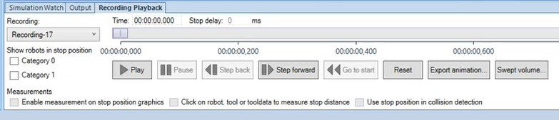

xx2000002027

1. In the **Recording:** list, select the required file and then click **Play** to view the recording.

Use the buttons in the **Recording Playback** tab to navigate through the recording during play back.

*Continues on next page*

11.4 Recordings *Continued*

Use the following check-boxes to enhance play back visualization.

##### Option Description

**Category0** View a semitransparent robot that moves along the *category 0 stop* positions.

**Category1** View a semitransparent robot that moves along the *category 1 stop* positions.

**Export Animation** Export a recording with joint signals to a 3D animation in *glTF (.glb)* format.

SafeMove zones and geometries can be included if Visual SafeMove is open.

**Swept Volume** Creates a new part based on the current recording that represents the approximate total volume of the robot and tool movement along a path. This will help in assessing collisions between the environment and the volume. These parts can be exported in polygon formats such as, glTF, STL, VRML and so on, but CAD formats are not supported.

Part Swept volume

xx2100002564

xx2100002565

The following options are available:

**Construct from interpolated positions**: Creates a point cloud with extra points added to compensate for the discrete nature of the recording, then use an algorithm to construct a volumetric polygon mesh from the point cloud. The resultant volume will be rough and contains significantly less polygons and avoids discretization holes. **Combine discrete positions**: Creates a single part combining the robot geometry in each discrete position of the recording. The part is processed to remove redundant polygons. The resultant volume will be bigger(greater memory usage) than the volume created using the **Construct from interpolated positions** option. While creating volumeusingthisoption,discretepositionsonlyareincluded,hence, the result can contain holes especially when the speed is high.

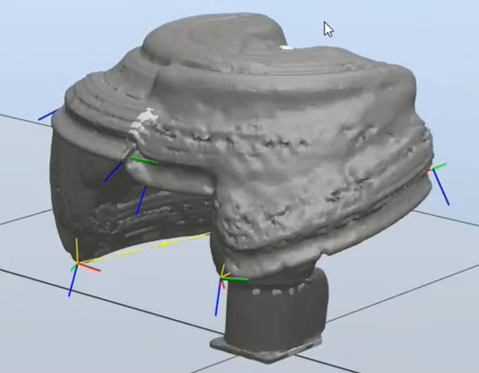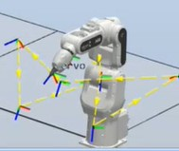

##### Note

The RAM usage can be significantly high for longer recordings.

**Enablemeasurement** Enable measurement on the semitransparent robot.

##### on stop position graphics

**Click on robot, tool or** Measure the distance between a selected point on the robot and **tooldata to measure** the corresponding stop position on the semitransparent robot.

##### stop distance

11.4 Recordings

*Continued*

**Description**

**Option**

Detect

collision

using

the

Category0

or

Category

1

stop

positions.

**Use**

**stop**

**position**

**in**

**collision**

**detection**

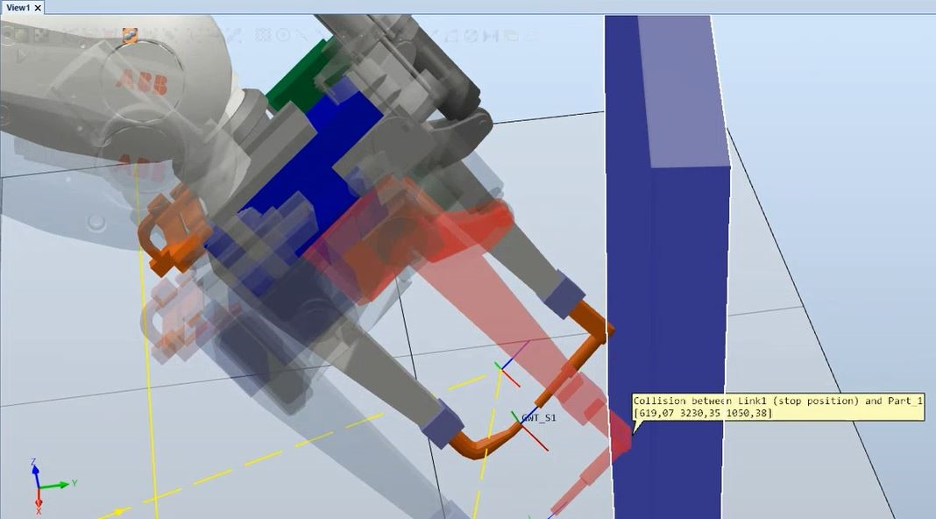

xx2000002209

**Accessing the RAPID code from signal recording**

Signal recordings are analyzed to find the root-cause of any unexpected robot events. From signal analyzer, it is possible to open the RAPID module that causes this robot event. Use the following procedure to access the RAPID code from signal analyzer. The *Target Changed* event must be recorded for using the following procedure.

**Note**

The

*Target*

*Changed*

event

data

do

not

represent

the

current

target,

instead

it

represents

the

subsequent

target.

1. In the **Recordings** window, right-click the signal recording and then click **Open**.

The **Signal Analyzer** window opens with the selected signal recording.

1. Scroll down and access the **Events** table, and click the required RAPID event to view the **Current Target** details.
2. Click the **Location** link to open the respective RAPID module.

**12 Jobs**

**Understanding jobs**

Overview

RobotStudio is designed to work with one *robot controller* at a time. Use Jobs function to perform certain actions on a large population of robot controllers. Fleet or device set is a collection of selected set of controllers in a network that are identified by the IP Address or the DNS name. A Job is defined by a Device list and an Action. Action will be carried out for the selected controllers in the Device list.

The default set of actions are designed to monitor and to collect data from the controllers in the device list. This data can be analyzed for error detection and further rectification for maintaining uniform configuration across all controllers in a fleet.

Jobs tab

The Jobs feature is managed from the **Jobs** contextual tab. On the **Controller** tab, in the **Controller Tools** group, click **Jobs** to open the **Jobs** Contextual tab. The **Jobs** contextual tab contains the following groups.

**Groups Description**

Device Lists A user-defined group of robot controllers for applying a job. Device lists can be reused between jobs.

Jobs A command group containing various job options.

Device Lists group

The Device Lists group contains the following commands and controls.

**Commands Description**

New Device List Opens a new empty device list window for creating a new group of robot

controllers.

Open Device List Opens a previously saved device list to edit or review.

Save Device List Saves the contents of an active device list window to disk in *.xlsx* format. These files can be edited in Microsoft Excel without changing the grid structure.

Scan Subnet Populates the active device list window with all controllers that Netscan finds on the local subnet.

Jobs group

The Jobs group contains the following commands and controls.

**Commands Description**

New job Opens a new Job window.

Templates Provides options, **Save Job** and **Edit Job Templates**.

* **Save Job** : Saves the job specification as an *.xml* file.
* **Edit Job Templates**: Allows you to edit an existing template file.

Verify Verifies the status of the group of robot controllers.

Execute Executes the user-selected action.

**Description**

**Commands**

Temporarily

stops

an

active

action.

Pause

Resumes

the

paused

action.

Resume

Aborts

the

active

job.

Cancel

Device List window

You can define the population of robot controllers that the job should be applied to, using the **Device List** window. This window contains the metadata of all robot controllers that are part of the group.

* Network Address: This field is mandatory. IP address or DNS name of the controller. The controllers can be distributed on multiple subnets. You can add controllers that cannot be directly found by Netscan from the current location.
* Controller Name: This is an optional field. This value is used to verify the controller name that can be identified by the network address.
* System Name: This is an optional field. This value is used to verify the system name running on the controller that can be identified by the network address.
* Group: This is an optional field. This value is used to filter out a subset of robot controllers from a list while executing jobs.
* Subgroup: This is an optional field. This value is used to filter out a subset of robot controllers from a list while executing jobs.
* Comments: This is an optional field. You can type in comments in this field. If you add a controller to the list using the **Scan Subnet** command, then the system displays **Found by Netscan** message in this field.

Allow Execution State Running

You can not execute a job when the controller's program execution is in the *Running* state. This precaution is to avoid production getting disturbed when robots are performing sensitive *path* following applications such as laser cutting or arc welding. Jobs such as backup or search *RAPID* data can put load on the controller. Select the **Allow Execution State Running** check box available in the **Device Selection** area while executing these jobs.

Allow System Failure state

When the **Allow System Failure state** check-box is selected, the job will be executed even if the connected controller is in system failure state. When this check-box is not selected, the jobs will not be executed if the controller is in system failure state.

Verify identity of OmniCore controllers

Refer to *Operating manual - Integrator's guide OmniCore* for details about certificate handling in OmniCore controllers. When the **Verify identity of OmniCore controllers** check-box is selected, the security certificate will be verified before executing the job.

*Continues on next page*

*Continued*

Supported actions

Using the Jobs feature, you can perform the following actions on a group of robot controllers. You must select the required action in the **Selected Action** list in the **Jobs** window. Some of these actions require the following additional data.

**Action Description**

Backup • Backup Path: User-defined destination folder for saving the

backup file, this file contains controller specific backup folders with a date and time stamp in the format Backup_{Date}_{Time}.

• Backup name: The name of the backup file in the format {SystemName}_{Date}. The name template can be modified according to the user needs. The strings in curly brackets will be replaced by the current values.

**Note**

The complete list of options to use for creating the file and folder names are {NetworkAddress}, {ControllerName}, {SystemName}, {SerialNumber}, {Comments}, {Group}, {Date} and {Time}.

Backup Program Creates backup of program modules with a date and time stamp in

Modules the format Backup_{Date}_{Time}. You can specify the name and destination folder of the backup program module in the **Backup name** and **Backup Path** fields.

Distribute Update Copies the selected distribution package to the controller. Package

Update UAS Updates the password of UAS file of the selected controller from the

device list.

Set Time Threshold (seconds): User-defined threshold time in seconds. The threshold defines the allowed time difference.

Verify Time Reads the time for each controller and compares it with the local PC

time.

SetTimeServerand Select this action to set the time zone of the NTP server.

Time Zone Enter the name of the server in the **NTP Server** box and select the required time zone in the **Time Zone** list.

Save Event Logs Reads the specified event logs and saves it to the specified location on the PC.

Search Event Logs Searches the event logs for a specified type (All, Warnings and Errors, Errors) and upto an optional time(in days). You can also specify the range for the error codes to include in the search.

**Action Description**

Read Single Data You canread RAPID Data,I/O Signalvalues,Configurationparameters and device information with this function.

* For RAPID Data, you must specify the URL of the RAPID instanceasTask/Module/DataoronlyTask/Data,forexample,

T_ROB1/Module1/myToolData, or T_ROB1/myToolData. The result will be the value of the instance.

* For I/O Signals, you must specify the name of the signal, for example, *mySignal*. The result will be the signal value.
* For configuration parameters, you must specify the URL to the instance attribute in the form

DOMAIN/TYPE/InstanceName/AttributeName,forexample

MOC/ARM_LOAD/r1_load_4/mass or

EIO/EIO_SIGNAL/diMySignal/access.

* Select the **Devices** option, to read device information like *Main Computer Fan Speed*, *Main Computer Module Temperature*, *CPU Temperature* and *Free RAPID Memory(MB)* by selecting the required option in the **Copy From the device browser**.

To read other properties, copy the device property ID from the **Device Browser**. Right-click the desired property and select **Copy device property ID** from the context menu. Paste the ID into the text field above.

Search RAPID Data Searches for RAPID instances that matches the specified search patterns. You can restrict the search to *tasks*, *modules*, data types and names of record fields that match the specified pattern.

Search RAPID Text Searchesfor lines that contain the specified text string.You can restrict the search to tasks or modules that match a certain name pattern.

Write File or Direct- Writes the selected file or directory to the specified target directory.

ory

Read File or Direct- Reads the selected file or directory from *HOME* folder or from a task.

ory

System Information Reads the options, languages and media versions of the controllers.

Run External Tool Invokes an external executable.

* External Tool Path: Location of the folder where the external tool is placed.
* Arguments: User specified arguments which the external tool passes,forexample{SystemName},{Networkaddress},{Group} and so on.
* Timeout(s): Specifies command time out period.

Compare Folder Compares two folders and generates a report with the differences. These reports are available in two file formats, *Excel* and *xml*. These reports are not exclusive to Compare Folder.

Save System Dia- Saves the system diagnostics file that contains the information about gnostics the current state of the controller.

Save Assessment Saves the assessment data (Assessment_Data _{Date}_{Time}) of Data the device to the selected location.

Assessmentdata contains usage statistics of a robot such as Production Time, Duty factor, Program speed, Cycle time, Workload stress, Operating hours and so on. This data is used for predictive maintenance of the robot (manipulator).

Jobs with several actions

* Use the **Add** button to create a job with several Actions.
* Use the **Up** and **Down** buttons to change the execution order. There will be one sheet per Action in the resulting Excel report.

*Continues on next page*

|  |  |
| --- | --- |
|  | *Continued* |
| • | Use the **Remove** button to remove the selected Action. |
| • | The **Save** function, **Verify** and **Execute** are not specific to the multi-action Job. |
| **Creating a device list** 1 | In the **Device Lists** group, click **New Device** List. The **Unnamed Device List** window opens.  This device list can be saved in *.xlsx* format. |
| 2 | Enter the required details such as **Network Address**, **Controller Name** and so on. In the **Device Lists** group, click **Save Device List**. |
| 3 | To create a device list with all available devices in the network, click **Scan Subnet** the **Device Lists** group. |
| **Creating a new job** 1 | On the **Controller** tab, in the **Controller Tools** group, click **Jobs**. The **Jobs** contextual tab opens. |
| 2 | In the **Device Lists** group, click **New Device** List. The **Unnamed Device List** window opens.  This device list can be saved in *.xlsx* format. |
| 3 | In the **Device Selection** area, select a device list in the **Device List**. The **Group Filter** list will be populated if the selected list contains data in the **Group** field. |
| 4 | Enter valid credentials in the **Username** and **Password** boxes, or select **Default Credentials** if the **Default User** has sufficient grants to perform the selected action.  The specified user must be available and this user should have sufficient grants for all controllers. |
| 5 | In the **Action** list, click the action that you want to perform. Depending on the selected action, additional action specific data might be required.  To configure these actions, you must provide the required data. |
| 6 | In the **Jobs** group, click **Verify/Execute** to perform the selected action.  Once the action gets completed, a report and a log file are created. You can open this report (in *.xlsx* format) from the **History browser**. The log file is used for troubleshooting and support. |

**Reuse a job template**

Jobs are saved as xml files. These files can later be edited in RoboStudio. Job files must be placed in

C:\Users\rs_user\Documents\RobotStudio\JobTemplates to be able to edit them. The files located in this location will be listed in the **Templates** drop down.

1. In the **Jobs** group, click **Templates**. Jobs available in the

C:\Users\rs_user\Documents\RobotStudio\JobTemplates location will be listed here.

1. Click the particular job file to open.
2. Customize the file and then click **Templates** and then click **Save Job** and save the file.

**Running job from the Command Prompt window**

Use the following steps to run a job or a batch of jobs from the Command Prompt window.

**Step Action**

1. Create a Job and save it with a suitable name, for example *Job1*.

For a default installation of RobotStudio, the job gets saved in C:\Users\<user name>\Documents\RobotStudio\JobTemplates folder as a *\*.xml* file.

1. Open **Notepad** and type in "C:\Program Files (x86)\ABB\RobotStudio

YYYY\Bin\Addins\FleetManagement\runjob.exe" "C:\Users\<user name>\Documents\RobotStudio\JobTemplates\Job1.xml" /defaultcredentials .

The example assumes that RobotStudio is installed in the default location. A specific user name and password can be supplied with the options /user:<user name> and /password:<password>.

1. Save the *\*.txt* file with the *\*.cmd* extension.
2. Double-click the *\*.cmd* file to run the job.

Log files and reports get generated and is available in the **Jobs browser**.

**Note**

You can schedule jobs using the Windows built-in Task Scheduler.

The following table provides details of various command-line arguments along with their descriptions.

**Arguments Description**

/user:<user> /password:<pw> Run job with a specific username and password.

/defaultCredentials Run job using the default user credentials.

/logDirectory:<path> Directory for log and report files.

/disableCertificateVerification Disable RobotWare 7 certificate verification.

/allowExecStateRunning Allow execution state Running.

13.1 Introduction to ScreenMaker

1. **Screenmaker**

**13.1 Introduction to ScreenMaker**

**What is ScreenMaker?**

ScreenMaker is a tool in RobotStudio for developing custom screens. It is used to create customized FlexPendant GUIs without learning Visual Studio development environment and .NET programming.

**Note**

ScreenMaker

is

only

relevant

for

systems

using

IRC5

controllers.

**Why use ScreenMaker?**

A customized operator interface on the factory floor is the key to a simple robotic system. A well-designed custom operator interface presents the right amount of information at the right time and in the right format to the user.

**GUI concepts**

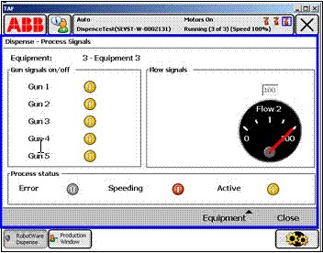

xx0800000226

A GUI makes it easier for people to work with industrial robots by presenting a visual front end to the internal workings of a robotic system. For FlexPendant GUI applications, the graphical interface consists of a number of screens, each occupying the user window area (the blue box in the figure above) of the FlexPendant touch screen. A FlexPendant screen is then composed of a number

13.1 Introduction to ScreenMaker

*Continued*

of smaller graphical components in a design layout. Typical controls (sometimes referred as widgets or graphic components) include buttons, menus, images, and text fields.

A user interacts with a GUI application by:

* + Clicking a button
  + Selecting from a menu
  + Typing a text in a text box
  + Scrolling

An action such as clicking a button is called an event. Whenever an action is performed, an event is sent to the GUI application. The exact content of an event is solely dependent on the graphic component itself. Different components trigger different types of events. The GUI application responds to the events in the order generated by the user. This is called event-driven programming, since the main flow of a GUI application is dictated by events rather than being sequential from start to finish. Due to the unpredictability of the user’s actions, one major task in developing a robust GUI application is to ensure that it works correctly no matter what the user does. Of course, a GUI application can, and actually does, ignore events that are irrelevant.

The event handler holds sets of actions to be executed after an event occurs. Similar to trap routines in the RAPID program, the event handler allows the implementation of application-specific logic, such as running a RAPID program, opening a gripper, processing logic or calculating.

In summary, from a developer’s point of view, a GUI consists of at least two parts:

* + *the view part*: layout and configuration of controls
  + *the process part*: event handlers that respond to events

Modern GUI development environments often provide a form designer, a (What You See Is What You Get ) WYSIWYG tool to allow the user to select, position and configure the widgets. As for event handlers, typically the developer must use a special programming language recommended by the development environment.

**Note**

ScreenMaker

does

not

support

Undo/Redo

operations.

13.1 Introduction to ScreenMaker *Continued*

**FlexPendant concepts**

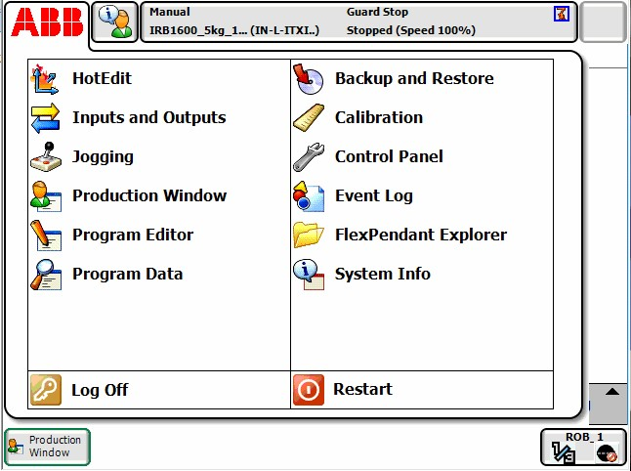

xx0800000228

Running Windows CE, the ABB FlexPendant has limited CPU power and memory compared to a PC. A custom GUI application must therefore be placed in the designated folders on the controller hard drive before being loaded. Once loaded, it can be found in the ABB menu as seen in the figure above. Click the menu item to launch the GUI application.

As the robot controller is the one actually controlling the robot and its peripheral equipment by executing a RAPID program, a GUI application needs to communicate with the RAPID program server to read and write RAPID variables and set or reset I/O signals.

It is essential for RAPID programmers to understand that there are two different levels controlling a work cell: an event-driven GUI application running on the FlexPendant, and a sequential RAPID program running in the controller. These reside on different CPUs and use different operating systems, so communication and coordination are important and must be carefully designed.

**Limitations**

ScreenMaker supports English language when building the application in

RobotStudio. ScreenMaker Designer does not provide a localization tool. Therefore, applications created with ScreenMaker display the same text specified at the design time, regardless of the choice of language on the FlexPendant.

When Asian languages are used (Chinese, Japanese, Korean), these screens display accurately only when the FlexPendant language matches with the the ScreenMaker language. Otherwise empty markers will be displayed instead of text characters.

**13.2 Development environment**

**Overview**

This section presents an overview of the ScreenMaker development environment for creating user screens.

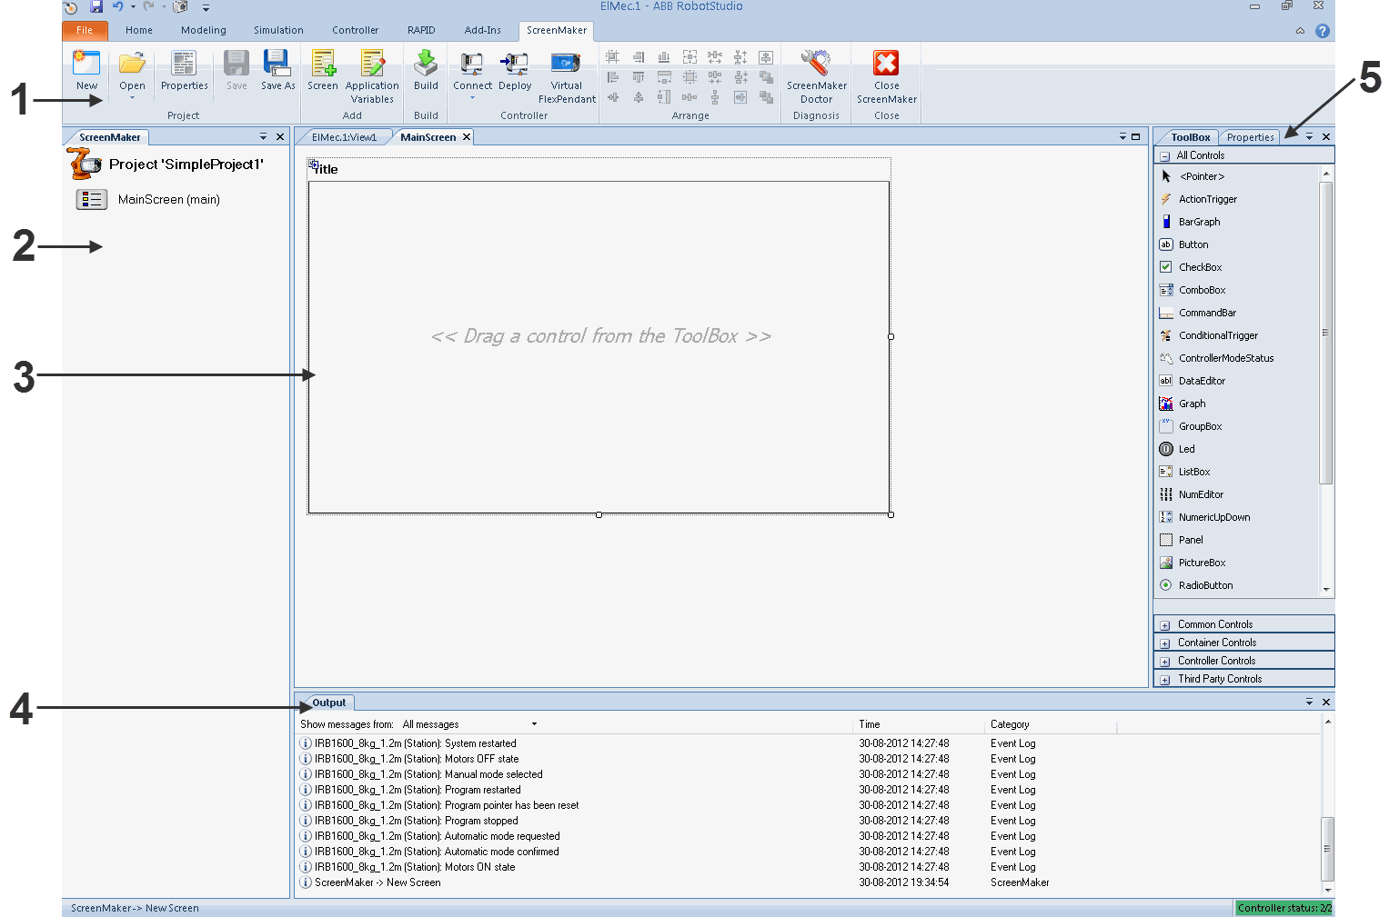

en0900000584

**Description**

**Parts**

Displays

group

of

icons

organized

in

a

logical

sequence

of

functions.

Ribbon

1

Shows the active screen project and lists the screens that

are

defined

in

the

project.

Project

explorer

2

Layout

to

design

the

screen

with

the

available

controls.

Design

area

3

Displays

information

about

the

events

that

occur

during

ScreenMaker

development.

Output

window

4

Displays

a

list

of

available

controls.

ToolBox

/

Properties

5

Contains the available properties and events of the selec-

ted

control(s).

The

value

of

the

properties

can

either

be

a

fixed

value

or

a

link

to

an

IRC5

data

or

an

Application

Variable.

**Ribbon**

The ScreenMaker tab contains groups of commands organized in a logical sequence of functions that facilitates the user in managing ScreenMaker projects. The tab consists of the following groups:

**Functions**

**used**

**for**

**Group**

Managing a ScreenMaker project. See Managing ScreenMaker

Projects.

Project

13.2 Development environment *Continued*

**Functions**

**used**

**for**

**Group**

Adding screen and application variables. See Managing screens

and

Managing

Application

Variables.

Add

Building

a

project.

See

Building

a

project.

Build

Connecting

and

deploying

to

the

controller.

See

Connecting

to

controller

and

Deploying

to

controller.

Controller

Also

for

opening

the

**Virtual**

**FlexPendant**

.

Re-sizing

and

positioning

the

controls

on

the

design

area.

Arrange

Detecting

problems

in

the

project

and

providing

a

diagnostic

solution.

Diagnosis

Closing

a

project.

Close

**Arrange**

This toolbar displays icons for resizing and positioning controls on the design area. The icons are enabled once you select a control or group of controls on the design area.

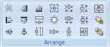

en0900000592

**ToolBox**

ToolBox acts a container for holding all the available controls that can be placed on a screen.

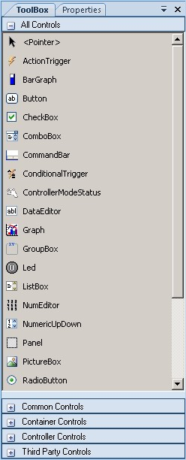

en0900000407

The following table displays the GUI controls that can be dragged to the design area.

##### Control Description

ActionTrigger Allows to run a list of actions when either a signal or rapid data changes.

BarGraph Represents an analog value in a bar.

Button Represents a control that can be clicked.

Provides a simple way to trigger an event, and is commonly used to execute commands. It is labeled either with text or an image.

CheckBox Allows multiple selections from a number of options. They are displayed as a square box with white space (for unselected) or as a tick mark (for selected).

13.2 Development environment *Continued*

##### Control Description

ComboBox Represents a control that enables to select items from a list.

Combination of a drop-down list and a textbox. It allows you to either type a value directly into the control or choose from the list of existing options.

It is not possible to add I/O signals to the combobox/listbox control.

CommandBar Provides a menu system for a ScreenForm.

ConditionalTrigger Allows to define conditions while defining action triggers. An action is triggered, if there is any change in value of the data bound.

ControllerModeStatus Displays the mode of the Controller (Auto - Manual).

DataEditor Represents a text box control that can be used to edit the data. Graph Represents a control that plots data with lines or bars.

GroupBox Represents a Windows control that displays a frame around a

group of controls with an optional caption.

Is a container used to group a set of graphic components. It usually has a title at the top.

LED Displays a two states value, like a Digital Signal.

ListBox Represents a control to display a list of items.

Allows the user to select one or more items from a list contained within a static, multiple line text box.

NumEditor Representsa text box controlthat can be used to edit a number. When the user clicks it, a Numpad is opened.

It is not recommended to add a NumEditor in a container control.

NumericUpDown Represents a spin box that displays numeric values.

Panel Used to group collection of controls.

PictureBox Represents a picture box control that displays images.

RadioButton Allows to select only one of a predefined set of options.

RapidExecutionStatus Displays the execution status of the Controller Rapid Domain (Running - Auto).

RunRoutineButton Represents a Windows button control that calls a RapidRoutine when clicked.

Switch Displays and lets change a two states value, like a Digital

Output Signal.

TabControl Manages a set of tab pages.

TpsLabel Very commonly used widget that displays text, a label is usually

static, that is, it has nointeractivity. A label generally identifies a nearby text box or other graphic component.

VariantButton Used to change the values of RAPID variables or Application

variables.

**Properties window**

A control is characterized by its properties and events. Properties describe the appearance and behavior of the component, while events describe the ways in which a control notifies its internal state change to others. By changing the value of a property, the controls have a different look and feel, or exhibit different behavior.

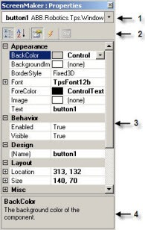

en0900000408

**Description**

**Element**

Displays the selected component, and lists the

available

components

of

the

active

design

screen.

Graphical component name panel

1

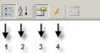

en0900000409

Properties

window

toolbar

2

1

Organizes

table

panel

in

categories

2

Organizes

table

panel

alphabetically

3

Displays

Properties

in

table

panel

4

Displays

Events

in

table

panel

Displays

all

the

properties

or

events

in

two-

columns.

The

first

column

shows

the

property

or

event

name,

the

second

shows

the

value

of

the

property

or

name

of

the

event

handler.

Table

panel

3

Display

information

about

a

property

or

event.

Information

panel

4

**13.3 Working with ScreenMaker**

##### 13.3.1 Managing projects

**Overview**

This section describes how to manage projects in ScreenMaker. A complete cycle includes creating, saving, building, connecting, and deploying a ScreenMaker project.

You can manage a project (create, delete, load, or save) either from the ScreenMaker ribbon or the context menu.

**Creating a new project**

ScreenMaker does not support Unicode characters. Hence, do not use these characters when you create a ScreenMaker project.

Use the following procedure to create a new project:

1. Click **New** from the ScreenMaker ribbon or right-click **Project** context menu and select **New Project.**

The **New ScreenMaker Project** dialog box appears.

or *ScreenMaker custom templates*.

**Note**

You can create a new project either from

*ScreenMaker installed templates*

1. To create a new project from the *ScreenMaker installed templates*, a Click *Simple Project*.
   1. Enter a name and specify the location for the new project. By default, the new project is saved on *C:\My Documents\RobotStudio\My ScreenMaker Projects.*
   2. Click **OK**.
   3. A screen *MainScreen(main)* is added in the tree view.
2. To create a new project from the **ScreenMaker custom templates**, a Click **Basic**, *Standard*, or **Extended**.
   1. Enter a name and specify the location for the new project. By default, the new project is saved on **C:\My Documents\RobotStudio\My ScreenMaker Projects.**
   2. Click **OK**.

**Note**

* + If you select the template **Basic**, a project with two screens are created.
  + If you select the template **Standard**, a project with four screens are created.
  + If you select the template **Extended**, a project with six screens are created.

**Loading a project or template**

Use this procedure to load an existing project or an existing template:

1. Click *Open* from the ScreenMaker ribbon or right-click **Project** context menu and select **Open Project.**

The **Open Screen Project File** dialog box appears.

**WARNING**

A warning message appears when you open an existing ScreenMaker project where the FlexPendant SDK version is different from the version the project was created.

1. Browse to the location of the project file or template file to be loaded and click **Open.**

**Note**

You

can

also

load

an

existing

project

using

a

quick

access

method.

1

Click

**Recent**

from

the

ScreenMaker

ribbon

or

right-click

**Project**

context

menu

and

select

**Recent**

**Projects**

.

2

Select

the

project

file

from

the

list

of

most

recently

opened

projects.

**Saving**

**a**

**project**

To save a project or template, follow this step:

* Click **Save** from the ScreenMaker ribbon or right-click **Project** context menu and select **Save**.

To save the existing project or template with a new name, follow this step:

* Click **SaveAs** from the ScreenMaker ribbon or right-click **Project** context menu and select **SaveAs**.

**Note**

•

Project

files

are

saved

with

the

extension

*

*.smk*

.

•

Template

files

are

saved

with

the

extension

*\*.smt*

.

SaveAs FlexPendant Project

To save the ScreenMaker project as a FlexPendant project, in the project context menu, click **SaveAs FlexPendant Project**.

The project is saved with the extension **\*.csproj** which can be opened using Microsoft Visual Studio 2008.

**Designing screens**

This section describes adding, copying, renaming, deleting, and editing a screen.

Overview

The Form designer is a tool to edit or design a screen. It allows you to design the screen with the required controls and the design area resembles a FlexPendant screen.

Editing a screen

To edit a screen, follow these steps:

1 Drag a control from the toolbox and drop it on the design area.

The **Properties** window displays all the properties of the control. 2 Select the control and resize or reposition for configuration.

**Note**

You can either select a single control or multiple controls:

* Single control : Left-click the control on the design area or select the control from the list in the Properties window.
* Multiple controls: Left-click on the design area, drag the mouse and create a window selecting all the controls.

3 Click the smart tag on the upper right corner of the control to perform the basic tasks of configuration.

**Note**

You

can

perform

additional

configuration

by

editing

the

attributes

in

the

Properties

window.

Using ScreenMaker controls

This section describes building the GUIs using the following controls from the ToolBox.

ActionTrigger

An action trigger initiates an event, such as making a hidden object visible when an action is performed using a control. It allows to run a list of actions when the property value changes. The property value can be bound to a signal, rapid data, or application variable.

ActionTrigger control can also be used to invoke the application from RAPID.

Use this procedure to add an ActionTrigger control:

**Action**

Drag

an

*ActionTrigger*

control

from

the

**ToolBox**

on

to

the

design

area.

1

###### Action

2 You can modify the name, set the default value and configure data binding value for a ActionTrigger control.

* Set the values of a property in the *Properties window*.
* You can set the trigger event for an ActionTrigger to any of the event handler created either from a control or from an Events Manager option.
* Configure the data binding values using Configuring Data Binding.
* Set the application variables using the Managing Application Variables.

**Note**

An action is not triggered when the screen is launched for the first time, but is triggered when there is a difference in the bound value at any point of time. This functionality is supported only in RobotWare 5.12.02 or higher.

**Example:** Consider a signal being bound to the value property. The value of the signal changes at runtime on performing a specific action. The event handler configured for ActionTrigger control gets triggered based on this signal value change.

TpsLabel

TpsLabel is a standard Windows label that displays a descriptive text. Use this procedure to add a TpsLabel control:

###### Step Action

1. Drag a **TpsLabel** control from the **ToolBox** on to the design area.
2. You can set the values, setup events, configure data binding values and set the application values for a TpsLabel control.
   * Set the values of a property in the *Properties window*.
   * Set up the events , see *Setup Events*.
   * To configure the data binding values, see *Configuring Data Binding*.
   * To set the application variables, see *Managing Application Variables*.
3. You can set the option Allow Multiple States to true and change the property. 1 Click Allow Multiple States. The StatesEditor dialog box appears.

2 Click the check-box Allow Multi-States, select the properties to change from Properties For States and click OK.

The controls Button, PictureBox, and TpsLabel support AllowMultipleStates. For more information on how to use AllowMultipleStates, see *Picture object and changing images due to I/O*.

Panel

Panel is used to group a collection of controls.

Use this procedure to add a Panel control:

**Action**

**Step**

Drag

a

Panel

control

from

the

ToolBox

on

to

the

design

area.

1

You

can

add

a

group

of

controls

to

a

panel.

2

###### Step Action

3 You can modify the name, set the default value and binding value for a Panel control.

* To set the values of a property, see *Properties window*.
* To set up the events, see *Setup Events* .
* To configure the data binding values, see *Configuring Data Binding*.
* To set the application variables, see *Managing Application Variables*.

**Note**

Currently only EventHandler, CancelEventHandlers, and MouseEventArgs are supported.

ControllerModeStatus

ControllerModeStatus displays the mode of the controller (Auto - Manual). Use this procedure to add a ControllerModeStatus control:

###### Step Action

1. Drag a ControllerModeStatuscontrol from the ToolBox on to the design area.
2. You can set the values, setup events, configure data binding values, and set the application variables for a ControllerModeStatus control.
   * To set the values of a property, see *Properties window*.
   * To set up the events, see *Setup Events*.
   * To configure the data binding values, see *Configuring Data Binding*.
   * To set the application variables, see *Managing Application Variables*.
3. You can select the image to be displayed when the controller is in Auto mode and in Manual mode.
   * Click AutoImage in the Properties window and browse to select the image to be displayed in Auto mode.
   * Click ManualImage in the Properties window and browse to select the image to be displayed in Manual mode.

RapidExecutionStatus

RapidExecutionStatus displays the execution status of the Controller Rapid Domain (Running - Auto).

Use this procedure to add a RapidExecutionStatus control:

###### Step Action

1. Drag a RapidExecutionStatus control from the ToolBox on to the design area.
2. You can set the values, setup events, configure data binding values, and set the application values for a RapidExecutionStatus control.
   * To set the values of a property, see *Properties window*.
   * To set up the events, see Setup Events.
   * To configure the data binding values, see *Configuring Data Binding*.
   * To set the application variables, see *Managing Application Variables*.
3. You can select the image to be displayed when the Program is running and is stopped.
   * Click RunningImage in the Properties window and browse to select the image to be displayed when the Program is running.
   * Click StoppedImage in the Properties window and browse to select the image to be displayed when the Program is stopped.

RunRoutineButton

RunRoutineButton represents a Windows button that calls a RapidRoutine when clicked.

**Note**

To call a routine containing movements, you are not recommended to use the RunRoutine Button control. Instead use a normal button control to call a Trap routine. In the Trap routine, use instructions such as StopMove, StorePath, RestorePath and StartMove to control the movements of the robot.

Use this procedure to add a RunRoutineButton control:

###### Step Action

1. Drag a RunRoutineButton control from the ToolBox on to the design area.
2. Click the smart tag on the RunRoutineButton and select one of the following RunRoutineButtonTasks.
   * Define Actions before calling Routine
   * Select Routine to call
   * Define Actions after calling Routine
3. Click Define Actions before calling Routine to define an action/event before calling the routine.

The Events Panel dialog box appears.

1. Click Define Actions after calling Routine to define an action/event after calling the routine.

The Events Panel dialog box appears.

1. Click Select Routine to call.

The Controller Object Binding dialog box appears.

1. In the Properties window, set the value for the following properties:
   * RoutineToCall - Set the routine to be called. Indicates the RAPID Routine that will be called when this button is pressed.
   * AllowInAuto - Set to True or False. Indicates if the routine could be called in the Auto mode.
   * TextAlign - Set to MiddleLeft and MiddleCenter. Indicates the text alignment. Note the following restrictions:
   * You cannot bind RunRoutineButton to built-in Service routines.
   * Only user defined procedures with no arguments can be bound.
   * Set the PP to task before performing action through RunRoutineButton.

CommandBar

CommandBar allows you to add menu items in a controlled and organized order. Use this procedure to add menu items to the CommandBar control:

###### Step Action

1. Drag a CommandBar control from the ToolBox on to the design area. The CommandBar appear at the bottom of the screen.
2. Click the smart tag on the CommandBar and select Add/Remove Items. The MenuItem Collection Editor window appears.

###### Step Action

1. Click Add.

A new menu item is added and its properties are displayed which can be edited.

Note that while editing the menu item, ensure that the property Text is filled. If not, nothing appears on the CommandBar.

1. To remove the menu item, select the menu item and click Remove.
2. Click Close to close the MenuItem Collection Editor window.

To add an event to a menu item, for example *menuItem1* on the command bar, use this procedure:

###### Step Action

1. Go to the Properties window and select *menuItem1* from the drop-down list.
2. Click Events icon and then double-click the Click event. This opens the Events Panel dialog for the Click event.
3. Click Add Action from the Events Panel dialog. This opens a sub-list of actions.
4. Click an action from the sub-list of actions to add it to *menuItem1*'s Click event.

**Note**

ScreenMaker does not support the FlexPendant controls feature to add sub menu items on CommandBar.

VariantButton

The VariantButton control is a simple button control with additional features and properties. Using this control, you can change the values of RAPID or Application variables.

Use this procedure to add the VariantButton control:

###### Step Action

1. Drag a VariantButton control from the ToolBox on to the design area.
2. You can perform the following VariantButton tasks from the SmartTag:
   * Define Actions before value change
   * Define Actions after value change
3. You can set the following VariantButton specific properties from the Properties window:
   * Select Increment or Decrement from Behavior drop down. The default behavior of VariantButton is Increment.
   * Select StepRate and set the rate at which the value must be varied.
   * Select DataType to which the value should be bound and set the value property of the selected datatype.

Supports only the RAPID datatypes, **Num** and **Dnum**. For more information on data binding, see *Configuring Data Binding*.

1. You can also perform the following common tasks from the Properties windows:
   * Set BackColor, ForeColor, Location, and Size of the control.
   * Select True or False from the Visible dropdown to hide or unhide the control.
   * Select True or False from the Enabled drop down to enable or disable the control.

ConditionalTrigger

The ConditionalTrigger button defines the condition while defining action triggers. An action will be triggered if there is a change in the value of the data bound. Use this prcodedure to add the ConditionalTrigger control:

###### Step Action

1. Drag a ConditionalTrigger control from the ToolBox on to the design area.
2. You can set the followingConditionalTriggerpropertiesfromthe Propertieswindow:
   * + Select the condition to execute from the Condition drop down. The following are the supported conditions AND, OR, XOR, NOT, and EQUAL.
     + Select True or False from the Enabled drop down to enable or disable the control.
     + Select LHS and RHS and bind the data value to Controller Object or Application Variable.

Defining Events

Event handler is a set of actions to be executed after an event occurs.

To set up an event, follow these steps:

* 1. Select the control for which the event handler is to be defined.
  2. Open the **Events Panel** dialog box in any one of the following ways:
     + Double-click the control.
     + Right-click the control, select **Events Manager**, click **Add** enter the name, and click **OK** and close.
     + Click smart tag and select the task from the list.
     + In the **Properties** window, click **Events** icon and select the desired event from the list.

1. Click **Add Action** to add an action from a predefined list of actions. The following table lists the set of predefined actions:

•

Open

Screen

•

Close

Screen

Screens

•

Set

a

Digital

Signal

•

Invert

a

Digital

Signal

•

Pulse

a

Digital

Signal

•

Read

a

Signal

•

Write

a

Signal

•

Reset

a

Digital

Signal

Signals

•

Read

a

Rapid

Data

•

Write

a

Rapid

Data

RapidData

•

Read

and

Write

Application

Variable

•

Call

another

Action

list

•

Call

.NET

method

•

Call

Custom

Action

•

Call

FP

Standard

View

Advanced

1. Select the action from the left window and perform the following:
   * + Click **Delete** to delete the action.
     + Click **Move Up** or **Move Down** to change the order of execution of actions.
2. Click **OK**

Deleting an event handler

To delete a user created event handler, do the following:

1. Right-click the control, select **Events Manager**. The **Events Manager** dialog box appears.
2. Select the event handler to be deleted from the list and click **Delete**.

Advanced Actions

Call another Action List

Existing event handlers from Events Manager can be reused by other controls while defining actions for event. You can call another event handler from an existing event handler.

In the following example, **listbox1_SelectedIndexChanged** event handler is called from **comboBox1_SelectionIndexChanged** event handler.

Select the *Show warning message before performing actions* check box to have a warning displayed before you can perform these actions.

Call .NET Method

You can import the dlls and add references to the *Advanced* tab of the **Project Properties** dialog box.

Once the references are defined, .NET methods appear in the *Project Properties* dialog box and can be included in the *Actions* list which will be executed on performing the desired action.

The .NET assembly supports only public static methods.

Double click the method and bind the return value to the application variable.

Binding can be done only to the application variable.

**Note**

ScreenMaker allows you to call static methods of the public classes defined in another DLL. This DLL is usually a class library or a control library. It has the following limitations and the user should be aware of them while using .Net DLLs. • DLL’s references must be in the same directory in order to load the DLL.

• ScreenMaker provides access only to the static methods which contain basic data types such as string, int, double, boolean, object.

The following procedure provides information on creating a .NET assembly. This assembly can be added as a reference to ScreenMaker Project and for performing certain computations which are not directly possible using ScreenMaker or to call methods of FlexPendant or PCSDK.

Use Visual Studio 2010 or above to create a .NET assembly.

1. Create a new project with Class Library as your template.
2. Create public static methods like the following.

namespace SMDotNetMethods {

public class Methods

{

/// <summary> /// Inverts a boolean value

/// </summary>

/// <param name ="Value">input boolean value</param> /// <returns>inverted boolean value</returns> public static bool InvertBool(bool value) {

return (value == false); }

/// <summary> /// Increments a numerical value

/// </summary> /// <param name="value">value to be incremented</param> /// <returns>incremented value</returns> public static double Increment(double value) {

return (value + 1); } }

}

1. Build the project.
2. Use the assembly generated from this Class Library project. 5 Add it as a reference to the ScreenMaker project.

Call Custom Action

You can add an user control to the *ScreenMaker toolbox* and call a custom method for that control by defining it in the *ScreenMaker.dll.config file*. Call Custom Action supports only the Graph control.

Call FP Standard View

Standard FlexPendant screens can be opened on any action performed on the control. The standard FlexPendant screens include Rapid Editor, Rapid Data, LogOff, Jogging, Backup and Restore.

For example, on button1_click, Rapid Editor view is opened.

Editing the property value

You can edit the property value of a control from the *Properties window* in three ways:

1. By typing the numerics, strings and text. For example, Location, Size, Name etc.
2. By selecting the predefined values from the list. For example, BackColor, Font etc.
3. By entering the values in the dialog box. For example, Enabled, States, BaseValue etc.

Deleting an event handler

To delete a user created event handler, do the following:

1. Right-click the control, select **Events Manager**. The **Events Manager** dialog box appears.
2. Select the event handler to be deleted from the list and click **Delete**.

**Modifying Project properties**

Project properties define the properties of the ScreenMaker project, including how the GUI is loaded and displayed in the FlexPendant.

Use this procedure to modify the project properties:

1. Right-click **Project** context menu and select **Properties**.

The **Project Properties** dialog box appears.

1. In the **Display** tab under **Caption**, enter the text in the **Caption of the Application** field to edit the caption.

The updated caption appears in the **ABB Menu** on the right side.

1. In the **Display** tab under **ABB Menu**, select the following options,

**Description**

**Option**

application

is

visible

to

the

left

in

the

ABB

Menu.

Left

application

is

visible

to

the

right

in

the

ABB

Menu.

Right

application

is

not

visible

at

all

in

the

ABB

Menu.

None

**Note**

The

applications

that

uses

the

option

**None**

cannot

be

run

on

RobotWare

releases

earlier

than

5.11.01.

1. In the **Display** tab under **ABB Menu**, browse and select the **ABB menu image**.
2. In the **Display** tab under **TaskBar**, browse and select the **TaskBar image**.

**Note**

By default, the **Use Default Image** and **Use Menu Image** checkbox is enabled and the deafult image *tpu-Operator32.gif* is selected.

1. In the **Display** tab under **Startup** , select **Automatic** to load the screen automatically at the Startup.

By default, the start up type is **Manual**.

**Note**

1. In the **Advanced** tab under **Run Settings**, select **Launch virtual FlexPendant after deploying** checkbox.

The virtual FlexPendant will be launched after deploying the ScreenMaker project to the virtual controller.

This feature is not applicable if connected to a robot controller.

**Note**

1. In the **Project Properties** dialog, select the **General** tab to view the project properties which includes, **Name**, **Assembly**, **Version**, and **Path**. Version displays the specific versions of Controller and FlexPendant SDK that the ScreenMaker project uses.

**Connecting to controller**

Use this procedure to connect to both robot controller and virtual controller:

1 Click **Connect** from the ScreenMaker ribbon or right-click **Project** context menu and select **Connect**. icon before the row as an indicator.

The

**Select**

**a**

**Robot**

**Controller**

dialog

box

appears.

**Note**

Click

the

**Connect**

dropdown

from

the

ScreenMaker

ribbon

to

directly

connect

to

the

controller.

2

Click

**Refresh**

to

find

a

list

of

all

the

available

controllers.

**Note**

By default, the currently connected controller is highlighted and has a small

3 Select the controller to be connected from the list and click *Connect*.

The connection status is displayed in the Project tree view.

To remove the connection with the controller, click **Disconnect** from the Project context menu.

**Building a project**

The result from building the ScreenMaker project is a set of files including DLL file and images. The ScreenMaker project can be compiled into binary format (.dll) that can be deployed on a FlexPendant.

Use this procedure to build a project:

1 Click **Build** from the ScreenMaker ribbon or right-click Project context menu and select **Build**.

The result is displayed in the output window.

**Deploying to controller**

Use this procedure to deploy a ScreenMaker project to a robot controller or virtual controller:

1. Connect to the controller you want to deploy to.
2. Click **Deploy** from the ScreenMaker ribbon or right-click Project context menu and select **Deploy Screen to Controller**.

The **Download** dialog box appears displaying the progress of download. It disappears once the download is successful.

The

**TpsViewxxxxxx.dll**

file

is

downloaded.

3

Restart

the

controller.

**Note**

•

If a robot controller is used, you can reboot the FlexPendant by moving

its

joystick

three

times

to

the

right,

once

to

the

left,

and

once

towards

you.

•

If a virtual controller is used, you can reboot the FlexPendant by closing

the

virtual

FlexPendant

window.

**Closing**

**a**

**project**

To close a project, follow this step:

* Right-click **Project** context menu and select **Close Project**.

Closing ScreenMaker

To close ScreenMaker, follow this step:

* Click **Close ScreenMaker** from the ScreenMaker ribbon.

**Managing ScreenMaker Widgets**

What is a widget

A widget is a visual building block, containing an information arrangement, which represents an aspect of a robot application. It is a reusable and sharable user interface building block which can help speed up the development of screens. A ScreenMaker widget is similar in function to the widgets used in computer programming. The widget is an element of a graphical user interface (GUI) that displays an information arrangement which is changeable by the user. The widgets, when combined in an application, hold data processed by the application and the available interactions on this data.

Widget Workflow

Widget created from ScreenMaker can be used in ScreenMaker application and in Production Screen application.

The following are the steps required to create a Widget in ScreenMaker.

1. Start RobotStudio.
2. Launch ScreenMaker.
3. Create a new **Widget Project** or open an existing widget project.

For information on how to create a new widget project.

1. Connect to a robot or a virtual controller, as required.
2. If required, change the widget properties, using the **Widget Properties** dialog box.

For information on the Widget Properties dialog box.

1. Drag-and-drop the necessary user interface components, as you would in a normal ScreenMaker project.
2. Link the user interface properties to the IRC5 data or to the application variables
3. Build the widget project. The widget component is created and saved in

...\Documents\RobotStudio\Widget Components folder.

Sample use case

Consider a case where you want to design a production screen which can do the following:

* Display a graph
* Show alarms
* Show status of the controller To achieve this:

1. Create a new widget project in ScreenMaker and names it as, for example, GraphWidget.
2. Drags-and-drop the graph control and other necessary controls on the widget form.
3. Connect to a robot controller or virtual controller, as required.
4. Bind the controls to the controller data.
5. Use the widget properties dialog box, to change the size of the widget.
6. Build the project.
7. Download the output to the production screen.

You can then repeat the above steps to create widgets either in the same or in different projects based on your need to show the alarms and the status of the controller.

Creating a ScreenMaker widget project

1. On the ScreenMaker tab, click **New**. Alternatively, in the project context menu, click **New Project**.

The **New ScreenMaker Project** dialog box appears.

1. Under Widget Templates, click **Widget**.
2. Specify a name for the widget project.

ScreenMaker widgets projects are by default stored in the

...\Documents\RobotStudio\Widget Projects folder.

1. Click **OK**.

The widget project along with a screen **MainScreen(main)**, appears in the tree view. The widget project has **.wzp** file name extension. Widgets also appear in the **Toolbox**.

**Note**

* You can open one widget project at any time. Close an open widget project before opening a new one.
* A widget project has only one screen, the main screen, on which the widgets are designed. All controls defined on a widget are considered as one widget.
* Widgets are loaded into the toolbox from a folder that contains the widget component DLLs, from Additional Options folder under MediaPool. If you delete the widget components from these locations

(...\Documents\RobotStudio\Widget Components), then the widgets will not appear in the Toolbox.

Creating Production Screen Widget

ScreenMaker helps the user to create two types of widgets, Production Screen widget and Standard widget. Controls in a widget can be bound to rapid or signal data.

The Production Screen option is a framework for creating a customized GUI that can be used to present process data and status and execute FlexPendant applications.

To run widgets on the Production Screen, FlexPendant Interface option must be selected. Use the following procedure to create the Production Screen widget.

1. In the **Screenmaker** ribbon, select **New**. The **New Project** dialog opens.
2. Select **Widget Template** to create a new widget project.
3. Drag and drop controls to the widget.
4. Select **Widget Properties**, **Widget Properties** dialog opens.
5. Under **Type**, click **Production Screen** and click **OK**.
6. Build the project.

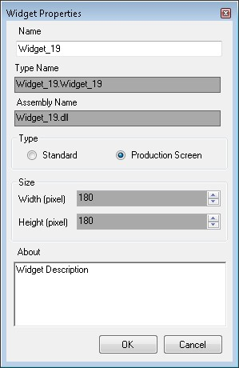

xx1400000275

The *ProductionSetup.xml* file must be updated with widget details to view the widget that was created in the Production Screen. You can find *ProductionSetup.xml*

under $System\HOME\ProdScr and Widget components under *$System\HOME\ProdScr\tps*.

An example of widget detail is provided here:

<Widget>

<Name>Widget_9</Name> <Page>1</Page>

<Assembly>Widget_9.dll</Assembly> <Type>Widget_9.Widget_9</Type> <Position>

<X>1</X> <Y>2<Y>

</Position>

<ZIndex>1</ZIndex>

<Bindings>

<Binding PropertyName ="led1.Value" BindingType="SIGNAL"

DataName="MOTLMP" />

<Binding PropertyName ="button1.Text" BindingType="RAPID"

DataName="T_ROB1/BASE/wobj0" />

</Bindings>

</Widget>

The production screen provides the flexibility to modify bindings of the widget. This is provided under Bindings tag as shown here:

<Bindings>

<Binding PropertyName ="led1.Value" BindingType="SIGNAL"

DataName="MOTLMP" />

<Binding PropertyName ="button1.Text" BindingType="RAPID"

DataName="T_ROB1/BASE/wobj0" />

</Bindings>

Specifying widget properties

To specify the properties of a widget project, right-click a widget project, and then click **Properties**. The Widget Properties dialog box appears.

You set and modify the following in the properties for the widget project:

* Name of the project
* Size of the widget - x,y (in mm)
* Select the type of Widget
  + Production Screen: The Widget can be used with Production Screen environment
  + ScreenMaker: The Widget can be used with ScreenMaker applications

Modifying Binding Information of Widget

Use this option to modify the binding information of widget. When a widget is built from the Widget Project, an xml file is created. This xml contains widget details and binding information. This entry must be vailable in the *Production.xml* file to work with the Production Screen Environment.

<Bindings>

<Binding PropertyName ="meter1.Value" BindingType="IO"

DataName="aoMeterSignal" />

<Binding PropertyName ="meter1.Title" BindingType="RAPID"

DataName="Flow1Title" />

</Bindings>

It is possible to create, use and modify the bindings of a widget created from ScreenMaker and to view the results in Production Screen and in ScreenMaker application environment.

Building and Deploying

The output of the Widget Project is a single Widget Component dll file, for example,

*TpsViewMyWidget.dll*. The widgets built from the Widget Project are used in the ScreenMaker project. Widgets cannot be deployed to the controller from ScreenMaker. If Widgets are used in ScreenMaker projects, it gets deployed.

When the ScreenMaker project which uses a widget is built, the widget component is added as a reference to the project.

When the ScreenMaker project output is deployed to the controller, the referenced widget components are also copied to the system *HOME* folder.

13.3.2 Application variables

##### 13.3.2 Application variables

**Overview**

Application Variables are variables defined inside a ScreenMaker application. An application variable is similar to a RAPID variable. It supports the data types supported by RAPID, such as num, dnum, string, tooldata, wobjdata, and so on.

An application variable’s definition includes its name, data type and initial value. During the execution of the ScreenMaker application, an application variable has a persistent value. It can store values coming from controller data or can be used to write values to controller data. Therefore, it is like an intermediate persistent variable which is used during RAPID execution along with other RAPID variables.

**Managing application variables**

To create, delete, and rename an application variable, follow these steps:

1. On the **ScreenMaker** tab, in the **Add** group, click **Application Variables**.

Alternatively, in the **ScreenMaker** browser, right-click the project, and then click **Application Variables**.

The **Project Application Variables** dialog box appears.

1. Click **Add** and define the name, type and value of the new variable.
2. Select the variable, click **Delete** to delete a variable.
3. Select the variable, click **Rename**, enter the new name and click **OK** to rename a variable.
4. Click **Close**.

You can view the application variables related to a project listed in the **Project Application Variables** dialog box. To filter and view the variables according to their data types, use the **Type** list.

13.3.3 Data binding

##### 13.3.3 Data binding

**Overview**

Data binding is the mechanism that links a GUI property with an external data source such that whenever the data source is updated, the GUI property will be updated automatically and vice versa.

There are two ways of linking the data with the GUI properties:

* Controller object data binding
* Application variable data binding

**Configuring data binding**

Data binding can be configured using the Properties window.

Using Properties window

1. On the design area, select the control.
2. In the Properties window, locate the row from the table for binding the value.
3. Select the property and click the list to display the Binding menu.

**to...**

**Click...**

remove

the

existing

data

binding.

Remove

actual

binding

select

available

data

in

the

controller

for

binding.

Bind

to

a

Controller

object

select

available

data

in

the

project

*Application*

*Variables*

for

binding.

Bind

to

an

Application

variable

select

available

RAPID

array

in

the

controller

for

binding.

Bind

to

an

Array

**Configuring data binding for different controls**

Binding to an array can be done with the following controls:

###### Control Description

DataEditor The default index value is 1. DataEditor is designed in such a way that the default value of the Rapid array starts with 1 and not 0.

ComboBox and ListBox The default index value is -1. You can enter the appropriate index value but cannot bind to a controller object or an application variable.

Note the following:

* You can limit the number of items to be displayed in the ComboBox and ListBox of an array.
* While using a ComboBox, a RAPID index starts with 1 (1 specifies the first element) and the ComboBox index starts with 0( 0 specifies the first index).
* When adding items to the ListBox or ComboBox control, it is not possible to add I/O signals.

**Controller object data binding**

Controller object data binding lets you to select the data in the controller for binding.

Use the following procedure to set up a binding with controller objects.

Open the Controller Object Binding dialog box and follow these steps:

1. In the **Type of Object** group, select either **Rapid data** or **Signal data**.

*Continues on next page*

13.3.3 Data binding *Continued*

1. In the **Shared** group, select **Built-in data only** to access shared **Rapid data**. When you select **Built-in data only**, the option **Signal data** and the text box **Module** are disabled.
2. If you have selected **Rapid data**, then in the **Scope** group, you can select a task and module from the list.

When you select **Signal data**, the **Scope** group is disabled. 4 In the **See** list, select the desired data.

**CAUTION**

**Unwanted**

**toggle**

**of**

**I/O**

**Signals**

**&**

**RAPID**

**data**

**when**

**using**

**data**

**binding**

**to**

**Enabled**

**properties.**

When you bind the Enabled property to a Controller object, and a dialog (like the

confirm

Going

to

Auto)

is

displayed

on

top,

then

your

screen

will

be

disabled

and

all

the

Enabled

properties of

all

its

controls

will

be

set

to

false

and

all

bound

Controller

objects

with

it.

To avoid this behavior it is recommended to bind Enabled properties to I/O Signals

with

Access

Level:

ReadOnly

as

this

results

in

a

one

way

binding.

**Note**

ScreenMaker

supports

binding

to

only

constant

and

persistant

variables.

The

variables

must

not

be

declared

LOCAL.

TASK

PERS

is

supported.

For

example,

the

following

binding

is

supported:

PERS num n1:=0;

TASK PERS num n2:=0;

CONST num n3:=0;

The

following

binding

is

not

supported:

LOCAL PERS num n1:=0;

VAR num n1:=0

**Note**

A

data

bound

RAPID

array

should

be

declared

as

PERS,

it

will

not

work

as

CONST.

**Application variable data binding**

Use the following procedure to set up a binding with project application variables.

Open the Application Variables Bind Form dialog box and follow these steps:

1. Select an application variable and the field to connect.
2. Click **Setup Variables** to manage the variables.

The **Project Application Variables** dialog box appears.

1. Click **OK**.

13.3.4 ScreenMaker Doctor

##### 13.3.4 ScreenMaker Doctor

**Overview**

ScreenMaker Doctor is a diagnostic solution to detect problems in the ScreenMaker project. It helps analyze the project and fix errors such as:

* Unused events
* Broken references, application variables, signals, modules, and Rapid data
* RunRoutine issue

**Using ScreenMaker Doctor**

Use this procedure to launch ScreenMaker Doctor, detect and report issues, and to view causes and solutions:

1. In the ScreenMaker ribbon, click **ScreenMaker Doctor**.

The **ScreenMaker Doctor** Wizard opens.

1. Click **Next**.

The wizard starts detecting issues and are reported as **Completed Checks**. The detected issues are categorized as:

* + Broken References
  + Unused Events
  + Broken ApplicationVariables
  + Broken Signals
  + Broken Modules
  + Broken RapidData
  + RunRoutine issue
  + Broken Routine
  + Other Dependencies

1. Click **View Causes and Solutions** to generate a report.

The left hand side of the report displays issues under each category and the right hand side of the report displays the Probable Causes and Solutions for the issues.

To check for issues again using the same instance, click **Re-Detect Issues**.

**Note**

In

order

to

detect

the

signal

data

and

RAPID,

ScreenMaker

project

should

be

connected

to

the

controller.

**Errors fixed by ScreenMaker Doctor**

The following sections show you how errors, which can be fixed by ScreenMaker Doctor, may manifest.

Unused Events

The following sequence of actions will result in creating unused events. 1 Create a ScreenMaker project.

*Continues on next page*

13.3.4 ScreenMaker Doctor *Continued*

1. Define events for the controls.
2. Define the events *Button1_Click* and *Button2_Click* for the controls *Button1*and *Button2* respectively.
3. Delete the control *Button1*. The event *Button1_Click* will still exist. An unused event is created.

You can run ScreenMaker Doctor to detect and fix this error.

Broken Reference

The following sequence of actions will result in creating broken references.

1. Create a ScreenMaker project.
2. Define events for the controls.
3. Define the events *Button1_Click* and *Button2_Click* for the controls *Button1*and *Button2* respectively.
4. Define action *ScreenOpen - Screen2* for the event *Button1_Click*.
5. Delete or rename the screen. A broken reference is created. You can run ScreenMaker Doctor to detect and fix this error.

Broken Application Variables

The following sequence of actions will result in creating broken application variables.

1. Create a ScreenMaker project.
2. Add an Application variable to the project.
3. Rename or delete the Application variable. No error is reported.

An error is reported during the run time due to the broken application variable. You can run ScreenMaker Doctor to detect and fix this error.

Broken Rapid Data/Signals

If rapid data is bound but not found in the controller connected in the ScreenMaker project, then perform the following procedure:

1. Create a ScreenMaker project.
2. Connect to a controller.
3. Bind the properties of the controls with controller data.
4. Build the project and deploy it to the controller.

The application works.

1. Connect the ScreenMaker project to another controller and deploy the same project.

The application produces errors in the FlexPendant.

1. Run ScreenMaker Doctor. It detects that RapidData is not found in the controller, thereby suggesting to define the same.

Broken Modules

If modules are bound but not found in the controller connected in the ScreenMaker project, then perform the following procedure:

1. Create a ScreenMaker project.
2. Connect to a controller.
3. Bind the properties of the controls with controller data.

*Continues on next page*

13.3.4 ScreenMaker Doctor

*Continued*

1. Build the project and deploy to controller.

The application works.

1. Connect the ScreenMaker project to another controller and deploy the same.

The application produces errors in the FlexPendant.

1. Run ScreenMaker Doctor.

It detects that the module in which the rapid data was defined is not found in the controller, thereby suggesting to define the same. ScreenMaker doctor also detects Hidden modules.

RunRoutine Issue

A check is made whether *ScreenMaker.sys* file is loaded on the controller or not. An issue is detected if the system module is not loaded.

You can run ScreenMaker Doctor to detect and fix this error.

A *System.NullReferenceException* appears if *ScreenMaker.sys* entry is not available in *SYS.CFG* file of robot system. To overcome this issue, add the following entry under *CAB_TASKS_MODULES* in the *SYS.CFG* file and save and load the modified file back into the robot system and then restart the robot system.

File "RELEASE:/options/gtpusdk/ScreenMaker.sys" -ModName "ScreenMaker"\ -AllTask -Hidden

13.4 Frequently asked questions

**13.4 Frequently asked questions**

**How to deploy manually to a Virtual Controller**

If for any reason you wish to manually by-pass the Deploy button in RobotStudio and the virtual controller, the following information describes what files are to be moved.

Location of output files

The files that contain the FlexPendant application from ScreenMaker are found (for example) in the **bin** directory under the **My ScreenMaker Projects** located in the **My documents** directory of the user.

For example, **My Documents\My ScreenMaker Projects\SCM_Example\bin** where SCM_Example is the example ScreenMaker project.

The files in the **bin** directory are to be copied to a location where the Virtual FlexPendant can read them during the start of the FlexPendant.

Location where the Virtual FlexPendant reads the files

The recommended location for manually copying the ScreenMaker output files is the location of the virtual controller system.

If the system is created manually from **System Builder**, it is located in the **My Documents** directory.

For example, **My Documents\IRB4400_60_SCM_Example\HOME** where IRB4400_60_SCM_Example is the example controller system.

If the system is created by a Pack and Go and then restored, it is located in the **RobotStudio\Systems** folder.

For example,

**MyDocuments\RobotStudio\Systems\IRB4400_60_SCM_Example\HOME** where IRB4400_60_SCM_Example is the example controller system.

Copy files

Copy the files from the ScreenMaker output to the Home directory of the virtual controller system.

Restart the Virtual FlexPendant and the new application will be loaded.

**Picture object and changing images due to I/O**

The typical user objective is to have an image that changes when an I/O signal changes, this is common for a digital input to affect the state on the FlexPendant.

Actions

This is accomplished by adding an image and allowing the image to have multiple states.

Set AllowMultipleState to TRUE and set the Image state.

Create two states and add images for each state.

The Value property is extremely important. If binding to a digital input then there are two states for the input, 0 and 1. Set the Value property to the value of the bound variable 0 and 1 for digital input. It is also possible to bind to RAPID variables and have multiple states and values for the values in the RAPID variable.

*Continues on next page*

13.4 Frequently asked questions

*Continued*

Set the SelectedStateValue property to bind to a controller object.

**How to get radio buttons to show state when entering**

The objective is to have two radio buttons that controls one digital output. When the screen is loaded, the buttons should show the current state of the output.

Actions

Create a group or a panel and place the two radio buttons on the group or panel. For button1, set the property default value to **True** and bind the property to the value of the controller digital output signal.

For button2, do not do any changes.

When the screen is loaded, the state of the two radio buttons is established correctly.

**What is RAPID array**

A RAPID array is a variable that contains more than one value. An index is used to indicate one of the values.

Sample RAPID array

Consider the following RAPID code.

VAR string part{3} := ["Shaft", "Pipe", "Cylinder"];

Here, ‘part’ is a RAPID array which consists of three values. The index of the array in part ranges from 1 to 3.

The index of a RAPID array should not be negative and should start with 1.

**Screen navigation**

Screen navigation in ScreenMaker follows a tree structure.

Consider the following example:

* + To open screen **A1,** you first have to open **Screen A**
  + To navigate from screen **A1** to screen **B1**, you first have to close screen **A1** and then **Screen A** and navigate from **Main Screen** through **Screen B** to screen **B1**.
  + Similarly, to navigate from screen **B1** to screen **C1**, you first have to close screen **B1** and **Screen B** and then navigate from **Main Screen** through **Screen C** to screen **C1**.

13.4 Frequently asked questions *Continued*

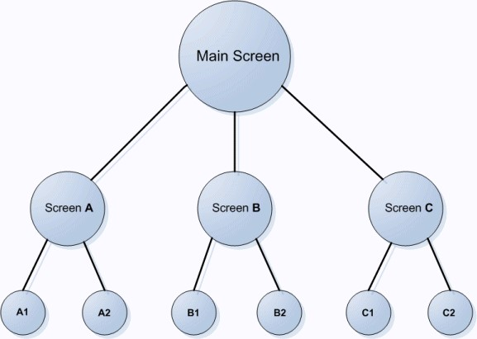

en0900000645

**13.5 Tutorial**

**Overview**

This chapter is designed as a tutorial to take you through the steps involved in designing a FlexArc Operator Panel.

The FlexArc Operator Panel is a simple arc welding cell, where the robots can perform the following three different jobs.

**Description**

**Job**

Welding

the

part

Produce

Service

the

welding

gun

Service

Calibrate

with

bull’s

eye

Bull’s

Eye

The FlexArc Operator Panel displays the following graphic elements:

* + Controller Status (controller mode auto or manual and the RAPID execution status)
  + Part Status (number of produced parts, the average cycle time per part, and a Reset button)
  + Robot jobs (Produce, Service, and Bull’s Eye) and Robot locations (Robot at home position, service location, calibration location, and part location) • Start and Stop buttons.

**Designing the FlexArc operator panel**

Use this procedure to design the FlexArc operator panel:

**Action Information**

1. Create a system for the FlexArc operator panel. Select the following options:
2. Load **EIO.cfg** and **MainModule.mod** files.

* FlexPendant Interface
* PC Interface

Select the following options,

By default:

* For *Windows XP*, the files can be found at *C:\Documents and Settings\<user name>\My Documents\RobotStudio\My ScreenMaker Projects\Tutorial*

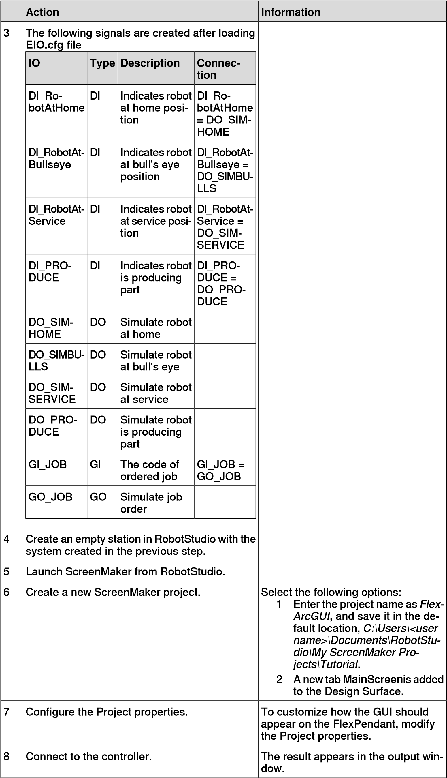

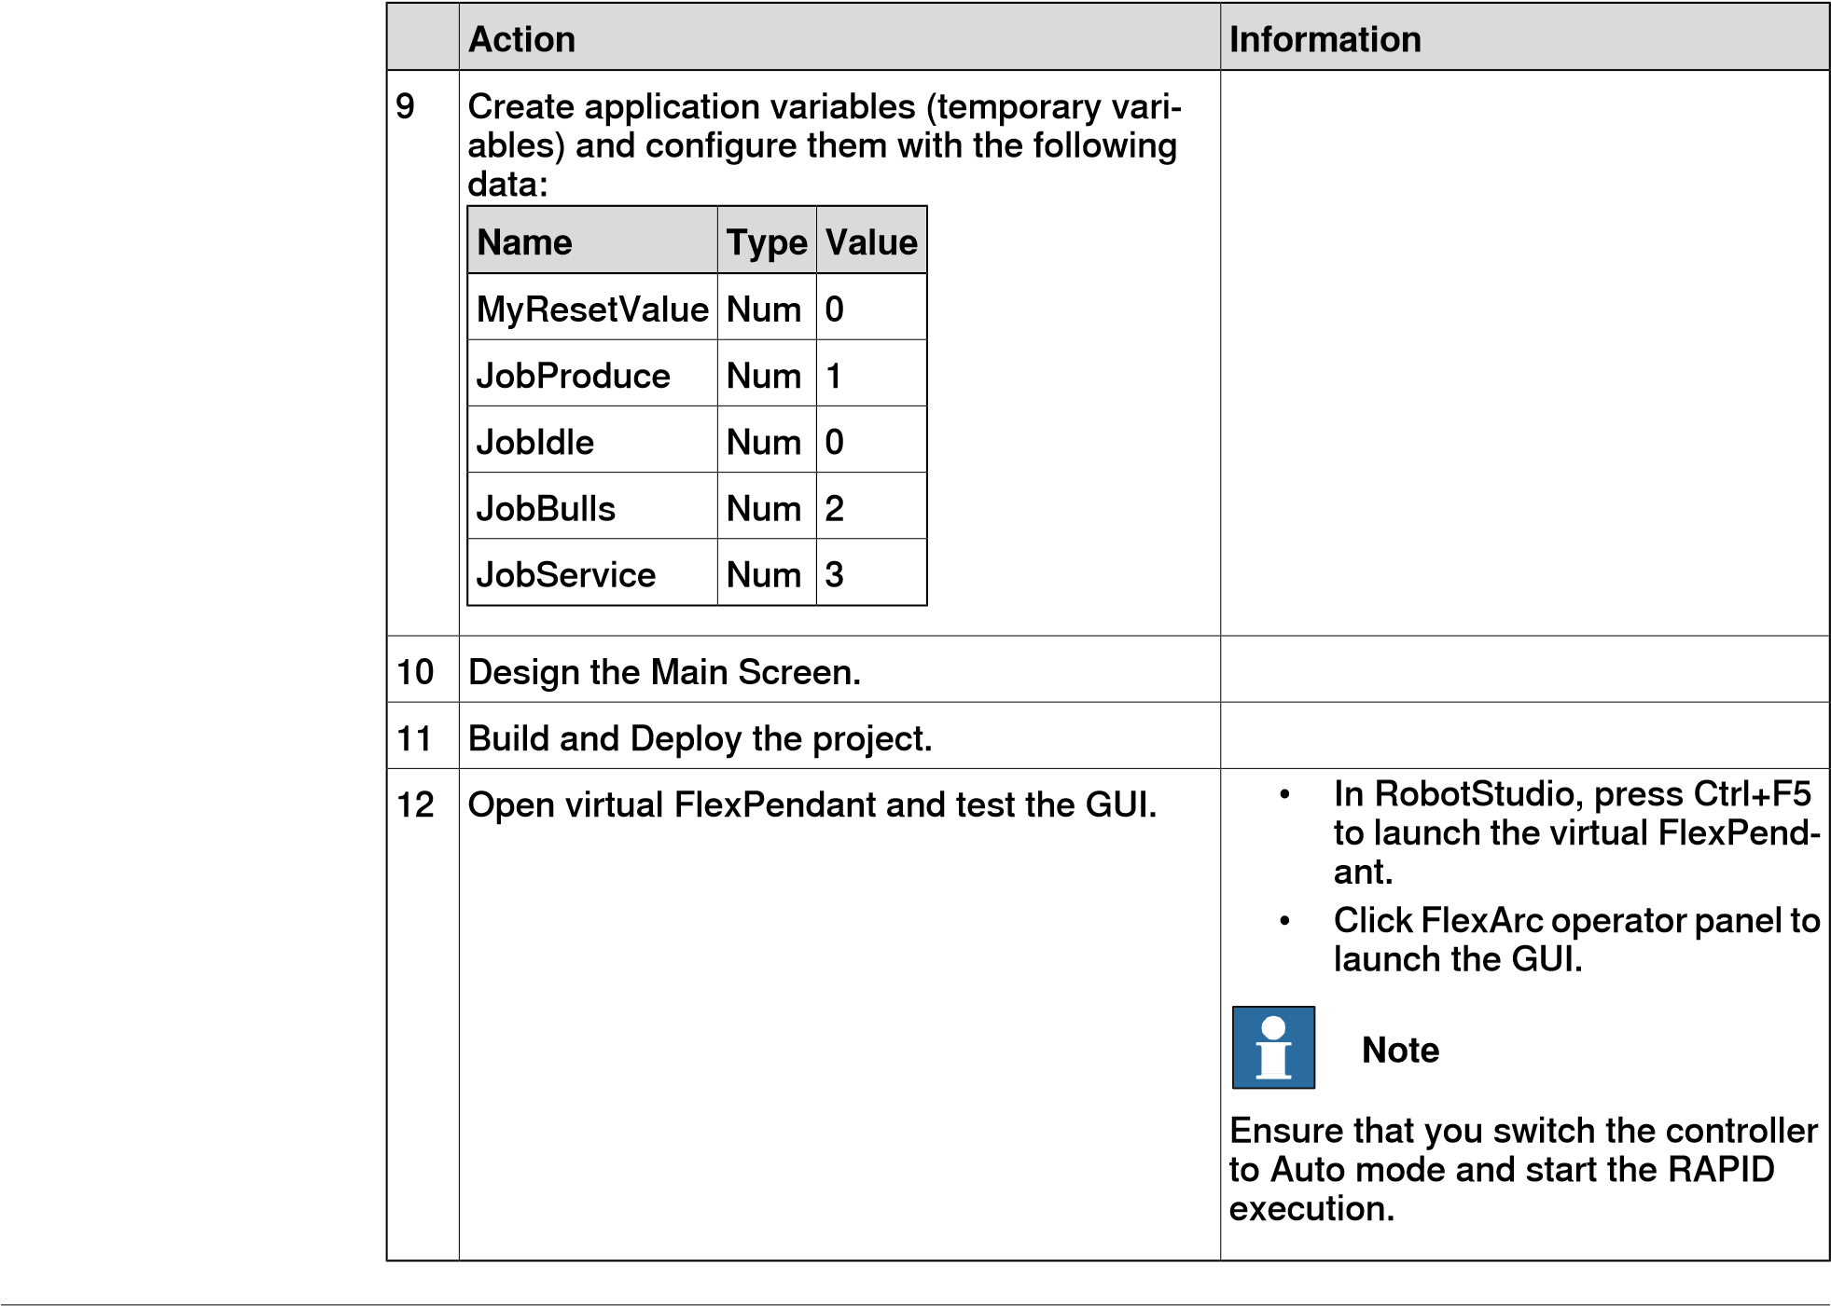

**Introduction to designing the screen**

A major effort in the GUI project development is designing screens. The Form designer in the ScreenMaker allows you to drag controls from the toolbox to the design surface. Using the Properties window, you can resize, position, label, color, and configure the controls.

**Designing FlexArc Operator Panel screen**

Use this procedure to design the FlexArc Operator Panel screen:

* 1. Drag a GroupBox control from the General category; place it on the design surface and set the following values in the Properties window.

**Value**

**Property**

14

,

45

Location

150,100

Size

Controller

Status

Title

LightGray

BackColor

* 1. Drag another GroupBox control from the General category; place it on the design surface and set the following values in the Properties window.

**Value**

**Property**

14,170

Location

150,204

Size

**Value**

**Property**

Part

Status

Title

LightGray

BackColor

* 1. Drag a ControllerModeStatus control from the Controller Data category; place it in the *Controller Status* groupbox created and set the following values in the Properties window:

**Value**

**Property**

19

,

40

Location

44

,

44

Size

LightGray

BackColor

* 1. Drag a RapidExecutionStatus control from the ControllerData category; place it in the *Controller Status* groupbox created and set the following values in the Properties window:

**Value**

**Property**

80

,

40

Location

44

,

44

Size

LightGray

BackColor

* 1. Drag a TpsLabel control from the General category; place it in the *Part Status* groupbox created and set the following values in the Properties window:

**Value**

**Property**

16

,

30

Location

131,20

Size

Parts

Produced

Text

LightGray

BackColor

TpsFont10

Font

* 1. Drag a NumEditor control from the ControllerData category; place it in the

*Parts Status* groupbox created and set the following values in the Properties

window:

**Value**

**Property**

16

,

56

Location

116,23

Size

Link

to

RAPID

variable

*partsReady*

defined

in

the

module

*MainModule*

.

Value

* 1. Drag another TpsLabel control from the General category; place it in the *Part*

*Status* groupbox created and set the following values in the Properties

window:

**Value**

**Property**

16

,

89

Location

**Value**

**Property**

131,20

Size

Cycle

time/part

Text

LightGray

BackColor

TpsFont10

Font

* 1. Drag another NumEditor control from the General category; place it in the

*Part Status* groupbox created and set the following values in the Properties

window:

**Value**

**Property**

16,115

Location

116,23

Size

Link

to

RAPID

variable

*cycleTime*

defined

in

the

module

*MainModule*

.

Value

* 1. Drag a Button control from the General category; place it in the *Part Status* group box created and set the following values in the Properties window:

##### Property Value

Location 33,154

Size 85,34

Text Reset

Perform the following for the **Reset** button in the *Part Status* group:

##### Step Action

1. Double-click the button **Reset**. The **Events Panel** dialog box appears which is used to define the actions for Events.
2. In the **Events Panel** dialog box, click **Add Action**; point to **Rapid Data** and select **Write a Rapid Data**.

The **Action Parameters** dialog box appears; assign Rapid data to the following value and click **OK**.

* + **T_ROB1.MainModule.partsReady** to **MyResetValue.Value** Similarly, assign Rapid data to the following value and click **OK**.
  + **T_ROB1.MainModule.cycleTime** to **MyResetValue.Value** Two actions of similar type are needed to perform the **Reset** action. One is to reset Rapid variable **partsReady** to 0, the other is to reset Rapid variable **cycleTime** to 0.

1. Drag a PictureBox control from the General category; place it on the design surface and set the following values in the Properties window:

**Value**

**Property**

177,28

Location

284,359

Size

StretchImage

SizeMode

FlexArcCell.GIF

Image

You can find the graphic (.GIF ) files at *C:\MyDocuments\RobotStudio\My ScreenMaker Projects\Tutorial\Images*.

**Note**

1. Drag another PictureBox control from the General category; place it on the design surface and set the following values in the Properties window:

Add **AllowMultipleStates** option to the PictureBox control. The objective is to have an image that changes when an I/O signal changes.

**Value**

**Property**

237,31

Location

48

,

48

Size

StretchImage

SizeMode

RobotAtHome.GIF

Image

True

AllowMultipleStates

Select

**Image**

property

from

the

**StatesEditor**

dialog

box.

DI_RobotAtHome

SlectedStateValue

Link

State{0}

to

*RobotAtHome_gray.GIF*

States

Link

State{1}

to

*RobotAtHome.GIF*

**Note**

For more information on how to use **AllowMultipleStates** for PictureBox control, see *Picture object and changing images due to I/O*.

1. Drag a Button control from the General category; place it on the design surface and set the following values in the Properties window:

##### Property Value

Location 486,66

Size 116,105

Text Start

Font TpsFont20b

BackColor LimeGreen Enabled Link to DI_RobotAtHome

Perform the following for the **Start** button:

##### Step Action

1. Double-click the button **Start** or click the **Smart tag** and select *Define Actions when clicked*. The **Events Panel** dialog box appears which is used to define the actions for Events.
2. In the **Events Panel** dialog box, click **Add Action**; point to **Rapid Data** and select **Write a Rapid Data**. The **Action Parameters** dialog box appears.
3. In the **Action Parameters** dialog box, assign Rapid data to the following value and click **OK**.

• **T_ROB1.MainModule.JobProduce** to **Job**.

13 Drag a Button control from the General category; place it on the design surface and set the following values in the Properties window:

##### Property Value

Location 486,226

Size 116,105

Text Stop

Font TpsFont20b

BackColor LimeGreen Enabled Link to DI_PRODUCE

Perform the following for the **Stop** button:

##### Step Action

1. Double-click the button **Stop** or click the **Smart tag** and select *Define Actions when clicked*. The **Events Panel** dialog box appears which is used to define the actions for Events.
2. In the **Events Panel** dialog box, click **Add Action**; point to **Rapid Data** and select **Write a Rapid Data**. The **Action Parameters** dialog box appears.
3. In the **Action Parameters** dialog box, assign Rapid data to the following value and click **OK**.

##### • T_ROB1.MainModule.JobIdle to JobIdle

14 Drag a Button control from the General category; place it on the design surface and set the following values in the Properties window:

##### Property Value

Location 274,246

Size 111,47

Text Bull’s Eye

Font TpsFont14b

Enabled Link to DI_RobotAtHome

AllowMultipleStates True

Select **BackColor** property from the **StatesEditor** dialog box

SelectedStates DI_RobotAtBull'sEye

States Link State{0} to *Red*

Link State{1} to *Green*

Perform the following for the **Bull’s Eye** button:

##### Step Action

1. Double-click the button **Bull’s Eye** or click the **Smart tag** and select *Define Actions when clicked*. The **Events Panel** dialog box appears which is used to define the actions for Events.
2. In the **Events Panel** dialog box, click **Add Action**; point to **Rapid Data** and select **Write a Rapid Data**. The **Action Parameters** dialog box appears.
3. In the **Action Parameters** dialog box, assign Rapid data to the following value and click **OK**.

##### • T_ROB1.MainModule.JobBulls to JobBulls

15 Drag a Button control from the General category; place it on the design surface and set the following values in the Properties window:

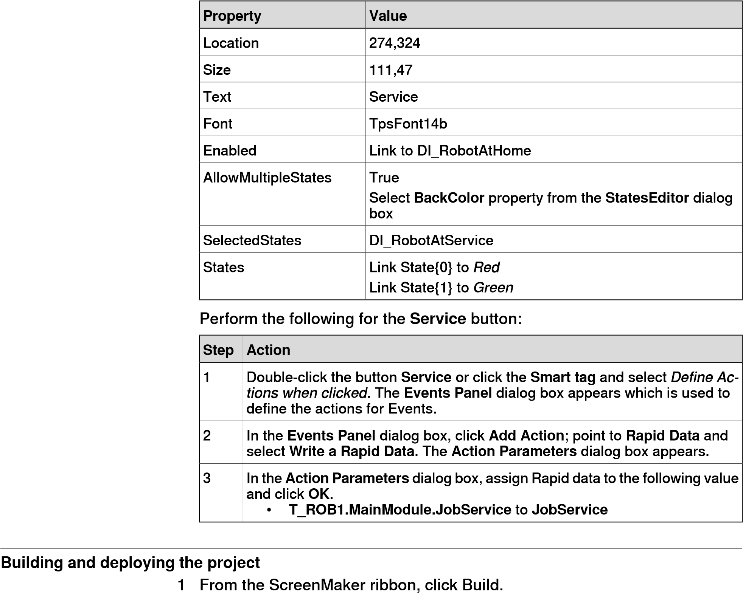

1. From the ScreenMaker ribbon, click Deploy.
2. In RobotStudio, press **Ctrl+F5** to launch the Virtual Flexpendant and click FlexArc Operator Panel to open the GUI.

**Note**

Ensure

that

you

start

the

RAPID

execution

and

switch

the

controller

into

Auto

mode.

This page is intentionally left blank

**14 RobotStudio®Cloud**

**Overview**

Use this feature to:

* + Edit, visualize and verify robot programs.
  + Store and manage RobotStudio projects.
  + Track and manage changes to projects using Version Control.
  + Stay connected to your project repository and edit from anywhere.
  + Share projects and collaborate with others.

**Getting started**

Activating the license key

RobotStudio Premium license includes the RobotStudio Cloud subscription. This must be activated from the **Activation Wizard**.

|  |  |
| --- | --- |
| **Opening RobotStudio Cloud**  1 | **web page**  In RobotStudio, on the top right corner, above the ribbon, click on your user name, then click **View My Cloud Projects** to open RobotStudio Cloud in the web browser. |
| 2 | You'll be asked for credentials before signing in to the site. Type in your credentials and press ENTER. |
| **Creating a Cloud project** 1 | Start RobotStudio. |
| 2 | Click the **File** tab to open the **Backstage** view.  *Continues on next page* |

To activate RobotStudio Cloud subscription, user must have an account in the myABB Business Portal, [*www.abb.com/myABB*](http://www.abb.com/myABB).

Activating the RobotStudio Cloud subscription

* 1. Click the **File** tab, and then click the **Help** section.
  2. Under **Support**, click **Manage Licenses**. The **Options** dialog appears with the **Licensing** options.
  3. If you have not activated your RobotStudio license, click the **Activation Wizard** and follow the instructions.
  4. If your RobotStudio license includes the RobotStudio Cloud subscription, a **Sign In** button will be visible in RobotStudio in the last step of the **Activation Wizard** and on the **Options:General:Licensing** page.
  5. Click the **Sign In** button, and enter your credentials in the **Sign in to your account** dialog.

If the signing in is successful, the RobotStudio *Subscription key* and your *username(email address)* gets displayed.

* 1. Click the **Activate** button.

If the activation is successful, you can see the **Activated** icon and the **View My Cloud Projects** link. Click this link to open RobotStudio Cloud.

* 1. On the left navigation pane, click **New**.
  2. Under **Project**, click **Project**.
  3. In the **Project** pane, in the **Name** box, type the name for the new project.
  4. Under **Location**, select **RobotStudio Cloud**.
  5. Click **Create**. A new project gets created in RobotStudio Cloud.

**Note**

To

start

from

scratch,

create

an

empty

project

and

customize.

Or,

for

practice

using

RobotStudio

features

try

including

Robot

and

Virtual

Controllers

with

robot

model

and

RobotWare

from

the

options

provided.

**Opening a Cloud project in RobotStudio**

* 1. In the **Backstage** view, click the project tile, to view the project details on the right navigation pane.
  2. Under **Branches**, click the **Open** button to open the project in RobotStudio.

By default the Main opens, to open a specific branch, select the branch and click the **Open** button.

**Opening a Cloud project in a web browser**

* 1. In the **Backstage** view, click the project tile, to view the project details on the right navigation pane.
  2. On the right navigation pane, click the **View Online** link, to open the RobotStudio Cloud web page in the web browser.

You'll be asked for credentials every time before signing in to the site. Type in your credentials and press ENTER to view the project in RobotStudio Cloud.

|  |  |
| --- | --- |
| **Uploading an existing project**  1 Open an existing project in RobotStudio. | |
| 2 | Click the **File** tab to open the **Backstage** view. |
| 3 | On the left navigation pane, click **Share** to see the available options. |
| 4 | Click **Upload to RobotStudio Cloud**. The Upload to RobotStudio Cloud pane opens. |
| 5 | Type-in the Project Name and commit message in the fields provided, click **Upload**.  A copy of the project gets created and uploaded to RobotStudio Cloud. |
| **Copying a project** 1 | On the File menu, click **Save Project As** to open the **Save MyProject As** dialog. |
| 2  *Continues on next page* | Select the check boxes **RobotStudio Cloud** or **This PC** to save the copy of the project to the respective location. |

*Continued*

* 1. If you choose to save the copy of the project locally, browse and select the required folder and click **OK**.

The entire Project structure including Virtual Controllers, library components and user files inside the Project folder will be copied to the new location. The user can select to open the copy or keep the current Project open.

**Version Control**

RobotStudio's version control functionality allows you to manage and keep track of changes made to your RobotStudio project. It also enables you to work on parallel versions of a RobotStudio project by creating branches.

Accessing the RobotStudio Cloud portal requires a working Internet connection and valid credentials.

**What is a branch?**

A branch is a copy of the RobotStudio project where you can explore changes without affecting the original files. It allows you to work in parallel and independently from other branches. Branches are useful to:

* Share and collaborate on projects with colleagues and stakeholders.
* Isolate experiments and test different versions of a robot program or cell layout.

Any new project in RobotStudio has a Main branch. This is the primary or default branch in RobotStudio.

**Create a branch**

* 1. In RobotStudio, click the **File** tab to open the **Backstage** view.
  2. On the left navigation pane, click **Open** and then click **RobotStudio Cloud** to see all available cloud projects.
  3. Click the project tile, to view the project details on the right navigation pane.
  4. On the right navigation pane, under **My Branches**, click **New**.
  5. Type the name of the branch in the **Create New Branch** dialog.

If you click **Create** , a new branch gets created, you can see the name of the branch under **My Branches**. Select this branch and click **Open** to view the project under this branch.

If you click **Create & Open**, the project opens under the newly created branch in RobotStudio.

**Committing changes**

All development updates can be saved using the **Commit** button. Commit has two options, **Commit** and **Review and Commit**.

* To commit the latest updates, on the top right corner, above the ribbon, click **Commit**. The **Commit Changes** dialog opens, type-in the required descriptions and click the **Commit** button to save the changes.

Alternatively, **Commit** can also be accessed from the **File** menu, On the **File** menu, click the **Commit** option.

* If a branch has uncommitted changes from the last edit or when the cloud version of the branch has been edited, use the **Review and Commit** option. On the top right corner, above the ribbon, click **Commit** and then click **Review and Commit**. The **Review Changes** window displays the module, with the latest changes and the last committed file side by side. Review the updates and click the **Commit** button.

**Note**

The

**Save Project**

option saves the project on the local disk, while

**Commit**

stores

a

version-controlled

commit

in

the

Cloud.

**Merging changes from a branch to main**

The branch must be updated with the latest changes in the Main before starting the merge operation.

* 1. In the **Backstage** view, click the project tile, to view the project details on the right navigation pane.
  2. On the right navigation pane, under **Branches**, click **Merge**.

Alternatively, the **Merge** button can also be accessed as follows:

On the left navigation pane, click **Info**, the **Project Info** pane opens, under **Branch Information** click **Merge**.

The **Merge** button will only be active if there are changes in the branch.

* 1. The **Merge** dialog opens in a web browser, click the **Merge** button. On successful merge, the branch gets deleted and main will be updated to reflect the changes in the branch.

**Getting updates to a branch from main**

* 1. Hover the mouse over the project tile and click **View Project** to open the **Version Control** page.
  2. On the **Main** navigation pane, under **My Branches**, click the branch that must be updated.

If there are changes in the **Main** branch, the **Update** button will be enabled.

* 1. Click the **Update** button, the **Update from Main** dialog opens in a web browser detailing the changes that will be merged into the branch from the **Main** branch.
  2. Click the **Update** button to accept the changes in the **Main** to the branch.

If the branch has committed updates, the *getting updates to a branch from main* operation can trigger conflicts.

Resolving conflicts

All conflicting changes must be resolved before the branch is updated.

* 1. If there are conflicting changes in the branch, when you click the **Update** button, the **Resolve Conflicts** window opens.

This dialog shows the changes in both main and branch.

*Continues on next page*

*Continued*

* 1. Select the check boxes next to the highlighted changes, your selections will be available in the **Output** box.

Review and customize the contents in the **Output** box and click **Update**.

**Getting the latest changes to the local copy of the branch**

When the current branch in RobotStudio has new changes in RobotStudio Cloud, user gets the following notification.



xx2200001839

These changes can be reviewed and subsequently updated to the local copy.

1 Click the **Review** button in the notification. The **Get Changes** dialog opens. 2 Click the **Get Changes** button to get the changes to the local copy. Making changes to the local copy of the branch when the branch has been changed in the RobotStudio Cloud can trigger conflicts, which must be resolved before getting the latest changes.

* 1. Click the **Review** button in the notification. The **Get Changes** dialog opens

When there are conflicting changes, the **Get Changes** dialog displays the **Resolve** button.

* 1. Click the **Resolve** button, the **Resolve Conflicts** window opens. This window shows the changes in both **Latest version from RobotStudio Cloud** and **Your uncommitted changes**.
  2. Select the check boxes next to the highlighted changes, your selections will be available in the **Output** box. You can choose to edit manually to resolve conflicts.

The **Apply** button will not be enabled till all conflicts are resolved.

* 1. Click **Apply** and then **Get Changes** to get the changes to the local copy of the branch.

**Delete a branch**

* 1. In RobotStudio, click the **File** tab to open the **Backstage** view.
  2. On the left navigation pane, click **Open** and then click **RobotStudio Cloud** to see all available cloud projects.
  3. Click the project tile, to view the project details on the right navigation pane.
  4. On the right navigation pane, under **My Branches**, select the branch and click **Delete**.

**Creating and exporting project viewer**

Use the following steps to create and save the project viewer as a file to RobotStudio Cloud. The viewer can be shared by generating a link.

1 • To create a project viewer without simulation.

On the **File** tab, click **Share** and then click **Export Viewer** .

• To create a project viewer with simulation.

On the **Simulation** tab, in the Simulation Control group, click **Export Viewer**.

1. The **Export Viewer** dialog opens. In the **Location** group, select **RobotStudio Cloud**.

The **RobotStudio Cloud** option is only available for a Cloud project where the user has signed in.

1. Select **Create link to share file** for generating a link for sharing the project viewer file with other Cloud users.

Type-in description in the **Additional description** to describe project.

If **Create link to share file** is selected, the resulting link can be copied to the clipboard or sent in an e-mail.

1. Click **Create**. This project viewer will be created in the *\*.glb* (gITF file) format and uploaded to RobotStudio Cloud.

Simulation control buttons are enabled when the Project Viewer contains a recorded simulation. When recording a simulation the user can confirm that the simulation was successful before the viewer is created .

Project viewers and other attachments can be managed in the **Attachments** view in the RobotStudio Cloud web application.

15.1 Virtual controller

1. **Home tab**
   1. **Virtual controller**

**About this button**

With the **Virtual Controller** button, you can either create a *virtual controller* from layout or template, choose an existing virtual controller, or select a virtual controller from a robot gallery.

**Creating a virtual controller from layout**

To create virtual controller using layout follow below procedure:

* + 1. Click **From Layout** to bring up the first page of the wizard.
    2. In the **Name** box, enter the name of the virtual controller. The location of the virtual controller will be displayed in the **Location** box.
    3. In the **RobotWare** drop down, select the version of *RobotWare* you want to use.
    4. Click **Next**.
    5. In the **Mechanisms** box, select the *mechanisms* that you want to include in the virtual controller.
    6. Click **Next**.

If only one mechanism was selected in the previous page, this page will not be shown.

Tasks can be added and removed using the respective buttons; mechanisms can be moved up or down using the respective arrows.

* + 1. Optionally, make any edits in the mapping, and then click **Next**.

The **Controller Option** page appears.

* + 1. On the **Controller Option** page, you have the option to align *Task Frame*(s) with the corresponding *Base Frame*(s).
       - For single robot system, select the check-box to align task frame with base frame.
       - For *MultiMove* Independent system, select the check box to align task frame with base frame for each robot.
       - For MultiMove Coordinated system, select the robot from the drop down list and select the check box to align task frame with base frame for the selected robot.
    2. Verify the summary and then click **Finish**.

If the system contains more than one robot, the number of tasks and the base frame *positions* of the mechanism should be verified in the **Motion Configuration** window.

**Note**

To create a system from layout, all your mechanisms such as robots, track motions and positioners, must be saved as libraries.

15.1 Virtual controller *Continued*

**Creating a New Virtual Controller**

* + 1. Click **New Controller** to bring up a dialog box.
    2. Under the **Controller** group, enter the name of the controller in the **Name** box.
    3. Select **Create new** and then select the required robot model from the **Robot Model** list for downloading to create a controller. If the selected model is not downloaded already, then user will be notified to download.
    4. Based on the robot model, select the **RobotWare** version and **Variant**.

While selecting Robot model that uses **RobotWare** version 7, **Controller** also must be selected.

* + 1. To create from backup, select **Create from backup** and then browse to select the required backup file. You can also select the RobotWare version followed by the RobotWare Add-in version. Select the **Restore backup** check box to restore backup on the new controller.
    2. In the **Mechanisms** group, select whether to **Import from library** or to **Use existing station mechanisms**.

**Adding an existing virtual controller**

* + 1. Click **Existing Controller** to bring up a dialog box.
    2. In the **Location** list, select a folder.
    3. In the **Virtual Controller** list, select a controller.

Optionally, to modify or create a new the virtual controller, click on **Manage** *link*, select **Modify Installation** from the list and then select the controller.

* + 1. In the **Options** group, select whether to import libraries or to use the existing station libraries.

User can tick the **Reset controller (I-start)** check-box to reset the virtual controller before adding it to the station.

* + 1. Click **OK**.
  1. Target

**15.2 Target**

**Overview**

You can create multiple targets at once, either enter the coordinates manually or click in the Graphics window to pick the desired positions.

You can align the target *orientations* with the surface of an adjacent CAD *part* by selecting the check box for aligning the surface to the closest part.

Type-in the target name prefix and select the task and workobject where the targets should go, and optionally select the *path* where the corresponding move instruction must be created. The selected instruction template will be used for the created move instruction.

**Creating a target**

* + 1. In the **Layout** browser, select the workobject in which you want to create the target and set it as **Active**.
    2. Click **Create Target** to bring up a dialog box.
    3. Select the **Reference** *coordinate system* you want to use to position the target:

**Select**

**If**

**you**

**want**

**to**

**position**

**the**

**target**

**World**

absolute

in

the

world

coordinate

system

of

the

station

**workobject**

relative

to

the

position

of

the

active

workobject

**UCS**

in

a

user-defined

coordinate

system

* + 1. In the **Points** box, click **Add New** and then click the desired position in the graphics window to set the position of the target. You can also enter the values in the **Coordinates boxes** and click **Add**.
    2. Enter the **Orientation** for the target. A preliminary cross will be shown in the graphics window at the selected position. Adjust the position, if necessary. To create the target, click **Create**.
    3. If you want to change the workobject for which the target is to be created, expand the **Create Target** dialog box by clicking the **More** button. In the **WorkObject** list, select the workobject in which you want to create the target.
    4. If you want to change the target name from the default name, expand the **Create Target** dialog box by clicking the **More** button and entering the new name in the **Target name** box.
    5. Click **Create**. The target will appear in the browser and in the graphics window.

15.2 Target

**Note**

The

created

target

will

not

get

any

configuration

for

the

robot

axes.

To

add

the

configuration

values

to

the

target,

use

either

**Auto**

**Configuration**

or

the

**Configurations**

dialog

box.

If

using

external

axes,

the

position

of

all

activated

external

axes

will

be

stored

in

the

target.

*Continued*

**Creating a jointtarget**

*Joint* target defines each individual axis position, for both the robot and the external axes.

* + 1. Click **Create Jointtarget** to bring up a dialog box.
    2. If you want to change the default name of the jointtarget, enter the new name in the **Name** box.
    3. In the **Axes Values** group, do as follows:
       - For the **Robot axes**, click the **Values** box and then click the down arrow. The **Joint Values** dialog box will be displayed. Enter the joint values in the boxes and click **Accept**.
       - For the **External axes**, click the **Values** box and then click the down arrow. The **Joint Values** dialog box will be displayed. Enter the joint values in the boxes and click **Accept**.

4 Click **Create**. The jointtarget will appear in the browser and in the graphics window.

**Note**

JointTargets

for

external

axis

are

not

visualized

in

the

graphical

window.

**The**

**Create**

**Jointtarget**

**dialog**

**box**

Specify

the

name

of

the

jointtarget.

**Name**

Click the

**Values**

list, enter the values in the

**Joint values**

dialog

box

and

click

**Accept**

.

**Robot**

**axes**

Click the

**Values**

list, enter the values in the

**Joint values**

dialog

box

and

click

**Accept**

.

**External**

**axes**

Select

the

**Storage**

**TypeTASK**

**PERS**

if

you

intend

to

use

the

jointtarget

in

multimove

mode.

**Storage**

**Type**

The

storage

type

of

a

data

object

determines

how

it

is

stored

in

memory

and

how

it

can

be

used.The

available

types

are

**CONST,VAR,PERS,TASK**

**PERS**

.

Select the module in which you want to declare the jointtarget.

**Module**

**name**

**Overview**

Targets on Edge creates targets and move instructions along the edges of the geometric surface by selecting target points in the graphics window. Each point on a geometric edge has certain properties that can be used to position robot targets relative to the edge.

*Continues on next page*

15.2 Target *Continued*

**Creating targets on edge**

* + 1. On the **Home** tab, click **Target** and select **Create Targets on Edge**. The **Targets on Edge** dialog box appears.

and the snap mode is set to **Edge**.

**Note**

The

selection

mode

in

graphics

window

is

automatically

set

to

**Surface**

,

* + 1. Click on the surface of the *body* or part to create target points.

The closest point on the adjacent edge is calculated and added to the list box on as target points Point 1, Point 2 ....

* + 1. the edge.

**Note**

When

an

edge

is

shared

between

two

surfaces,

the

normal

and

tangent

directions

depend

on

the

surface

selected.

Use

the

following

variables

to

specify

how

a

target

is

related

to

a

point

on

**Select... to...**

**Vertical offset** specify the distance from the edge to the target in the surface normal direction.

**Lateral offset** specify the distance from the edge to the target perpendicular to the edge tangent.

**Approach angle** specify the angle between the (inverse) surface normal and the approach vector of the target.

**Reverse travel direction** specify if the travel vector of the target is parallel or inversely parallel to the edge tangent.

**Note**

For each target point, a preview of the approach and travel vectors are displayed as arrows and as a sphere representing the point on the edge in the graphics window. The preview of the arrows are updated dynamically once the variables are modified.

1. Click **Remove** to remove the target points from the list box.
2. Click **More** to expand the **Create Targets on Edge** dialog box and to choose the following advanced options:

**Use... to..**

**Target name** change the target name from the default name to a new user defined name

**Task** select the task for which to add targets.

By deafult, active task in the station is selected.

**Workobject** select the workobject for which you want to create the targets on edge.

15.2 Target *Continued*

**Use... to..**

**Insert Move Instructions** create Move instructions in addition to targets, which **in** will be added to the selected path procedure.

The active process definition and process template will be used.

1. Click **Create**.

The target points and Move instructions (if any) are created and are displayed in the Output window and graphics window.

15.3 Path

**15.3 Path**

**Empty path**

Use the below procedure to create an empty path:

1. On the **Home** tab, click **Path**.
2. Click **Empty Path**.
3. In the **Paths&Targets** browser, the new empty path is created in the folder of the active task.

**Note**

The

active

task

is

as

per

the

**Task**

selected

in

the

combobox.

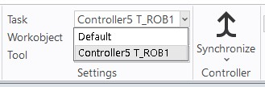

xx1900001906

**AutoPath**

Use the AutoPath feature to generate accurate paths (linear and circular) based on CAD *geometry*. You need to have a geometric object with edges, *curves*, or both.

AutoPath feature can create paths from curves or along the edges of a surface. To create a path along a surface use selection level Surface, and to create a path along a curve, use selection level Curve. When using Selection level Surface, the closest edge of the selection will be picked for inclusion in the path. An edge can only be selected if connected to the last selected edge.

When using Selection level Curve, the selected edge will be added to the list. If the curve does not have any branches, all edges of the entire curve will be added to the list if holding the SHIFT button when selecting an edge. The Approach and Travel directions as defined in the RobotStudio options are used to define the orientation of the created targets.

Use this procedure to automatically generate a path.

1. In the **Home** tab, click **Path** and select **AutoPath**.

The AutoPath tool appears. Select the **Create multiple paths from curves** check-box to create multiple paths from the selected curves.

1. Select the edge or curve of the geometric object for which you want to create a path.

15.3 Path

*Continued*

The selection is listed as edges in the tool window.

**Note**

* + - If in a geometric object, you select curve (instead of an edge), then all the points that result in the selected curve are added as edges to the list in the graphic window.
    - Ensure you always select continuous edges.

1. Click **Remove** to delete the recently added edge from the graphic window.

**Note**

To change the order of the selected edges, select **Reverse** check box.

1. You can set the following **Approximation Parameters**:

##### Select or enter values in to

MinDist Set the minimum distance between the generated

points. That is, points closer than the minimum distance are filtered.

Tolerance Set the maximum deviation from the geometric descrip-

tion allowed for the generated points.

MaxRadius Determines how large a circle radius has to be before

considering the circumference as a line. That is, a line can be considered as a circle with infinite radius.

Linear Generate a linear move instruction for each target.

Circular Generate circular move instructions where the selected edges describe circular segments.

Constant Generate points with a Constant distance.

End Offset Set the specified offset away from the last target.

Start Offset Sets the specified offset away from the first target.

The **Reference Surface** box shows the side of the object that is taken as normal for creating the path.

Click **More** to set the following parameters:

**to**

**Select**

**or**

**enter**

**values**

**in**

Generate

a

new

target

at

a

specified

distance

from

the

first

target.

Approach

Generates

a

new

target

at

a

specified

distance

from

the

last

target.

Depart

1. Click **Create** to automatically generate a new path.

A new path is created and move instructions are inserted for the generated targets as set in the Approximation parameters.

**Note**

The

targets

are

created

in

the

active

workobject.

*Continues on next page*

15.3 Path

*Continued*

1. Click **Close**.

15.4 Other

**15.4 Other**

**Create Workobject**

Overview

A workobject is a local coordinate system that indicates the reference position (and orientation) of a work piece. The workobject contains two *frames*, the user frame and the object frame. The user frame (user coordinate system) is one of the two frames of a workobject, is defined relative to the controller world coordinate system. The object frame is defined relative to the user frame. To create a workobject, the following parameters must be specified in the **Create Workobject** dialog.

**Name** Specify the name of the workobject.

**Robot holds workobject** Select whether the workobject is to be held by the robot. If you select **True**, the robot will hold the workobject. The tool can then either be stationary or held by another robot.

**Moved by mechanical unit** Select the *mechanical unit* that moves the workobject. This

option is applicable only if **Programmed** is set to **False**.

**Programmed** Select **True** if the workobject is to use a fixed coordinate system, and **False** if a movable (that is, external axes) will be used.

**Position x, y, z** Click in one of these boxes, and then click the position in the

graphics window to transfer the values to the **Position** boxes.

**Rotation rx, ry, rz** Specify the rotation of the workobject in the UCS.

**Frame by points** Specify the frame position of the user frame.

**Position x, y, z** Click in one of these boxes, and then click the position in the graphics window to transfer the values to the **Position** boxes.

**Rotation rx, ry, rz** Specify the rotation of the workobject.

**Frame by points** Specify the frame position of the object frame.

##### Storage type Select PERS or TASK PERS. Select the Storage TypeTASK

**PERS** if you intend to use the workobject in multimove mode.

**Task** Specify the task of the sync properties.

**Module** Select the module in which to declare the workobject.

Creating a workobject

1. On the **Home** tab, in the **Path Programming** group, click **Other** and select **Create Workobject**.

The **Create Workobject** dialog box appears.

1. In the **Misc Data** group, enter the values for the new workobject.
2. In the **User Frame** group, do one of the following:
   * + Set the position of the user frame by entering values for the **Position x,y,z** and the **Rotation rx, ry, rz** for the workobject by clicking in the **Values** box.
     + Select the user frame by using the **Frame by points** dialog box.

*Continues on next page*

|  |  |
| --- | --- |
|  | 15.4 Other *Continued* |
| 4 | In the **Object Frame** group you can reposition the object frame relative to the user frame by doing any of the following:   * Set the position of the object frame by selecting values for **Position x, y, z** by clicking in the **Values** box. * For the **Rotation rx, ry, rz**, select **RPY (Euler ZYX)** or **Quaternion**, and enter the rotation values in the **Values** dialog box. * Select the object frame by using the **Frame by points** dialog box. |
| 5 | In the **Sync Properties** group, enter the values for the new workobject. |
| 6 | Click **Create**. The workobject will be created and displayed under the **Targets** node under the robot node in the **Paths&Targets** browser. |
| **Creating tooldata** 1 | In the **Layout** browser, make sure the robot in which to create the tooldata is set as the active task. |
| 2 | On the **Home** tab, in the **Path Programming** group, click **Other**, and then click **Create Tooldata**.  The *Create Tooldata* dialog box opens. |
| 3 | In the **Misc Data** group:   * Enter the **Name** of the tool. * Select whether the tool is to be held by the robot in the **Robot holds tool** list. |
| 4 | In the **Tool Frame** group:   * Define the **Position x, y, z** of the tool. * Enter the **Rotation rx, ry, rz** of the tool. |
| 5 | In the **Load Data** group:   * Enter the **Weight** of the tool. * Enter the **Center of gravity** of the tool. * Enter the **Inertia** of the tool. |
| 6 | In the **Sync Properties** group:   * In the **Storage type** list, select **PERS** or **TASK PERS**. Select **TASK PERS** if you intend to use the tooldata in MultiMove mode. * In the **Task** list, select the robot in which the task to be done using the tooldata. * In the **Module** list, select the module in which to declare the tooldata. |
| 7 | Click **Create**. The tooldata appears as a coordinate system in the graphics window.  *Continues on next page* |

15.4 Other *Continued*

**Create Action Instruction**

Overview

An action instruction is an instruction other than a move instruction that can, for example, set parameters, or activate or deactivate equipment and functions. The action instructions available in RobotStudio are limited to those commonly used for controlling the robot’s motions. For inserting other action instructions or another kind of RAPID code in the program, use the RAPID Editor.

The following table lists the action instructions that are available by default. It is possible to add the corresponding instruction template using the instruction template tool.

##### Action instruction Description

ConfL On/Off *ConfL* specifies whether to monitor the robot’s configurations

during linear movements. When *ConfL* is set to Off, the robot may use another configuration than the programed one for reaching the target during program execution.

ConfJ On/Off *ConfJ* specifies whether to monitor the robot’s configurations

during joint movements. When *ConfJ* is set to Off, the robot may use another configuration than the programed one for reaching the target during program execution.

Actunit *UnitName Actunit* activates the mechanical unit specified by *UnitName*.

DeactUnit *UnitName Deactunit* deactivates the mechanical unit specified by *UnitName*.

Creating an action instruction

1. In the **Paths&Targets** browser, select where to insert the action instruction. To insert the action instruction at the beginning of a path then select the path.

To insert the action instruction after another instruction then select the proceeding instruction.

1. On the **Home** tab, in the **Path Programming** group, click **Other**, and then click **Create Action Instruction**.

The **Create Action Instruction** dialog box appears.

1. In the **Task** list, select the robot to which action instruction to be done.
2. In the **Path** list, select the path.
3. From the *Instruction Templates* list, select the action instruction to create.
4. Optionally, modify instruction arguments in the **Instruction Arguments** grid.
5. Click **Create**.

15.5 Virtual Reality

**15.5 Virtual Reality**

**Introduction**

The Virtual Reality (VR) button gets enabled on the **Home** tab when you connect a VR headset to the PC. RobotStudio and its Export Viewer works with HTC VIVE, HTC VIVE Cosmos, Oculus Rift, Meta/Oculus Quest 2, Oculus Rift S, Valve Index and Samsung HMD Odyssey (Windows Mixed Reality). These devices have motion tracking sensors for location and orientation tracking of the headset and for the hand controls. The hand controls can be used to interact with the virtual reality environment.

**Note**

Before

activating

Virtual

Reality

in

RobotStudio,

it

is

recommended

to

test

the

VR

headset

with

the

samples

from

the

supplier

to

ensure

its

functionality.

**Prerequisites**

* A high-performance gaming PC that matches the specifications of the VR headset requirements. Check the supplier web page for installation details.
* Microsoft Windows 10 operating system.
* It is recommended to ensure that the physical space is obstacle-free. However, even in a limited space, the teleport function can be used to move around in the VR environment.

**Programming**

The VR function enables robots to be lead through programmed in a safe way which is otherwise not possible. You can teach movements to the robot by simply moving the robot around.

**Navigation modes in the VR environment**

The main navigation modes in the VR environment are:

* Physically moving around
* Snap move/turn
* Teleportation
* Drag navigation

Physically moving around

Take short steps or rotate yourself in the real world to make small adjustments to your viewpoint.

Snap move/turn

Press the left hand controller joystick/trackpad forward or backward to snap move in that direction in short steps. Press the joystick/trackpad left or right to snap turn in that direction.

*Continues on next page*

15.5 Virtual Reality *Continued*

Teleportation

To achieve teleportation, press the **Grip** button on the left hand controller. Pressing the **Grip** button displays a beam, press the **Trigger** button to teleport to the yellow spot where the beam hits the floor. To cancel the teleportation, just release the left **Grip** button.

To move the teleportation target to a higher or lower level, with the left **Grip** button pressed, press the left joystick/trackpad forward or backward.

Drag navigation

To move and rotate the VR environment around a point that is centered between the left and right hand controllers, press the left and right **Grip** buttons simultaneously. Use the same buttons to move up/down, forward/backward, right/left and rotate in the VR environment.

16.1 Import Geometry

1. **Modeling tab**
   1. **Import Geometry**

**Overview**

Use Import geometry to add 3D parts to the station. The User Geometry gallery will display 3D geometry files in the Geometry folder of the user document location. If you have a project, the Project Geometry gallery will display 3D geometry files in the User Files folder of the current project. Additional galleries can be specified with the Locations option. To import general files, use the Browse for Geometry option. This dialog provides the following additional options.

* + - Convert CAD geometry to single part: Converts an assembly containing multiple parts to a single part.
    - Surface model(render both sides of surfaces): Render both sides of surfaces.
    - Import hidden/no-show entities: Entities specified as hidden/no show in the geometry file will be imported and made visible.
    - Link to Geometry(remember source location): The file path of the imported geometry file will be remembered to allow geometry to be updated at a later occasion. Right click a part in Layout browser and click Update Linked geometry.
    - Duplicate instanced geometry: If the geometry file contains entities which have multiple instances, each instance will be imported as separate entities.

**Mathematical versus graphical geometries**

A geometry in a CAD file always has an underlying mathematical representation. Its graphical representation, displayed in the graphics window, is generated from the mathematical representation when the geometry is imported to RobotStudio, after which the geometry is referred to as a part.

For this kind of geometry, you can set the detail level of the graphical representation, thus reducing the file size and rendering time for large models and improving the visual display for small models you might want to zoom in on. The detail level only affects the visual display; paths and curves created from the model will be accurate both with coarse and fine settings.

A part can also be imported from a file that simply defines its graphical representation; in this case, there is no underlying mathematical representation. Some of the functions in RobotStudio, such as snap mode and creation of curves from the geometry, will not work with this kind of part.

* 1. **Create Mechanism**

**Overview**

It is possible to create *mechanisms* to simulate external objects such as, turn tables, grippers, *positioners*. The following list describes some of the mechanisms:

* + - Robot is a mechanism that has a TCP and can be controlled by a *virtual controller*.
    - Device is a mechanism which does not have a TCP.
    - External axes is mechanism that does not have a TCP but can be controlled by a virtual controller, like track motion or a workpiece positioner or a gantry. An external axis can move a robot, for example, track motion.
    - Tool is a mechanism that has TCP which can be moved by a robot.

**Note**

A

mechanism

must

include

two

links.

**Create a new mechanism**

* + 1. Click **Create Mechanism.**

The Create Mechanism window is opened.

* + 1. In the **Mechanism Model Name** box, enter a mechanism name.
    2. From the **Mechanism Type** list, select a mechanism type.
    3. In the tree structure, right-click **Links**, and then click **Add Link** to bring up the **Create Link** dialog box.

A suggested name appears in the **Link Name** box.

* + 1. In the **Selected Component** list, select a component (which will be highlighted in the graphics window) and click the arrow button to add the component to the components list box.

The **Selected Component** list then automatically selects the next component, if any more are available. Add these, as required.

**Note**

Components

that

are

component

of

a

library

or

mechanism

cannot

be

selected.

* + 1. Select a component in the components list box, enter any values in the **Selected Components** group boxes, and then click **Apply to component**. Repeat for each component, as required.
    2. Click **OK**.
    3. In the tree structure, right-click **Joints**, and then click **Add Joint** to bring up the **Create Joint** dialog box.

A suggested name appears in the **Joint Name** box.

*Continues on next page*

16.2 Create Mechanism *Continued*

* + 1. Complete the **Create Joint** dialog box, and then click **OK**.

The joint axes must be mapped to complete the joint values.

**Note**

* + 1. In the tree structure, right-click **Frame/Tool Data**, and then click **Add Frame/Tool** to bring up the **Create Frame/Tool** dialog box.

A suggested name appears in the **Frame/Tool Data name** box.

* + 1. Complete the **Create Frame/Tool** dialog box, and then click **OK**.

The validity criteria for the **Frame/Tool** node are as follows:

* + 1. In the tree structure, right-click **Calibration**, and then click **Add Calibration** to bring up the **Create Calibration** dialog box.
    2. Complete the **Create Calibration** dialog box, and then click **OK**.
    3. In the tree structure, right-click **Dependency**, and then click **Add Dependency** to bring up the **Create Dependency** dialog box.
    4. Complete the **Create Dependency** dialog box, and then click **OK**.
    5. If all nodes are valid, compile the mechanism.

**Compiling a mechanism**

When compiling, a new mechanism, created in the create mode of the Mechanism Modeler, is added to the station with the default name "Mechanism_" followed by an index number.

When compiling, an existing editable mechanism, modified in the modify mode of the Mechanism Modeler, is saved without any poses, joint mapping ot transition times.

To compile a mechanism, follow these steps:

* + 1. To compile a new or edited mechanism, click **Compile Mechanism**.

The mechanism is inserted into the active station. The link parts are cloned with new names, but the corresponding links will update their part references. When the Mechanism modeler is closed, these cloned parts will be removed.

* + 1. The Mechanism Modeler now switches to modify mode. To complete the mechanism, see below.

**Completing or modifying a mechanism**

To complete the modeling of a mechanism, follow these steps:

* + 1. If the values in the **Joint Mapping** group are correct, click **Set**.
    2. Configure the Poses grid. To add a pose, click **Add** and then complete the **Create Pose** dialog box. Click **Apply**, followed by **OK**.
       - * To add a pose, click **Add** and then complete the **Create Pose** dialog box. Click **Apply**, followed by **OK**.
         * To edit a pose, select it in the grid, click **Edit**, and then complete the **Modify Pose** dialog box. Click **OK**.
         * To remove a pose, select it in the grid and then click **Remove**.
    3. Click **Edit Transition Times** to edit transition times.
    4. Click **Close**.

**The Create Mechanism dialog box**

**Mechanism Model Name** Specifies the model name of the mechanism.

**Mechanism Type** Specifies the mechanism type.

Tree structure The components of the mechanism in a tree structure. The tree structure will not be visible unless the mechanism is editable. Each node (link, joint, frame, calibration and dependency) can be edited in its own dialog box, see below.

**Compile Mechanism** Click this button to compile the mechanism. This button will not be visible unless the mechanism is editable and the mechanism model name is valid.

**Using variable joint limits for interdependent joints**

The Variable limit type can be assigned to joint limits as way of delimiting the range of motion for interdependent joints (area of movement as depicted on a graph).

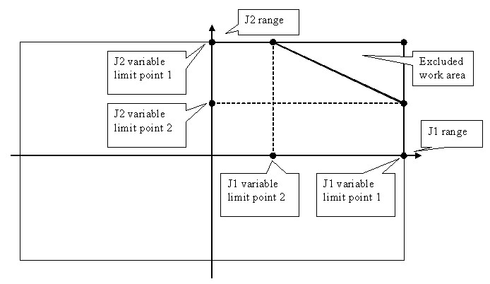

xx060012

Consider two joints Joint 1 and 2 as depicted below. Joint 2 can move between y1 and y4 when Joint 1 is at x1 degrees, and between y3 to y2 when Joint 1 is at x2

*Continues on next page*

16.2 Create Mechanism *Continued*

degrees. That is, an area is formed by 4 points for each joint pair (Joint1 value: Joint2 value): x1: y1, x2: y2, x3: y3 and x4: y4

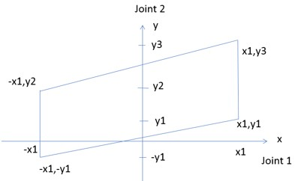

xx2100000521

Use the following example to visualize variable joint limits. For example, Joint 2 has a range of motion between -10 to +30 when Joint 1 is at -90 degrees and between +10 to +70 when Joint 1 is at +90 degrees

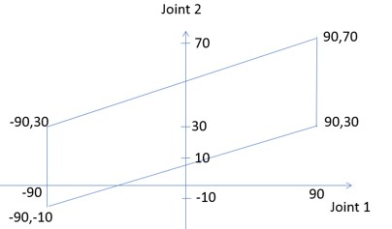

xx2100000522

An area will be formed by 4 points for each joint pair (Joint1:Joint2): -90:30, 90:70, 90:10 and -90, -10. In the mechanism modeler, add the following values for the variable limits in the following order J1: -90, 90, 90, -90 and J2: 30, 70, 10, -10.

**The Modify Mechanism dialog box**

The **Modify Mechanism** dialog box contains the objects found in the **Create mechanism** dialog box, as well as the following:

**Joint Mapping** Theseboxeshandlethe jointmappingof the mechanism.When editing, the mechanism must be disconnected from its library. The values must be integers from 1 – 6 in ascending order.

**Set** Click this button to set the joint mapping.

**Poses** Displays the poses and their joint values.

Selecting a pose will move the mechanism to it in the graphics window.

**Add** Click this button to bring up the **Create Pose** dialog box for

adding a pose.

**Edit** Click this button to bring up the **Modify Pose** dialog box for

editing a selected pose.

A SyncPose cannot be edited unless the mechanism is disconnected from its library.

**Remove** Click this button to remove the selected pose.

A single SyncPose cannot be removed.

**Set Transition Times** Click this button to edit the transition times.

16.3 Create Tool

**16.3 Create Tool**

**Creating a tool**

You can create a robot hold tool by using the **Create Tool Wizard**. The wizard allows you to easily create a tool from an existing part or by using a dummy part to represent a tool. To create a tool complete with tooldata, follow these steps:

1. Click **Create Tool**.
2. In the **Tool Name** box, enter a tool name and choose one of the following options:

##### Option Action

**Use Existing** Select one of the existing parts from the list. The selected part will represent the tool graphics.

The selected part must be a single part. Parts with attachments cannot be selected.

**Use Dummy** A cone will be created to represent the tool.

1. Continue entering the **Mass** of the tool, the **Center of Gravity** and the **Moment of Inertia Ix, Iy, Iz**, if these values are known.

**Note**

If you do not know the correct values, the tool can still be used for programming motions, but this data must be corrected before running the program on real robots or measuring cycle times.

**Tip**

If the tool is built from materials with a similar density, you can find the center of gravity by clicking the tool model using the **Center of gravity** snap mode.

1. Click **Next**.
2. In the **TCP Name** box, enter a name for the Tool Center Point (TCP).

**Note**

The default name is the same as the name of the tool. If creating several TCPs for one tool, each TCP must have a unique name.

1. Enter the position of the TCP relative to the world coordinate system, which represents the tool mounting point, by any of the methods below:

##### Method Description

Read values from exist- Click in the **Values from Target/Frame** box, then select ing target or frame the frame either in the graphics window or the **Paths&Targets** browser.

16.3 Tool

##### Method Description

Enter position and orient- In the **Position** and **Orientation** boxes, type the values.

ation manually. If **Use Dummy Part** is selected, the position value can not

be 0,0,0. At least one coordinate has to be > 0 in order for a cone to be created.

1. Click the arrow right button to transfer the values to the **TCP(s):** box.

If the tool shall have several TCPs, repeat steps 5 to 7 for each TCP.

1. Click **Done**.

The tool is created and appears in the **Layout** browser and in the graphics window.

**Creating tooldata for an existing geometry**

Ensure to select the robot in which tooldata is created. To create tooldata for an existing geometry, follow these steps:

1. Click **Create Tool** and select **Use Existing** and the imported tool from the list.
2. Enter the requested data in the boxes in the **Create Tool Wizard**.
3. Attach the tool by dragging it to the robot.

**What to do next**

To make the tool ready to use, do one of the following:

* To make the robot hold the tool, attach the tool to the robot.
* In the graphics window, check the position and orientation of the TCP. If it is incorrect, modify the values in the tool frame part of the tooldata.
* To simplify future usage of the created tool, save it as a library. On the **File** menu, click **Save As Library**. Browse to the folder where you want to store the tool component, enter a name for the tool component and click **Save**.

1. **Simulation tab**

**17.1 Station Logic**

**Overview**

The *station logic* is a typical connection between an IO signal/properties over different items/objects of the station and an output signal/properties from a *virtual controller*. The convenient way to connect different items/objects of a station is to use design view.

Example: In a simulation module, where the gripper is controlled by IO signal you can connect the output signal of the virtual controller to the gripper through the station logic.

**Note**

The properties are connected through binding and the connection are displayed

in

red

color.

The signals are connected through connections and the connection are displayed

through

green

color.

The

Station

Logic

editor

consists

of

the

following

tabs:

**Description**

**Tab**

In

this

option,

you

can

add

and

edit

the

*smart*

*components*

and

all

the

smart

components

are

listed

in

child

components.

Compose

The

state

of

the

component

can

be

saved

to

be

restored

later.

The

state

contains selected modifiable aspects of the component and its child compon-

ents

at

the

time

when

the

state

was

saved.

•

Child

components:

Lists

all

smart

components.

•

Saved

States:

The

state

of

the

components

can

be

saved.

•

Assets:

Allows

you

to

browse

and

select

any

file

as

an

asset

related

to

RobotStudio

Its a graphical view where all the selected objects/items are listed. Its a most

convenient

way

to

connect

different

items/objects

of

a

station

Design

Displays

all

object/item

properties.

Properties

and

Bind-

ings

Displays

all

object/item

signals.

Signals

and

Connections

**Connecting smart components in the Design view**

In this procedure you can connect the I/O signal/properties over different items/objects of the station and an output signal/properties using **Design view** tab.

1. Click on the **Simulation** tab and select **Station Logic** option.

The **Station Logic** window is displayed.

1. To add a smart component, press "**Add component**" link and select it from the drop down menu.

The object is listed under **Child Components** option.

1. Go to the **Design** tab.

All the **Smart Components** of the station are listed in **Design** view.

1. To connect two smart components, select and hold the property or I/O signal from the source component, slow drag and drop on the other property or I/O signal of the target component.

The connectivity line is displayed to show that connection is created.

**Compose tab**

Overview

The Compose tab consists of the following:

* Child components
* Saved States
* Assets

Child components

It is a list box that displays all the objects contained by the component. Objects connected to a library have an overlay that indicates that the objects are locked. Smart Components are displayed first followed by other type of objects. The following commands are displayed in child components:

##### Command Description

**Add component** Adds a child object to the component from the list.

You can select a built-in base Smart Component, a new empty Smart Component, a library from file or a geometric part from file.

Base components are organized as sub-menus based on the usage. For example, *Signals and Properties*, *Sensors*, *Actions* and so on. Recently used base components are listed at the top.

**Edit parent** Sets the context of the Editor to the parent of the component

that is currently being edited.

**Disconnect from library** Disconnects the selected object from library, allowing it to be edited.

**Export to XML** Opens a dialog box where you can export and save the com-

ponent definition along with its properties as an *\*.rsxml* file Right-click on the selected object to display the following context menu items:

##### Item Description

**Edit** Sets the context of the Editor to the selected child object.

**Delete** Deletes the child object.

**Show in Browser** Indicates if the object should be displayed in the Layout browser.

**Set as Role** Sets the object as the **Role** of the component. The Smart

Componentwill inherit certaincharacteristicsof the Role object. For example, attaching a component with a tool as Role to a robot will cause a ToolData to be created.

**Properties** Opens the Property editor dialog box for the object.

Saved States

The *state* of the component can be saved to be restored later. The following commands are available:

##### Command Description

**Save Current State** Opens the **Save Current State** dialog box.

**Restore Selected State** Restores the component to the selected state.

**Details** Opens a window that displays detailed information about the

selected state.

**Delete** Deletes the selected state.

Save Current State

1. In the **Name** text box, enter a name for the state. If a state with the same name already exists, you will be asked to overwrite the existing state.
2. In the **Description** text box, enter the description for the state.
3. In the **Values to save**, select the value to be saved.
4. Select the check box to save the state of all child components.

**Note**

When

working

on

a

station

level,

•

In

the

**Values**

**to**

**save**

,

you

can

also

select

certain

*Virtual*

*Controller*

values

in

the

saved

states.

•

You

need

not

select

the

option

**Recursive**

as

the

state

of

the

station

is

always

saved.

It is possible to include the following states of selected objects while saving and restoring the *state* of a station or a Smart Component. To save these states, in **Values to save**, select the corresponding check-box.

* Property values
* Joint values
* Visibility
* *Physics behavior*
* Position, orientation and attachment

In addition to these object states, following controller states can also be saved. • Variable values

* I/O signal values

Assets

The assets contained in the component are displayed as grid.

The following commands are available:

**Description**

**Command**

Opens

a

dialog

box

and

allows

you

to

browse

and

select

any

file

as

an

asset.

**Add**

**Asset**

##### Command Description

**Update All Assets** Replaces the data of all the assets with the data of the corresponding file on the disk. If the file is not available, a warning message is displayed in the output window.

**View** Opens the selected asset in the associated program.

**Save** Opens a dialog box and allows you to save the selected asset.

**Delete** Deletes the selected asset.

**Note**

The text resources (descriptions) for properties and signals are stored in an asset called *Resources.<language-id>.xml*. If this is deleted, the texts for that language will be empty and the default (English) will be used. The default language when authoring a component is always English, regardless of the application language.

**Design View**

Its a graphical view where all the selected objects/items are listed. Its a most convenient way to connect different items/objects of a station.

**Description**

**Command**

Displays

the

property

connections.

Show

Bindings

Displays

the

signal

connections.

Show

Connections

Displays

all

unused

objects

which

are

not

connected.

Show

unused

You can zoom the size of the object as required using the slider

or

for

default

size

click

on

**Auto**

**Arrange**

option.

Zoom

**Properties and Bindings tab**

Overview

The Properties and Bindings tab consists of the following:

• Property Bindings

Property Bindings

The property bindings contained in the component are displayed in a grid. The following commands are available:

##### Command Description

**Add Binding** Opens the **Add Binding** dialog box.

**Add Expression Binding** Opens the **Add Expression Binding** dialog box.

**Edit** Opens the Edit Binding or Edit Expression Binding dialog box,

depending on the type of binding selected.

**Delete** Deletes the selected binding.

**Add or Edit Binding**

The **Add Binding** dialog box allows you to create or edit a property binding.

The following options are available:

##### Control Description

**Source Object** Specifies the owner of the source property.

**Source Property** Specifies the source of the binding.

**Target Object** Specifies the owner of the target property.

**Target Property or Signal** Specifies the target of the binding.

Only properties of the same type as the source property type are listed.

**Allow cyclic binding** Allows the target property to be set two times in the same context, which otherwise generates an error.

The target list box, besides dynamic properties also displays some common properties such as object transform that can only be used as target and not as source.

**Add or Edit Expression Binding**

The **Add Expression Binding** dialog box allows you to specify a mathematical expression as the source of a property binding. The following controls are available:

##### Control Description

**Expression** Specifies the mathematical expressions.

The following lists the allowable mathematical expressions:

* **Allowed operators**: +, - (unary and binary) *, /, ^ (power), Sin(), Cos(), Sqrt(), Atan() and Abs().
* **Allowed operands**: Numeric constants, PI, and Numeric dynamic properties on the current smart component and any child smart components.

The text box has the IntelliSense-like funtionality which allows you to select from the available properties. If the expression entered in the text box is invalid, an error icon is displayed.

**Target Object** Specifies the owner of the target property.

**Target Property** Specifies the target of the binding.

Only numeric properties are listed.

**Signals and Connections tab**

Overview

The Signals and Connections tab consists of the following:

* I/O Signals
* I/O Connections

I/O Signals

The **I/O Signals** contained in the component are displayed in a grid. The following commands are available:

##### Command Description

**Add I/O Signals** Opens the **Add I/O Signals** dialog box.

**Expose Child Signal** Opens the **Expose Child Signal** dialog box.

**Edit** Opens the **Edit Signal** dialog box.

**Description**

**Command**

Deletes

the

selected

signal.

**Delete**

**Add or Edit I/O signals**

The **Add I/O Signals** dialog box allows you to edit an I/O signal, or add one or more I/O signals to the component.

The following controls are available:

##### Control Description

**Type of Signal** Specifies the type and direction of the signal.

The following are the available types of signals:

* Digital
* Analog
* Group

**Signal Base Name** Specifies the name of the signal.

The name must contain an alphanumeric character and start with a letter (a-z or A-Z).

If more than one signal is created, numeric suffixes specified by Start Index and Step are added to the names.

**Signal Value** Specifies the initial value of the signal.

**Auto-reset** Specifies that a digital signal should have transient behavior.

This applies to digital signals only. Indicates that the signal value is automatically reset to 0.

**Number of Signals** Specifies the number of signals to create.

**Start Index** Specifies the first suffix when creating multiple signals.

**Step** Specifies the suffix interval when creating multiple signals.

**Minimum** Specifies the minimum value for an analog signal.

This applies to Analog signal only.

**Maximum** Specifies the maximum value for an analog signal.

This applies to Analog signal only.

**Hidden** Indicates if the property should not be visible in GUI such as

the Property Editor and I/O Simulator.

**Read only** Indicates if the property value should be possible to modify in GUI such as the Property Editor and I/O Simulator.

**Note**

When editing an existing signal, only the **Signal Base Name** and **Signal Value** can be modified, while all other controls are locked.

If the input is valid,**OK** is enabled allowing you to create or update the signal. If not, an error icon is displayed.

**Expose Child signal**

The **Expose Child Signal** dialog box allows you to add a new I/O signal that is connected to a signal in a child object.

The following controls are available:

##### Control Description

**Signal Name** Specifies the name of the signal to be created. By default, it is the same as the name of the selected child signal.

**Child Object** Specifies the object for which to expose a signal.

**Child Signal** Specifies the child signal.

I/O Connections

The **I/O Connections** contained in the component are displayed in a grid. The following controls are available:

**Description**

**Control**

Opens

the

**Add**

**I/O**

**Connection**

dialog

box.

**Add**

**I/O**

**Connection**

Opens

the

**Edit**

**I/O**

**Connection**

dialog

box.

**Edit**

Deletes

the

selected

connection.

**Delete**

**Add or Edit I/O Connection**

The **Add I/O Connection** dialog box allows you to create an I/O connection or edit an existing connection.

The following controls are available:

##### Control Description

**Source Object** Specifies the owner of the source signal.

**Source Signal** Specifies the source of the connection. The source must either be an output from a child component, or an input to the current component.

**Target Object** Specifies the owner of the target signal.

**Target Signal or Property** Specifies the target of the connection. The target must be of the same type as the source, and either an input to a child component or an output from the current component.

**Allow cyclic connection** Allows the target signal to be set two times in the same context, which would otherwise generate an error.

17.2 TCP Trace

**17.2 TCP Trace**

**The TCP Trace tab**

**Enable TCP Trace** Select this check box to activate tracing of the TCP path for the selected robot.

**Note**

For TCP trace to work correctly, ensure that the workobjects and tools used by the program are synchronized to the station.

**Follow moving Workob-** Select this check box to activate tracing of moving workobject. **jects**

**Clear trace at simulation** Select this check box to remove the current trace when simu**start** lation starts.

**Primary color** You can set the color of the trace here.

**Color by signal** Select this check box to assign a particular color to the TCP path of the selected signal.

**Use color scale** Select this button to define how the trace shall be colored. As the signal changes between the values defined in the **From** and **To** boxes, the color of the trace also varies according to the color scale.

**Use secondary color** You can assign a color to the trace which gets displayed when the signal value meets the specified conditions.

**Show events** Select this check box to view events along the trace.

**Clear TCP traces** Click this button to remove the current trace from the graphics window.

**Show stop position** Select *category 0 stop* or *category 1 stop* and color to visualize the corresponding stop positions along trace.

18.1 Add Controller

1. **Controller tab**
   1. **Add Controller**

**Overview**

Use the **Add Controller** feature for connecting to a robot controller that is connected to the management port or to virtual controllers.

**Note**

RobotWare options must be selected while connecting RobotStudio to robot controller over Ethernet (LAN).

* + - For controllers with RobotWare 7, the required *RobotWare* option is **3119-1 RobotStudio Connect**.
    - For controllers with RobotWare 6, the required *RobotWare* option is **616-1 PC Interface**.

This feature is not required when connecting through the management port.

On the **Controller** tab, click the arrow next to the **Add Controller** icon, and then click one of the following options as per the requirement:

* + - **One Click Connect**: for connecting to a robot controller that is connected to the management port.
    - **Connect to Controller**: for connecting to a robot controller from the network, a virtual controller, or a controller from a device list.

**Local and remote clients**

Users can add and connect to a robot controller as a local or remote client. When logged on as a local client, the user will be able to get write access in manual mode and will be granted permission to perform operations that are usually allowed only from the FlexPendant, for example, starting execution, moving the program pointer and so on.

When a controller is in manual mode, requests for write access by remote clients must be approved by a local client, such as the FlexPendant. To approve the write access, the enabling device on the FlexPendant has to be pressed a number of

18.1 Add Controller

*Continued*

times. Once logged on as a local client, write access in manual mode is granted without approval.

**Note**

•

Local

login

is

useful

when

the

controller

is

in

manual

mode.

When

the

controller

is

in

*auto*

mode,

write

access

is

granted

for

clients

without

local

login.

•

Virtual

controllers

that

are

part

of

a

station

do

not

require

write

access

(

RobotStudio

acts

as

local

client).

Whereas

the

write

access

and

*Login*

*as*

*local*

*client*

for

virtual

controllers

that

are

not

part

of

a

station

are

similar

to

that

of

the

robot

controllers.

•

OmniCore

supports

*Login*

*as*

*local*

*client*

only

when

it

is

connected

over

management

port.

**One Click Connect**

Prerequisites for using the **One Click Connect** feature.

* + - Connect the PC to the management port .
    - Ensure correct network settings on the PC, enable DHCP or provide static IP address.

Use the following steps to connect to a robot controller.

* + 1. On the **Controller** tab, click the arrow next to the **Add Controller** icon, and then click **One Click Connect**.
    2. The **Login** dialog opens, enter valid credentials and click **OK**.
    3. On successful login, in the **Controller** browser, under **Management Port**, the connected robot controller will be visible.

**Connecting to a robot controller on the network**

* + 1. In the **Controller** tab, click **Add Controller** and then click **Connect to Controller**.

The **Connect to Controller** window opens.

* + 1. In the **Connect to Controller** window, click the **Network** tab.

By default, all available robot controllers on the network are listed here. To view the virtual controllers on the network, click the **Show virtual controllers on the network** check-box.

* + 1. To connect to a specific controller on the network, type-in its IP address in the **Locate Remote Controller** box, and then click **Locate**.
    2. Select the controller and click **OK**.
    3. The **Login** dialog opens, enter valid credentials and click **OK**.

**Connecting to a controller in Low Bandwidth mode**

The Low Bandwidth mode is useful when connecting RobotStudio to a controller over a network connection with limited bandwidth. In Low Bandwidth mode, the controller communication is considerably reduced when compared with the regular connection mode.

*Continues on next page*

18.1 Add Controller *Continued*

When a controller is connected in Low Bandwidth mode:

* + - the signal analyzer gets disabled.
    - system requires manual refresh to update the I/O Viewer, RAPID Watch window, RAPID Program Pointer, Online Monitor and FlexPendant Viewer in RobotStudio with the current controller status, hence manual buttons are added to initiate the refresh.
    - semantic check in the RAPID editor will be restricted.

Use the following steps to connect to a controller in Low Bandwidth mode:

**Note**

RobotWare

version

installed

in

the

controller

and

in

the

connecting

PC

must

be

same.

* + 1. In the **Connect to Controller** window, click the **Network** tab.
    2. Select the required controller and then click the **Low bandwidth** check-box and click **OK**.
    3. The **Login** dialog opens, enter valid credentials and click **OK**.

**Starting a virtual controller**

* + 1. In the **Controller** tab, click **Add Controller** and then click **Connect to Controller**.

The **Connect to Controller** window opens.

* + 1. In the **Connect to Controller** window, click the **Virtual Controllers** tab.
    2. Click the **...** button, the **Select Folder** dialog opens, select the required folder and click **Select Folder**.

All virtual controllers from the selected folder will be displayed. The **Start Controller** check-box is selected by default.

**Note**

When the **Start Controller** check-box is not selected, a virtual controller (inactive state) will be added in the **Controller** browser.

* + 1. Select the required controller and click **OK**.

**Local login**: User can log in to a virtual or robot controller as local or a remote client. In **Local client**, the user will be logged on as a local user where the program execution can be started in manual mode, in addition, program pointer can be set in manual mode.

The opposite of a local user is a remote user, which is the default user of

RobotStudio. The privileges of a remote user is restricted when the controller is in manual mode. When compared to a local user, a remote user cannot start program execution or set the program pointer.

18.1 Add Controller

*Continued*

**Handle Write Access Automatically**: Selecting this check box initiates write access in the selected controller automatically.

Creating a new virtual controller

* + 1. In the **Virtual Controllers** tab, click the **New Controller** button. The **New Virtual Controller** dialog opens.
    2. To create a new virtual controller:
       1. Click **Create new**, and then select the required **Robot model**, **RobotWare** and **Controller**.
       2. Select **Customize options** check-box and then click **OK**, to open the **Change Options** window to add options.
       3. Click **OK**. The new controller gets added to the list of **Virtual Controllers**.

3 To create a virtual controller from backup:

* + - 1. Click **Create from backup**, then under **Select backup**, click **...**. The **Select Folder** window opens.
      2. Select the backup, and then click **Select Folder**, to view the details of the backup (name, RobotWare and so on) in the **New Virtual Controller** window. c Click **OK**. The new controller gets added to the list of **Virtual Controllers**

Deleting a virtual controller

* + 1. In the **Virtual Controllers** tab, from the list of virtual controllers, select the controller, and then click the **Delete Controller** button.
    2. The **Delete Virtual Controller** dialog opens, click **OK** to delete the selected virtual controller.

**Connecting to a controller from the device list**

A device list contains a selected set of controllers on a network that are identified by IP Address or DNS name. Device list can be saved to disk in *.xlsx* format. It is possible to connect to a controller from the device list.

* + 1. In the **Connect to Controller** window, click the **Device List** tab.

The most recently saved device list with the controllers get displayed.

* + 1. Click the **...** button, the **Select a device list** dialog opens, select the device list and click **Open**.
    2. All controllers that are part of the list gets displayed. Click the controller to connect and then click **OK**. The authentication dialog opens, type-in the credentials and click **Login**.

Click **Manage Device Lists** to open the **Jobs** tab.

* 1. **Authenticate**

**Overview**

Introduction

The data, functionality, and commands on a controller are protected by a User Authorization system (also called UAS). The UAS restricts the parts of the system the user has access to. Different users can have different access grants. You can perform the following functions from the **Authenticate** menu:

|  |  |
| --- | --- |
| • | Login as a Different User |
| • | Log off |
| • | Log off all controllers |
| • | Edit User Accounts |
| •  Login as a Different User | UAS Grant Viewer |
| 1 | In the **Authenticate** menu, click **Login as a Different User**. The **Add new user** dialog box appears. |
| 2 | In the **User Name** box, enter the user name you want to log on as. |
| 3 | In the **Password** box, enter the password for the user name you are logging on as. |
| 4 | Click **OK**. |

Log off

In the **Authenticate** menu, click **Log off** to log the user off from the controller.

Login off all controllers

In the **Authenticate** menu, click **Log off** to log the user off from all the controllers.

**Managing user rights and write access on an IRC5 controller**

Overview

*User Authorization System* (UAS) restricts user access to the controller data and functionalites. These functionalities are categorized and protected by UAS grants. There are two types of grants; controller grants and application grants. Controller grants are predefined and provided by *RobotWare*. Application grants are defined by RobotWare add-ins. These grants are managed using the **UAS Administration Tool**.

UAS grants are viewable using the UAS grant viewer. The *UAS Grant Viewer* page displays information about the grants of the current user. In the **Authenticate** menu, click **UAS Grant Viewer** to open the viewer.

**Group**

Group is a collection of grants that represents user roles. The available user roles are administrator, programmer, operator and user defined. User inherits the grants of the group it is associated to.

All the controllers have a preset group and preset user named *Default Group* and

*Default User* respectively. The *Default User* has an open password *robotics*. The

*Default Group and User* cannot be removed and the password cannot be changed. However, the user with the user grant *Manage UAS settings* can modify the controller grants and application grants of the default user.

You can deactivate the *Default User* except for RobotWare 6.04 and earlier. Before deactivating the default user, it is recommended to define at least one user with the grant *Manage UAS settings* so as to continue managing users and groups.

**Write access**

Write access is required to change data on a controller. The controller accepts a single user with write access at a time. RobotStudio users can request write access to the system. If the system is running in manual mode, the request for write access is accepted or rejected on the FlexPendant. User loses write access if the mode changes from manual to automatic, or vice versa. If the controller is in manual mode, then the write access can be revoked from the FlexPendant.

Adding a user to the administers group

In addition to the *Default Group*, certain predefined user groups are available in the *robot controller*. The predefined groups are, *Administrator*, *Operator*, *Service* and *Programmer*. The Administrator group has the controller grant *Full access* enabled.

1. On the **Controller** tab, click **Add controller** and then click **Add Controller..**

and then select the controller from the **Add Controller** dialog.

1. On the **Controller** tab, click **Request Write Access**.
2. Click **Authenticate** and then click **Edit User Accounts**.

**UAS Administration Tool** opens.

1. On the **Users** tab, click **Add**. The **Add new user** dialog opens.
2. In the **User Name** and **Password** boxes, enter suitable values. Click **OK**.

The new user gets added to the **Users on this controller** list.

1. Select the user, and then from the User's groups, click the **Administrator** check box.
2. Click **OK**. The new user gets added to the **Administrator** group. Use the same steps to create users for various groups.

**Note**

To view the Controller/Application grants assigned to a particular group, in the **UAS Administration Tool**, on the **Groups** tab, select the group and then select the particular category of grant.

Creating a new user group

1. In the **UAS Administration Tool**, click the **Groups** tab.
2. On the **Groups** tab, click **Add**. The **Add new group** dialog opens.
3. Enter the required details and click **OK**. The new group gets added.

Modifying an existing user group

1. In the **UAS Administration Tool**, click the **Groups** tab.
2. On the **Groups** tab, Select the group and then click **Edit**. Enter the required changes and click **OK**.

Creating a new user

1. In the **UAS Administration Tool**, click the **Users** tab, and then click **Add**. The **Add new user** dialog opens.
2. In the **User Name** and **Password** boxes, enter suitable values. Click **OK**.

The new user gets added to the **Users on this controller** list.

1. Select the user, and then from the **User's groups**, click the group to which the user must be added.
2. Click **OK**. The new user gets added to the **Administrator** group.

Modifying an existing user

1. In the **UAS Administration Tool**, click the **Users** tab.
2. On the **User** tab, select the group from **User's groups** and then select the required user.
3. Click **Edit**. Enter the required changes and click **OK**.

UAS Grant Viewer

The UAS Grant Viewer page displays information about the grants provided to the user currently logged in and the groups owning them.

1 In the **Authenticate** menu, click **UAS Grant Viewer**. The **UAS Grants** window appears.

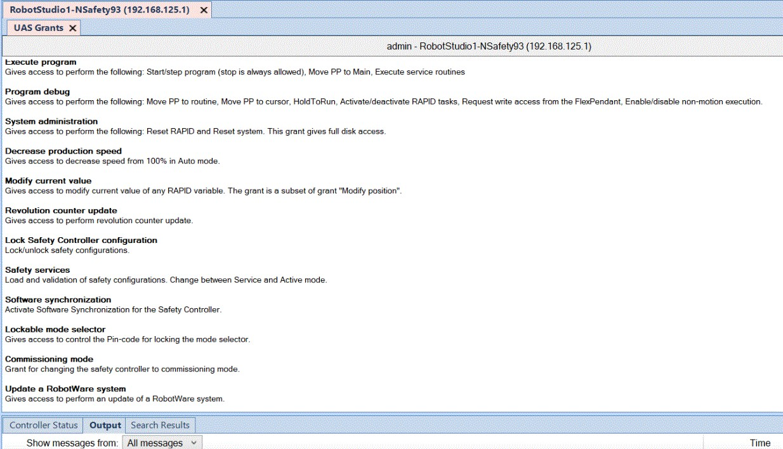

en0900000852

Examples of common actions to perform

##### Action Necessary grants

Rename the controller Modify controller properties

(A restart of the controller is necessary) Remote restart

Change system parameters and load configura- Modify configuration

tion files Remote restart

##### Action Necessary grants

Install a new system Administration of installed system

Perform a backup Backup and save

(A restart of the controller is necessary) Remote restart

Restore a backup Restore a backup

(A restart of the controller is necessary) Remote restart

Load/delete modules Load program

Create new module Load program

Edit code in RAPID modules Edit RAPID code

Save modules and programs to disk Backup and save

Start program execution from Task Window Execute program

Create a new I/O signal, that is, add a new in- Modify configuration

stance of the type Signal Remote restart

(A restart of the controller is necessary)

Set the value of an I/O signal I/O write access

Access to controller disks from File Transfer Read access to controller disks window Write access to controller disks

Controller grants

Full access This grant includes all controller grants, also new grants added in future RobotWare versions. The grant does not include any application grants or the *Safety Controller configuration* grant.

Manage UAS settings Gives access to read and write the UAS configuration, that

is to read, add, remove and modify UAS users and groups.

Execute program Gives access to perform the following:

* Start/step program (stop is always allowed)
* Move PP to Main
* Execute service routines

Perform ModPos and HotEdit Gives access to perform the following:

* Modify or teach positions in RAPID code (ModPos)
* During execution modify positions in RAPID code as single points or as a path (HotEdit)
* Restore ModPos/HotEdit positions to original
* Modify current value of any RAPID variable

Modify current value Gives access to modify current value of any RAPID variable.

This grant is a subset of the grant *Perform ModPos and*

*HotEdit*.

I/O write access Gives access to perform the following:

* Set I/O signal value
* Set signal as simulated and remove simulation
* Set the device and industrial network as enabled/disabled

Backup and save Gives access to perform a backup and to save modules,

programs and configuration files. The grant gives full FTP accesstothecurrentsystemsBACKUPandTEMPdirectory.

Restore a backup Gives access to restore backup and restart the controller using the restart mode **Revert to last auto saved**.

|  |  |
| --- | --- |
| Modify configuration | Gives access to modify the configuration database, that is to load configuration files, change system parameter values and add/delete instances. |
| Load program | Gives access to load/delete modules and programs. |
| Remote restart | Givesaccesstoperformrestartandshutdownfromaremote location. No grant is required to perform restart via a local device, as for example the FlexPendant. |
| Edit RAPID code | Gives access to perform the following:   * Modify code in existing RAPID modules * Frame calibration (tool, workobj) * Commit ModPos/HotEdit positions to current values * Rename program |
| Program debug | Gives access to perform the following:   * Move PP to routine * Move PP to cursor * HoldToRun * Activate/deactivate RAPID tasks * Request write access from the FlexPendant * Enable/disable non-motion execution |
| Decrease production speed | Gives access to decrease speed from 100% in Auto mode. This grant is not required if speed is already below 100%, or controller is in Manual mode. |
| Key-less mode selector | Unlock key-less mode selector. |
| Calibration | Gives access to perform the following:   * Fine calibrate mechanical unit * Calibrate *base frame* * Update/clear SMB data   Frame calibration (tool, wobj) requires the grant *Edit RAPID code*. Manual offset of mechanical unit calibration data and loading new calibration data from file require the grant *Modify configuration*. |
| Administration of installed systems | Gives access to perform the following:   * Install new system * Reset RAPID * Reset system * Start Boot Application * Select System * Install system from device   This grant gives full FTP access, that is, the grant gives the same rights as *Read access to controller disks* and *Write access to controller disks*. |
| Read access to controller disks | Gives external read access to controller disks. This grant is only valid for explicit disk access, for example with an FTP client or the File Manager of RoboStudio.  It is possible, for example, to load a program from /hd0a without this grant. |
| Write access to controller disks | Gives external write access to controller disks. This grant is only valid for explicit disk access, for example with an FTP client or the File Manager of RoboStudio.  It is possible, for example, to save a program to the controller disk or perform a backup without this grant. |
| Modify controller properties | Gives access to set controller name, controller ID and system clock. |

Delete log Gives access to delete messages in the controller Event

Log.

Revolution counter update Gives access to update the revolution counter.

Safety Controllerconfiguration Gives access to perform a configuration of the Safety Controller. This is valid only for the PSC-option and is not included in the *Full access* grant.

Application grants

Access to the ABB menu on Value **true** gives access to the ABB menu on the FlexPendFlexPendant ant. This is the default value if a user does not have the

grant.

Value **false** means that the user cannot access the ABB menu when the controller is in Auto mode. The grant has no effect in Manual mode.

Log off FlexPendantuser when A user having this grant is automatically logged off from switching to Auto mode the FlexPendantwhen switching from Manual mode to Auto mode.

**Managing user rights and write access on an OmniCore controller**

Overview

The OmniCore controller is delivered with a preset user named *Default User*. This user is assigned certain grants by default and it belongs to the role *Operator*. If a new user is created with specific grants, the *Default User* can be removed. An active *Default User* has *read only* rights to the controller data even if all grants are removed. Hence, to prevent any unauthorized access to OmniCore controller data, the *Default User* must be deleted.

The OmniCore controller is delivered with a default configured user, named *Admin*. All UAS grants are assigned against this user, such as, adding, removing and modifying users. The *Admin* user belongs to the role *Administrator* by default. You can deactivate the *Admin* user. Before deactivating default users, it is recommended to define at least one user with the grant *Manage UAS settings* so as to continue managing users and roles.

Controller grants

Manage UAS settings Gives access to read and write the UAS configuration, that is to read, add, remove and modify UAS users and groups.

Modify system parameters Gives access to modify the system parameters, that is load system parameter files, change system parameter values and add/delete instances.

Backup and save Gives access to perform a backup and to save modules, programs and system parameter files. This grant gives read/write access to the BACKUP folder.

Modify current value Gives access to modify current value of any RAPID variable.

This grant is a subset of the grant *Perform ModPos and*

*HotEdit*.

Modify controller properties Gives access to set controller name, system clock and WAN IP configuration.

Modify network security prop- Gives access to set network security settings, such as fireerties wall configuration and syslog server.

|  |  |  |
| --- | --- | --- |
| Delete log | Gives access to delete messages in the controller Event Log. | |
| Read access to controller disks | Gives external read access to controller disks. This grant is only valid for explicit disk access, for example with the File Manager of RoboStudio or with RWS file service. | |
|  | **Note**  TEMP folder is always possible to read even without this grant.  This grant doesn't give access to the BACKUP folder. This grant doesn't give access to remote mounted devices. |
| •  •  • |
| Write access to controller disks | Gives external read and write access to controller disks. This grant is only valid for explicit disk access, for example with the File Manager of RoboStudio or with RWS file service. | |
|  | **Note**  It is always possible to write to the TEMP folder even without this grant.  This grant doesn't give access to the BACKUP folder. This grant doesn't give access to remote mounted devices. |
| •  •  • |
| IO write access | Gives access to perform the following:   * Set I/O signal value * Set signal as simulated and remove simulation * Set I/O unit and bus as enabled/disabled. | |
| Remote restart | Gives access to perform system restart and main computer shutdown from a remote location. No grant is required to restart the system through a local device, for example, the FlexPendant. | |
| Restore a backup | Gives access to restore backup. This grant gives read access to the BACKUP folder | |
| System administration | Gives access to Reset RAPID and to Reset system. This grant gives full disk access. | |
| Edit RAPID code | Gives access to perform the following:   * Modify code in existing RAPID modules * Rename program. | |
| Load program | Gives access to load/delete modules and program. | |
| Modify position | Gives access to perform the following:   * Modify positions in RAPID code * Modify current value of any RAPID variable. | |
| Modify current value | Gives access to modify current value of any RAPID variable. The grant is a subset of grant **Modify position**. | |
| Execute program | Gives access to perform the following:   * Start/step program (stop is always allowed) * Move Program Pointer to Main * Execute service routines * Set run mode and cycle | |

Program debug Gives access to perform the following:

* Move Program Pointer to routine,
* Move Program Pointer to cursor
* HoldToRun
* Activate/deactivate RAPID tasks • Request write access from the FlexPendant • Enable/disable non-motion execution.

Calibration Gives access to perform the following:

* Fine calibrate mechanical unit
* Calibrate base frame • Update/clear SMB data.

**Note**

Frame calibration (tool, wobj) requires the grant **Edit RAPID code**. Manual offset of mechanical unit calibration data and loading a new calibration data from file requires the grant **Modify system parameters**.

Revolution counter update Gives access to perform revolution counter update.

Decrease production speed Gives access to decrease speed from 100% in Auto mode.

Lock Safety Controller config- Lock/unlock safety configurations. uration

Safety services Load and validate safety configurations. Changes between Service and Active mode.

Software synchronization Activate Software Synchronization for the Safety Controller.

Commissioning mode Grant for changing the safety controller to commissioning mode.

Lockable mode selector Gives access to control the Pin-code for locking the mode

selector.

Update a RobotWare system Gives access to perform an update of a RobotWare system.

Remote login A user with this grant can request FlexPendant to login as

another user.

Remote Start and Stop in Auto A remote user with this grant can start and stop program in Auto mode.

Read files on remote mounted A user with this grant have access to read files on a remote devices mounted device.

Read and write files on remote A user with this grant have access to read and write files mounted devices on a remote mounted device.

Detach the FlexPendant A user with this grant can detach the FlexPendant in automatic mode without causing any stops. The hot swappable FlexPendant option is required.

Log off FlexPendant user A user with this grant is automatically logged off from the when switching to Auto FlexPendant when switching from Manual mode to Auto mode.

**Note**

Application grants are not supported in OmniCore systems.

Adding a user to the Administrators group

The predefined user roles available in the *robot controller* are *Administrator* and *Operator*. For the Administrator role the controller grant *UAS_ADMINISTRATION* is enabled by default.

1. On the **Controller** tab, click **Add controller** and then click **Add Controller..**

and then select the controller from the **Add Controller** dialog.

1. On the **Controller** tab, click **Request Write Access**.
2. Click **Authenticate** and then click **Login as Different User**. The **Login** dialog opens, enter the default credentials **User Name** and password as *Admin* and *robotics* respectively and click **Login**.
3. Click **Authenticate** and then click **Edit User Accounts**.

The **Edit User Accounts** window opens.

1. On the **Users** tab, click **Add user**.
2. Enter suitable values in the fields as required and then under **Roles** select the **Administrator** check box. Click **Apply**.

The new user gets added to the **Users on this controller** list. Use the same steps to create users for various roles.

|  |  |
| --- | --- |
| Creating a new user role |  |
| 1 | In the **Edit User Accounts**, click the **Roles** tab. |
| 2 | On the **Roles** tab, click **Add Role**. |
| 3 | Enter the required details and click **Apply**.  The new role gets added to the selected user. |

Modifying an existing user role

1. In the **Edit User Accounts**, click the **Roles** tab.
2. On the **Roles** tab, select the role and then click **Edit User**. Enter the required changes and click **Apply**.

Creating a new user

1. In the **Edit User Accounts**, click the **Users** tab, and then click **Add User**.
2. In the **User Name** and **Password** boxes, enter suitable values. Select the required roles and then click **Apply**.

The new user gets added to the **Users on this controller** list with the selected roles.

18.3 Events

**18.3 Events**

**Overview**

You can view events in the **Event Log**. The severity of each event is indicated by its background color; blue for information, yellow for warning and red for an error which needs to be corrected to proceed.

On the **Controller** tab in the Controller Tools group, click **Events** to view the **Event Log**.

**Types of Events**

##### Name of the Event Description

Operational events Events dealing with handling of the system.

System events Events dealing with system functions, system states, and so

on.

Hardware events Events dealing with system hardware, manipulators as well as controller hardware.

Program events Events dealing with RAPID instructions, data, and so on.

Motion events Events dealing with the control of the manipulator movements and positioning.

I/O events Events dealing with inputs and outputs, data buses, and so on.

User events Events defined by the user.

Functional safety events Events related to functional safety.

Process events Application specific events, arc welding, spot welding, and so on.

Configuration events Events dealing with the configuration of the system.

Connected Service events Connected Service Embedded event logs which are generated during starting, registering, unregistering, losing connectivity, and so on.

**18.4 Configuration**

**Configuration**

From the Configuration you can view and edit the system parameters in a controller. The Configuration has a direct communication with the controller. This means that changes you make are applied to the controller as soon as you complete the action. With the Configuration Editor, the following actions can be performed for each topic:

* view types, instances, and parameters
* edit instances and its parameters
* copy and paste instances within a type
* add and delete instances

**Layout of the Configuration**

The Configuration consists of the Type name list and the Instance list.

The **Type name** list displays all available configuration types for the selected topic. The list of type names can not be edited.

The **Instance** list displays all system parameters of the selected type in the **Type name** list. Each row in the list is an instance of the type. The columns show the parameters and their values.

The Configuration editor includes the following:

* Configuration topics
  + Communication
  + Controller
  + I/O
  + Man-machine communication
  + Motion
  + PROC
* Add Signals
* I/O Engineering Tool

Add Signals

This is a special window to add several I/O signals at the same time. You need to have write access to the controller to be able to open the add signal window.

Type of Signal Defines the type of signal.

Signal Base Name Defines the name for one or more signals.

Assigned to Device Defines the device to which the signal belongs.

Signal Identification Label Optionally,offersfilteringandsortingbasedonthiscategory.

Number of Signals Defines the number of signals to add in a range.

Start Index Defines the index (number) to start the range with.

Step Defines the number which the index should increase with.

Device Mapping Start Defines the bits in the I/O memory map of the assigned unit to which the signal is mapped.

18.4 Configuration

*Continued*

Category Optionally, offer filtering and sorting based on this category.

Access Level Defines the write access to I/O signals for categories of I/O controlling clients connected to the robot controller. This field is enabled only when Advance check-box is selected. NotnecessarilyWriteaccess.OptionsareDefault,ReadOnly and All.

Default Value Specifies the I/O signal value to be used at the start.

Invert Physical Value Appliesan inversionbetweenthephysicalvalueof thesignal and its logical representation in the system.

**Viewing configurations**

1. To view the topics of a controller, from the **Controller** tab, expand the **Configuration** node for the controller.

All topics in are now displayed as child nodes to the Configuration node.

1. To view the types and instances of a topic, double-click the topic node for the topic to view.

The Configuration Editor is now opened, listing all types of the topic in the

**Type name** list. In the **Instance** list, each instance of the selected type in the **Type name** list is displayed as a row. The parameter values of the instances are displayed in the columns of the instance list.

1. To view detailed parameter information for an instance, double-click the instance.

The instance editor now displays the current value, restrictions, and limits of each parameter in the instance.

**Editing parameters**

You can either edit the parameters of one single instance, or you can edit several instances at the same time.

1. In the **Controller** tab, expand the **Controller** and the **Configuration** node and double-click the topic that contains the instances to edit.

This opens the Configuration Editor.

1. In the **Type name** list of the Configuration Editor, select the type that the instance to edit belongs to.

The instances of the type are now displayed in the Instance list of the Configuration Editor.

1. In the **Instance** list, select the instances to edit and press the Enter Key. To select several instances at once, hold down the SHIFT or CTRL key while selecting.

Alternatively, right-click an instance and then click **Edit**.

The Instance Editor is now displayed.

1. In the Parameter list of the Instance Editor, select the parameter to edit and change the value of the parameter in the **Value** box.

When editing several instances at one time, the parameter values you specify will be applied to all instances. For parameters that you do not specify any new value, each instance will keep its existing value for that parameter.

*Continues on next page*

*Continued*

1. Click **OK** to apply the changes to the configuration database in the controller. For many parameters, the changes will not take effect until the controller is restarted. If your changes require a restart, you will be notified of this.

You have now updated the controller's system parameters. If you are going to make several changes, you can wait with the restart until all changes are done.

**Adding instances**

With the Configuration Editor, you can select a type and create a new instance of it. For example, adding a new instance of the type Signal creates a new signal in the system.

1. In the **Controller** tab, expand the **Controller** and the **Configuration** node and double-click the topic that contains the type of which you want to add an instance.

This opens the Configuration Editor.

1. In the **Type name** list of the Configuration Editor, select the type of which you want to add an instance.
2. Right-click anywhere in the configuration editor or on the Type node and then select **New Type** from the context menu.

A new instance with default values is added and displayed in the **Instance Editor** window.

1. If required, edit the values.
2. Click **OK** to save the new instance.

The values in the new instance are now validated. If the values are valid, the instance is saved. Otherwise, you will be notified of which parameter values to correct.

For many instances, the changes will not take effect until the controller is restarted. If your changes require a restart, you will be notified of this.

You have now updated the controller's system parameters. If the changes require a restart of the controller, the changes will not take effect until you do this. If you are going to make several changes, you can wait with the restart until all changes are done.

**Copying an instance**

1. In the **Controller** tab, expand the **Controller** and the **Configuration** node and double-click the topic that contains the instance to copy.

This opens the Configuration Editor.

1. In the **Type name** list of the Configuration Editor, select the type of which you want to copy an instance.
2. In the **Instance** list, select the instance to copy.
3. Right-click the instance to copy and then select **Copy Type** from the context menu.
4. Change the name of the new instance. If required, also edit the other parameter values.

|  |  |
| --- | --- |
| 18.4 Configuration  *Continued*  6 | Click **OK** to save the new instance.  The values in the new instance are now validated. If the values are valid, the instance is created. Otherwise, you will be notified of which parameter values to correct.  For many instances, the changes will not take effect until the controller is restarted. If your changes require a restart, you will be notified of this.  You have now updated the controller's system parameters. If the changes require a restart of the controller, the changes will not take effect until you do this. If you are going to make several changes, you can wait with the restart until all changes are done. |
| **Deleting an instance** 1 | In the **Controller** tab, expand the **Controller** and the **Configuration** node and double-click the topic that contains the type of which you want to delete an instance.  This opens the Configuration Editor. |
| 2 | In the **Type name** list of the Configuration Editor, select the type of which you want to delete an instance. |
| 3 | In the **Instance** list, select the instance to delete. |
| 4 | Right-click the instance to delete and then select **Delete Type** from the context menu. |
| 5 | A message box is displayed, asking if you want to delete or keep the instance. Click **Yes** to confirm that you want to delete it.  For many instances, the changes will not take effect until the controller is restarted. If your changes require a restart, you will be notified of this.  You have now updated the controller's system parameters. If the changes require a restart of the controller, the changes will not take effect until you do this. If you are going to make several changes, you can wait with the restart until all changes are done. |

**Save a configuration file**

The system parameters of a configuration topic can be saved to a configuration file, stored on the PC or any of its network drives.

The configuration files can then be loaded into a controller. They are thereby useful as backups, or for transferring configurations from one controller to another.

1. In the **Controller** tab, expand the **Configuration** node and select the topic to save to a file.
2. In the **Controller** tab click **Save Parameters**.

You can also right-click the topic and then select **Save Parameters** from the context menu.

1. In the **Save As** dialog box, browse for the folder to save the file in.
2. Click **Save**.

**Saving several configuration files**

1. In the **Controller** tab, select the **Configuration** node, not any of its types.

*Continues on next page*

*Continued*

1. In the **Controller** tab click **Save System Parameters**.

You can also right-click the Configuration node and then click **Save Parameters**.

1. In the **Save System Parameters** dialog box, select the topics to save to files. Then click **Save**.
2. In the **Browse for Folder** dialog box, browse for the folder to save the files in, and then click **OK**.

The selected topics will now be saved as configuration files with default names in the specified folder.

**Loading a configuration file**

A configuration file contains the system parameters of a configuration topic. They are thereby useful as backups, or for transferring configurations from one controller to another.

When loading a configuration file on a controller, it must be of the same major version as the controller. For instance, you cannot load configuration files from an IRC 5 system to an OmniCore controller.

1. In the **Controller** tab, select the **Configuration** node.
2. In the **Controller** tab click Load Parameters.

You can also right-click the configuration node and then select **Load Parameters** from the context menu.

This opens the **Open** dialog box.

1. In the **Open** dialog, browse to the configuration file to load.
2. In the **Open** dialog box, select how you want to combine the instances in the configuration file to load with the existing in the controller:

**If you want to then**

replace the entire topic with the contents select **Delete the existing topic and load** in the file. **instances**

add new instances from the configuration select **Load if no existing instances** file to the topic, without modifying the existing ones.

add new instances from the file to the click**Loadandreplaceexistinginstances** topic and replace the existing ones with values from the file. Instances that only exist in the controller and not in the configuration file will not be changed at all.

Instances that exist in the controller will first be deleted and then loaded with values from the file, that is, it will get default values for parameters not listed in the file.

1. Click **Open** to load.
2. In the information box, click **OK** to confirm that you want to load the instances from the configuration file.

If a restart of the controller is necessary for the changes to take effect, you will be notified of this.

* 1. Configuration *Continued*

**Layout of the Instance editor**

The Instance Editor window lists the parameters and their values of the selected instance.

In the **Value** column you can view and edit the value of the parameters.

When you click a row, the lower section of the Instance Editor window displays the type of parameter, restrictions for the parameter value and other conditions for the parameter.

* 1. FlexPendant Viewer

**18.5 FlexPendant Viewer**

**Overview**

FlexPendant Viewer is an add-in to RobotStudio that retrieves and displays a screenshot from the FlexPendant. The screenshot is generated automatically at the moment of the request.

**Prerequisites**

The controller you want to retrieve screen shots from must be added to your robot view.

A FlexPendant must be connected to the controller. If no FlexPendant is currently connected (option *Hot plug* is installed and the jumper plug is used) then no screen shot can be retrieved.

**Using FlexPendant Viewer**

* 1. Make sure you are connected to the controller.
  2. In the **Controller Tools** group, click the arrow next to the **FlexPendant** icon, and then click **FlexPendant Viewer**.

A screen shot will be displayed in the workspace.

* 1. To reload the screen shot, click **Reload** in the workspace.
  2. To set an automatic reload period for the screen shot, click on the menu **Tools**, point to **FlexPendant Viewer** and click **Configure**.

Set the desired reload period and select the check-box **Activated**. Then click **OK**.

**Results on the controller**

The screenshot will automatically be saved as a file on the controller. When a new request is sent, a new screenshot is generated and saved, overwriting the previous file.

No message will be displayed on the FlexPendant.

**18.6 Properties**

**Overview**

Select this option to view and edit various properties of the connected robot controller.

**Renaming the controller**

The controller name is an identification of the controller that is independent of the system or the software running on the controller. Unlike the controller ID, the controller name does not have to be unique for each controller.

**Note**

The

controller

name

must

be

written

with

characters

from

the

ISO

8859-1

(

Latin

1)

character

set.

* 1. In the **Configuration** group, click **Properties**, and then click **Rename**.

The **Rename Controller** dialog box appears.

* 1. Enter the new name of the controller in the dialog box.
  2. Click **OK**.

The new name will be activated when the controller is restarted.

You will be prompted to either click **Yes** to restart the controller immediately or click **No** to restart later.

**Setting the controller date and time**

You can either set the date and time to the same as the network time server, or you can specify the date and time manually.

Use this procedure to set the controller date and time:

* 1. In the **Configuration** group, click **Properties**, and then click **Date and Time**.

The **Set Date and Time** dialog box appears.

* 1. This dialog provides two options: **Network Time** and **Manual Time**.
     + - Select **Network Time** and in the **Time server address** box, enter the IP address of the network time server.
       - Select **Manual time** and then set the **Date** and **Time** in the boxes provided. You can select the required time zone in the **Time zone** list.

**Setting the Controller ID**

The Controller ID is by default set to the serial number of the controller. The Controller ID is a unique identifier for the controller and should not be changed. However, if the hard disk of the controller is replaced, the ID will be lost and you must set it back to the serial number of the controller.

**Note**

You

must

**Request**

**Write**

**Access**

to

the

controller

before

setting

the

controller

ID.

*Continues on next page*

18.6 Properties *Continued*

1 In the **Configuration** group, click **Properties**, and then click **Controller ID**. The **Set Controller ID** dialog box appears.

While connecting RobotStudio to the public network, IP address must be set only on the MGMT port for RobotWare 7.

2

Enter

the

Controller

ID

and

then

click

**OK**

.

**Note**

Use

only

characters

from

the

ISO

8859-1

(

Latin

1)

character

set

and

no

more

than

40

characters.

**Configuring**

**the**

**public**

**network**

**interface**

**of**

**the**

**controller**

**Note**

* 1. On the **Controller** tab, in the **Configuration** group, click **Properties** and click **Network settings** and then click **Public Network**.
  2. Select **Obtain an IP address automatically** to set the controller to receive the IP address from the network's DHCP server.

OR

Select **Use the following IP address** and then enter the required **IP address**, **Subnet Mask** and **Default Gateway** boxes to manually set the IP address of the controller.

* 1. Click the **Port Speed (Mbps)** drop-down to select the port speed, this selection is only available for RobotWare 7.1 onwards.

Port speed has three options, Auto, 10, 100. When the port speed is set to **Auto**, the network switch and the network interface automatically finds the highest available supported speed and adapts to this port speed. The adapted maximum port speed will be displayed.

* 1. It is possible to set the DNS server address for the controller, write access to the controller is required to use the following procedure.

Select **Automatically get DNS server address** to set the controller to receive the DNS server address automatically.

OR

Select the **Use the following server addresses** and then enter the **Preferred DNS server** and **Alternate DNS server** and click **Apply**.

**Configuring the I/O network of the controller**

The following procedure is applicable for RobotWare 7.4 onwards.

* 1. On the **Controller** tab, in the **Configuration** group, click **Properties** and click **Network settings** and then click **I/O Network**.
  2. Enter suitable values as required in the **IP Address** and **Subnet Mask**. The value of the **Default Gateway** is retrieved from the public network interface of the controller, hence this is a read-only field.
  3. Select the **Port Speed (Mbps)**, and click **Apply**.

The actual port speed on the network interface may differ from the port speed selected in the **Port Speed (Mbps)** if the network switch does not support the selected speed. When the port speed is set to **Auto**, the network switch and the network interface automatically finds the highest available supported speed and adapts to this port speed.

**Viewing controller and system properties**

You can view the following properties for a controller and its running system.

**System**

**Properties**

**Controller**

**Properties**

Control

Module

Boot

Application

Drive

Module

#1

Controller

ID

Serial

Number

Controller

Name

System

Name

Installed

Systems

Network

Connections

* 1. In the **Configuration** group, click **Properties**, and then click **Controller and System Properties**.

The **Controller and System Properties** window appears.

* 1. In the tree view at the left of the window, browse to the node for which you want to view the properties.

The properties of the selected object are displayed in the Properties list to the right of the window.

**Viewing the Device Browser**

The Device Browser displays the properties and trends of the various hardware and software devices in a robot controller. To open the Device Browser, in the **Configuration** group, click **Properties**, and then click **Device Browser**.

Displaying the properties of a device

In the tree view, browse to the node for which you want to view the properties and then click it. The properties of the selected object, along with their corresponding values, are listed to the right of the tree view.

Updating the tree view

Press **F5**, to update the tree view.

Alternatively, right-click inside the tree view pane, and then click **Refresh**.

Displaying a trend

Select a device in the tree view and then double-click any property, that has a numerical value, in the right-hand panel. This opens a trend view. The trend view collects data at a rate of one sample per second.

Hiding, stopping, starting or clearing a trend

Right-click anywhere on the trend view and then click the required command.

*Continues on next page*

18.6 Properties *Continued*

**Saving system diagnostics**

You can create a System Diagnostics data file from RobotStudio.

To save a System Diagnostics data file to your PC, in the **Configuration** group, click **Properties**, and then click **Save system diagnostics**.

**Manage Certificates**

When connecting to an OmniCore controller, the communication is encrypted using certificates on the controller. By default, these are self-signed certificates that must be trusted by the RobotStudio user. In this case, the following dialog will be displayed.

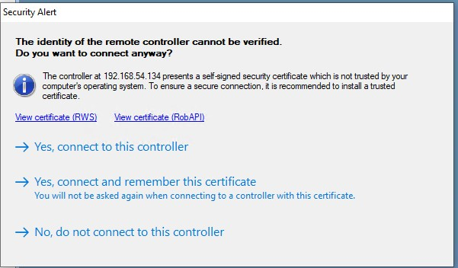

xx1900001786

To ensure a trusted connection, it is recommended to replace the certificates of the controller with the certificates that are trusted by the PCs, which will be connected to the controller. RobotStudio supports only PEM (.pem) certificate. Refer *Operating manual - Integrator's guide OmniCore* for more information on certificate handling.

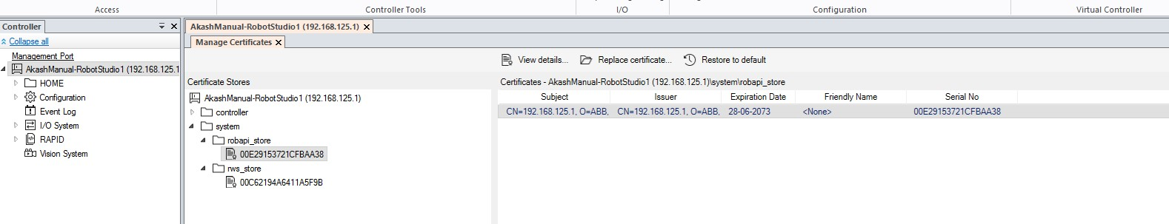

xx1900001787

**Configure firewall**

Use this feature to set up the firewall to allow network connections. When you choose **Allow**, it configures the firewall to allow connections through the public network port on the controller. To prevent connections press **Block**. **Advanced** button opens the **Configuration editor** to manually edit the configuration file. By default, the firewall will be blocked. This must be configured to allow network connection through WAN.

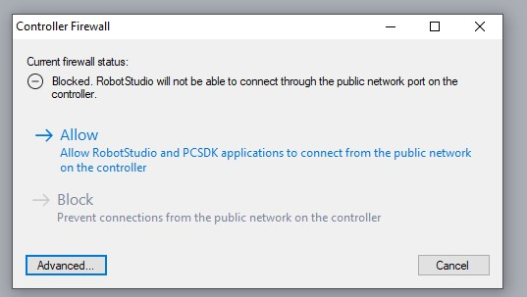

xx1900001788

**18.7 Installation**

**Updating an existing RobotWare system**

Description

The most frequent RobotWare system update use case is updating one or more software, for example, RobotWare and add-ins. This is a frequent operation during the commissioning time, especially on large installations.

**Note**

To perform a RobotWare system update, the controller must be in the RobotWare

system

mode.

System update changes the configuration of the currently installed RobotWare system. There are different types of configuration changes, such as:

* Adding or removing licenses
* Upgrading, removing installed software or adding new software
* Activating or deactivating optional features

Before performing a system update, it is recommended to:

* create a backup of the system (user data) and store it on an external storage media.
* create a snapshot of the current system state.

Upgrading a software in the RobotWare system

The following procedure provides the steps involved during the update of the RobotWare system.

**CAUTION**

Do not turn off the controller while system update is in progress. Doing this may in worst case lead to data corruption in the RobotWare system, in which case it needs to be reinstalled.

1. Access the **Modify Installation** view in RobotStudio.
2. Select **Software > Included**.
3. The **Included Software** window displays the software that is included in the current RobotWare system.
4. Select the product that should be upgraded and tap **Update**.
5. In the **Update Software** window, select the software version to be used and tap **OK**.
6. The **Summary** tab shows an overview of all the changes.
7. Continue to modify the system, or select **Apply/Apply and reset** to confirm and save the changes.

**Note**

The **Modify Installation** dialog will be closed during the controller update. When the update process is finished, check the event log for information about the update results. A successful update will be indicated in the event log, and if the update has failed, one or more error logs will be generated.

Adding/removing software

The following procedure provides the steps involved during the update of the RobotWare system.

**CAUTION**

Do not turn off the controller while system update is in progress. Doing this may in worst case lead to data corruption in the RobotWare system, in which case it needs to be reinstalled.

1. Access the **Modify Installation** view in RobotStudio.
2. Select **Software > Included**.
3. The **Included Software** window displays the software that is included in the current RobotWare system. Select one of the following:
   * Select the product box for the software that should be added to the system.
   * Deselect the product box to remove the product from the system.

**Note**

Products may have dependences to certain versions of other products. A product may only be removed if all products that are dependent on it are removed as well.

1. The **Summary** tab shows an overview of all the changes.
2. Continue to modify the system, or select **Apply/Apply and reset** to confirm and save the changes.

**Note**

The **Modify Installation** dialog will be closed during the controller update. When the update process is finished, check the event log for information about the update results. A successful update will be indicated in the event log, and if the update has failed, one or more error logs will be generated.

Adding/removing add-in packages

The following procedure provides the steps involved during the update of the RobotWare system.

**CAUTION**

Do not turn off the controller while system update is in progress. Doing this may in worst case lead to data corruption in the RobotWare system, in which case it needs to be reinstalled or recovered from a snapshot.

1. Access the **Modify Installation** view in RobotStudio.
2. Select one of the following:
   * To add add-in packages, select **Software > Available** and tap **Include**.
   * To remove add-in packages, select **Software > Included** and tap **Remove**.

RobotWare is mandatory and cannot be removed from the system.

**Note**

Products

may

have

dependences

to

certain

versions

of

other

products.

A

product

may

only

be

removed

if

all

products

that

are

dependent

on

it

are

removed

as

well.

**Note**

1. The **Summary** tab shows an overview of all the changes.
2. Continue to modify the system, or select **Apply/Apply and reset** to confirm and save the changes.

**Note**

The **Modify Installation** dialog will be closed during the controller update. When the update process is finished, check the event log for information about the update results. A successful update will be indicated in the event log, and if the update has failed, one or more error logs will be generated.

Changing the software installation order when adding/removing RobotWare add-ins

When adding and removing RobotWare add-ins to/from the system, sometimes it is necessary to manually adjust the installation and initialization order or the included add-ins.

1. Access the **Modify Installation** view in RobotStudio.
2. Select **Software > Included**.
3. In the **Included Software** window, tap the **Installation order** button to open the **Change Installation Order** window. Select a product and use the up and down arrows to change the installation order. Select **Done**.
4. The **Summary** tab indicates that the installation order has been updated.
5. Continue to modify the system, or select **Apply/Apply and reset** to confirm and save the changes.

**Note**

The

**Modify Installation**

dialog

will

be

closed

during

the

controller

update.

When

the

update

process

is

finished,

check

the

event

log

for

information

about the update results. A successful update will be indicated in the event

log,

and

if

the

update

has

failed,

one

or

more

error

logs

will

be

generated.

**Working**

**with**

**option**

**selections**

Overview

The following categories of system features can be updated:

* System options
* Controllers
* Robots
* FlexPendant

**Note**

Some features extend, showing more options upon selection. For example, in the group controller variant, you get the option of choosing variant type only when a controller first is selected. The additional drive units work similarly, some are unavailable until you select a different drive system type. This means options can be locked behind selections.

Turning options on/off

**CAUTION**

Do not turn off the controller while system update is in progress. Doing this may in worst case lead to data corruption in the RobotWare system, in which case it needs to be reinstalled.

1. Access the **Modify Installation** view in RobotStudio.
2. Select the tab **Options**.
3. Select the option category to be updated, and the corresponding **Options** that should be activated/deactivated for the system.

**Note**

Linked

options

will

be

selected

automatically.

Conflicting

options

cannot

be

selected.

4

The

**Summary**

tab

shows

an

overview

of

all

the

changes.

5 Continue to modify the system, or select **Apply/Apply and reset** to confirm and save the changes.

**Note**

The **Modify Installation** dialog will be closed during the controller update. When the update process is finished, check the event log for information about the update results. A successful update will be indicated in the event log, and if the update has failed, one or more error logs will be generated.

Adding licenses to enable additional option access

**CAUTION**

Do not turn off the controller while system update is in progress. Doing this may in worst case lead to data corruption in the RobotWare system, in which case it needs to be reinstalled.

1. Access the **Modify Installation** view in RobotStudio.
2. Select the tab **Options**.
3. Select **Edit** to access the **Edit License files** window. Select one of the following:
   * Select **Add** to browse for a new license to be added.
   * Select an existing license and tap **Remove**.
4. The **Summary** tab shows an overview of all changes.
5. Continue to modify the system, or select **Apply/Apply and reset** to confirm and save the changes.

**Note**

The

**Modify Installation**

dialog

will

be

closed

during

the

controller

update.

When

the

update

process

is

finished,

check

the

event

log

for

information

about the update results. A successful update will be indicated in the event

log,

and

if

the

update

has

failed,

one

or

more

error

logs

will

be

generated.

**Exporting**

**and**

**importing**

**option**

**selections**

**CAUTION**

Do

not

turn

off

the

controller while

system update

is

in

progress. Doing

this

may

in

worst

case

lead

to

data

corruption

in

the

RobotWare

system,

in

which

case

it

needs

to

be

reinstalled.

1. Access the **Modify Installation** view in RobotStudio.
2. Select the tab **Options**.
3. Select one of the following:
   * Select **Export** and browse to the location where the exported option selections should be saved. Select **Save**.

The current option selections will be saved to an RSF file that can be imported or added to other systems.

* + Select **Import** and browse to the location of the configuration file, and then select **Open**.

All current selections will first be cleared.

**Note**

* + Select **Add** and browse to the location of the configuration file, and then select **Open**.

**Note**

Existing

selections

are

kept,

and

options

that

are

not

currently

selected

will

be

added.

1. Continue to modify the system, or select **Apply/Apply and reset** to confirm and save the changes.

**Note**

The

**Modify Installation**

dialog

will

be

closed

during

the

controller

update.

When

the

update

process

is

finished,

check

the

event

log

for

information

about the update results. A successful update will be indicated in the event

log,

and

if

the

update

has

failed,

one

or

more

error

logs

will

be

generated.

**Drive system types**

The following matrix describes the existing drive system types and some examples of compatible products:

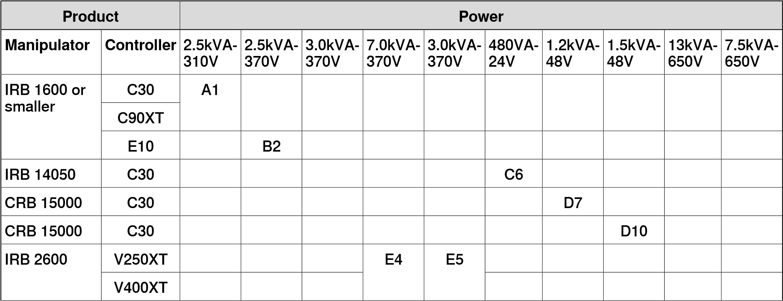

**Power**

**Product**

E9

E8

V250XT

IRB

4600

or

larger

V400XT

**Installing a new RobotWare system**

Description

Before installing a new RobotWare system on the controller, it is required to:

* create a virtual controller.
* create an installation package.

Create a virtual controller

1. Start RobotStudio.
2. Select **Add Controller > Connect to Controller** in the **Controller** ribbon. 3 In the **Connect to Controller** window, select the **Virtual Controllers** tab.
3. Select **New Controller**.
4. In the **New Virtual Controller** dialog, select option **Create New** and complete the following:
   * **Name**

Give the new system a valid name. If you enter an invalid name you will not be able to proceed.

**Note**

The system name can contain between 1 to 55 characters. Allowed characters are "A–Z", "a–z", "0–9", and "-" (hyphen). Hyphen "-" is only allowed between characters.

* + **Location**
  + **Robot model**
  + **RobotWare**
  + **Controller**

**Note**

Selecting option **Create from backup** can be used to create a system based on the configuration found in the selected Backup. This means that the same set of SW products (RobotWare and add-ins), licenses and options will be used.

Note, however that the software referred to by the Backup is not included in the Backup itself and must be previously downloaded to your computer by using the RobotStudio **Add-Ins** page.

Note also that this procedure will not automatically include RAPID programs and system parameters to your new system. If needed, they can be loaded to the new system by restoring the Backup once the new system is installed and started.

1. Select **OK** to continue.
2. Continue with creating an installation package.

**Creating a new installation package**

**Overview**

The installation package is a software package that consists of predefined directory structure and number of files, used for purpose of re-deploying RobotWare System on a robot controller. The installation package is created in RobotStudio and is deployed on the controller using RobotWare Installation Utilities on the FlexPendant. RobotWare Installation Utilities is a small package of installation related utilities that is always present on each robot controller and cannot be removed. It is used to deploy and re-deploy RobotWare system which is the operating system of the robot controller. When in RobotWare Installation Utilities mode, the robot cannot be moved using the FlexPendant and robot programs cannot be written or executed. **Prerequisites**

The following prerequisites must be met before you can start creating an installation package:

* Latest version of RobotStudio must be installed.
* License files for products to be installed must be available. Licenses are included in the RobotWare system at purchase, but can also be retrieved from a backup of the RobotWare system currently deployed on the controller, or exported from the controller via RobotWare Installation Utilities.

**Note**

Virtual

licenses

can

also

be

used.

* Product versions to be installed must be available in RobotStudio or in a custom location.

These versions can be made available by selecting a RobotWare distribution package (.rspak file) from RobotStudio (tap **Install Package** in the **Add-Ins** tab). All products that are installed this way, have matched versions and correct dependencies to each other.

* A virtual controller must be created.

**Create installation package** 1 Start RobotStudio.

1. Select **Add Controller > Connect to Controller** in the **Controller** ribbon.
2. In the **Connect to Controller** window, select the controller and tap **OK**.
3. Request write access.
4. Launch the **Modify Installation** dialog from the **Controller** ribbon.
5. Select the tab **Software**.
6. Select **Create Package** to create an installation package based on the virtual controller configuration.

**Note**

If the virtual system has been built using virtual licenses, these will not be included in the installation package.

If virtual licenses are used, the selected feature configuration will be matched against the real licenses present in the controller and the installation will stop if some licenses are missing. This situation can be avoided if real licenses from the controller are exported and imported into the virtual system when it is built.

1. In the **Create Installation Package** dialog, define the following:

* **Package Name**

Enter a name for the installation package.

* **Location**

Browse and select the output folder (for example, a USB-stick) for the installation package.

Select **OK**.

1. The window **Installation Package created** is displayed. The installation package for the selected system has been created. Select **OK**.
2. Continue with installing the package on the controller.

**18.8 Conveyor Tracking**

**Introduction**

The Conveyor Tracking tab contains a tree view browser displaying the connected DSQC2000 units and other related objects. It is used as a user interface to configure settings and monitor live signals of the DSQC2000 tracking units.

**Note**

While

in

the

tree

view

browser

or

any

of

the

related

object

dialogues,

pressing

F1

will

open

the

*Application*

*manual*

*-*

*Conveyor*

*tracking*

.

To

open

the

Conveyor

Tracking

tab:

**Action**

Click

**Conveyor**

**Tracking**

from

the

**Configuration**

group,

in

the

**Controller**

tab.

The

**Conveyor**

**Tracking**

tab

opens.

1

**Connecting**

**and**

**adding**

**a**

**CTM**

Connecting a CTM

One of the following methods can be used to connect the CTM to the computer:

* + 1. **Connecting the CTM through a WAN port**

192.168.126.200

CTM

-

LAN

interface

192.168.126.246

Computer

network

interface

This method is recommended only after a fixed IP address is configured for the CTM - WAN interface.

Connect the computer with a fixed IP address to the same WAN network, through a network switch or a direct connection. Configure the computer’s IP address with the CTM’s subnet. Example:

192.168.8

.xx

CTM

-

WAN

interface

192.168.8.246

Computer

network

interface

The default factory setting for WAN is **Obtain an IP address automatically** (DHCP client). To connect a WAN with this setting a DHCP server is required on the network.

* + 1. **Connecting through a LAN port**

This method is recommended for the initial setup of a CTM with default factory settings. It can also be used for debugging, when there is a connection problem with the CTM.

Configure the fixed IP address of the computer with the subnet of the CTM – LAN interface. The LAN interface has IP address 192.168.126.200.

Example:

Adding a CTM

To add a CTM, a connection must be established between the computer and the CTM:

**Action**

Click

**Add**

**CTM**

.

1

The

**Add**

**CTM**

dialog

box

displays

all

the

detected

CTMs.

Select

the

CTM

from

the

list

and

click

**OK**

.

The

CTM

is

added

to

the

tree

view

object

browser.

2

Identifying a CTM in RobotStudio

If RobotStudio is connected to a network with multiple CTMs, it may become difficult to identify a particular CTM. This can be avoided by a direct connection via LAN port.

To simplify identification, it is recommended to assign a unique and descriptive name for every CTM.

One of the following methods can also be used to identify a CTM:

* Select the device in the tree view browser, its corresponding green discovery LED will start blinking on the CTM module.
* Press the white SW1 button on the CTM module once, a green dot will start blinking on the corresponding CTM symbol in the tree view browser.

**Description**

**Default**

**pass-**

**word**

**User**

It

is

an

advanced

user

and

is

used

for

advanced

maintenance

and

troubleshooting.

abbadmin

abbadmin

**WARNING**

Do not press the SW1 button while the CTM is restarting, this will reset the

CTM

to

default

factory

settings

and

any

updates

or

upgrades

will

be

lost.

**Network settings**

The WAN port of the CTM is connected to the robot controllers through an Ethernet network. To establish communication between the robot controllers and the CTM, a fixed IP address must be assigned to the CTM. The IP address should be located on the same subnet as the network interface of the connected robot controllers. To change the network settings:

**Action**

Right-click

the

CTM

in

the

tree

view

browser,

select

**Network**

**settings**

,

and

then

click

**WAN**

**interface**

.

1

Enter

the

**IP**

**address**

,

the

**Subnet**

**mask**

,

and

the

**Default**

**gateway**

(

optional

)

and

then

click

**OK**

.

2

**Authenticate**

A CTM has the following two predefined users:

Login as an advanced user to upgrade the firmware.

**Description**

**Default**

**pass-**

**word**

**User**

It

is

a

normal

user

and

is

used

for

everyday

mainten-

ance

and

troubleshooting.

ctmuser

ctmuser

**Note**

To use some features of a CTM, a login is required. If you are using the default credentials, login is automatic to the Conveyor Tracking tab. Otherwise, authentication is requested whenever required.

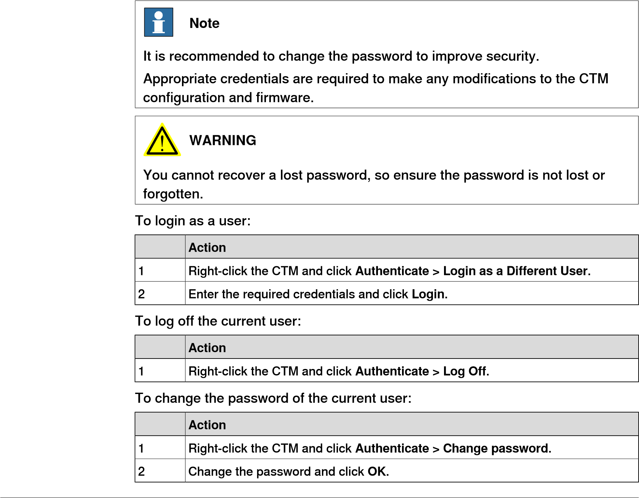

**Rename**

You can rename the CTM, the encoders, and the sensors.

To rename any object:

##### Action

1. Right-click the object in the tree view browser and then click **Rename**. The **Rename** dialog box opens.
2. Enter a new name for the object and then click **OK**.

The new names are stored in the CTM and will be displayed in RobotStudio, once it is restarted.

**Configuring an encoder**

You can configure some settings of an encoder, for example, Speed filter.

To configure an encoder:

##### Action

1. Right-click the encoder in the tree view browser and then click **Configure encoder**. The **Configure encoder** tab opens.
2. Modify the settings and click **Apply**.

An encoder can be configured as used or not used. This change in configuration will affect how the encoder is displayed in the tree view browser. To tune the encoder speed filtering, you can define the **Low-pass filter cut off frequency** in the **Speed filter** section.

**Configuring a sensor**

You can configure some settings of a sensor, for example, Sync Separation.

To configure a sensor:

##### Action

1. Right-click the sensor in the tree view browser and then click **Configure sensor**. The **Configure sensor** dialog box opens.
2. Modify the settings and click **Apply**.

Sync separation is used to filter an unstable signal in the sync input signal. It defines the minimum encoder distance (counts) between two sync pulses from the sensor. When the actual distance is shorter than this value, then the second sync pulse is ignored.

The sensor type can be configured as **I/O Sensor**, **Camera**, or **Not used**. This change in configuration will affect how the sensor is displayed in the tree view browser.

It is recommended to set the same sync separation value for all the encoders.

**Note**

The camera pulse width defines the pulse length (ms) used with the camera trigger signal.

**Note**

For high speed conveyors, the pulse length must be shorter than the time between

consecutive

camera

images,

so

that:

Camera

pulse

width

<

(

Trigger

distance

in

mm

/

Max

conveyor

speed

in

mm/s)

/

1000

**Restart**

Overview

A restart or reboot of a CTM can be performed using the tree view browser.

Restart

A restart is required after modifying the settings of the CTM. To restart the CTM:

**Action**

Right-click

the

desired

CTM

in

the

tree

view

browser

and

then

click

**Restart**

.

1

Reboot

A reboot is slower than a restart, it corresponds to the restart after cycling the power.

To reboot the CTM:

**Action**

Right-click

the

desired

CTM

in

the

tree

view

browser

and

then

click

**Reboot**

.

1

**Signals**

There are 3 types of live signals: encoder, sensor, and other. You can sort and filter the signals by various properties:

**Description**

**Signal**

**property**

Name

of

the

signal

Name

Signal

value

type,

for

example,

float

Type

Signal

live

value

Value

Signal

value

unit,

for

example,

Hz

Unit

Signal

category,

for

example,

Public

or

Internal

Category

Sensor

number

(1-8)

Sensor

Encoder

number

(1-4)

Encoder

Signal

name

used

in

the

robot

controller,

for

example,

*TrigVis*

Function

Connector

on

the

CTM,

for

example,

X11

Label

Information

on

what

the

signal

represents

Description

List all signals

To list all the signals:

**Action**

Right-click

the

desired

CTM

in

the

tree

view

browser

and

then

click

**Signals**

.

1

List all encoder signals

To list all the encoder signals:

**Action**

Right-click

the

desired

encoder

in

the

tree

view

browser

and

then

click

**Signals**

.

1

List all sensor signals

To list all the sensor signals:

**Action**

Right-click

the

desired

sensor

in

the

tree

view

browser

and

then

click

**Signals**

.

1

**Backup and Restore**

You can save a backup of the CTM settings. The backup will contain:

* Data about the CTM configurations, including encoder and sensor parameters and new names. While restoring the backup, these settings are applied to the target CTM
* Network settings
* Firmware version information

Creating a backup of the CTM

Keeping a backup is recommended to simplify the task of replacing the CTM with a new unit.

To create a backup of the CTM:

##### Action

1. Right-click the CTM in the tree view browser and then select **Create Backup…** . The **Create Backup from CTM** dialog box opens.
2. Enter a **Backup Name**.
3. Enter or select a save **Location** and click **OK**.

A backup of the CTM is created in the entered location.

Restoring a backup

To restore a backup of the CTM:

##### Action

1. Right-click the CTM in the tree view browser and then select **Restore Backup…**. The **Restore from Backup to CTM** dialog box opens.
2. Enter or browse to the required **Location**, select backup folder and click **Open**. The backup of the CTM saved in the folder is displayed in the list of the **Available backups** section.
3. Select the required backup from the list and click **OK**.

The CTM’s settings will be restored according to the backup, after a restart of the CTM.

**Firmware upgrade**

A firmware upgrade is normally provided by ABB, as a .cab file.

**WARNING**

It

is

recommended

to

backup

the

CTM

configurations,

as

a

firmware

upgrade

may

result

in

the

factory

default

network

settings.

To

upgrade

the

firmware

of

the

CTM:

**Action**

Login

as

an

advanced

user

to

upgrade

the

firmware.

1

Right-click

the

CTM

and

then

click

**Firmware**

**Upgrade**

.

The

**Firmware**

**Upgrade**

dialog

box

opens.

It

displays

the

current

version

of

the

firmware.

2

##### Action

1. Click **Browse**, navigate to the .cab file and then click **Open**. The **Verify Software** dialog box opens. It displays the publisher of the file.
2. If the publisher is trusted, click **Yes**.

The **Firmware Upgrade** dialog box opens. It displays the new firmware version.

1. Verify it and click **Upgrade**, to download it.

The CTM will restart after the download and installation.

After a firmware upgrade, you may have to restore the network settings of the CTM.

18.9 Motion Configuration

**18.9 Motion Configuration**

**Overview**

The **Motion Configuration** window contains functions for making and viewing advanced system configurations, such as changing controller and baseframe positions, calibrating and setting up external axes.

**CAUTION**

Editing

the

system

may

result

in

corrupted

systems

or

unexpected

robot

behaviors.

Be

sure

to

understand

the

effects

of

the

changes

before

proceeding.

**The mechanism folder node**

The property page of this node contains controls for mapping and setting axis and joints. It is from this page you set up external axes.

**The mechanism library node**

The property page of this node contains controls for changing the *baseframe* of the robot or mechanism. Here, too, you specify whether the baseframe is moved by another *mechanism* (coordinated motion), like a track *external axis*.

**Updating the baseframe position**

1. Move the *mechanical unit* (robot or external axis) to its new location using the ordinary tools for moving and placing objects.
2. In the **Controller** browser, select the controller for the mechanical unit.
3. On the **Controller** tab, in the **Virtual Controller** group, click **Motion Configuration**.

This opens the **Motion Configuration** dialog.

1. Select the node for the mechanical unit in the hierarchical tree. The baseframe property sheet for the robot is now displayed.
2. Select the baseframe position values to use after restarting the robot.

##### Select To

**Controller Values** Reset all changes to the baseframe made since the last time the *virtual controller* was started.

**Stored Station Values** Reset all changes made to the baseframe since the last time the station was saved.

Optionally, you can enter new values in the baseframe coordinate boxes (relative to the controller world coordinate system).

**Use Current Station Val-** Read and use the current location of the baseframe.

**ues** Optionally, you can enter new values in the baseframe

coordinate boxes (relative to the controller world coordinate system).

6 Click **OK**.

18.9 Motion Configuration *Continued*

**Calibrating the baseframe position**

The station with a virtual controller that includes a workpiece *positioner* which is based on backup from a robot controller. RobotStudio needs to take the calibration of the workpiece positioner into account, otherwise the positioner will be misplaced. The calibration parameter for a mechanism can be used to take the calibration of the real positioner into account.

The positioner mechanism is placed according to the *base frame* values of the virtual controller. When a virtual controller is created from backup, in which, the positioner was calibrated online using four points method, and if the positioner was not in its sync position at the first calibration point, then the positioner mechanism will not be aligned with the system's *task frame*.

You can calibrate base frame values to realign the positioner mechanism with the system's task frame.

1. In the **controller** tab, click **Motion Configuration**. The **Motion Configuration** dialog opens.
2. In the **Motion Configuration** window, select the positioner mechanism and then click **Calibrate**.

The **Base Frame Calibration Position** dialog opens.

1. From the **Motion Configuration** dialog, copy the **Orientation** values under **Base Frame** and paste these values in the boxes under **Orientation** in the **Base Frame Calibration Position** dialog.
2. Click **Apply** and then click **OK**. You must restart the controller when prompted. The positioner mechanism will be aligned with the system's task frame now. Any object attached to the positioner will take the orientation of the positioner.

18.10 Task Frames

|  |  |
| --- | --- |
| **18.10 Task Frames**  **Modifying Task frame** |  |
| 1 | On the **Controller** tab, in the **Virtual Controller** group, click **Task Frames.** The **Modify Task Frames** dialog box appears. |
| 2 | Set the reference to **World**, **UCS**, or **Local**. |
| 3 | Edit the position and orientation of task frames in the **Task Frames** coordinate box. |
| 4 | Click **Apply.** |

To the question, *Do you also want to move the Base Frame(s)?*

* + - Click **Yes** to move the base frame, but keeps its relative placement to the *task frame*.

The related robot will move in relation with the station world, but since the robot moves with the task frame, the robot base frame values remain unchanged.

* + - Click **No**. The following question appears **Do you want to update the controller configuration and restart?**. Click **Yes** to restart the controller and update the base frame configuration of the connected virtual controller.

The related robot will not move in relation with the station world. Here the task frame has moved, hence the base frame values will be recalculated. The controller must be restarted for the configuration changes to take place.

**Note**

If there are any stationary RAPID objects (tooldata, workobjects) connected to the robot, the following question appears **Do you want to keep the positioning of all stationary RAPID objects?**

* + - Click **Yes** to keep all the stationary RAPID objects in their global coordinates.

Stationary workobject and *tooldata* will remain constant in relation to the station world but their values will be recalculated.

* + - Click **No** to move all the stationary RAPID objects along with the base frame (same coordinates relative to base frame).

Stationary workobject and tooldata will move with the robot and its values will not be recalculated.

18.11 Go Offline

**18.11 Go Offline**

**Overview**

The main purpose of this feature is to create a new station with a *VC* similar to the connected *robot controller*. This helps a robot technician to work offline even when the robot controller is disconnected.

**Using Go Offline**

1. Connect the PC to a robot controller.
2. On the **Controller** tab, click **Request Write Access.**
3. Click **Go Offline**.

The **Go Offline** dialog box is displayed.

1. Enter a name in the **Virtual Controller Name** field and browse for the location to save the system.
2. Select the *RobotWare* version followed by the RobotWare Add-in version and click **OK**.

A new station gets created with a virtual controller which has the same configuration as the robot controller.

**Note**

A pre-requisite is that any RobotWare add-ins used by the system must be available on the PC. A Relation is automatically created between the virtual controller and the robot controller.

18.12 Create Relation

**18.12 Create Relation**

**Overview**

The transfer function allows easy transfer of offline-created RAPID programs to the real robot on the shop floor. This means that you can transfer data from a *virtual controller* (which is offline) to a *robot controller* (which is online). As part of the transfer function you can also compare the data present in the virtual controller with that present in the robot controller and then select which data to transfer.

You can also use the transfer function to transfer data from a virtual controller to another virtual controller.

**Relations for transfer of data**

To transfer data, you must first set up a **Relation** between the two controllers. A Relation defines the rules for the transfer of data between the two controllers.

**Creating a Relation**

When you have two controllers listed in the Controller browser, you can create a Relation between them. To create a Relation:

1. On the **Controller** tab, in the **Transfer** group, click **Create Relation**.

The Create Relation dialog box is displayed.

1. Enter a **Relation Name** for the relation.
2. Specify the **First Controller**, from the list.

The First Controller, also called the Source, owns the data being transferred.

1. Specify the **Second Controller**, from the list. This can either be a robot controller or another virtual controller.

The Second Controller, also called the Target, receives the data being transferred.

1. Click **OK**.

The relation between the controllers is now created.

After this, the *Relation* dialog box opens, using which you can configure and execute the transfer. Relations of a controller are listed under its Relations node in the Controller browser.

**Note**

The

properties

of

the

relation

are

saved

in

a

XML

file

under

INTERNAL

in

the

owner

controller’s

system

folder.

**Transferring data**

You can configure the details of the transfer of data and also execute the transfer, in the *Relation* dialog box.

18.12 Create Relation

*Continued*

To open the *Relation* dialog box, double-click a relation. Alternatively, select a relation in the **Controller** browser, and then in the **Transfer** group, click **Open Relation**.

Configuring the transfer

Before executing a transfer, you can configure the data to be transferred, under the *Transfer Configuration* heading. Configure using these guidelines:

* Use the check boxes in the *Included* column to include or exclude the corresponding items shown in the tree structure. All items in a module that are included will be transferred. Other non-listed items of a module such as comments, records and so on will be automatically included in the transfer.
* The *Action* column shows a preview of the transfer’s result, based on the items you include or exclude.
* If a module exists both in the source and the target controllers, and the *Action* column shows *Update*, then click **Compare** in the Analyze column. This opens the *Compare* box which shows two versions of the module in different panes. The affected lines are highlighted and you can also step through the changes. You can choose one of the following options for the comparison:
  + **Source with target** - Compares the source module with the target module
  + **Source with result** - Compares the source module with the module that will be the result of the transfer operation
* BASE (module), wobjdata and tooldata are excluded by default.
* wobjdata wobj0, tooldata tool0, and loaddata load0 of the BASE module are unavailable for inclusion.

A task can be transferred only if:

* + Write access to the target controller is present (must be manually retrieved).
  + Tasks are not running.
  + Program execution is in the stopped state.

Executing the transfer

After you have configured the transfer, you can execute it.

Under the *Transfer* heading, the Source and Target modules are shown along with the arrow showing the direction of the transfer. You can change the direction of the transfer by clicking **Change Direction**. This also switches the source and target modules.

To execute the transfer click **Transfer now**. A dialog showing a summary of the transfer appears. Click **Yes** to complete the transfer. The result of the transfer is displayed for each module in the output window.

The **Transfer now** button is disabled if:

* + None of the included tasks can be transferred.
  + Write access is required but not held.

18.13 Online monitor

**18.13 Online monitor**

**Overview**

This feature allows you to remotely monitor the robot connected to a real controller. It displays a 3D layout of the connected robot controller and enhances user’s current perception of reality by adding motion visualization augmentation.

**Note**

The

Online

Monitor

shows

TCP

robots

and

TCP

robots

with

track.

When

connecting

the

Online

Monitor

to

a

virtual

controller,

the

motion

is

shown

only

if

the

virtual

controller

is

using

Free-Run

mode,

not

the

Time

Slice

mode.

**Using Online Monitor**

The following procedure describes the Online Monitor feature in RobotStudio:

* 1. Connect the PC to a controller and add the controller.
  2. Click **Online Monitor**.

The 3D view of the mechanical units of the controller system is displayed in the graphics window.

**Note**

The

robot

view

is

refreshed

every

second

with

the

current

joint

values

of

all

the

mechanical

units.

**Gravity parameters in online monitor**

Online Monitor displays the orientation of a robot according to its gravity parameters. The Gravity Alpha, Gravity Beta and Gamma Rotation parameters define the rotation of the robot around the X, Y and Z axis in the world coordinate system. The Online Monitor orients the robot in the Graphical view according to the gravity parameters.

These parameters describe how the robot is oriented in relation with the floor or ground, whether it is suspended (mounted on the ceiling), shelf mounted (mounted on the wall), or mounted on the regular floor. If the robot is configured to be mounted on the ceiling, it will be displayed upside down in the Online Monitor. You can set these parameters in the **Motion configuration file**.

For more information about gravity parameters, see *Technical reference manual - System parameters*

**Indication of TCP**

A cone is automatically created to indicate the active tool data being used. The cone has its base in the robot wrist and its tip at the location of the tool data.

**Kinematic Limitations**

When the Kinematic Limitation button is enabled, the graphical 3D viewer indicates whether the robot is at a joint limit or at a singularity.

18.13 Online monitor

*Continued*

For joint limits, the corresponding link is highlighted in yellow to indicate a warning and in red to indicate an error. The tolerance limits are defined in RobotStudio Options - Online - Online Monitor.

For singularity, a markup indicates when the axis 5 is close to singularity. The singularity level is also defined in RobotStudio Options.

**Visualizing Safety Zones in Online Monitor**

This feature lets you to visualize the current status of the manipulators in a robot system and provides an augmented reality of the robot cell. It allows you to visualize a failure scenario, for example, an unplanned stopping of a robot. To give the user an idea of the physical layout and the safety zone that has caused this stopping of the robot, safety zones are visualized in online monitor. When the robot enters a restricted zone, the safemove supervision feature stops the robot.

Features

* A **Show Safety Zones** button is available in the Online Monitor for each manipulator in the system, for example, four buttons in a MultiMove system with four manipulators.
* The name of each tool zone and the corresponding manipulator is shown as a markup, for example, Rob1 STZ1, …, Rob4 STZ8, Rob1 MTZ1, …, Rob4 MTZ8 and so on.
* Zones that are defined as **Allow inside** are visualized as a green semitransparent hollow shape.
* Zones that are defined as **Allow outside** are visualized as a red semitransparent solid shape.
* A message is displayed in the output window if no STZ or MTZ is defined for the manipulator.
* The controller event log message **20468 SC STZ violation** is displayed in the output window if it is present in the controller event log.

**Note**

You can open one SafeMove Configurator at a time, even though several controllers may be connected. If the SafeMove Configurator is opened for one controller, real or virtual, the icon gets disabled for the other controllers.

19.1 Synchronize

1. **RAPID tab**

**19.1 Synchronize**

**Overview**

To synchronize is to make sure that the RAPID program in the *virtual controller* corresponds to the program in the station. You can synchronize from the station to the virtual controller and vice versa.

In a station, a robot’s position corresponds to the targets and its movements are defined by move instructions in the robot path. These correspond to data declarations and instructions in the modules of the RAPID program.

**Synchronizing to RAPID**

This operation updates the RAPID program of the virtual controller to reflect the latest changes in the station. Perform this operation before running a simulation, saving a program to file and before taking a backup of a virtual controller.

1. To synchronize, click the arrow next to the **Synchronize** icon, and then click **Synchronize to RAPID**.
2. Select the elements to be synchronized from the list.

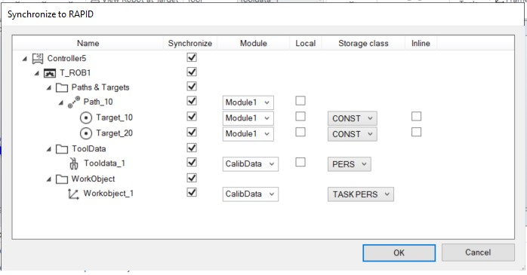

xx1900001535

**Description**

**Element**

Specifies

the

target

module

of

the

virtual

controller,

if

it

does

not

exist

,

it

will

be

created.

Module

Select

from

the

list

of

modules

or

type

in

the

name

of

the

new

module.

Specifies

whether

the

data

must

be

created

as

**LOCAL**

.

Adds

the

keywork

**LOCAL**

before

the

data

declaration

and

creates

data

**LOCAL**

to

the

module.

Local

Specifies

the

storage

type

of

the

data

declaration.

Storage

class

Specifies

whether

the

data

declaration

must

be

declared

as

inline

or

named.

In

this

case

the

data

is

declared

in

the

instruction

itself.

Inline

1. Click **OK**.

19.1 Synchronize

*Continued*

The message **Synchronization to RAPID completed** is displayed in the Output window.

**Note**

To

see

the

properties

of

targets

,

the

containing

path

must

be

expanded.

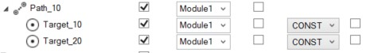

xx1900001536

Any

reference

to

workobjects

or

tooldata

from

an

instruction

will

be

synchronized

even

if

they

are

not

selected.

**Synchronizing to the station**

This operation updates the station to reflect the latest changes of the RAPID code in the virtual controller. Perform this operation when you start a virtual controller with RAPID program, when you have loaded a program or module from a file, or after editing a program.

To synchronize to station, click the arrow next to the Synchronize icon, and then click Synchronize to Station.

Select the objects to be synchronized to the station from the list. It is not possible to change the properties in this step. For changing any of the following properties the RAPID code must be edited.

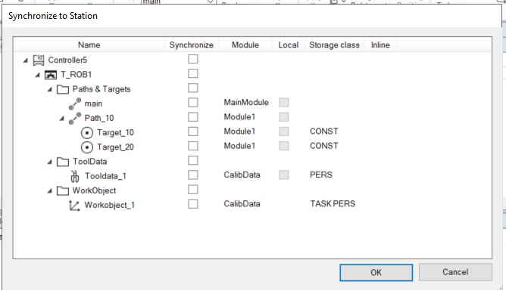

xx1900001534

Click **OK**. The message Synchronization to Station completed is displayed in the Output window.

*Continues on next page*

19.1 Synchronize *Continued*

**Synchronize to and from files**

RAPID can be synchronized from the files of the **HOME** folder as an alternative. This option is available **only** in the context menu of the selected file.

* In the **Controller** browser, under **Home** folder, right-click any RAPID module and then click **Synchronize to Station** to synchronize the selected file to the station.
* In the **Controller** browser, under **Home** folder, right-click a RAPID module and then click **Synchronize to File** to match the station into the selected file.

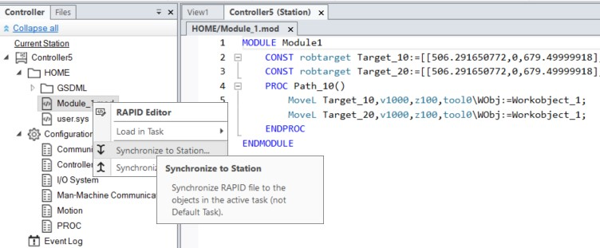

xx1900001533

Limitations

* Robtargets that are local to a procedure are not supported by **Synchronize to Station**. Only robtargets that are local to a module are supported.
* RobotStudio does not fully support instructions using *Offs* or *RelTool* functions. These are synchronized and will appear in the element browser, but commands such as *View Tool at Target* and *Locate Target* will not work. Targets used in the instructions will not be visible in graphics. However, instructions can be programmed and edited using the RAPID Editor and can be simulated using the virtual controller.
* RobotStudio does not support RAPID programs containing arrays of tooldata, robtargets and workobjects. These programs will not be synchronized to the station.
* Workobjects and tooldata that are shared between several tasks must be specified in RAPID with its full value for each task when programming offline with RobotStudio. This will trigger a warning *Initial value for PERS not updated* in the controller event log. You may ignore this warning. However, you must carefully ensure that the RAPID variable definitions are the same in all tasks, otherwise you may get unexpected behavior.

19.2 Adjust Robtargets

**19.2 Adjust Robtargets**

**Overview**

The Adjust Robtargets feature helps in recalculating and changing the robtarget data (tooldata and workobject data) while maintaining the joint angles of the robot. The robtarget data related to the specified source tooldata and workobject will be adjusted for usage with the new tooldata and workobject. In the **RAPID** tab, in the **Controller** group, click **Adjust Robtargets** to access this feature.

**Prerequisites**

* You should have a controller (virtual or robot) running with one or more modules containing procedures with a sequence of move instructions expressed with a defined tool and workobject.
* You should have RobotStudio Premium license to use this feature.
* The **Execute** button of the feature Adjust Robtargets will be enabled only if the selected tool data or workobject data have the same properties, such as robhold, ufprog, ufmec and so on.

Take a backup copy of your modules before adjusting your robtargets.

**Note**

Arrays,

event

records,

and

offsets

are

not

supported.

Relative

tool

is

also

not

supported.

Circular

move

instruction

)

MoveC

(

is

supported.

**Using**

**Adjust**

**Robtargets**

**Note**

The following procedure describes the Adjust Robtargets feature in RobotStudio:

1. On the **RAPID** tab, in the **Controller** browser, select a RAPID task or module under the RAPID icon. Then click **Adjust Robtargets** on the **RAPID** tab.

Alternatively, right-click the RAPID task or module in the **Controller** browser, and then click **Adjust Robtargets** in the context menu. The Robtarget Adjust dialog box appears.

**Note**

You can access **Adjust Robtargets** from the **Controller** tab also. Right-click the RAPID task or module in the **Controller** browser and then click **Adjust Robtargets** in the context menu.

1. If the module you want to adjust is selected, then go to Step 4. Otherwise continue with the next step.

*Continues on next page*

19.2 Adjust Robtargets *Continued*

1. Select a task from the **Task** drop-down list and module from the **Module** drop-down list.

**Note**

In

the

**Module**

drop-down

list,

you

can

either

select

a

particular

module

or

**<**

**ALL**

**>**

to

update.

1. Select the source robtarget data (that is, the data defined in the selected task) from **Old tooldata** and **Old wobjdata** drop-down list.
2. Select the destination robtarget data (that is, new tooldata and workobject) from **New tooldata** and **New wobjdata** drop-down list.
3. Click **Execute**.

The **Execute** button is enabled only if source robtarget data (that is, old tooldata and workobject) and destination robtarget data (that is, new tooldata and workobject) are different.

The module searches for move instructions that use the specified old tooldata or workobject and recalculates the robtarget data for the new tooldata and workobject.

For example,

1. Select "tool0" as the source tool and "wobj0" as the source workobject.
2. Select "toolb" as the new tool and "wobjb"as the new workobject. 3 Click Execute.

Robtargets of "tool0" and "wobj0" will be replaced with re-calculated robtargets which correspond to the same robot configuration (all joint angles will be the same), and with the new tool "toolb" and "wobjb". Note that both the tooldata and the wobjdata are replaced independently.

**Update instruction**

By default, the **Update instruction** check box is selected. This means that move instructions using the specified source (old) tooldata and workobject will be updated to use the target (new) tooldata and workobject in addition to recalculating the robtargets.

If the **Update instruction** check box is cleared, the robtargets will be recalculated, but the move instructions will not be updated. They will still use the source tooldata and workobject.

This feature is useful after the calibration of tooldata and workobject. After calibration, you might still want to use the old names of the tooldata and workobject, but update their values and recalculate the robtargets accordingly. The following sample procedure illustrates how this can be accomplished.

Sample procedure

**Prerequisite:** RAPID module with robtargets and move instructions that use uncalibrated tooldata tool1, and workobject wobj1.

1. Calibrate your tooldata tool1, and workobject wobj1. Store the new values in tool1_calib and wobj1_calib, respectively. Keep the old values of the

*Continues on next page*

19.2 Adjust Robtargets *Continued*

uncalibrated tooldata and workobject in tool1, and wobj1. An error message gets displayed for an invalid selection of tooldata or workobject data.

1. Open the Adjust robtargets tool and clear the **Update instruction** check box. Select your RAPID module, enter tool1, and wobj1 as your old tooldata and wobjdata, and tool1_calib, and wobj1_calib as the new tooldata and wobjdata, respectively.
2. Click **Execute**, and apply the changes to the controller from the RAPID Editor
3. In the RAPID Editor, rename your tooldata tool1 to tool1_uncalib, and tool1_calib to tool1 and apply the changes to the controller. Also, perform the same for wobj1.

Now, your robtargets are updated to match the calibrated values of tool1 and wobj1.

**Limitations**

* If a robtarget is used more than once but with different tools or workobjects, then a message *Target is referenced* is displayed in the output window.
* The adjust robtargets function operates on a module level and does not update any referenced targets defined in other modules. It ignores the scope of the robtargets when the referenced targets are local to a procedure. In this case, any targets with the same name in the module scope will also be updated.
* Adjust Robtargets function works for modules with semantic errors, the editor excludes the particular line containing the error and continues with program execution. But Syntax errors stop program execution.

**20 Add-Ins**

20.1 Gearbox Heat Estimation

1. **Add-Ins tab**

**20.1 Gearbox Heat Estimation**

**Overview**

The Gearbox Heat Estimation tool helps to estimate heat problems in the gearboxes. When the temperature is above a predefined value, you can adjust the cycle to reduce the temperature or order a fan that can cool down the gear.

Robots with compact gearboxes have a risk of getting overheated under certain circumstances. The gearbox temperature is supervised by *Service Information System* (SIS). SIS is a software function within the robot controller, that simplifies its maintenance. It supervises the operating time and mode of the robot, and alerts the operator when a maintenance activity must be scheduled. It also supervises large robots from damaging the motors during high load operations with a safety shutdown.

The temperature supervision is based on an algorithm that estimates the stationary temperature of the gearboxes and motors of the robot. The algorithm estimates the heat based on the character of the robot motion and also the room temperature. Intensive motion (high average speed and/or high average torque and/or short wait time) will increase the heat of the gearbox and motors.

To avoid overheating, SIS stops the robot if the temperature becomes too high. For large robots, there is an option to add a cooling fan to axis 1, 2, and sometimes axis 3, to allow the robot to run even with a heavy duty program.

**Note**

Gearbox

Heat

Estimation

is

not

supported

for

Tool

and

External

axis.

When

a

*virtual*

*controller*

has

more

than

one

robot,

only

one

robot

will

have

estimations

calculated.

The

other

robots

will

only

display

0

%

chance

of

overheating.

**Prerequisites**

1

RobotStudio

5.14.02

or

later.

1. RobotWare 5.14.01 or later.
2. RobotStudio station with controller having a programmed cycle that includes payload for the robot.

**Estimating the gearbox heat**

Use the following procedure for estimating the heat generated by the robot:

1. Create a new station or open a saved station. The Gearbox heat button is now visible in the **Add-Ins** tab.
2. In the **Add-Ins** tab, click Gearbox Heat. The **Gearbox Heat Estimation** window opens.

*Continues on next page*

1. **Add-Ins tab**

20.1 Gearbox Heat Estimation

*Continued*

3 In the **Add-Ins** tab, select **Enabled** to enable the **Gearbox Heat Estimation** tool.

4

**Note**

For

a

manipulator

without

compact

gear,

**Gearbox**

**Heat**

**Estimation**

is

disabled.

Run

a

simulation.

**Note**

For

RobotStudio

Basic,

the

**Play**

button

in

the

**Simulation**

tab

will

be

disabled.

As

such,

you

will

be

unable

to

run

the

simulation

from

the

**Simulation**

tab.

In

such

a

scenario,

use

the

**Play**

button

which

will

now

be

visible

in

the

**Gearbox**

**Heat**

**Estimation**

tab

window

to

run

the

simulation.

**Note**

The

data

is

recorded

during

the

simulation

only

if

the

**Gearbox Heat**

tab

is

visible.

* 1. In Cycles, define the behavior of the cycle for estimating the heat generated by the robot:
     + **Continuous**: Select this option to calculate the estimations continuously, that is, without waiting time between two consecutive cycles.
     + **Number of cycles per hour**: Select this option to manually define the number of cycles per hour used for calculation.
     + **Waiting time between cycles (sec)**: Select this option to define the waiting between cycles. Enter the waiting time in seconds.
  2. In **Ambient Temperature**, define the ambient temperature.
     + Use the slider to change the temperature.
     + Select **Use temperature from controller(s)** to reset the the ambient temperature and read the temperature from the robot configuration as specified in the parameter *Motion->SIS Parameter -> r1_sis_param->Robot temperature*.

**Note**

The temperature value used while configuring the robot in the real environment must be used for ambient temperature calculations.

* 1. Calculate the result in either of the following ways:
     + In the **Recordings** section, either double-click a recording or select a recording and click **Calculate**.

*Continues on next page*

**20 Add-Ins**

20.1 Gearbox Heat Estimation *Continued*

• In the **System** section, either double-click a controller or select a controller and click **Calculate**.

**Note**

* The **Recordings** section displays the recordings to be analyzed when **Gearbox Heat Estimation** is enabled.

The results are displayed for each joint and with fans for the joints that can have fans installed as an option.

**Note**

The following factors influence the heat accumulated:

* Axis speed
* Payload
* Room temperature (ambient temperature)
* Waiting time (to allow robot to cool down)

**Note**

The calculated energy is displayed as different heat levels:

* **Green**: Indicates no heat problem
* **Orange**: Indicates it is recommended to install a fan.
* **Red**: Indicates a fan must be installed.
* **Grey**: Indicates it is not possible to calculate the possible energy level for this joint.
* **Not available**: Indicates the joints that cannot have a fan installed.

**Note**

Recommended action is displayed along with the warning level for each joint.

* **Joint**: Represents the joint.
* **Without fan**: Displays the percentage of heat levels calculated to the corresponding joint without fan.
* **With fan**: Displays the percentage of heat levels calculated to the corresponding joint with fan.
* **Action**: Displays the recommended action.

This page is intentionally left blank

**A Options**

**Common buttons**

**Apply** Click this button to save all options in the current page.

**Reset** Click this button to reset to the settings you had before this

session all values that you have changed on the current page.

**Default** Click this button to reset to their default values all settings on the current page.

**Options:General:Appearance**

**Select application lan-** Select the language to be used. RobotStudio is available in the **guage** following seven languages: English, French, German, Spanish,

Italian, Japanese, and Chinese (simplified).

**Select color theme** Select the color to be used.

Default scale for zoomable Defines the default scale to use for windows that are zoomable, windows for example, RAPID Editor, RAPID Data Editor and Configura-

tion Editor.

**Show ScreenTips** Select this check box to view ScreenTips.

**Display Position Edit** Select the check box if you want to display the position boxes **boxes with** in the modify dialog boxes with colored background. Default **Red/Green/Blue back-** value: selected. **ground**

**Group related document** Select this check box to group related document window under **windows under one tab** one tab. Modifying this option requires a restart for the changes to take effect.

**Restore hidden dialogs** Select this check box to restore dialogs or messages which **and messages** you may have hidden while using RobotStudio.

**Options:General:Licensing**

**Disable licensing** Reverts to Basic mode to use features that do not require

activation.

**View installed licenses** Click to view the licenses listed by feature, version, type, expiration date and status.

**Activation Wizard** Click to activate RobotStudio license.

**RobotStudiouser experience** For RobotStudio Basic users, it is mandatory to participate **program** in the user experience report.

* I want to help improve For RobotStudio Premium users, you can choose whether RobotStudio or not to participate in the user experience report .
* I do not want to participate right now

**Options:General:Units**

**Quantity** Select the quantity for which you want to change the units.

**Unit** Select the unit for the quantity.

**Display decimals** Enter the number of decimals that you want to be displayed.

**Edit decimals** Enter the number of decimals that you want when modifying.

**Default orientation format** Specifies the default format to use for orientations.

* RPY angles (Euler ZYX)
* Quaternions

**Options:General:Advanced**

**Number of undo/redo** The number of operations that can be undone or redone. **steps** Lowering this value can decrease memory usage.

**Warn about running Virtu-** Warns of orphaned VC processes.

**alControllerprocesseson startup Show acknowledgedialog** Warns when deleting objects. **box when deleting objects**

**Show acknowledgedialog** Warns when deleting targets and move instructions.

**box when deleting targets**

**and corresponding move instructions**

**Bring the output window** Select this check box to bring the output window to front if an **to front if an error mes-** error message is displayed **sage is displayed**

**Options:General:Autosave**

**Enable autosave of RAPID** This check-box is selected by default. RAPID programs are saved automatically in every 30 seconds.

**Enable autosave of station** Unsaved stations are saved automatically at the interval specified in the **minute interval** box.

**Options:General:Files & Folders**

**User Documents location** Shows the default path to the project folder.

**Local projects location** Shows the default path to the project folder.

**...** To browse to the project folder, click the browse button.

**Automaticallycreatedocu-** Select this check box to enable the creation of individual sub**ment subfolders** folders for document types.

**minute interval** Specify the interval between the savings when using Autosave in this box.

**Document Locations** Launches the Document Locations dialog box.

**Clear Recent Stations and** Clears the list of recently accessed stations and controllers.

**Controllers**

**Additional distribution** RobotWare 6 and related RobotWare add-ins mediapools are **package location** distributed as distribution packages. For RobotStudio to find them, they need to be located in a specific folder. If the folder is not specified, the default location is used.

On a Windows installation with English language, the default folderisC:\User\<username>\AppData\Local\ABB\DistributionPackages.

The location can be customized by entering a search path here.

**Download packages to** Select this check box to dowload distribution packages to the **this location** user defined location instead of the default folder.

**Unpacked RobotWare** Shows the default path to the unpacked RobotWare folder. **Location**

**Media Pool for RobotWare** This is where RobotStudio searches for RobotWare 5.xx me-

**5.x** diapools.

**Options:General:Screenshot**

**Entire application window** Select this option to capture the entire application.

**Active document window** Select this option to capture the active document window, typically the graphics window.

**Copy to clipboard** Select this check box to save the captured image to the system

clipboard.

**Save to file** Select this check box to save the captured image to file.

**Location** Specify the location of the image file. The default location is the "My Pictures" system folder.

**...** Browse for the location.

**File name** Specify the name of the image file. The default name is "RobotStudio" to which is added a date.

**The file suffix list** Select the desired file format. The default format is JPG.

**Options:General:Screen Recorder**

**Framerate** Specify the framerate in frames per second.

**Start recording after** Select this option to start recording after the specified time.

**Stop recording after** Select this option to stop recording after the specified time.

**Include mouse cursor** Select this option to include the mouse cursor for the functions **Record Application** and **Record Graphics**.

**Resolution - Same as win-** Select this option to use the same resolution as in the graphics **dow** window.

**Resolution - Limit resolu-** Select this option to scale down the resolution as per the **tion Maximum Width** and **Maximum Height** you specify.

**Maximum width** Specify the maximum width in pixels.

**Maximum height** Specify the maximum height in pixels.

**Video compression** Select the video compression format.

Note that DivX format is not supported.

**Location** Specifies the location of the videos.

**File name** Enter a file name to save the output file in an MP4 format.

**Options:Robotics:Text Editor**

**Show line numbers** Select this check-box to view line numbers in the RAPID editor

**Show ruler** Select this check-box to show the ruler in the RAPID editor

**Show whitespace** Select this check-box to show whitespace characters in the RAPID editor

**Word wrap** Select this check-box if you want to wrap long lines.

**Convert tabs to spaces** Select this check-box to convert tabs to spaces in the RAPID

editor

**Tab size** Specify the number of spaces for a Tab press.

**RAPID Text styles** Specify the appearance of the various text classes.

**Text color** Specifies the text color of the RAPID editor.

**Background color** Specifies the background color of the RAPID editor.

**Bold** Select this check-box for bold-face fonts in the RAPID editor.

**Italic** Select this check-box for italicized fonts in the RAPID editor.

**Followprogrampointerby** Select this check-box to enable the program pointer by default. **default**

**Options:Robotics:Graphical Programming**

**Show dialog when warn-** Select this check box if you want RobotStudio to display a **ing for globally defined** warning when there are workobjects with the same name that **workobjects** have been declared as in other tasks. Default value: selected.

**Show synchronize dialog** Select this check box if you want the synchronize dialog box **box after loadingprogram** to be displayed when you have loaded a program or a module.

**/module** Default value: selected.

**Show notification that de-** Select this check box if you want to be notified that *wobj0* **fault data is used** and/or *tool0* is active and will be used in the current action. Default value: selected.

**Set as active when creat-** Select this check box if you want newly created tooldata to be **ing tooldata** set as active. Default value: selected.

**Set as active when creat-** Select this check box if you want newly created workobjects **ing workobjects** to be set as active. Default value: selected.

**AutoPath** Specify the maximum gap allowed when creating an AutoPath.

**Options:Robotics:Synchronization**

**Use default synchroniza-** Converting data, such as target to Workobject, shall use the **tion locations** default behavior for synchronization locations. Default value: selected.

**Showdefaultsynchroniza-** Notifies of the behavior above. Default value: selected. **tion locations notification**

**Declaration default loca-** Specifythelocationsforcorrespondingobjectswhensynchron**tions** izing to the VC.

**Options:Robotics:Mechanism**

**Approach Vector** Select the approach vector. Default value: Z.

**Travel Vector** Select the travel vector. Default value: X.

**When jumping to a target** Selectthe requiredoptionto enableconfigurationto eitherallow **or move instruction with** the user to set the configuration or to select a configuration **undefined configuration** closest to the current one when it jumps to target or move in-

* **Show dialog for** structions. **Show dialog for setting the configuration** is selec**settingtheconfigur-** ted by default. **ation**
* **Use the configuration closest to the current one**

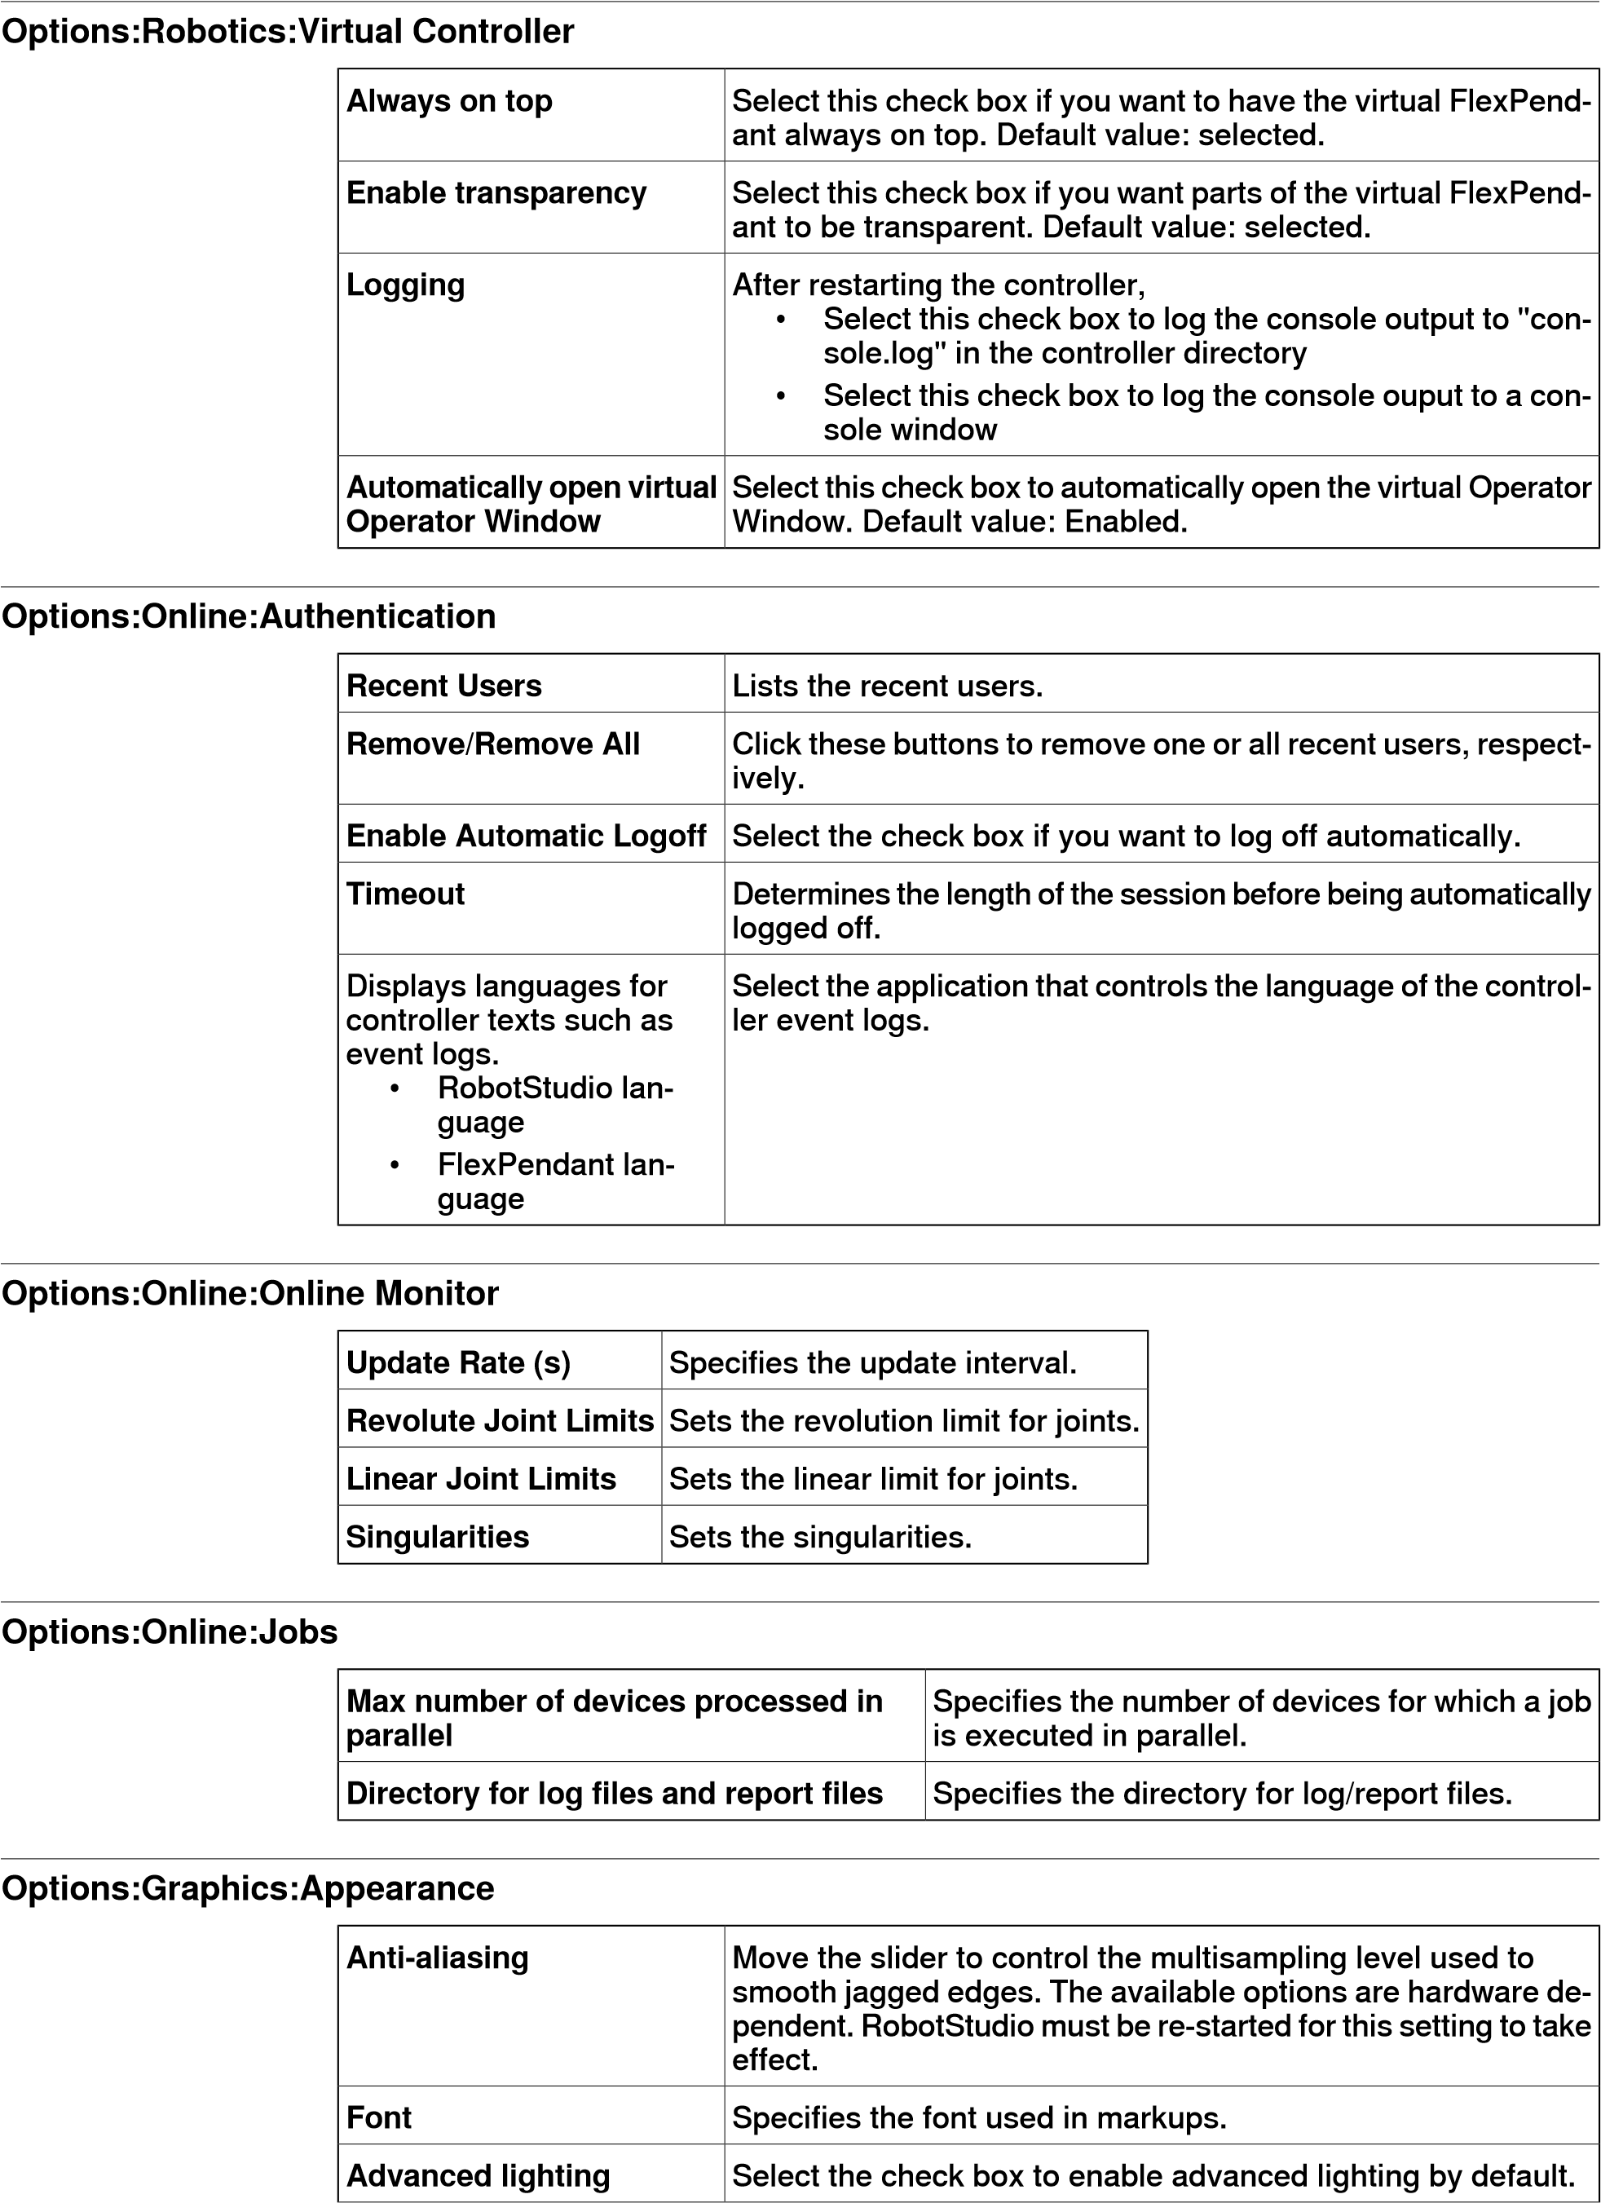

**Perspective** Click this option to view the perspective view of the object by

default.

**Orthographic** Click this option to view the orthographic view of the object by default.

**Custom backgroundcolor** Click the colored rectangle to change default background color.

**Show floor** Select the check box if you want the floor (at z=0) to be dis-

played by default. Change the floor color by clicking the colored rectangle. Default values: selected.

**Transparent** Select the check box if you want the floor to be transparent by default. Default values: selected.

**Show UCS Grid** Select the check box if you want the UCS grid to be displayed.

Default value: selected.

**Grid Space** Change the UCS grid space in the X and y coordinate directions by entering the requested value in the box. Default value: 1000 mm (or equivalent in other units).

**Show UCS coordinate** Select the check box if you want the UCS coordinate system **system** to be displayed. Default value: selected.

**Show world coordinate** Select the check box if you want the coordinate systems to be **system** displayed. Default value: selected.

**Show navigation and se-** Select this check box to have the navigation and selection **lection buttons** buttons on the graphics window.

The settings you make take effect when creating a new station or when selecting **Default View Settings** from the **Settings** menu of the **View** tab of the Graphics Tools ribbon.

**Options:Graphics:Performance**

**Rendering detail level** Select if the detail level is to be Auto, Fine, Medium or Coarse. Default value: Auto.

**Render both sides of sur-** Select the check box if you want to ignore the back-facing tri**faces** angles. Default value: selected.

Culling back-facing triangles improves the graphics performance but may give unexpected display if surfaces in models are not faced correctly.

**Cull objects smaller than** Select the size in pixels under which objects will be disregarded. Default value: 2 pixels.

The settings you make here are generic for all objects in RobotStudio. With the

**Graphic Appareance** dialog box you can, however, override some of these settings for single objects.

**Options:Graphics:Behavior**

**Navigation** Select a navigational activity and then specify the mouse buttons to be used for the selected navigational activity.

**Navigation sensitivity** Select the navigation sensitivity when using the mouse movements or navigation buttons by clicking the bar and dragging it into position. Default value: 1.

**Automatically adjust view** Select to automatically adjust the view center distance when **center distance** rotating or zooming a 3D view.

**Selection radius (pixels)** Change the selection radius (that is, how close the mouse cursor click must be to an item to be selected) by entering the requested pixel value in the box. Default value: 5.

**Selection highlight color** Click the colored rectangle to change the highlight color.

**Selection preview** Select the check box to enable temporarily highlighting of items

thatmay be selectedwhenthemousecursorpassesoverthem. Default value: selected.

**Show local coordinate** Select the check box to show the local coordinate system for **system for selected ob-** the selected objects. Default value: selected. **jects**

**Options:Graphics:Geometry**

**Detail Level** Specify the level of detail required when importing geometries. Select **Fine**, **Medium** or **Coarse** as required.

**Options:Graphics:Stereo/VR\***

**Mirror Output** Displays the image available in the VR glasses in the Graphics view.

**Quality** Move the slider to adjust the quality of the image to an acceptable

level of lag.

**Disable Anti-Aliasing** This option is disabled by default for better performance.

**Options:Simulation:Clock**

**Simulation speed** Sets the simulation speed relative to real time. You can define the simulation speed to a maximum of 200%

**As fast as possible** Select this check box to run the simulation as fast as possible.

When you select this option, the simulation speed slider is disabled.

**Simulation timestep** Specifies the simulation timestep.

**Run time slice in parallel** When simulating a large number of controllers (such as ten **for multiple controllers** controllers), this option may increase performance by utilizing multiple CPU cores.

This option is hardware dependent and hence may give different results depending on the computer used.

**Options:Simulation:Collision**

**Perform collision detec-** Select if collision detection is to be performed during simulation **tion** or always. Default value: always.

**Pause/stop simulation at** Select this check box if you want the simulation to stop at a **collision** collision or at a near miss. Default value: cleared.

**Log collisions to Output** Select this check box if you want the collisions to be logged to **window** the output window. Default value: selected.

**Log collisions to file:** Select this check box if you want to log the collisions to a file. Browse for the file to log in by clicking the browse button. Default value: cleared.

**Enablefastcollisiondetec-** Select this check box to enhance the performance by detecting

**tion** collisions between geometrical bounding boxes instead of

geometrical triangles. This might result in falsely reported collisions, since the triangles are the true geometry and the bounding boxes always are larger. All true collisions will, however, be reported. The larger the object, the greater the number of false collisions that are likely to be detected.

**View** Click this button to open the log file specified in the file box in

Notepad.

**Clear** Click this button to delete the log file specified in the file box.

**...** Click this button to browse for the file in which you want to log

the collisions.

**Options:Simulation:Physics**

**Collision Geometry detail level** Set the slider to set the physics collision geometry either to faster or to a more accurate state.

**B Terminology**

**A**

ABB Library

The default repository of downloaded robots, positioners, tracks and their respective galleries.

Add-In

A software program that expands the capabilities of RobotStudio or RobotWare. Creating Add-Ins is the recommended way for third party developers to add new features into RobotWare or RobotStudio.

A RobotWare Add-In contains RAPID modules and configuration files that holds the code for loading the add-in and configuring it at start up. The Add-In may also include .xml files with event log messages in different languages. Add-Ins can be packaged using the RobotWare Add-In Packaging tool. You can download the tool from http://www.abb.com/abblibrary/DownloadCenter/

Activation key

A 25-character string that ABB sends by e-mail during RobotStudio purchase. This key is used for activating RobotStudio standalone license during manual activation in the absence of Internet connection.

**B**

Base frame

The base coordinate system is called the Base Frame (BF). The base frame for a robot is located at the center of its foot. It describes the location of the robot in relation to the world coordinate system.

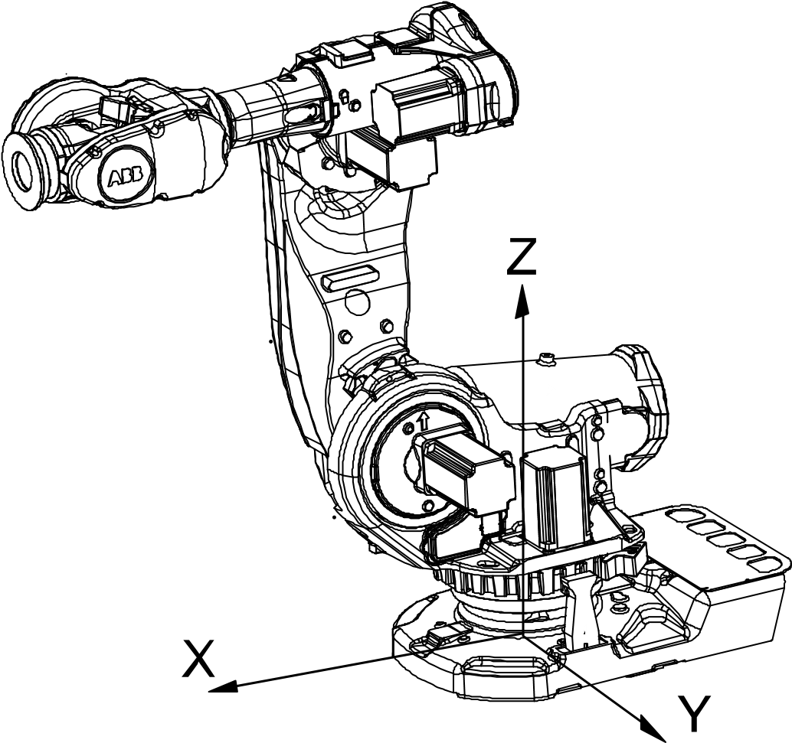

xx0300000495

Ball joint

Defined by a point that allows free rotation but no translation.

Body

A body is a shape, which can be a solid, surface, or curve.

Boot Server

It is a software installed in the controller along with RobotWare. The Boot Application on the FlexPendant copies the installation files for the selected system to the controller inbox. The Boot Server application on the robot controller uses these files in the controller inbox to create a RobotWare system on the memory card in the robot controller. Once the installation finishes, the selected RobotWare system starts.

Breakpoint

A breakpoint is an intentional stop placed for debugging in a RAPID program. A breakpoint is a signal that tells the debugger to temporarily stop the RAPID program at a certain point. When execution stops at a breakpoint, the program is in the break mode. Entering the break mode does not stop the program, you can resume program execution at any time.

**C**

Category 0 stop

Stop by immediate removal of power to the actuators. Mechanical brakes are applied. A robot that is stopped with a category 0 stop does not follow its programmed path while decelerating.

Category 1 stop

Controlled stop with power available to the actuators to achieve the stop. Power is removed from the actuators when the stop is achieved. A robot that is stopped with a category 1 stop follows its programmed path while decelerating.

Checksum

A checksum is an auto-generated unique mandatory text string of 64 characters appended to the safety configuration file of a controller. This string captures any changes that may happen to the file during transmission or installation. It is applied to the safety configuration file that Visual SafeMove creates.

Clip Plane

A clip plane is an imaginary infinite plane that cuts through geometric objects in the station. It allows the user to temporarily cut parts of the model away to help visualize the interior of a geometry or mesh. Objects on one side of the plane are visible while objects on the other side are invisible. A station can contain multiple clip planes, but each graphics view can only have one active clip plane.

Collision Geometry

Collision geometry is the simplified shape of an object where sharp edges and uneven surfaces of complex geometries are removed for easiness in collision calculations. The simplified collision geometry is used in physics simulations.

RobotStudio uses regular geometry for collision detection.

Collision detection

Useful to identify intersections between 3D objects in a station during programming phase and to detect any probable collisions with robot. It helps in modifying robot programs accordingly and avoid collisions on the shop floor at run-time. There is a performance penalty in using collision detection as it is a compute-intensive feature and demands computer resources extensively for collision calculations. Therefore, it is recommended that it must include parts that can potentially collide and exclude others during collision calculations.

Collision Set

A collision set is a pair of object sets that are checked for mutual collisions. A common use of collision sets is to create one for each robot in the station. Add robot and its tool in the first object set and objects against which you want to check collision in the other. Each collision set can be activated and deactivated separately.

Curve

A curve is a wire body like a line, circle, arc, polygon, polyline, or spline.

Cylindrical joint

Defined by a line and is a combination of prismatic and rotational joint.

Coordinate system

A coordinate system specifies the position and orientation of an object in the 3D space using three coordinates x, y and z. Orientation of an object can be specified either by using three angles or quadrants. RobotStudio allows using the following coordinate systems to define the orientation and placement of components. A coordinate system defines a plane or space by axes from a fixed point called the origin. Robot targets and positions are located by measurements along the axes of coordinate systems. A robot uses several coordinate systems, each suitable for specific types of jogging or programming. RobotStudio uses the following coordinate systems, World, Local, UCS, Active Work object, Active Tool.

* The base coordinate system is located at the base of the robot. It is the easiest one for just moving the robot from one position to another.
* The work object coordinate system is related to the work piece and is often the best one for programming the robot.
* The tool coordinate system or the Tool Center Point frame(TCP) defines the position of the tool the robot uses while reaching the programmed targets.
* The world coordinate system defines the robot cell, all other coordinate systems are related to the world coordinate system, either directly or indirectly. The world coordinate system has its zero point on a fixed position in the cell or station. This makes it useful for handling several robots or robots moved by external axes.

By default, the world coordinate system coincides with the base coordinate system. The user coordinate system is useful for representing equipment that holds other coordinate systems, like work objects.

Cycle time

Simulations are calculated cyclically. The cycle time specifies the time frame in which the calculations are to be performed and data is to be exchanged.

**D**

Drive module

Houses power supply and the drive units of the robot and additional motors. If you have external axis in the system the corresponding drive modules must be in place.

Distribution Package

Distribution Package is the basic unit for the distribution and installation. Package Components are the smallest non-divisible unit of distribution containing a version and type, for example, a RobotStudio add-in. The contents of the Distribution Package may be installed on an embedded device such as the robot controller. RobotWare 6 and related RobotWare add-ins media pools are packaged and distributed in specific folders called distribution packages.

On a Windows installation with English language, the default folder is C:

\User\<user name>\AppData\Local\ABB\DistributionPackages, this location can be customized. A distribution package may consist of one or more products. When distributed as one file, the suffix of the file is .rspak. Use the Install Package command in the Add-Ins page to install a distribution package.

**Locations of distribution package**

In RobotStudio 6, RobotWare and related packages are referred as application data. A distribution package is available in the following locations.

* ProgramData: used when the appdata is shared among users on the computer. If RobotWare is installed with RobotStudio, the path is

%ProgramData%\ABB Industrial IT\Robotics IT\DistributionPackages\.

* LocalAppData: used if a package or manifest is installed by a particular user. If RobotWare is installed with RobotStudio, the path is

Users\<username>\AppData\Local\ABB Industrial IT\Robotics IT\DistributionPackages .

* Customized location (optional): may be used when several users share a package repository. For more information, see Additional distribution package location in RobotStudio Options:General:Files & Folders.

**E**

External Axis

Moving equipment that is controlled by the robot controller (in addition to the robot) is denoted as an external axis, for example, track motion, a positioner, and so on.

Entry point

Point where the program execution starts.

**F**

Frame

Frame is the visual representation of a coordinate system in RobotStudio.

* Position of a component is represented with respect to World, Base and Work object frames.
* Orientation format is set to Quaternion or Euler angles.
* Position angle format is set to Angles.
* Presentation angle unit can be set to Degrees or Radians.

Face

Each surface of the body is called a face. Solid bodies are 3D objects, made up of faces. A true 3D solid is one body containing multiple faces.

Freerun mode

Controllers run independently of each other. The cycle time will be accurate, but the timing for setting signals and triggering events will be inaccurate.

**G**

Geometry

3D representation of real objects like box, cylinder and so on. CAD models of work pieces and custom equipment are imported as geometries to the station. Geometry consists of two layers; the mathematical representation of the curves and surfaces known as boundary representation (BReps), and the graphics layer, containing triangles that approximate the BReps. Graphics layer is used in collision detection and for visualizing the mathematical layer.

**I**

Instruction Templates

A RAPID instruction file (template) containing predefined argument values used to create new instructions. These templates can be created for RAPID instructions in the virtual controller.

**J**

Joint

A joint defines how links around are connected. The most common joint types are prismatic or linear. But there are also ball joints, cylindrical, and lock joints.

**L**

License

RobotStudio features are activated using the activation key. Activation key is a 25-character key that is availed when you purchase RobotStudio. RobotWare options are enabled/unlocked by one or more RobotWare license files(.rlf). Several license files can be combined for one RobotWare. The license file is delivered with the robot. To extend the Virtual Controller with more RobotWare options, contact ABB. Only the RobotWare options that are made available/unlocked by the license file will be available for selection in the Installation Manager while building or modifying the RobotWare.

RobotWare license decides the parts of RobotWare (supported robot models, options and so on.) that must be part of the system. When running a system on a robot controller, it must be built with the license that was delivered with the robot. For running a virtual controller (for simulations in RobotStudio) either a license from a real robot or a virtual license can be used. Using a license from a real robot is a quick way to ensure that the virtual controller matches that robot. Using a virtual license provides possibility to simulate and evaluate any robot model with any configuration. A virtual controller built with a virtual license cannot be run on a robot controller.

Library files

Library files are standalone external reusable files that are added to a RobotStudio station. The ABB product range of robots are downloaded as library files. Library files contain geometrical data and RobotStudio specific data. For example, when a tool is saved as a library file, its tool data is saved along with the CAD data.

Local origin

All objects have coordinate systems of its own called the local coordinate system. Object dimensions are defined with respect to this coordinated system. When the object’s position is referred from other coordinate systems like WCS, the local origin of the object is used as the point of reference.

Lock joint

Connects two objects and does not allow them to move in relation to another.

Link

A link is a mechanical part. Several links are connected through joints to form a manipulator (mechanism).

**M**

Mechanism

A mechanism is a graphical representation of a robot, tool, external axis, or device, various parts of a mechanism move along or around axes.

MultiMove

Controls as many as 4 robots (36 axes) at a time. In a multimove system, common work objects are shared between robots which requires complex coordinated patterns. MultiMove also facilitates a dynamic switch between independent and coordinated motion.

Markup

A markup is a text box displayed in 3D. It is part of the station and appears as a text bubble pointing to a position in the **Graphics** window.

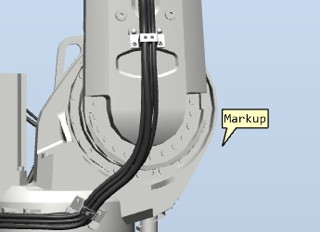

xx1900000306

Mechanical unit

A mechanical unit is the representation of a robot or one or more external axis in the robot controller, for example, robot, track motion and so on.

Module

RAPID code of the controller is structured into modules. A module contains several routines of type procedure, function or trap. Modules are of two types system and program.

**N**

Near-miss

Near-miss occurs when objects in collision sets are closer to each other but it avoids collision. Each collision set has its own near-miss settings. The near-miss feature can be used to add a margin to collisions and to gauge distance between the components in the station during movements.

**O**

Offline

User is disconnected from a robot controller and is working with a virtual controller.

Orientation

The orientation of an object such as a line, plane or rigid body is it’s placement in space. It is the imaginary rotation that is needed to move the object from a reference placement to its current placement. A rotation may not be enough to reach the current placement. It may be necessary to add an imaginary translation too. The location and orientation together fully describe how the object is placed in space. The above-mentioned imaginary rotation and translation may be thought to occur in any order, as the orientation of an object does not change when it translates, and its location does not change when it rotates.

Orientation formats available in RobotStudio are Quaternion, Euler angles and RPY angles.

**Quaternion**

A quaternion is a mathematical representation of orientation. They are points in space represented by their coordinates. A quaternion consists of four values between -1 and 1. The sum of its squares must be equal to one, that is, it has to be normalized (in which case it may be called unit quaternion). **Euler Angles**

The term Euler implies that each angle is applied to the original coordinate system (before the rotations are applied). The angles describe orientations around different axes and in different order. The convention used in RobotStudio and for the IRC5 controller is Euler ZYX, which means the first values describe the angle to rotate around the z axis, the second value describes the orientation angle around the original Y-axis and the last value describes the orientation around original x-axis. There are also other conventions like Euler ZYZ, and Euler XYZ which ABB does not use.

**RPY Angles**

The RPY convention describes orientation with three angles, it is short for Roll,

Pitch, Yaw. Any target orientation can be reached, starting from a known reference orientation, using a specific sequence of intrinsic rotations, whose magnitudes are the Euler angles of the target orientation. The difference compared to the Euler-convention is that each angle describes orientation around the new, rotated coordinate system. When rotating using the RPY convention, then the first angle describes orientation around x (same as Euler), but the second angle describes orientation around the y-axis of the rotated coordinate system (different from Euler), and the z-angle describes orientation around the rotated z axis. The RPY representation is equivalent of the Euler ZYX representation.

Offline programming

Robot programming using the virtual controller.

Open Platform Communications Unified Architecture (OPC UA)

It is a platform independent protocol and communicates data continuously among PLCs on the shop floor, RTUs in the field, HMI stations, and software applications on desktop PCs. Even when the hardware and software are from different vendors, OPC compliance makes continuous real-time communication possible.

Online

User is connected directly to a robot controller through the network.

**P**

Path

A path is a sequence of targets with move instructions that the robot follows.

Part

Top node of a geometry is called a part.

Pack & go

Way to share RobotStudio stations by combining the station and virtual controllers packaged into one file.

Physics behavior

Depicts to what extend an object’s physics behavior shall be simulated, any of the following types can be assigned:

* Dynamic: For a dynamic object, the physics simulation controls its motion which is affected by gravity. It can interact with other objects in the physics simulation.
* Kinematic: Here, an object interacts with other simulated objects, but its motion is controlled outside the physics simulation, for example, a robot whose movement is controlled by a robot controller is an object depicting kinematic behavior.
* Fixed: A fixed object takes part in the physics simulation but remains in a fixed position as if it has an infinite mass. Other objects can collide with it but there will not be any resultant motion.
* Inactive: Here, the object does not take part in the physics simulation, other objects move cross this object without colliding.

Positioner

A positioner is used to position a work piece for the robot to have better access. In arc welding, positioners are used to re-orient the work piece so that the weld is always done vertically due to gravity.

Position

Three coordinates that describe the x, and y and z- position of a point in a given coordinate system. In RobotStudio position of an object can be displayed relative to the reference coordinate systems World, Base and Work object.

Product

In the context of RobotWare 6, product is the collective name for software such as RobotWare, RobotWare add-ins, third party software and so on. Products are either free or licensed, licensed products require a valid license file.

Project

Projects add structure to the station data. It contains folders for structuring station data so as to keep related data together.

Protected Smart Component

A Smart Component which is protected using a password from being edited.

Prismatic joint

Allow two connected links to move along a line that defines the joint.

PLCSIM Advanced

Virtual PLC.

**R**

Robotware keys

The RobotWare key is the license key that decides the robot models and RobotWare options to run on the controller. The license key is delivered with the controller. The RobotWare keys unlock the RobotWare options included in the system and determine the RobotWare version from which the RobotWare system will be built. For IRC5 systems, there are three types of RobotWare keys:

* The controller key, which specifies the controller and software options.
* The drive keys, which specify the robots in the system. The system has one drive key for each robot it uses.
* Add-ins specify additional options, like positioner external axes.

Using a virtual key, you can select any RobotWare option, but a RobotWare system created from a virtual key can only be used in a virtual environment such as RobotStudio.

RobotWare license

This license unlocks the RobotWare options, for example, robots and RobotWare options. To upgrade from RobotWare version 5.15 or earlier, replace the controller main computer and get RobotWare 6 licenses. Contact ABB Robotics service representative at www.abb.com/contacts.

RobotWare system

A set of software files that, when loaded into a controller, enables all functions, configurations, data, and programs controlling the robot. RobotWare systems are created in RobotStudio. These systems can be saved on a PC or on a control module. RobotWare systems can be edited by RobotStudio or the FlexPendant.

Robot Controller

A physical robot controller. It contains all functions needed to move and control the robot.

RobotWare

Set of software products used to configure a robot controller.

RAPID

Programming language for ABB robot controller.

Rail

A mechanism consisting of a linear axis with a carriage on which the robot is mounted.

Robtarget

RobotStudio targets are translated to the RAPID data type robtarget during RAPID synchronization. It defines the position and orientation that the TCP shall reach. A robtarget defines a point in 3D space when it is associated with a work object. The position is defined based on the coordinate system of the work object, including any program displacement.

Routine

A well-defined part of a program for carrying out the intended task. Routines are either procedures, functions or traps.

Rotational joint

Defined by a line around which parts can rotate.

**S**

Station

A station is the 3D representation of the virtual robot cell. It is saved to a file with the extension *.rsstn.

Station logic

Station logic defines how smart components and virtual controllers of a station are connected.

State

State contains selected modifiable aspects of objects and its child objects which can be saved and restored when required.

Station Components

Physical objects such as robot, fixtures, tools, fences and so on, that are used to design an efficient and maintainable robotic cell are collectively referred to as station components.

Synchronization

The synchronization function converts targets, workobjects, tools and paths in the 3D environment to RAPID code in the virtual controller and vice versa.

Smart Component

Smart Component is a RobotStudio object (with or without a 3D graphical representation) whose properties are implemented by the code-behind or by aggregating other Smart Components. The base components that are availed with RobotStudio installation provides a complete set of basic building blocks. They can be used to build user defined Smart Components with more complex properties.

System

A set of software files that, when loaded into a controller, enables all functions, configurations, data and programs controlling the robot system. These systems can be saved on a PC or on a control module. RobotWare systems can be created and edited in RobotStudio or FlexPendant.

Solid model

Solid model is a consistent set of principles for mathematical and computer modeling of 3D solids, for example, a robot mechanism. Solid models are 3D objects, made up of faces consisting of shapes like boxes, cones, cylinders, pyramids, or spheres.

Solids (Primitive solids)

Basic 3D shapes like boxes, cones, cylinders, spheres, wedges, pyramids, and donuts. Combine primitive shapes to create more complex solids.

STATIC task

A STATIC task gets restarted at the current position of the robot when the system was powered off.

SEMISTATIC task

A SEMISTATIC task gets restarted from the beginning whenever the power is turned on. A SEMISTATIC task will also initiate the restart sequence, reload modules specified in the system parameters if the module file is newer than the loaded module.

Station Viewer

It can playback a station in 3D without RobotStudio. It packages the station file together with the files needed to view the station in 3D. It can also play recorded simulations.

Simit

SIMIT is a simulation platform from Siemens for virtual commissioning of factory automation.

Symbol

A signal is identified by this name in SIMIT.

**T**

Tool

A tool is an object that can be mounted directly or indirectly on the robot turning.

Tooldata

A tool is represented with a variable of the data type *tooldata*. Tooldata represents characteristics of a tool such as position and orientation of the TCP and the physical characteristics of the tool load.

Tool Centre Point (TCP)

Refers to the point in relation to which robot’s positioning is defined. It is the center point of the tool coordinate system that defines the position and orientation of the tool. TCP has its zero position at the center point of the tool. The tool center point also constitutes the origin of the tool coordinate system. Robot system can handle a number of TCP definitions, but only one can be active.

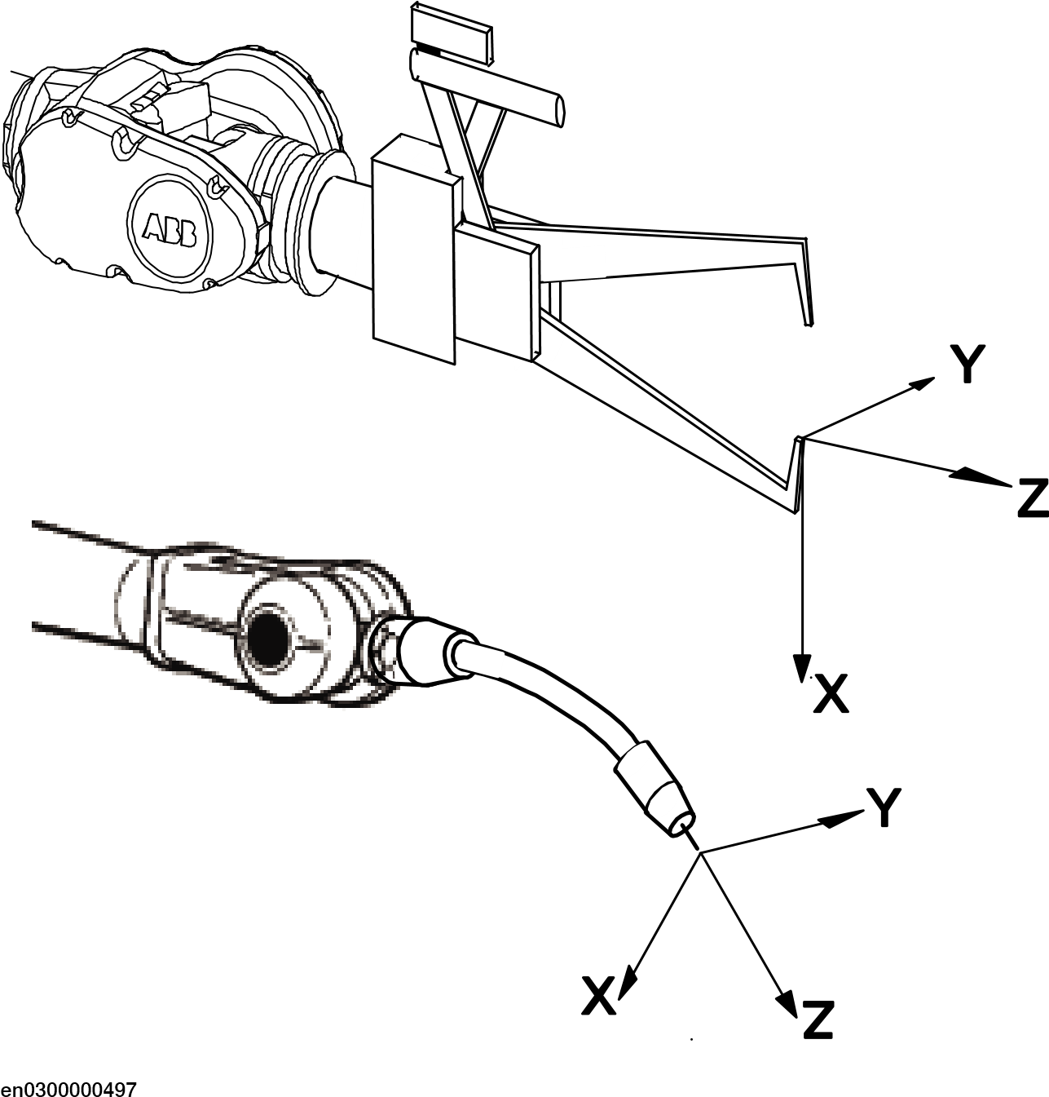

Task

A task is an activity or piece of work. RobotStudio tasks are either Normal, Static or Semistatic.

Task frame

Represents the origin of the robot controller world coordinate system in RobotStudio.

Track motion

A mechanism consisting of a linear axis with a carriage on which the robot is mounted. The track motion is used to give the robot improved reachability while working with large work pieces.

Target

Target signifies the position to which the robot is programmed to move. It is a RobotStudio object that contains the position and orientation of the point that the robot must reach. Position data is used to define the position in the move instructions to which the robot and additional axes will move.

As the robot is able to achieve the same position in several different ways, the axis configuration is also specified. Target object contains values that shows position of the robot, orientation of the tool, axis configuration of the robot and position of the additional logical axes.

Time slice mode

During a simulation involving stations with one or several controllers, RobotStudio manages time using the time slice mode for controller synchronization. In this mode, each controller gets a single time slice for execution. When all the participants have completed execution of their respective allotted time slice, RobotStudio moves on to the next time slice.

**U**

User Authorization System

Defines the correct access level for each user, protects the system from unauthorized usage.

User library

Library files imported to RobotStudio.

**V**

Virtual controller

A software that emulates the robot controller on the PC. It is used for offline programming and simulation. Virtual controller replicates the RobotWare system.

**W**

Work Object

A work object is a local coordinate system that indicates the reference position (and orientation) of a work piece. The work object coordinate system must be defined in two coordinate systems , the user coordinate system (related to the world coordinate system) and the object coordinate system (related to the user coordinate system). Work objects are often created to simplify jogging along the object’s surfaces. Work objects should always be global to be available to all modules in the program.

xx0600002738

World

coordinate

system

A

Work

Object

coordinate

system

1

B

Work

Object

coordinate

system

2

C

World coordinate system

The world coordinate system represents the entire station or the robot cell, all other coordinate systems are related to the world coordinate system, either directly or indirectly. The world coordinate system has its zero point on a fixed position in the cell or station. This makes it useful for handling several robots or robots moved by external axes. By default, the world coordinate system coincides with the base coordinate system.

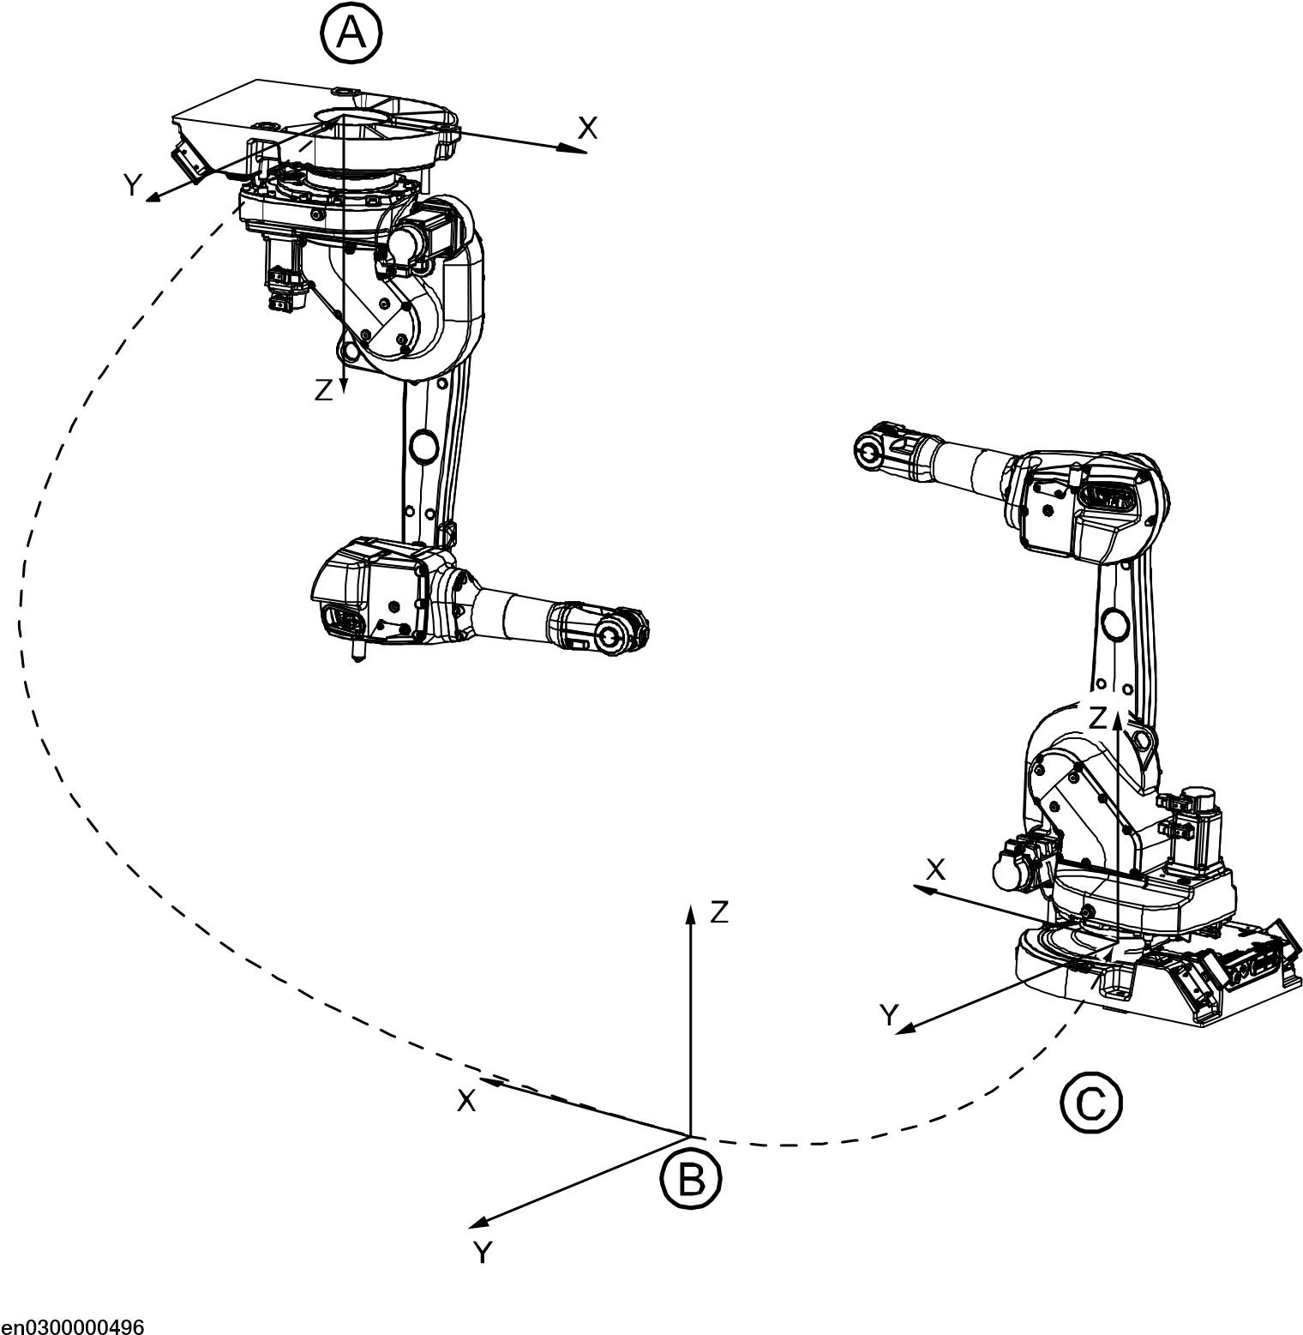

Base

coordinate

system

for

robot

1

A

World

coordinate

B

Base

coordinate

system

for

robot

2

C

Work Envelope

The defined area of space in which a robot can move is its work envelope. Work envelope for a robot is the maximum range of movement that can be visualized in 2D/3D graphics. Work envelope can be added to the station as a part, which can be saved in the station and exported as any geometry.

Wobjdata

A work object is represented with a variable of the data type *wobjdata*. It describes the work object that the robot welds, processes, moves within, and so on.

This page is intentionally left blank

**C Technical support**

**C Technical support**

**Overview**

**Contacting ABB**

If you have any questions or problems with your RobotStudio installation, please contact your local ABB Robotics Service representative, see *http://www.abb.com/contacts*.

**Have the following in mind**

1. Running the latest version of RobotStudio ensures that it works properly and also includes improvements and new product functionality. ABB recommends that you update to the latest version of RobotStudio whenever a new version is available and before contacting ABB for support.
2. Provide a brief description explaining how to reproduce your problem.
3. Provide screenshots if applicable. (Use ALT + PRINT SCREEN to get an image of the active window instead of the entire screen.)
4. Generate a Full Scan with the **RobotStudio Support Tool** available next to

RobotStudio in the Start menu. (Click **Start > Programs > ABB > RobotStudio > RobotStudio Support Tool**, then click on **Run Full Scan** and then click **Save Report**. Save this report and attach it with your problem description.

1. Provide us the following user information: a name b company

c contact information d name of the operating system including the language details e subscription ID of the purchased license f Machine ID, see **Help** section of **File** tab

**License support**

For license-related questions, please contact the team responsible for license support directly at *softwarefactory_support@se.abb.com*

This page is intentionally left blank

**Index**

**A**

Add Controller, 368–369

Adjust Robtargets, 420

Application grants, 376

**B**

Backup, 86 create backup, 86

**C**

collision

sets, 140

configuration editor, 381 instance editor, 386

configuration file, 384 Controller grants, 374, 376

Backup and save, 374

Calibration, 375

Delete log, 376

Edit RAPID code, 375

Execute program, 374

Full access, 374

I/O write access, 374

Manage UAS settings, 374, 376

Modify configuration, 375

Modify controller properties, 375

Modify current value, 374, 376

Program debug, 375

Read access to controller disks, 375 Safety Controller, 376

Write access to controller disks, 375 controller world coordinate system, 91

**D**

detecting collision, 141 device browser, 390

**G**

graphics window, 43

**L**

LED, 293

**M**

Manage ScreenMaker project

Close ScreenMaker, 307

Manage ScreenMaker Project Close project, 307

Managing ScreenMaker Projects Build project, 306

Modify project properties, 305

**N**

near-miss detection, 142 network security, 15 network settings

firewall settings, 36 local network connection, 36 remote network connection, 36 service port connection, 36

**P**

Properties

Device Browser, 390

**Index**

Renaming the controller, 388

Save System Diagnostics, 391

Set controller ID, 388

Set date and time, 388

View controller and system properties, 390

Properties Window

Event Help panel, 294

Graphical Component Name panel, 294

Properties window toolbar, 294

Table panel, 294

**R**

Relation, 413 remote subnet, 37

Robot system button, 337 adding an existing system, 338 adding a template system, 338 create system from layout, 337

**S**

safety, 14 station world coordiante system, 89 switch, 293

System Builder about virtual and real systems, 243 download a system to controller, 255

System Configuration controller values, 409 stored station values, 409 used current station values, 409

system parameters

editing parameters, 382

**T**

ToolBox

ActionTrigger, 292

BarGraph, 292

CheckBox, 292

ComboBox, 293

CommandBar, 293

ConditionalTrigger, 293

ControllerModeStatus, 293

DataEditor, 293

Graph, 293

GroupBox, 293

ListBox, 293

NumEditor, 293

NumericUpDown, 293

Panel, 293

PictureBox, 293

RapidExecutionStatus, 293

RunRoutineButton, 293

TabControl, 293 TpsLabel, 293

**U**

UCS, 94 user coordinate system, 94

**V**

VariantButton, 293

**W**

WorkObject, 94 world coordinate system, 89

**ABB AB**

**Robotics & Discrete Automation**

S-721 68 VÄSTERÅS, Sweden Telephone +46 10-732 50 00

**ABB AS**

**Robotics & Discrete Automation**

Nordlysvegen 7, N-4340 BRYNE, Norway

Box 265, N-4349 BRYNE, Norway

Telephone: +47 22 87 2000

**ABB Engineering (Shanghai) Ltd.**

Robotics & Discrete Automation

No. 4528 Kangxin Highway

PuDong New District

SHANGHAI 201319, China Telephone: +86 21 6105 6666

**ABB Inc.**

**Robotics & Discrete Automation**

1250 Brown Road

3

HAC032104-001,

Rev

AS,

en

Auburn Hills, MI 48326

USA Telephone: +1 248 391 9000 **abb.com/robotics**

© Copyright 2024 ABB. All rights reserved.

Specifications subject to change without notice.